**Assignment 5**

**Name : Manvi Pandya**

**Roll NO :43233**

**Batch – R10**



**Screenshots**

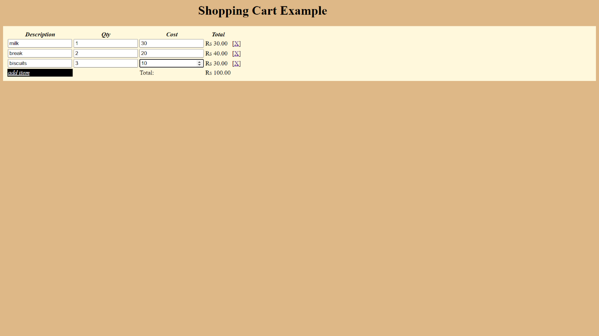

**Code**

**Cart.html**

<html>

 <head>

       <script src="angular.min.js"></script>

 </head>

 <body style="background-color: burlywood;">

<h1 style="padding-left:500px;font-style: bold;color: black">Shopping Cart Example</h1>

<div ng-app="myapp" ng-controller="CartForm" style="background-color: cornsilk;">

    <table class="table" style="padding: 10px;">

        <tr style="color: black;font-style: oblique;">

            <th>Description</th>

            <th>Qty</th>

            <th>Cost</th>

            <th>Total</th>

            <th></th>

        </tr>

        <tr ng:repeat="item in cart.items" >

            <td><input type="text" ng:model="item.description"></td>

            <td><input type="number" ng:model="item.qty" ng:required></td>

            <td><input type="number" ng:model="item.cost" ng:required></td>

            <td>{{item.qty * item.cost | currency:'Rs '}}</td>

            <td>[<a href ng:click="removeItem($index)">X</a>]</td>

        </tr>

        <tr>

            <td style="background-color: black;"><a href ng:click="addItem()" style="color:white;font-style: oblique;">add item</a></td>

            <td></td>

            <td>Total:</td>

            <td>{{total() | currency:'Rs '}}</td>

        </tr>

    </table>

</div>

 <script src="cart.js"> </script>

 </body>

 </html>

Cart.js

var app=angular.module('myapp',[]);

    app.controller('CartForm', function($scope)

    {

    $scope.cart = {

        items: [{ qty: '', description: '', cost: ''}]

    }

    $scope.addItem = function() {

        $scope.cart.items.push({ qty: '', description: '', cost: ''});

    }

    $scope.removeItem = function(index) {

        $scope.cart.items.splice(index, 1);

    }

    $scope.total = function() {

        var total = 0;

        angular.forEach($scope.cart.items, function(item) {

            total += item.qty * item.cost;

        })

        return total;

    }

}

);