Assignment No. 1

**Title :** Write Problem Statement and SRS for the given system.

**Objectives:**

● Identify Project of enough complexity, which has at least 4-5

major functionalities.

● Write Problem Statement for System / Project

● Identify stakeholders, actors

**Theory :**

A problem statement gives an overall understanding and flow of the project which helps in identifying system actors / stakeholders.It is a concise description of an issue to be addressed or a condition to be improved upon. It will also provide management with specific insights into the problem so that they can make appropriate project-approving decisions.

**Problem Statement 1.(A)** : Write a Problem Statement for NBA Attainment System.

Problem Statement for NBA Attainment System

* Teachers use excel sheets to store the marks of each student for calculating attainment. Attainment calculation basically deals with analysis of the target achieved for a particular class and subject. This approach is tedious, time consuming and error prone. The idea is to develop a web application which takes input marks of students and generates the attainment report for all classes and for each subject.
* Also, teachers set a test where each question maps to a CO. Therefore, flexibility is reduced. The application gives the flexibility to the teacher to set a test with sub sections depending on different CO’s. The PO’s and the CO-PO mapping according to subject are kept handy for the convenience of teachers.
* Further, scope can be increased to analyse the target that is to be set which depends on the previous years’ records.

The application should be able to :

1. Handle the logins of the teacher, subject coordinator, HoD with different access rights.
2. Display of the course outcomes for each course for each class and for each year (SE,TE,BE).
3. Display of Program Outcomes for convenience of teachers.
4. CO-PO mapping with update facility and validations. (only for subject-coordinator)
5. Flexibility in setting test (Input of user includes number of questions and number of sub

questions in each question.) with an updated facility.

1. Entry of marks according to the test set with update facility.
2. Data (Marks of students ) can be imported from excel files.
3. A proper course wise report. (It includes the level wise attainment and final attainment for the particular year and course.)
4. The report can be downloaded as pdf.

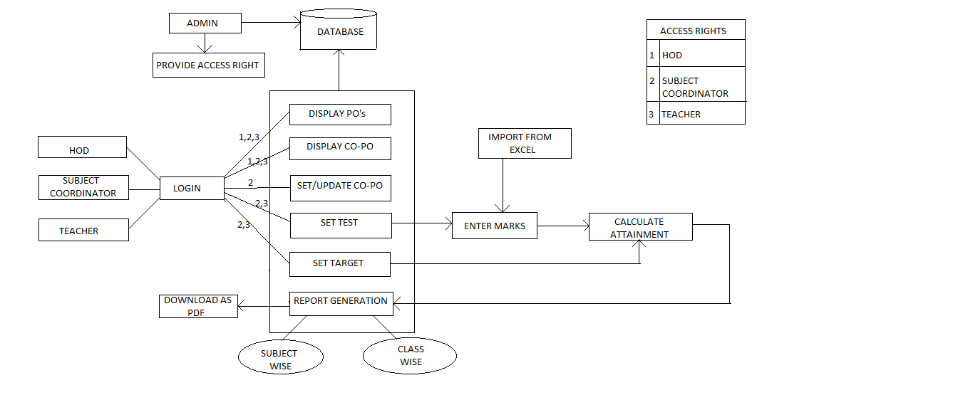

**Conclusion :** Identified the Problem Statement for NBA Attainment System along with the major functionalities like a) Display and update CO’s b) Display PO’s c) Set Test d) Enter marks and e) Report generation. Identified the actors for the system as well.

**Problem Statement 1.(B)** : Prepare a Software Requirement Specification document for NBA Attainment System

**Objectives:**

Prepare Software Requirement Specification Document.

**Theory :**

A software requirements specification (SRS) is a description of a software system to be developed. It lays out functional and nonfunctional requirements, and may include a set of use cases that describe user interactions that the software must provide. It is very important that they come up with a SRS listing out their requirements, how are they going to meet it and how will they complete the project. It helps the team to save upon their time as they are able to comprehend how are going to go about the project. Doing this also enables the team to find out about the limitations and risks early on.

**Table of Contents**

**1. Introduction**

1.1 Purpose

1.2 Document Conventions

1.3 Intended Audience and Reading Suggestions

1.4 Product Scope

1.5 References

**2. Overall Description**

2.1 Product Perspective

2.2 Product Functions

2.3 User Classes and Characteristics

2.4 Operating Environment

2.5 Design and Implementation Constraints

2.6 User Documentation

2.7 Assumptions and Dependencies

**3. External Interface Requirements**

3.1 User Interfaces

3.2 Hardware Interfaces

3.3 Software Interfaces

3.4 Communications Interfaces

**4. System Features**

4.1 System Feature 1

4.2 System Feature 2 (and so on)

**5. Other Nonfunctional Requirements**

5.1 Performance Requirements

5.2 Safety Requirements

5.3 Security Requirements

5.4 Software Quality Attributes

# **1.Introduction**

## **1.1 Purpose**

The purpose is to reduce the overhead of storage and manual calculation of attainment using software program (eg. Software program like excel sheet) and hence create an efficient web application which accepts required inputs and generates attainment wise reports for each course.

## **1.2 Document Conventions**

|  |  |
| --- | --- |
| CO | Course Outcome |
| PO | Program Outcome |
| NBA | National Board of Accreditation |
| HTTP | HyperText Transfer Protocol |

## **1.3 Intended Audience and Reading Suggestions**

This project is a prototype for the NBA Attainment calculation system and it is restricted within the college premises. This has been implemented under the guidance of college professors. This project is useful for the teachers as well as the higher authorities.

## **1.4 Product Scope**

Teachers use excel sheets to store the marks of students thereby setting targets and calculate the attainment manually. This web based application thus reduces the overhead of manual calculation and errors. A database server supports all the students in college as well as the marks secured by them in every subject. The web app also generates reports of attainment on the basis of class and subject. Also, further we can provide analysis for setting targets based on previous inputs. Above all, we hope to provide a comfortable, convenient and easy-to-use application for teachers along with the best functioning.

## **1.5 References**

[1] A Simplified approach to measure Course Outcomes and Program Outcomes for accreditation of Engineering Institutes.

[2] Measuring Attainment of Course Outcomes and Program Outcomes – A Simplified Approach as per Self-Assessment Report - June 2015, IOSR Journal of Research & Method in Education (IOSR-JRME) .

# **2. Overall Description**

## **2.1 Product Perspective**

Course Outcomes (CO) : They are the resultant knowledge skills the student acquires at the end of a course.

Program Outcomes (PO ) : As stated by NBA, represent the knowledge, skills and attitudes the students should have at the end of a four year engineering program in India.

Attainment refers to how much of the target is actually achieved in the range of 0 - 1

1. For every course, mapping of CO-PO is performed which infers to which CO maps to which PO and on what level (Levels are represented as 0,1,2,3 where 0 represents no mapping).
2. The target percentage of students achieving passed class, first class and distinction is set

for Unit test 1, Unit test 2, SPPU.

1. Each question in a test is based on a CO . The marks of students are segregated as per CO’s .

The number of students achieving actual marks for each level is calculated.

Calculations :

Level 1 : Number of students scoring marks > 40%

Level 2 : Number of students scoring marks > 60%

Level 3 : Number of students scoring marks > 66%

1. Compare the actual and targeted results (%attainment=actual/target). Now map the percentage attainment between 0 and 1.

## **2.2 Product Functions**

1. Display of the course outcomes for each course for each class and for each year (SE TE BE).
2. Display of Program Outcomes.
3. CO-PO mapping with update facility and input validations.
4. Flexibility in setting test (Input of user includes number of questions and number of sub

questions in each question.) with an updated facility.

1. Entry of marks according to the test set with update facility. (Data can be imported from csv or excel)
2. A proper course wise report.(Can be downloaded as a pdf)

## **2.3 User Classes and Characteristics**

Teachers :

1. Enter Marks of unit test based on CO.
2. Download report (assigned subject and class only).

Subject Coordinator :

1. Enter Marks of unit test based on CO.
2. Enter CO-PO Mapping.
3. Download report (subject wise for each class).

Head of Department :

Download the final report (wrt class , subject , student , teacher ).

Admin : Keep regular backups of data and handle all application generated data.

The following are the main features that are included :

1. There are different access rights for Admin , Teachers , subject coordinator and HoD. Subject Coordinator can also login as a teacher
2. Subject coordinator can alter the CO-PO mapping.
3. Provides flexibility for teachers to set tests based on CO.
4. Data can be imported from Excel Sheets and CSV files.
5. Report is generated for each class and for each subject.
6. The Report can be downloaded as pdf.

**2.5** **Design and Implementation Constraints**

**2.6 User Documentation**

## **2.7 Assumptions and Dependencies**

The data (marks of students) that is inserted in the database should be correct. If the input is wrong, all further procedures will be wrong.

# **3. External Interface Requirements**

## **3.1 User Interfaces**

The application is very user friendly and uses a GUI interface implemented in HTML and

Bootstrap to communicate with the user. Various features are self – explanatory. Forms

are easy to fill in and components can be updated very easily through a normal update

button with confirmation dialog boxes which will eventually prevent errors. The

application includes hints to give a brief description of the particular input Field. Proper

validations prevent the user from performing errors. Proper positioning of dashboard,

home button and sign out options enable a user-friendly interface.

## **3.2 Hardware Interfaces**

No hardware interfaces have been identified.

## **3.3 Software Interfaces**

1. Operating system: Windows / Linux .
2. Web Browser : Any (Chrome , Firefox)
3. Database: MySql (v. 1.2.12)
4. Connection : JDBC
5. Server : Tomcat (v5.0)

## **3.4 Communications Interfaces**

Support for all web browsers which eventually use HTTP.

# **5. Other Nonfunctional Requirements**

## **5.1 Performance Requirements**

The steps involved to perform the implementation of NBA Attainment are as listed below :

**A) E-R DIAGRAM**

The E-R Diagram constitutes a technique for representing the logical structure of a database in a pictorial manner. This analysis is then used to organize data as a relation, normalizing relation and finally obtaining a relation database.

* **ENTITIES:** Which specify distinct real-world items in an application.
* **PROPERTIES/ATTRIBUTES:** Which specify properties of an entity and relationships.
* **RELATIONSHIPS:** Which connect entities and represent meaningful dependencies between them.

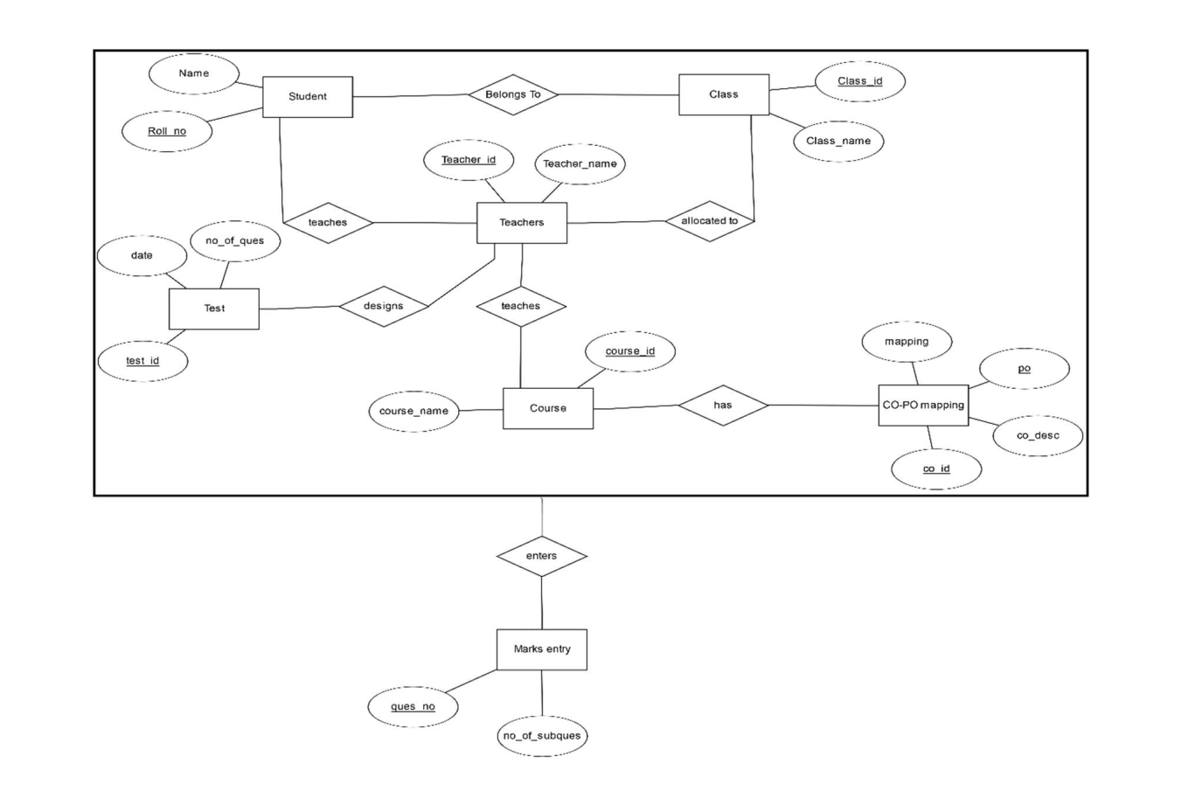

**B) NORMALIZATION:**

The basic objective of normalization is to reduce redundancy which means that information is to be stored only once. Storing information several times leads to wastage of storage space and increase in the total size of the data stored.

If a database is not properly designed it can give rise to modification anomalies. Modification anomalies arise when data is added to, changed or deleted from a database table. Similarly, in traditional databases as well as improperly designed relational databases, data redundancy can be a problem. These can be eliminated by normalizing a database.

Normalization is the process of breaking down a table into smaller tables. So that each table deals with a single theme. There are three different kinds of modifications of anomalies and formulated the first, second and third normal forms (3NF) is considered sufficient for most practical purposes. It should be considered only after a thorough analysis and complete understanding of its implications.

## **5.2 Safety Requirements**

If there is extensive damage to a wide portion of the database due to a catastrophic failure, such as a disk crash, the recovery method restores a past copy of the database.

## **5.3 Security Requirements**

Security systems need database storage just like many other applications. However, the special requirements in terms of security involve the access rights provided to the various stakeholders.The student must be provided with access that allows them to view data specific for their profile. And the same applies to the teachers too.

## **5.4 Software Quality Attributes**

* **Availability :** The data should be available on any specified date and at any specified time according to the user.
* **Correctness :** The records should have all the correct data and there should be no erroneous data available.
* **Maintainability :** The maintaness of the data should also be taken into account.
* **Usability :** The data available should satisfy the needs of the maximum number of users.

**Conclusion:** In this assignment we implemented a SRS document which will help the customers to define their requirements and helping the developers to understand them. The SRS document will ensure proper considerations in the design and the overall project flow.