**Name : Manvi Pandya**

**Roll No. : 33235**

**Batch : L10**

**Assignment No.4**

**Title :** EIGRP,RIP,WLAN

**Theory**

**1)EIGRP :**

* It is cisco proprietary routing protocol.
* It is an enhanced version of interior gateway routing protocol.
* In comparison with IGRP , it provide fastest convergence times, superior bandling of counting loops and improved scalability
* It maintains 3 table,

1.Neighbour table

EIGRP show routing information only with neighbour.

2. Topology table

EIGRP uses this table to show all router with it learnt from neighbour.

3.Routing table

EIGRP select single best source or route fro each destination in table.

K-Values :

* EIGRP may use s matric components to select the best route for routing table.These are,

k1 -> bandwidth

k2 -> load

k3 ->deny

k4 -> reliability

k5 -> Mtv

In order to become EIGRP neighbour two routes must use same K variable

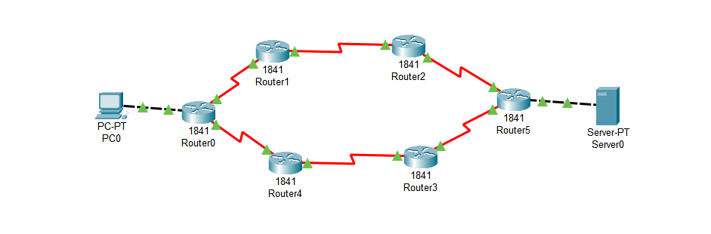

**Configuring wireless network**

Task to perform :

1. Configure DHCP on Pc & wireless router
2. Change SSID and provide WEP key
3. Change address of router
4. Secure your network by configure WAP key on router
5. Connect Pc by WAP key
6. Add MAC security filter,if you want to allow or deny same PC in network

**Conclusion :**

In this way, I have configured EIGRP,RIPV2,WLAN using network simulator.