Predicting Relation Between MOOD Metric and Maintainability of Object Oriented Projects
An Empirical Analysis of correlation of MOOD Metrics with Maintainability on JFreeChart.

Harpreet Singh Sran Jasminderjit Singh Sandeep Singh Brar
Dept. of Software Engineering Dept. of Software Engineering Dept. of Software Engineering
Concordia University Montreal, Canada Concordia University Montreal, Canada Concordia University Montreal, Canada

Manvir Singh Amritpal Singh Khurram Shahzad
Dept. of Software Engineering Dept. of Software Engineering Dept. of Software Engineering
Concordia University Montreal, Canada Concordia University Montreal, Canada Concordia University Montreal, Canada

Taranjot Singh Beerpreet Singh Nsr Khan
Dept. of Software Engineering Dept. of Software Engineering Dept. of Software Engineering
Concordia University Montreal, Canada Concordia University Montreal, Canada Concordia University Montreal, Canada

Abstract— MOOD metrics can be used to enhance quality of a software project. Several studies have proved that MOOD metrics are good indicator of maintenance efforts required for a software product. In this study, we implemented six MOOD metrics and analyzed their correlation with an open source java project, JFreeChart. We used 35 versions of JFreeChart to yield an accurate and better response. We performed analyses at different granularity levels and also verified the results using another open source java project, JUnit. Values for maintainability were retrieved with the help of Logiscope tool. It was observed that there is a relationship between the value of maintainability and MOOD metrics.
Keywords— MOOD, Maintainability, Metrics

Introduction
Software maintenance is the continuous process of modifying software in order to enhance performance and to correct faults. It is one of the basic need for evolution of the software project. Various researches have been done so far in the field of software maintenance. Numerous scientist are working on metrics suites to find more accurate information about the internal structure of the softwares. We also worked on one metric suites, MOOD metric suite which is defined by Fernando Brito e Abreu[2]. In our study, we tried to predict the relationship between MOOD metrics with maintainability as a quality indicator. To analyze this, we have implemented all six MOOD metrics wit h the help of Jdeodorant tool and calculated the value of these metrics over 35 versions of an open source java project, JFreeChart. The value of maintainability is calculated with the help of Logiscope tool for 35 versions. Then, we have analyzed the correlation between MOOD metrics values and value of maintainability. To verify our results, we performed similar analyses on one another open source java project, JUnit. After analyses and verification, we reached to the conclusion that MOOD metric suite has strong relationship with the maintainability.

Related Work

A. “An Evaluation of the MOOD Set of Object-Oriented Software Metrics”[1]
This paper is intended to empirically validate the MOOD set of metrics and discuss their merits from a measurement theory viewpoint. In this study they discussed the various MOOD metrics and they have provided a theoretical validation of the metrics. For empirical validation of the metrics, they used three releases their laboratory electronic retail system and a single release of a suite of image processing programs. They calculated the value of each MOOD metric for different releases and then the authors calculated metric values for nine samples of large industrial sized systems. The results depict the different metric values for different releases of the project. The AHF for all the projects used was 100 percent which means all the attributes were declared as private. MHF had a low value for all the versions which means that there was a lack of information hiding. However the PF was undefined for three out of four projects. All the systems also depicted less inter-class coupling as the value of CF was very low. The study showed that the MOOD set of metrics can be considered as valid measures for assessment of the quality of the system.

B. “Evaluating the Impact of Object-Oriented Design on Software Quality”[2]
In this paper the authors investigated the impact of Object Oriented design on the quality of the software. An attempt to quantify defect density (described as a reliability measure) and normalized rework effort (described as a maintainability measure) has been made. The authors choose MOOD set of metrics in order to measure the object oriented design characteristics. To collect product design data the authors used MOODKIT which is a tool to extract MOOD metrics from C++ or Eiffel source code. The product data was the measure of each of the MOOD metrics for all the eight projects developed by each team and then correlation between the two is established. Based on the findings of the above experiment, the authors proposed a prediction model that describes the cumulative effect of all the MOOD metrics on the defect density, failure density and normalized rework effort. The results showed that the individual impact of each metric is different. For the combined effect of all the MOOD metrics on quality measures, it was found that that AHF and CF are bigger contributors, while MIF and AIF have lower influence on the quality characteristics. The study showed that the design alternatives of the software have a strong impact on the quality of the software and by measuring the object oriented design characteristics, the reliability and maintainability of a software can be predicted.

Metrics

Metrices defination
In this study, we have used MOOD metric to measure different characteristics of softwares. This metric suite is defined by Fernando Brito e Abreu in 1995. Based on following six criteria’s, we selected MOOD metric suite for our study[3].
1. Metrics determination should be formally defined.
2. Metrics should be dimensionless or expressed in come consistent unit system.
3. Metrics should be obtainable early in the life cycle,
4. Metrics should be down-scalable.
5. Metrics should be easily computable.
6. Metrics should be language independent.
The MOOD metric suite is used to calculate encapsulation, inheritance, polymorphism and coupling in a software system. Metrics which are used to compute these factors are as follow:
1. Encapsulation
Method Hiding Factor (MHF) : Method Hidden Factor metric is used to measure invisibility of methods in the classes.

System Level : The MHF is given by ratio of sum of invisibility of all methods of all classes to total number of all methods declared in all classes.

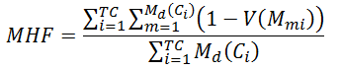
Where M_{d}(C_{i}) is the number of methods declared in class C_{i} , TC is the total number of classes, and

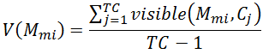
For Class Level: The MHF is given by ratio of sum of invisibility of all methods of a class to total number of methods declared in that class.

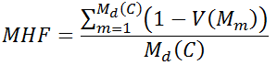
Where M_{d}(C) is the number of methods declared in class C, TC is the total number of classes, and
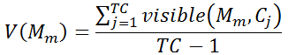

Attribute Hiding Factor (AHF): Attribute Hidden factor is used to measure the invisibility of attributes in the classes. AHF is calculated similar to MHF, but attributes are used instead of methods.

For System Level : AHF is given by ratio of sum of invisibility of all attributes of all classes to total number of all attributes declared in all classes.

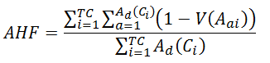
Where A_{d}(C_{i}) is the number of attributes declared in class C_{i} , TC is the total number of classes, and

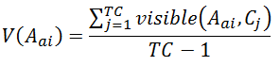
For Class Level: AHF is given by ratio of sum of invisibility of all attributes of a class to total number of attributes declared in that class.
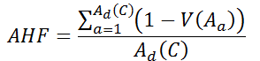
Where A_{d}(C) is the number of attributes declared in class C, TC is the total number of classes, and
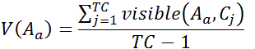
2. Inheritance
Method Inheritance Factor (MIF): Method Inheritance Factor metric is used to measure inheritance in a system due to access to methods of super classes.

For System Level : MIF for a system is given by the ratio of sum of number of methods inherited by each class to sum of the number of methods each class can access.

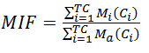
where
M_{i} (C_{i}) is the number of methods inherited in class C_{i} but not overridden,
M_{d} (C_{i}) is the number of methods declared in the class C_{i} ,

M_{a} (C_{i}) = M_{d} (C_{i}) + M_{i} (C_{i}).

For Class Level : MIF for a class is given by the ratio of number of methods inherited by a class to the number of methods that class can access.

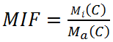
M(C) is the number of methods inherited (and not overridden) in class C.
M_{d}(C) is the number of methods actually declared in class C.
M_{a} (C) = M_{d} (C) + M_{i} (C).

Attribute Inheritance Factor (AIF): Attribute Inheritance Factor metric is used to measure inheritance in a system due to access to attributes of super classes. It is similar to MIF, but use attributes rather than methods.

For System Level : AIF for a system is given by the ratio of sum of number of attributes inherited by each class to sum of the number of attributes each class can access.

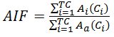
where
A_{i} (C_{i}) is the number of attributes inherited in class C_{i} but not overridden,
A_{d} (C_{i}) is the number of attributes declared in the class C_{i} ,

A_{a} (C_{i}) = A_{d} (C_{i}) + A_{i} (C_{i}).

For Class Level : AIF for a system is given by the ratio of number of attributes inherited by each class to the number of attributes a class can access.

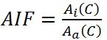
A_{i}(C) is the number of attributes inherited (and not overridden) in class C.
A_{d}(C) is the number of attributes actually declared in class C.
A_{a} (C) = A_{d} (C) + A_{i} (C).

3. Polymorphism

Polymorphism Factor (PF): Polymorphism Factor metric is used to measure degree of method overriding in the class inheritance trees. PF of a system is given by ratio of actual number of overrides to maximum number of possible overrides in a system.

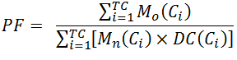

where M_{d}(C_{i}) = M_{n}(C_{i}) + M_{o}(C_{i})
M_{o}(C_{i}) is the number of overriding methods in class C_{i} ,
M_{n}(C_{i}) is the number of new methods in class C_{i} ,
DC(C_{i}) is the number of classes descending from C_{i} .

4. Coupling metrics
Coupling Factor (CF) : Coupling Factor measures the coupling between the classes of the system. CF of a system is measured by the formula
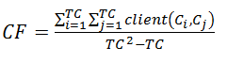
Where
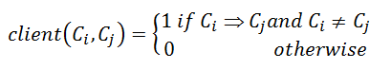

Ci ->Cj represents a relation between a client class Ci and a supplier class Cj . A class is said to be a client class if it access a method or an attribute of other class which acts as a supplier class.

Metrics Implementation details

We implemented MOOD metrics using Eclipse IDE. The metrics are implemented using functionalities of Jdeodorant. Implementations of metrics are as follow:

- METHOD INHERITANCE FACTOR

For implementation of this metric, we iterate through the list containing all classes of system. For each class in the list, extraction of all methods which a class inherit from its all super classes in one set and methods which are declared in the class in another set. Then, examined the duplicate entries in the set of inherited methods: if a method of one super class in overridden by some sub class in the inheritance tree, subsequent sub classes will receive only overridden copy of the method, not both. Further, removing private methods from the set of inherited methods as they are not inherited in sub classes. Applying this criteria to every class of the system, computation of number of inherited methods, overriding methods and total methods accessible to each class. Based on these values, MIF is calculated for system using above mentioned formula.

Challenge Faced : We faced a challenge in implementation of MIF metric. We have used "overridesMethod()" function of Jdeodorant to determine overriding methods in classes. While testing, we came across a issue which seems like a bug in "overridesMethod()" function.

Lets take an example of two classes ClassA and ClassB. The problem was as follow :

public class ClassA {
private void method1(){
System.out.println(" Private Method1 from class A");
}
}
public class ClassB extends ClassA{
private void method1(){
System.out.println(" Private Method1 from class B");
}
}

ClassB extends ClassA, therefore, it inherits all public and protected methods from ClassA but not private methods. We declare a private method “method1” in both classes with same method signature . As private methods are not inherited in sub classes, so "method1" in ClassB do not override "method1" of ClassA. But when use “overridesMethod() “ function of Jdeodorant to determine whether private method “method1” of ClassB overrides any method of its super class ClassA, it returns true.

For ClassB:
(private void method1()).overridesMethod() = true , which is expected to be false.

Our solution to this challenge is as follow:

If these is a private method "method1" in sub class ClassB, then three scenarios which can exist. First scenario is, if there exist a public, protected or default method with same name "method1" in any super class of ClassB, then java will not allow us to create private method "method1" in subclass ClassB as it will reduce the visibility of inherited method from super class. Second scenario is, if there exist a private method with same name "method1" in any super class of ClassB, then we can also create private method "method1" in the subclass ClassB, but it will not override method "method1" of super class because private methods of super class are not inherited. Third scenario is, when there is no super class having method with same "method1", then we can definitely create a private method "method1" in ClassB, which will not override any method of super class.
We can say, there is no case in which a private method of any class can override any method of super class. So, we do not need to check overriding of private methods declared in the class. So, we checked access of the methods declared in a class and if access is private then we consider it as new method which has not overridden any other method of super class.
The issue was also reported to Prof. Nikolaos Tsantalis and fixed by him in Jdeodorant.

- ATTRIBUTE INHERITANCE FACTOR

Same approach is used in the implementation of AIF as used in MIF, only difference is that in AIF, we count attributes where as in MIF, we count methods.

- POLYMORPHISM FACTOR

We implemented this metric using hash map in which key is class name and value is number of descendants. As Java does not support multiple inheritance, each class can have only one immediate super class. So, we iterate through the list containing all classes of the system and each class, we recursively checked all super classes of the class from starting immediate super class to the root super class. Then, we increment the number of descendants in the hash map for each super class encountered in the hierarchy. For each class, we also counts number of new methods declared and number of methods which are overriding the methods in the super classes. Moreover, final and private are not counted in methods which are available for descendants to override. Based on these calculated values, PF of the system is calculated using above mentioned formula.
Challenge Faced : The challenge we faced during implementation of Polymorphism factor metric was how to calculate all descendants for each class.

Our solution to this challenge is as follow:

As Java does not support multiple inheritance, there can be only one immediate super class of any class in java. To calculate descendant of all classes, we use hash map. The key of hash map is class name and value is number of descendants. We iterate through the list containing all classes of the system and for each class, we recursively check all super classes of the class starting form immediate super class to the root super class. Then, we increment the number of descendants in the hash map for each super class encountered in the hierarchy form bottom to top. After performing this operation on every class, the values in the hash set will be total number of descendants for corresponding class name key.

- METHOD HIDDEN FACTOR

To implementation this metric, we iterated all the classes of system. For each class in the list, we extracted all methods and iterate them to inspect their access type. Then, calculated the number of other classes where a method could be visible. In Java, private methods are not visible in any other class while public methods are visible in all classes. Methods with no access type are visible in same package to which it belong and methods with protected access type are visible in their class and their sub classes. Based on this logic, we calculated visibility of all methods and using visibility values MHF is calculated using above mentioned formula.

- ATTRIBUTE HIDDEN FACTOR

AHF calculation are similar to MHF except attribute are used rather than methods. We calculated the visibility of all attribute and then above mentioned formula is used to calculate the AHF.

- COUPLING FACTOR

For every class in the system we checked weather there is any interaction of that class with other classes. The interaction is checked with the help of MethodInvocationObject and FieldInstructionObject classes of JDeodorant. For every method of a class, we used getMethodInvocations() and getFieldInstructions() methods. getMethodInvocations() returns a list of all the method calls that occur inside a methods body and we checked the origin class of each method and compared it with the current class which was being in iteration. Similarly getFieldInstructions() method returns all the attributes used in a method and we checked the owner class of each attribute. Hence every method call to other classes acts as an interaction. Similarly if a class uses an attribute of other class ,it is also considered as an interaction. Same procedure is followed for the constructor of the class. Based on the value of these interactions, the overall Coupling factor for the system is calculated. An assumption which we made for the computation of the metric is that suppose if a class B extends a class A and another class C accesses a method of class A through an object of class B, then we assumed that the coupling is between class C and class B and not between class C and class A.

Empirical Study
This segment covers the different steps we followed to find correlation between the maintainability and MOOD metrics suite .

Examined variables

Dependent variables
The Maintainability is dependent variable in our experiment because its value effects our experiment. The value of maintainability is calculated by Logiscope based on the four factors: stability, changeability, testability and analyzability.

Independent variables

The independent variables of our experiment are metrics of MOOD metric suite i.e. MHF, AHF, MIF, AIF, PF, CF. As we defined these metrics, we have control on these variables. We will examine how maintainability correlate with each MOOD metric.
Maintainability value measure difficulty in maintaining a software. With increase in value of maintainability, software will become more difficult to maintain.
- Examined hypotheses

Our analysis focuses on finding the relationship between maintainability and MOOD metrics.

Encapsulation
Encapsulation simply means hiding methods and attributes of one class from another classes which they are not a part of . If we declare methods and attributes private then no other class of the system can directly access them. Increasing encapsulation reduces interdependency, coupling and complexity of code. Programmer will take less time to understand and modify the code. Therefore, both MHF and AHF have inverse relation with maintainability.

Inheritance

Inheritance has a strong relation with maintainability. If a class is inherited by many classes, this will increase the interdependency among system classes which increase probability of error propagation in the system and makes maintainability a difficult task. So, MIF and AIF have positive relation with maintainability.

Polymorphism

Polymorphism occurs due to overriding of methods. Overriding of methods reduce the probability of change error propagation due to inheritance. Moreover, overridden methods provide exact functionality required by the class. Therefore, it become easier for programmer to comprehend the code. So, PF has inverse relation with maintainability.

Coupling

Coupling increase the interdependency between the code. A change in a tightly coupled system required change in multiple classes which leads to injection of bugs in the system. Therefore, modification of code become more difficult. So,CF has a positive relation with maintainability.

Null Hypothesis
MOOD metric have no correlation with maintainability.

Alternative Hypothesis
MOOD metrics have correlation with maintainability in the following manner :
TABLE 1
Metrics | Correlation with Maintainability
MHF | Inverse correlation
AHF | Inverse correlation
MIF | Positive correlation
AIF | Positive correlation
PF | Inverse correlation
CF | Positive correlation

Experimental Design
For analysis we consider two open source projects, JFreeChart and JUnit. We have taken 35 versions of JFreeChart for analyses and 8 version of JUnit for verification of our results. In both projects we will examine how MOOD metrics values evolve with the maintainability.

JFreeChart:
TABLE 2
Versions | 0.0.9 to 1.0.19
Implementation Language | Java
Project Website | http://www.jfree.org/JFreeChart/
Historical Data (Total no. of versions) | 57
Version Examined | 35

JUnit:
TABLE 3
Versions | 4.6 to 4.11.B
Implementation Language | Java
Project Website | http://JUnit.org/
Historical Data (# of versions) | 20
Versions Examined | 10

Running Application

To run application, we have used Eclipse IDE. We have downloaded both maven and ant plug-in of Eclipse . Some project were build using ant build while some were build using maven. IBM Kalimetric Logiscope is used to calculate maintainability value for each version, we used. MOOD metrics were implemented using Jdeodorant developed by Prof. Nikolaos Tsantalis. After implementing all metrics, we ran application as an Eclipse plug-in, which open a new Eclipse environment in which 35 versions of JFreeChart and 8 version of JUnit are imported. Then we ran metrics on then and to parse each version and provide MOOD metric values.

D. Data Collection
Maintainability data and MOOD metric data are collected for both projects to find correlation between them.

MAINTAINABILITY

Collection of data is done on the both of class level and the system level for all considered versions of both projects. In order to find correlation between MOOD metrics and maintainability, we considered individual maintainability of each class. To calculate the maintainability of each class for class level maintainability, we are using class metric level approach of Logiscope. To calculate system level maintainability, we take average maintainability of all classes in each version. The maintainability for each class is calculated by logiscope with following formula:

Maintainability = Analyzability + Changeability + Stability + Testability

Maintainability is calculated by Logiscope based on four factors.

Analyzability

Analyzability is defined as the capability of the software product to be diagnosed for deficiencies or causes of failures in the software, or for the parts to be modified.
Analyzability = cl_wmc + cl_comf + in_bases + cu_cdused
Changeability

Changeability is defined as the capability of the software product to enable a specified modification to be implemented.
Changeability = cl_stat + cl_func + cl_data

Stability

Stability is defined as the capability of the software product to avoid unexpected effects from modifications of the software.
Stability = cl_data_publ + cu_cdusers + in_noc + cl_func_publ

Testability

Testability is defined as the capability of the software product to enable modified software to be validated.
Testability = cl_wmc + cl_func + cu_cdused

The operands being used to calculate these factors are as follows :

cl_wmc (Weighted Methods per Class) : Sum of the static complexities of the class methods. Static complexity is represented by the cyclomatic number of the functions.
cl_wmc = Sum (ct_vg)

cl_comf ( Class comment rate) : Ratio between the number of lines of comments in the module and the total number of lines.
cl_comf = cl_comm / cl_line

where
cl_comm is the number of lines of comments in the package,
cl_line is the total number of lines in the package.
in_bases (Number of base classes) : Number of classes from which the class inherits directly or not.
cu_cdused (Number of direct used classes) : Number of classes used directly by the current class.
cl_stat (Number of statements) : Number of executable statements in all methods and initialization code of a class.
cl_func (Total number of methods) : Total number of methods declared inside the class declaration.
cl_data (Total number of attributes) : Total number of attributes declared inside the class declaration.
cl_data_publ (Number of public attributes) : Number of attributes declared in the public section or in the public interface of a Java class.
cu_cdusers (Number of direct users classes) : Number of classes which use directly the current class.
in_noc (Number of children) : Number of classes which directly inherit from the current class.
cl_func_publ (Number of public methods) : Number of methods declared in the public section.
For calculating the operands used in calculation of Analyzability, Changeability, Stability and Testability, logiscope defines maximum and minimum bounds for each operand.

TABLE 4 : Operands used in calculations
Mnemonic | Metric Name | Min | Max | Out
cl_comf | Class comment rate | 0.20 | +∞ | 62.93%
cl_comm | Number of lines of comment | -∞ | +∞ | 0.00%
cl_data | Total number of attributes | 0 | 7 | 2.59%
cl_data_publ | Number of public attributes | 0 | 0 | 5.17%
cl_func | Total number of methods | 0 | 25 | 3.45%
cl_func_publ | Number of public methods | 0 | 15 | 6.03%
cl_line | Number of lines | -∞ | +∞ | 0.00%
cl_stat | Number of statements | 0 | 100 | 6.03%
cl_wmc | Weighted Methods per Class | 0 | 60 | 0.86%
cu_cdused | Number of direct used classes | 0 | 10 | 23.28%
cu_cdusers | Number of direct users classes | 0 | 5 | 7.76%
in_bases | Number of base classes | 0 | 3 | 6.03%
in_noc | Number of children | 0 | 3 | 4.31%

The Table 4 shows the Min and Max values for each operand and it also shows the percentage of the operand values that are out of bounds for a class. By calculating the value of analyzability, changeability, stability and testability using above mentioned formulas, the maintainability of each class is calculated. Hence if a class has high value of maintainability, it means that the class has higher percentage of operands(external) that are out of their bounds and therefore that class will be difficult to maintain. Therefore, for this approach, high maintainability value implies more difficulty in maintaining software.

MOOD METRIC

MOOD metric data is also collected for both class level and system level. For class level, we computed MHF, AHF, MIF, AIF metrics and for system level, we computed MHF, AHF, MIF, AIF, CF, PF metrics. After implementing metrics in Jdeodorant, we ran application as Eclipse plug-in, which open a new Eclipse environment in which all considered versions of both project are import. Then each version is parsed by metrics and MOOD metric values are returned. We have used CSV(Comma Separated Values) file for exporting MOOD metrics values (correlation) to users desktop.

Statistical analysis

We did statistic analysis at both system level and class level. System level analysis is done for both JFreeChart and JUnit while class level analysis is done only for one version of JFreeChart. In analyses of our study, we tried to find correlation between the metrics of MOOD metric suite and the values of Maintainability. We performed linear regression analysis which is commonly used to predict an unknown variable based on one or more variables. We performed univariate linear regression to examine the effect of every metric separately. In addition to this, we performed multivariate regression to examine the relation of maintainability with all independent variables. Apart from that, Pearson correlation coefficient is also used to determine the correlation of each metric with maintainability.

PEARSON CORRELATION

We calculated the values of Pearson Correlation for all dependent and independent variable and calculated values of correlation for each pair of the external quality attribute and internal attribute. The Pearson is the linear association between two variables and the formula is given by:

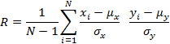
Where,

µ_{x} is mean of X , σ_{x} is Standard deviation of X
µ_{y} is mean of Y, σ_{y} is Standard deviation of Y

The value of Pearson correlation coefficient lies between -1 to 1.We considered that values of R between 0.5 to 1.0 and -1.0 to -0.5 shows strong correlation and values between -0.3 to -0.1 and 0.1 to 0.3 shows weak correlation, whereas values lies between -0.5 to -0.3 and 0.3 to 0.5 represents moderate correlation. Negative value implies inverse correlation while positive value implies direct positive correlation.

R-SQUARE

We applied univariate regression to determine the strength of correlation between each metric and maintainability. The Coefficient is the estimated regression coefficient. The larger the absolute value (either positive or negative) of the coefficient, the stronger is impact of independent variable on the external quality attribute. The R Square is the proposition of the total variation in the independent variable.

SYSTEM LEVEL ANALYSES

For system level analyses, the following Table 5 show MOOD metric values and average maintainability values for 35 versions of jFreeChat.

TABLE 5: MOOD metrics and maintainability values
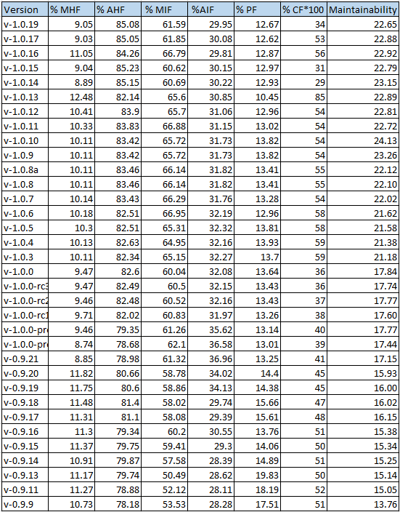

The graphical representation of table is provided by below given Figure1.
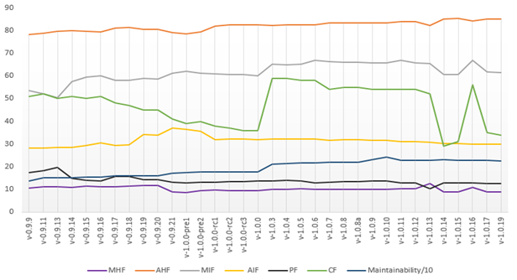
Figure 1 : Average Maintainability
The above in Figure 1, graph shows the variation in MOOD metrics values and average maintainability. The higher value of average maintainability mean it’s more difficult to maintain a class. Until the version v1.0.0 maintainability is not gradually increasing but on version 1.0.3 CF values is increased a lot and we can see a change in maintainability as well that shows a correlation. On version 1.0.14 although CF decrease but MHF and MIF also decreased that kept the value of average maintainability high. Other factors have not a significant influence to average maintainability. So we can assume that there is a correlation of maintainability with CF, MHF and MIF.

R-SQUARE

TABLE 6 : Result of Linear Regression of JFreeChart
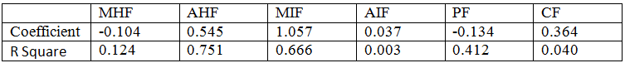

From Table 6, we can conclude that AIF metric has least impact on external quality attributes but MIF and AHF have highest Coefficient values that implies these both metrics have strong impact on maintainability. Moreover, MHF and PF have negative impact but AIF illustrate that metric has least impact on external quality attributes. On the other hand, AHF has least variation in values of all version because it has highest R Square value, followed by MIF. CF has least R Square value which shows that it has highest variation in the value of dependent variable (CF). Some correlation are shown in graphical form in Appendix A.

PEARSON CORRELATION

The following Table 7 shows calculation of Pearson correlation for every pair of dependent and independent variables for JFreeChart.

TABLE 7 : Pearson Correlation for JFreeChart
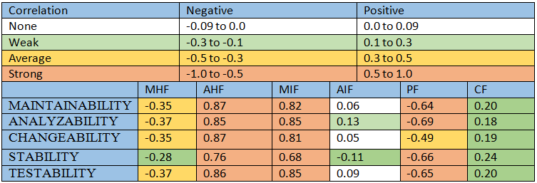

From the above Table 7, we can observe that MHF has negative moderate correlation (-0.35) with maintainability and AHF has a strong positive correlation (0.87) with maintainability. MIF has strong positive correlation (0.82) with maintainability which means with increasing MIF software become difficult to maintain. AIF do not have much impact (0.06) on maintainability. PF has negative strong correlation (-0.64) with maintainability where as CF has week correlation (0.20) with maintainability.

VERIFICATION USING JUNIT

To verify our results obtained from JFreeChart, we did a similar study on 8 versions of JUnit. JUnit is an eclipse plug-in which is used to write test cases for projects. Following Table 8 shows the values of all MOOD metrics for 8 versions of JUnit and value of average maintainability.

Table 8 : MOOD and maintainability values for JUnit
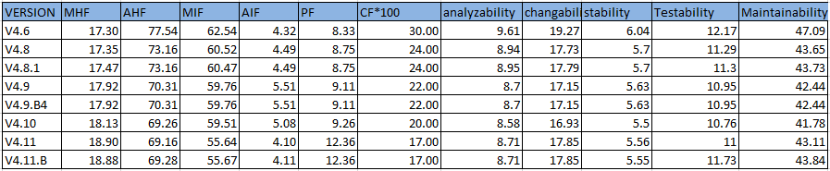

R-SQUARE

TABLE 9 : Result of Linear Regression of JUnit
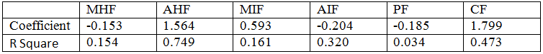

Table 9 shows the results of linear regression for JUnit .On the basis of Coefficient values we can see that CF has highest positive impact on maintainability. Similarly AHF also has high positive impact on maintainability. On the other hand PF, AIF and MHF do not have much impact on maintainability. Some correlation are shown in graphical form in Appendix A.

PEARSON CORRELATION

The following Table 10 shows calculation of Pearson correlation for every pair of dependent and independent variables for JUnit.

TABLE 10 : Pearson Correlation for JUnit
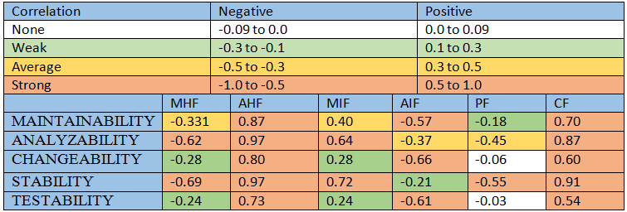

From Table 10, we can conclude MHF has negative moderate correlation (-0.331) with maintainability and AHF has a strong positive correlation (0.87) with maintainability. MIF shows an average positive correlation (0.40) while AIF shows a strong negative correlation. PF has a weak negative correlation with maintainability where as CF shows a strong positive correlation. Hence if coupling is high then it will be difficult to maintain the system.

In Table 7 , it shows strong correlation with PF but Table 10 does not show strong relation. This is because in Table 5, we considered 35 versions of JFreeChart while for Table 8, we considered only 8 versions of JUnit, just for verification. Therefore, due to less number of version, there is less variation in value of PF, which show smaller Pearson coefficient. Even then, it is following similar trend. Moreover, if you similarly consider first 8 versions of JFreeChart from Table 5, you can see there is not much variation in PF value, greater variation is shown in last 8 versions of JFreeChart which give stronger Pearson correlation.

CLASS LEVEL

For class level analyses, we have changed the implementation of MHF, AHF, MIF and AIF metrics of MOOD metric suite to provide metric values for each class of the system. We did class level analyses for only one version of JFreeChart. Table with metric and maintainability values in not included in this paper because it contains more than six hundred rows.

PEARSON CORRELATION

The following Table 11 shows calculation of Pearson correlation for every pair of dependent and independent variables.

TABLE 11 : Pearson Correlation of class level analyses
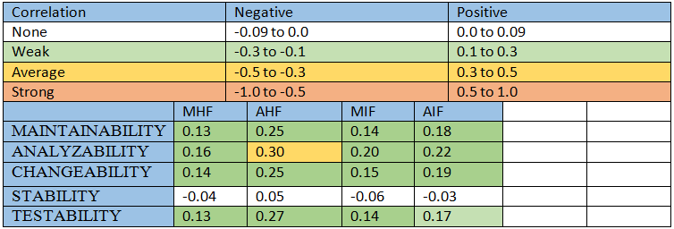

From the above Table 11 we can conclude that MHF has positive moderate correlation (0.13) with maintainability and AHF has a positive moderate correlation (0.25) with maintainability. MIF has positive moderate correlation (0.14) while AIF has a positive moderate correlation (0.18).

RESULTS
The Table 12 shows the results of our study. Based on the Table 12, we can conclude that AHF is not good predictor of maintainability because that hypothesis is not accepted in any analyses .On other hand, at system level, MHF, MIF, PF and CF are very good predictor of maintainability. At class level, AIF and MIF can be used as predictor of maintainability. Therefore, we can say that MOOD metric suite is good predictor of maintainability.

TABLE12 :RESULTS
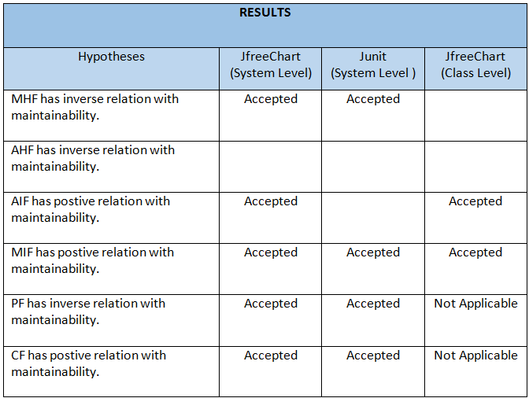

- Threats to validity

We have considered only 8 versions of JUnit. We can consider more versions of JUnit to get more data points, which will provide more generalized results. Apart from that, projects which we considered are built on Java programming language, if these metrics are to be used for some other programming language, then metrics need to be adjusted.

Conclusions

In this study, we performed both system and class level analyses to find correlation between MOOD metric suite and maintainability of software. We analyzed 35 version of JFreeChart to find correlation at system level and then analyzed 8 versions of JUnit to verify our results obtained from the analyses of JFreeChart. Majority of results obtained from the study are in agreement with our initial hypothesis. MIF and CF have positive relation with the maintainability while MHF and PF have inverse relation with the maintainability. AHF does not show result in accordance with our hypothesis. At class level, MIF and AIF show positive relation with maintainability where as MHF and AHF does not show up according to the hypothesis. However, from both system and class level results, MOOD metric suite can be considered as good predictor of maintainability.

References

[1] R. Harrison, S. J. Counsell and R. V. Nithi, “An Evaluation of the MOOD Set of Object-Oriented Software Metrics,” IEEE Trans. Softw. Eng., Vol. 24, No. 6, pp. 491-496, June 1998.

[2] F.Brito e Abreu and W. Melo, “Evaluating the Impact of Object-Oriented Design on Software Quality”, Proceedings of the 3rd International Software Metrics Symposium (METRICS’96),IEEE, Berlin, Germany, March 1996

[3] F. Abreu and R. Carapuça, Object-Oriented Software Engineering: Measuring and Controlling the Development Process, Proceedings of the 4th International Conference on Software Quality, McLean, VA, USA, 1994.

Appendix A

SYSTEM LEVEL
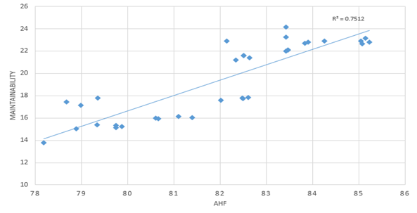
Figure 2: Correlation between maintainability and AHF for JFreeChart.
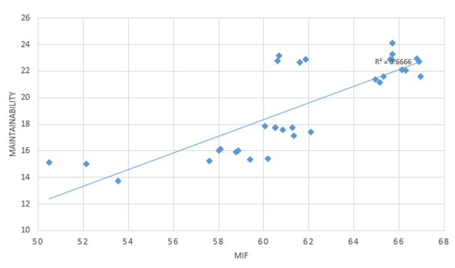
Figure 3: Correlation between maintainability and MIF for JFreeChart.

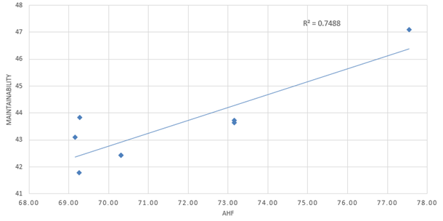
Figure 4 : Correlation between maintainability and AHF for JUnit.

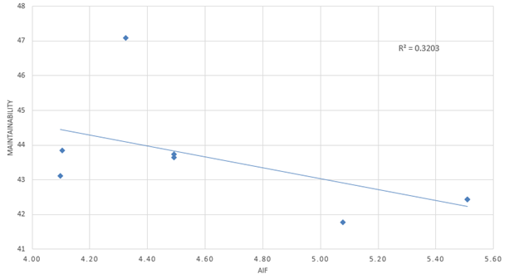
Figure 5: Correlation between maintainability and AIF for JUnit.

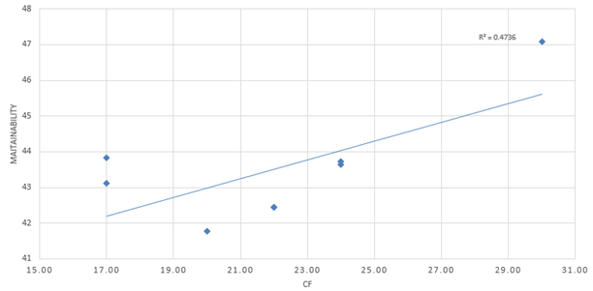
Figure 6: Correlation between maintainability and CF for JUnit.

CLASS LEVEL

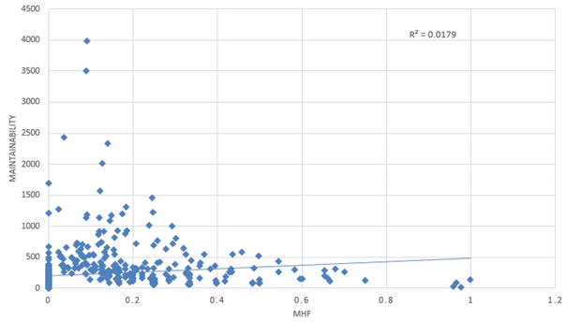
Figure 7: Correlation between maintainability and MHF for JFreeChart.

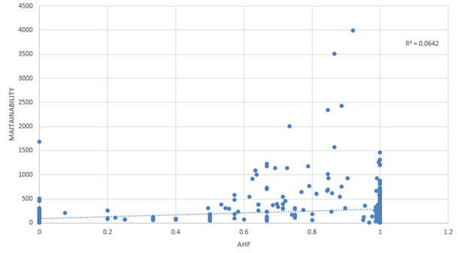
Figure 8: Correlation between maintainability and AHF for JFreeChart.

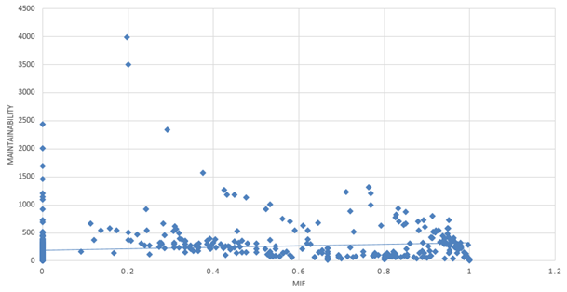
Figure 9: Correlation between maintainability and MIF for JFreeChart.

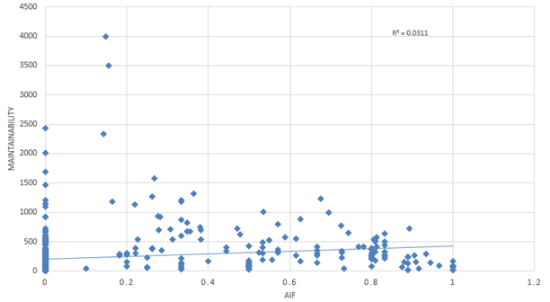
Figure 10: Correlation between maintainability and AIF for JFreeChart.

