ABSTRACT
THE ROBOTICS CLUB – SNIST
POST-INDUCTION’24
TEAM No – 9
TITLE OF THE PROJECT -: WALLACE
The Problem:

In the construction and maintenance industries, painting the exteriors of tall buildings presents significant safety risks and labour challenges. Traditional methods require workers to hang from great heights, increasing the chance of accidents and injuries. These manual processes are not only labour-intensive but also prone to inefficiencies, such as uneven paint application and delays caused by weather conditions or worker fatigue. Additionally, these methods lead to higher costs due to the extended time and manpower required. There is a growing need for a safer, more efficient automated solution that can streamline the painting process, reduce labour dependency, and ensure consistent, high-quality results across various building heights and surfaces.

THE TEAM’S APPROACH TO SOLVE THE PROBLEM:

To address these challenges, we propose an innovative solution: WallAce, a semi-autonomous bot designed to paint the exteriors of tall buildings. The bot consists of two parts; one moves horizontally along the wall (X-axis), while the other hangs vertically (Y-axis) to perform the painting task. The vertical component is equipped with a paint roller, a paint dispenser, and a pallet to store paint. A pulley mechanism enables smooth vertical movement while ensuring adherence to the wall. The horizontal component features a rack and pinion mechanism, allowing it to move forward efficiently. Once the vertical component finishes painting one lane in the Y direction, a sensor detects the end of that section and sends a signal to the X-component, prompting it to move slightly forward. This coordinated movement ensures complete coverage of the wall while optimizing the painting process.

BLOCK DIAGRAM:
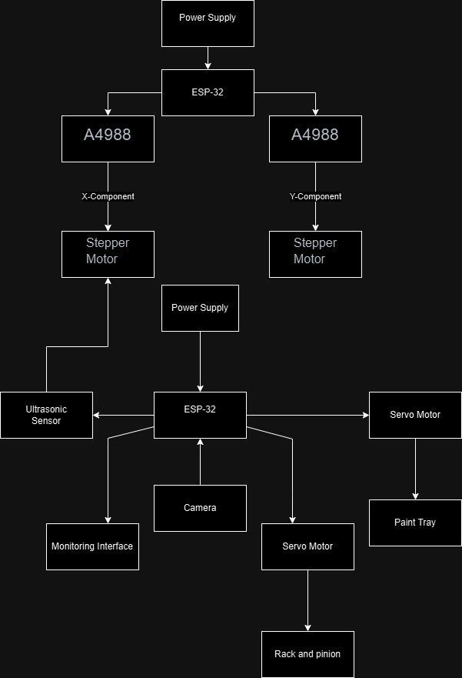

WHAT WE FOUND INNOVATIVE:
WallAce incorporates advanced robotics to enhance efficiency and safety in the exterior painting process. Its dual-axis movement system provides precise control for even paint application across large wall surfaces. Specialized tires ensure stability and adherence to vertical surfaces, allowing safe operation at great heights. A standout feature is the integration of sensors for real-time monitoring and adaptive movement. These sensors detect when painting is complete and signal the horizontal component to reposition itself automatically, reducing labour dependency and minimizing the risk of accidents. By combining cutting-edge technology with a focus on safety and quality, WallAce aims to revolutionize the painting industry and set new standards for building maintenance practices.

