# CMPE 280

## Web UI Design – Assignment 1

# SJSU CISCO DB – Wireframes - Desktop

### Login Screen

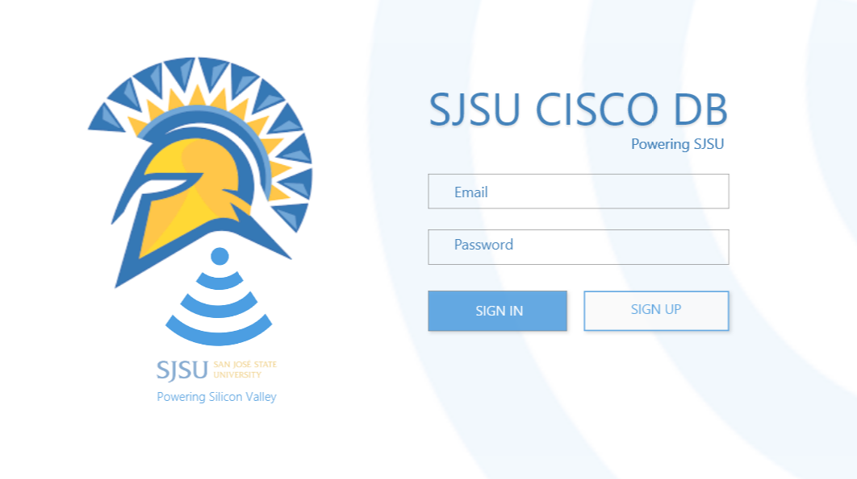

### Landing Page

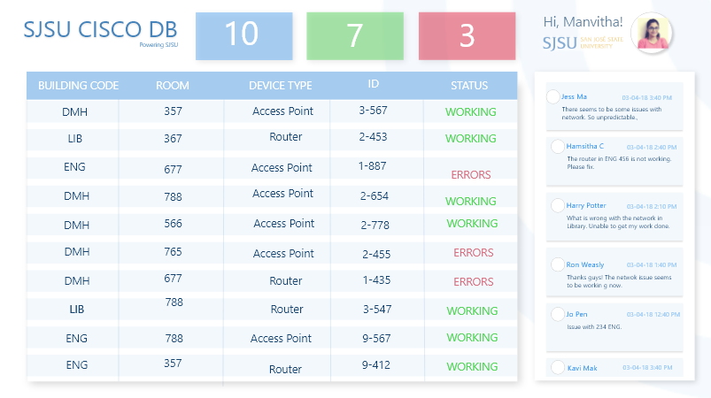

### Landing Page – Errors

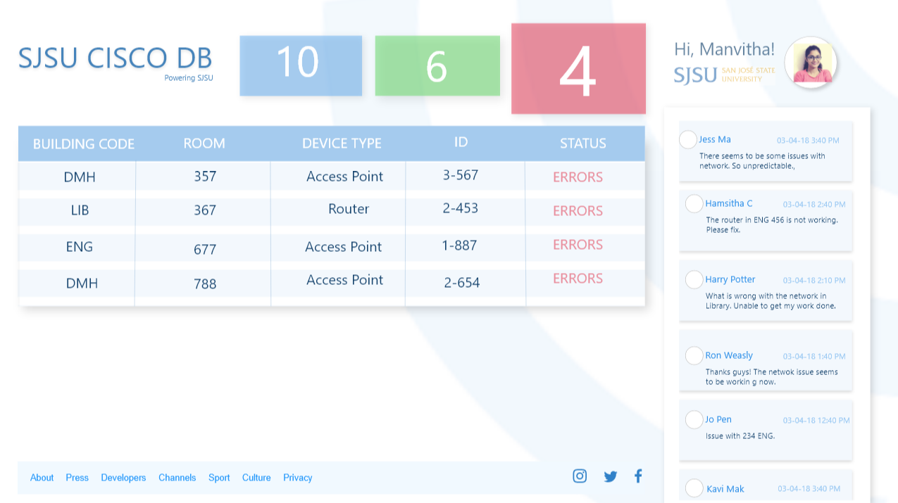

### Landing Page – Working

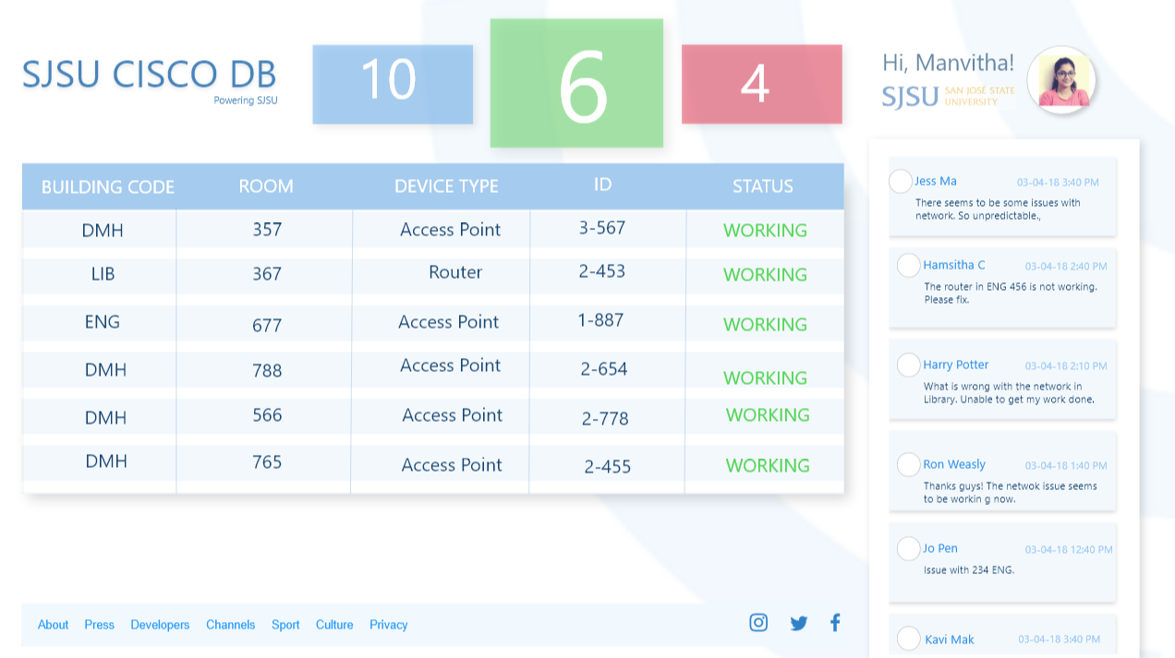

# SJSU CISCO DB – Wireframes - Mobile

### Login Screen

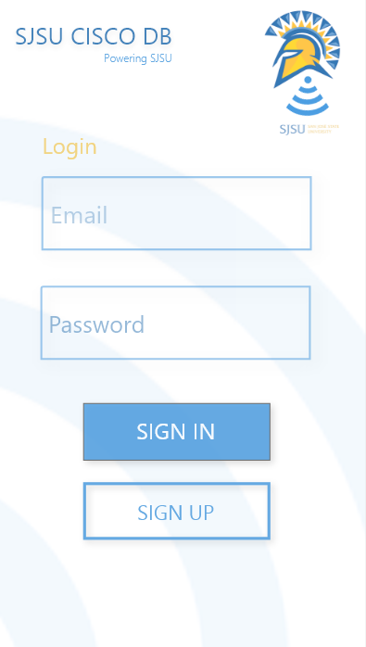

### Landing Page

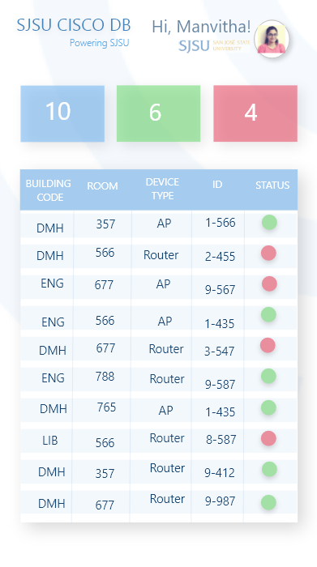

### Landing Page – Working

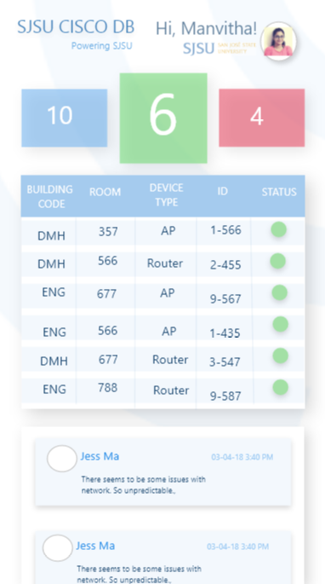

### Landing Page – Errors

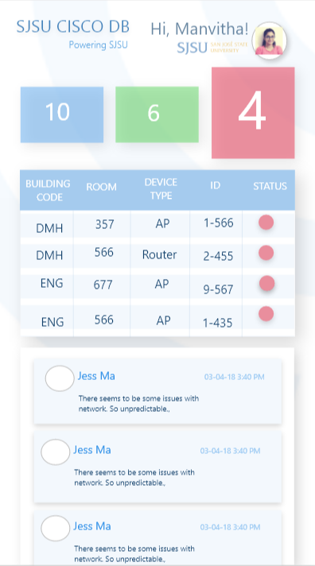

# SJSU CISCO DB – Adobe Project

