Multi-Agent Clinical Trial Protocol Negotiation
Fundamentals of Artificial Intelligence (23CSE401) - Case Study, Review 1
CB.SC.U4CSE23317 - Druva Teja Korlakunta
CB.SC.U4CSE23318 - Manvitha Dungi

1. Introduction
Designing a clinical trial protocol is a negotiation between stakeholders with conflicting goals and undisclosed limits: the Sponsor wants minimum cost and time, the Biostatistician wants statistical validity, the Ethics Committee (IRB) wants participant safety, and the Patient Advocate wants low burden and wide access. A single-prompt AI system collapses these into one blended answer, hides trade-offs, offers no veto and needs every confidential limit in one place.
This project implements a Multi-Agent System (MAS) in which four autonomous agents, each holding private objectives and constraints, negotiate one shared Phase II protocol over several rounds. An independent Constraint Checker audits every protocol version. The protocol is final only when all four agents approve. The system runs deterministically in mock mode (no API key) and optionally with an LLM. All data is synthetic; this is an academic simulation only.
Contributions: (i) a four-agent negotiation engine with enforced information asymmetry, IRB veto and advisory Patient Advocate; (ii) eight test scenarios; (iii) a single-agent baseline for comparison; (iv) a 96-test automated suite.

2. PEAS Description
Component | Description
Performance measure | Consensus reached (all 4 approve); constraint violations = 0 (independent checker); number of rounds; proposals accepted / partially accepted / rejected; objections raised; field changes accepted vs blocked; protocol validity (power >= 0.80, cost <= budget, safety limits)
Environment | Shared Phase II protocol document, negotiation history, guidelines, budget, timeline and public calculators (power, sample size, cost, recruitment); plus per-agent private state
Actuators | APPROVE / REJECT / COUNTER_PROPOSE decisions; amendments to the agent's own protocol fields; qualitative requests (e.g. hospital_visits: decrease); objections with reasons
Sensors | Current protocol version, public negotiation history, public tool report (power, cost, recruitment), feedback on own proposals, own private constraints

Performance metric definitions
Metric | Definition | Target
Consensus | All four agents APPROVE the same protocol version | Yes
Constraint violations | Hard-constraint failures reported by ConstraintChecker on the final protocol | 0
Rounds | Negotiation rounds until consensus (max 10) | Low
Proposal acceptance | (accepted + partially accepted) / total proposals | High
Objections | Blocking objections raised by other agents | Informational
Power | Statistical power of final design | >= 0.80
Cost | Estimated cost vs budget ceiling | <= budget

Input -> sensor and output -> actuator mapping
Agent | Inputs (sensors) | Outputs (actuators)
Sponsor | Shared protocol, public power/cost/recruitment report, feedback on blocked proposals, own budget / sample / duration limits | sample_size, number_of_hospitals, dosage_arms, budget, duration, remote_monitoring; requests to reduce visits/procedures
Biostatistician | Shared protocol, public power report, own power/alpha thresholds and locked fields | sample_size, randomization_scheme, primary_endpoint, alpha
Ethics Committee | Shared protocol, own max dose, monitoring and AE-reporting rules | dosage, safety_monitoring, adverse_event_reporting, exclusion/consent criteria (binding veto)
Patient Advocate | Shared protocol, own max visits / invasive procedures / exclusions | inclusion_criteria, hospital_visits, invasive_procedures, request for remote monitoring (advisory)

3. Agent and Environment Analysis

Agent category
Each agent is a goal-based, utility-oriented rational agent with a model of the shared protocol. Agents are deliberative (they reason over the current protocol and their constraints rather than reacting to a single percept) and the Sponsor additionally has a simple learning component: when a sample-size cut is blocked it records the power of the blocked design and proposes a higher sample next time, inferring the hidden power threshold. Overall the system is a mixed cooperative-competitive multi-agent system with heterogeneous authority (IRB veto, advisory Patient Advocate).

Environment classification
Property | Classification | Justification
Observability | Partially observable | Agents see the shared protocol but not each other's private constraints
Agents | Multi-agent (mixed cooperative/competitive) | Four stakeholders with conflicting goals that must still reach joint agreement
Determinism | Deterministic (mock mode); stochastic in LLM mode | Same input gives same negotiation in mock mode
Episodicity | Sequential | Each round builds on the previous protocol version
Static/Dynamic | Static between rounds, changes across rounds | Protocol changes only through accepted amendments; unexpected_interim changes constraints mid-trial
Discrete/Continuous | Discrete time (rounds), mixed variables | Sample size and visits are integers; dosage and budget are bounded numeric values
Known/Unknown | Known rules, hidden peer constraints | Power/cost models are public; peers' limits are hidden

4. Design

System architecture
Environment (shared protocol + guarded private states) -> four agents -> Negotiation Engine (reviews, proposals, objections) -> Constraint Checker (audit log) -> Consensus / Deadlock / No consensus. Only the Constraint Checker holds all constraints, and its detailed output goes to the audit log, not to the agents.
Module | Role
environment.py | ClinicalTrialEnvironment, SharedState; raises PrivateStateAccessError on cross-agent access
agents.py | Agent base class + Sponsor, Biostatistician, Ethics, PatientAdvocate agents; mock and LLM review; sanitize()
negotiation.py | NegotiationEngine: round loop, proposal processing, deadlock detection
constraints.py | Per-role hard-constraint checks and ConstraintChecker
trial_tools.py | Public calculators: power, required sample size, cost, recruitment
scenarios.py | Baseline + 7 scenarios
single_agent.py | Single-agent baseline for comparison
llm.py / config.py | OpenAI-compatible client (stdlib urllib) and .env settings
logger.py / main.py | JSON-lines event log, reports, CLI

Algorithms used
- Round-based iterative negotiation: all agents review the same protocol snapshot independently, then propose amendments.
- Priority-ordered proposal processing (IRB -> Sponsor -> Biostatistician -> Patient Advocate); IRB safety amendments are binding, Patient Advocate objections are advisory.
- Proposal evaluation: each other agent checks the amended copy against its own hard constraints; a blocking objection rejects the change.
- Field-by-field retry: a blocked multi-field proposal is split so compatible parts survive (partial acceptance).
- Sponsor concession learning: uses the public power of blocked designs to propose a feasible sample size.
- Termination: consensus, deadlock (protocol unchanged for two rounds) or max_rounds (default 10).
- Deterministic rule-based strategies in mock mode; LLM mode adds JSON-validated reasoning with fallback and a guard that overrides an APPROVE violating the agent's own constraints.

Hardware and software requirements
Item | Requirement
Hardware | Any standard PC/laptop, >= 4 GB RAM, no GPU; network only for optional LLM mode
OS | Windows / Linux / macOS
Language | Python 3.10+ (tested on 3.10.11)
Runtime libraries | Standard library only (urllib, dataclasses, argparse, json)
Test library | pytest
Optional | OpenAI-compatible API key, or local Ollama / LM Studio, for --llm

Tool / package details
Tool | Purpose
Python standard library | Core implementation, dataclasses for state, argparse CLI, json logging
pytest | Automated unit / integration / scenario tests
config.py (.env loader) | API key and model configuration
OpenAI-compatible HTTP API (optional) | LLM reasoning per agent from role prompt files in prompts/

5. Implementation

Input representation
The protocol is a Protocol dataclass (models.py) with fields: sample_size, number_of_hospitals, dosage, dosage_arms, trial_duration_months, budget, power, alpha, randomization_scheme, primary_endpoint, hospital_visits, remote_monitoring, invasive_procedures, inclusion_criteria, exclusion_criteria, safety_monitoring, adverse_event_reporting. Each agent has a PrivateState of numeric/enumerated limits. Decisions are AgentDecision objects, amendments are Proposal objects and each round is a NegotiationRound. A scenario is a named set of initial protocol, trial context and private states.

Dataset description
No external dataset is used. All parameters (budgets, dose-response, recruitment rates, constraints) are synthetic and defined in scenarios.py; the models in trial_tools.py are simplified analytic approximations. No patient data is used.

Modules and sub-modules
- Environment: shared state, guarded private state, protocol versioning.
- Agents: review_protocol, evaluate_proposal (self-check), sanitize (redacts private numbers), mock and LLM strategies.
- Negotiation: round loop, proposal processing, partial acceptance, deadlock/max-round detection.
- Constraints: check_sponsor / check_biostatistician / check_ethics / check_patient_advocate / check_all.
- Tools: power, required sample size, cost, recruitment calculators.
- Scenarios: baseline, budget_reduction, high_risk_drug, rare_disease, pediatric, pandemic, multi_country, unexpected_interim.
- Baseline: single_agent.py with blended weights (cost 0.35, power 0.25, safety 0.20, burden 0.20).
- Logging: transcript .txt, result .json, event .jsonl per scenario in outputs/.

User interface
Command-line interface (main.py): --mode {multi-agent,baseline,compare}, --scenario {name|all}, --llm, --max-rounds, --no-transcript, --summary, --output-dir, --verbose. Results are shown as a readable transcript and final-result summary and saved to outputs/.

Scalability and code structure
One module per concern; a new agent needs an Agent subclass, a prompt file, a PrivateState and a constraint check; a new scenario is one entry in scenarios.py; the LLM backend is swappable via OPENAI_BASE_URL. Private state isolation means new stakeholders (CRO, regulator) do not change existing agents.

Information asymmetry
- Private state is stored in the environment; get_private_state raises PrivateStateAccessError unless the requester is the owner.
- Each agent is constructed with only its own PrivateState; LLM prompts never include other agents' constraints (tested).
- Public messages are qualitative ("dosage exceeds my safety requirements", not "max 75 mg").

6. Testing and Results

Levels of testing
Level | File | Tests | What is verified
Unit - tools | test_trial_tools.py | 13 | Power, sample size, cost, recruitment calculations
Unit - constraints | test_constraints.py | 10 | Per-role violations and ConstraintChecker
Unit - models/utils | test_models.py, test_utils.py | 17 | Dataclasses, serialisation, helpers
Algorithm | test_negotiation_algorithm.py | 12 | Authority order, partial acceptance, deadlock, max rounds
Integration | test_mas.py | 18 | Private-state guard, no leakage into prompts, LLM validation / fallback, end-to-end runs
Scenario | test_scenarios.py | 12 | Scenario construction and valid consensus
Total |  | 82 test functions (96 cases incl. parametrised) | pytest: 96 passed in 9.6 s

Scenario results (mock mode)
Scenario | Status | Rounds | Proposals | Objections | Violations | Sample | Dose (mg) | Power | Budget ($M) | Visits
baseline | CONSENSUS | 4 | 9 | 5 | 0 | 180 | 75 | 0.847 | 9.5 | 4
budget_reduction | CONSENSUS | 5 | 9 | 5 | 0 | 180 | 75 | 0.847 | 9.0 | 4
high_risk_drug | CONSENSUS | 5 | 10 | 7 | 0 | 210 | 50 | 0.815 | 11.7 | 4
rare_disease | CONSENSUS | 5 | 9 | 6 | 0 | 190 | 75 | 0.848 | 14.5 | 6
pediatric | CONSENSUS | 4 | 9 | 6 | 0 | 180 | 40 | 0.861 | 9.7 | 3
pandemic | CONSENSUS | 4 | 9 | 5 | 0 | 180 | 75 | 0.847 | 10.5 | 6
multi_country | CONSENSUS | 4 | 9 | 5 | 0 | 180 | 75 | 0.847 | 11.5 | 4
unexpected_interim | CONSENSUS | 3 | 3 | 1 | 0 | 215 | 50 | 0.824 | 12.4 | 6

Multi-agent vs single-agent baseline
Scenario | MAS rounds | MAS violations | Single-agent violations
baseline | 4 | 0 | 7
budget_reduction | 5 | 0 | 8
high_risk_drug | 5 | 0 | 9
rare_disease | 5 | 0 | 7
pediatric | 4 | 0 | 10
pandemic | 4 | 0 | 8
multi_country | 4 | 0 | 8
unexpected_interim | 3 | 0 | 4

Discussion: in the baseline scenario the Sponsor's first cut (320 -> 180 patients) is blocked by the Biostatistician because power would fall too low; the IRB lowers the dosage to 75 mg and tightens exclusions; the Patient Advocate's visit reduction is only accepted once the Sponsor funds remote monitoring. The final protocol has power 0.847 and zero violations. The single-agent baseline, given all constraints in one place, still produced 4-10 violations because trade-offs are soft penalties with no veto. The baseline is intentionally naive, so this shows the effect of silent trade-offs, not that a well-engineered optimiser could never satisfy the constraints.
Limitations: synthetic simplified models, hand-written mock strategies, deterministic proposal evaluation even in LLM mode, fixed processing order, best-effort redaction of private numbers.

Simulation screenshots
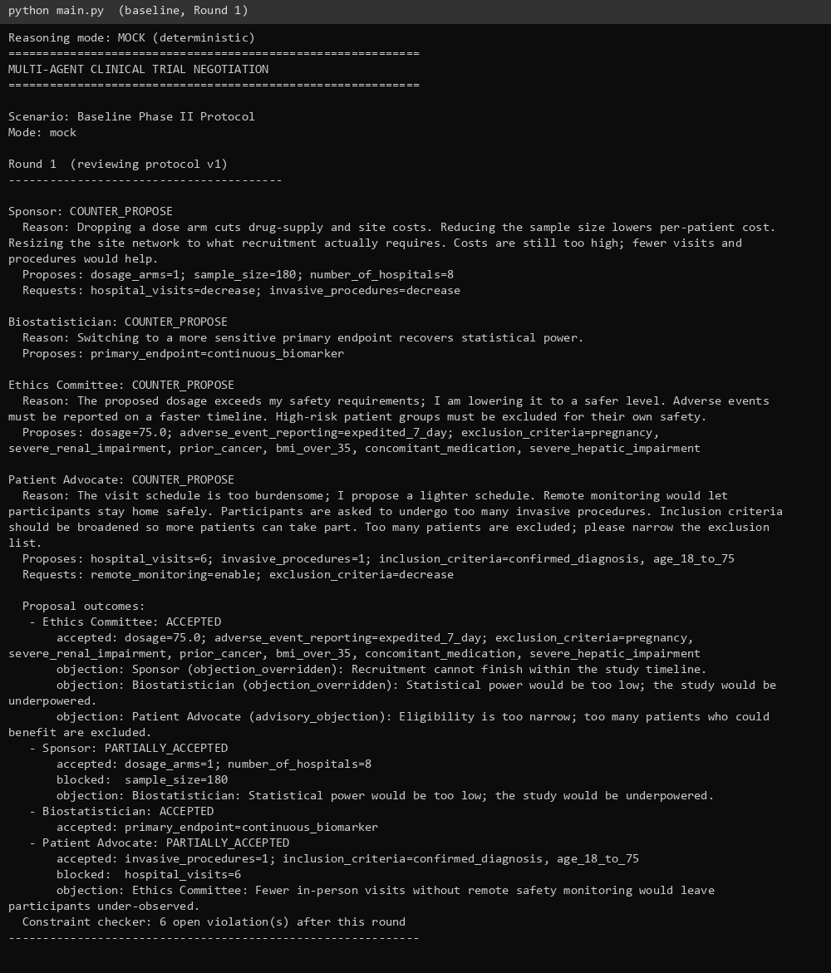
Figure 1: Baseline scenario, Round 1 negotiation transcript.
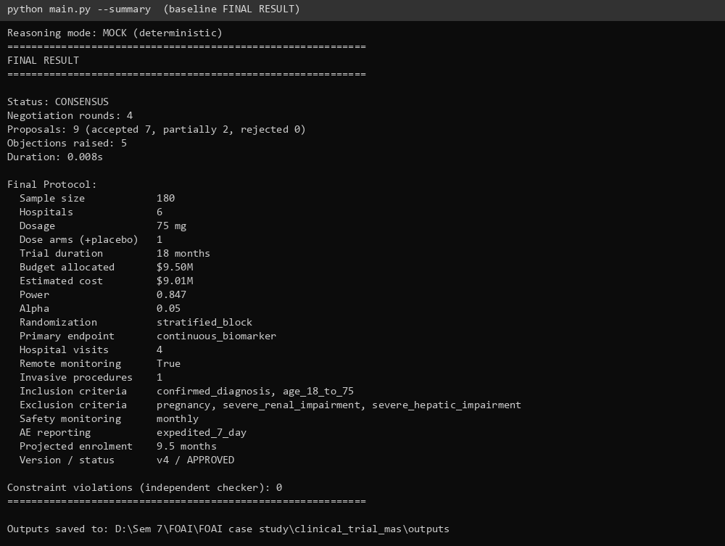
Figure 2: Baseline final result - CONSENSUS, 4 rounds, 0 violations.
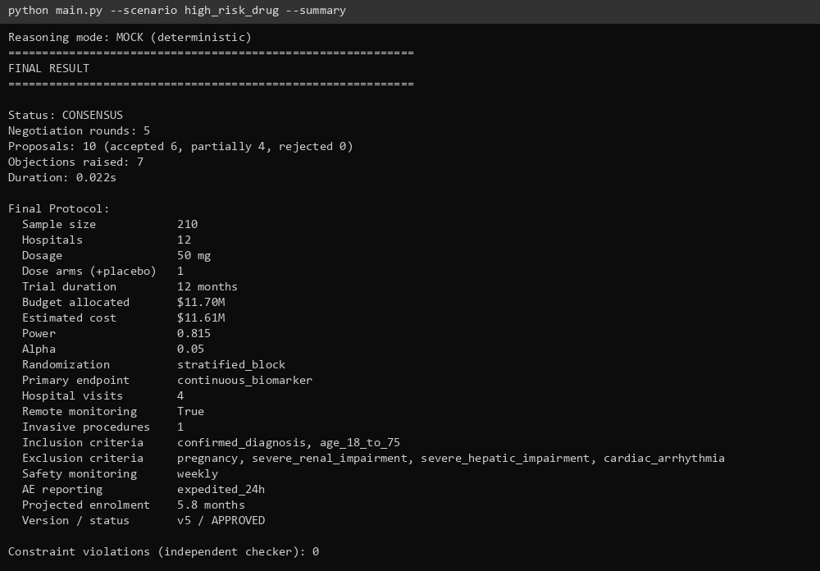
Figure 3: High-risk drug scenario - dosage held at 50 mg, duration 12 months.
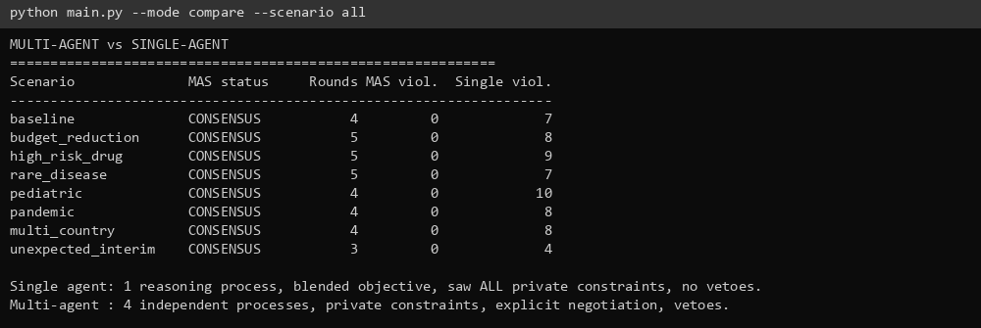
Figure 4: Multi-agent vs single-agent comparison across all scenarios.
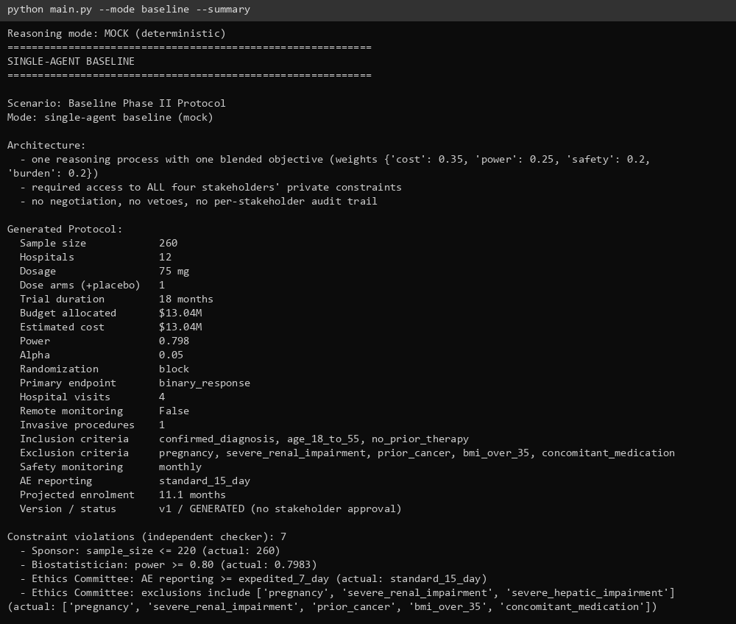
Figure 5: Single-agent baseline output with constraint violations.
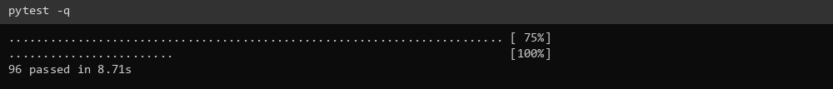
Figure 6: Automated test run - 96 passed.

