**COLLABORATIVE PROJECT WITH INTEL**

**PROJECT TITLE : INTEGRATED COMMON SERVICES TO COMMON PEOPLE**

**TEAM NAME :** **MediAI**

**Team Mentor : Dr T V RAJINI KANTH, Professor & Head,**

**Department of CSE-AI&ML**

[**rajinitv@gmail.com**](mailto:rajinitv@gmail.com)**,**

[**rajinikanthtv@sreenidhi.edu.in**](mailto:rajinikanthtv@sreenidhi.edu.in)

**Ph. No: 9849414375**

**Team Members : Jagadam Poojitha** Roll no: 22311A6617 CSE-AIML **Team lead**

**Shri Nitya Boini** Roll no: 22311A6647 CSE-AIML Team member

**Pallavi Rajan** Roll no: 22311A6638 CSE-AIML Team member

**Manvitha Pola** Roll no: 22311A6671 CSE-AIML Team member

**P. Harshita** Roll no: 22311A66B9 CSE-AIML Team member

**Institute : Department of CSE-AI&ML**

**Sreenidhi Institute of Science and Technology**

**Yamnampet, Ghatkesar**

**Hyderabad – 501301**

**Date of submission :**  **10-07- 2024**

**Problem Statement:**

In today's fast-paced world, access to efficient and comprehensive healthcare services remains a significant challenge for many individuals. Common people often face hurdles such as long waiting times, limited access to specialized care, lack of personalized treatment options, and fragmented healthcare services. These issues can lead to delayed diagnoses, ineffective treatments, and ultimately, poorer health outcomes.

The problem is further exacerbated by the increasing complexity of healthcare needs, requiring coordinated efforts across various healthcare providers and services. Many people, particularly in underserved and rural areas, struggle to receive timely and accurate medical attention. This gap in healthcare accessibility and efficiency highlights the need for an integrated approach that can streamline services and ensure that everyone receives the care they need when they need it.

Keywords: Artificial Intelligence (AI), Healthcare Services, Predictive Analytics, Personalized Medicine, Patient Monitoring

**Abstract**

Access to efficient and comprehensive healthcare services remains a significant challenge, especially for individuals in underserved and rural areas. Common people often encounter issues like long waiting times, limited access to specialized care, lack of personalized treatment, and fragmented healthcare services, leading to delayed diagnoses and poorer health outcomes.

Our project aims to address these challenges by integrating artificial intelligence (AI) technologies into a unified healthcare platform. This solution includes predictive analytics for early health issue detection, symptom entry and prediction, and an AI-driven chatbot for immediate assistance with symptoms and health queries. Users will benefit from seamless registration and login processes, detailed doctor profiles, and efficient appointment management.

We created a web/GUI application to facilitate this integration, ensuring that users can access these services through an intuitive and user-friendly interface. By leveraging AI, our platform enhances healthcare accessibility and efficiency, providing common people with proactive, personalized, and streamlined medical services.

This innovative approach aims to improve patient outcomes, reduce healthcare costs, and ensure that everyone receives timely and accurate medical attention. Ultimately, our solution seeks to revolutionize healthcare services, making them more accessible and effective, thus improving the overall quality of life for patients.

**Proposed Solution:**

Our project addresses these challenges by integrating artificial intelligence (AI) technologies into healthcare services to create a unified, accessible, and efficient web/GUI healthcare platform. By leveraging AI, we aim to provide:

1. **Predictive Analytics**: Early detection and prediction of health issues for proactive management.
2. **Enhanced Accessibility**: Advanced healthcare services for underserved and rural areas, ensuring equitable access.
3. **Symptom Entry and Prediction**: Users can enter symptoms, and AI algorithms will analyse and predict potential health issues.
4. **Registration and Login**: Easy and secure user registration and login process.
5. **Choosing Doctor**: Detailed profiles of doctors, including specializations and availability.
6. **Appointment Management**: Efficient booking, viewing, and managing of medical appointments.
7. **AI Chatbot**: Interactive chatbot for immediate assistance with symptoms, general health questions, and appointment bookings.

We created a web/GUI application and integrated these features to ensure that users can access these services through an intuitive and user-friendly interface. Our platform seeks to revolutionize healthcare services, making them more accessible, efficient, and personalized for all individuals, ultimately leading to better health outcomes and an improved quality of life.

**Features Offered:**

* **User Registration and Login**
* **Registration**: Users can create an account by providing essential information such as name, email, password, and other relevant details. The registration process includes email verification to ensure authenticity.
* **Login**: Users can log in to their account using their email and password. The login process includes security measures such as rate limiting to prevent brute force attacks.
* **User Profile Management**
* **Profile Viewing and Editing**: Users can view and update their profile information, including personal details, contact information, and preferences.
* **Appointment Management**
* **Booking Appointments**: Users can book appointments with doctors by selecting available time slots. The system checks for conflicts and confirms the booking.
* **View and Manage Appointments**: Users can view their upcoming and past appointments, reschedule, or cancel appointments as needed.
* **Doctor Profiles and Search**
* **Doctor Directory**: Users can browse through a list of available doctors, view their profiles, specializations, and availability.
* **Search and Filter**: Users can search for doctors based on name, specialty, location, and availability to find the most suitable healthcare provider.
* **Symptom Entry and Analysis**
* **Symptom Entry Form**: Users can enter their symptoms through a user-friendly form that includes various symptom categories.
* **Symptom History**: Users can view their past symptom entries and any related recommendations or diagnoses.
* **Analysis and Prediction**: The system analyzes the entered symptoms using machine learning models to provide possible diagnoses and recommendations.
* **AI Chatbot**
* **Interactive Chat**: Users can interact with the AI chatbot for immediate assistance with symptoms, general health questions, and appointment bookings
* **Natural Language Processing**: The chatbot understands and responds to user queries using a NLP techniques, providing a conversational experience.
* **Security and Compliance**
* **Data Encryption**: All user data is encrypted in transit and at rest to ensure confidentiality and integrity.
* **User Authentication**: Secure authentication methods, including JWT and OAuth, are implemented to protect user accounts.
* **Compliance**: The application adheres to healthcare regulations such as HIPAA and GDPR to ensure the privacy and security of user data.

**Process Flow:**

* **Initialization:**

The app is initialized using Flask(_name_).

The home() route is defined to handle requests to the root URL (/).

* **Homepage Rendering:**

When the user visits the root URL (/), the home() function is executed.

It prepares a list of symptoms and renders the index.html template, passing the symptoms data to it.

The index.html template displays the list of symptoms and likely provides a form or interface for user input.

* **User Input:**

The user interacts with the web page, likely entering a message in the provided form.

This input is submitted to the /chat route via a POST request.

* **Chat Route Handling:**

The /chat route, defined by the chat() function, receives the POST request.

It extracts the user's message from the request body using request.json.get('message').

The generate_response() function is called to process the user's message.

* **Response Generation:**

The generate_response() function implements a simple logic:

If the user's message contains "hello" (case-insensitive), it returns a greeting.

If the user's message contains "bye" (case-insensitive), it returns a farewell message.

Otherwise, it returns a generic "I don't understand" message.

* **Response Transmission:**

The chat() function returns the generated response to the user as JSON data using jsonify({'response': response_message}).

This response is likely handled by JavaScript in the index.html template, displaying it on the webpage.

* **Looping:**

The process repeats as the user continues to interact with the chat interface, sending new messages and receiving responses.

* **Key Components:**

Flask: The web framework for creating and running the web application.

Routes: URLs that map to specific functions to handle requests.

Templates: HTML files used to structure the webpage, potentially using Jinja2 templating for dynamic content.

JSON: Data format used for communication between the client (web browser) and the server.

User Input: User interaction with the web page, likely through a form or chat interface.

Response Logic: The generate_response() function determines the appropriate response based on user input.

* **Further Improvements:**

Implement more sophisticated response logic using natural language processing (NLP) techniques.

Use a database to store and retrieve user data and chat history.

Design a more user-friendly chat interface with features like message history and user authentication.

Integrate external APIs for accessing information or services related to the chatbot's purpose

**Three-Tier-Architecture**

**Frontend**

**(HTML and CSS)**

**Registration / Login**

**Service**

**(Django Views)**

**User**

**Service**

**Appointment**

**Services**

**Chatbot**

**Integration**

**Symptom**

**Diagnosis**

**Doctor**

**Service**

**Database**

**(MySQL** and **PHP)**

**Machine Learning**

**Models and NLP**

**Symptom**

**Analysis**

**Technologies used:**

**Frontend: HTML and CSS**

* **HTML:** The structure of the web application will be developed using HTML, ensuring a clear, semantic, and accessible layout for all users.
* **CSS:** Styling and design will be managed with CSS to create an intuitive, visually appealing, and responsive interface. This will ensure that the application is user-friendly and accessible on various devices, including desktops, tablets, and smartphones.

**Middleware: Python**

* **Python:** The backend of the application will be powered by Python, leveraging its extensive libraries and frameworks for AI and machine learning. Python will handle data processing, AI model integration, and backend logic to ensure smooth operation and efficient performance.
* **Flask/Django:** One of these frameworks will be used to develop the backend infrastructure, facilitating RESTful API creation, server management, and integration with the frontend and database.

**Backend(Data Storage): MySQL and PHP**

* **MySQL:** The primary data storage will be managed using MySQL, a reliable and efficient relational database management system. It will store patient records, AI-generated data, and other relevant information securely.
* **PHP:** PHP will be used for server-side scripting to manage database interactions, ensure data integrity, and provide secure access to stored data.

**Team Members and Contribution**

Poojitha and Nithya

Backend and Middleware:

Django Development: Developed backend services using Django, including user authentication, appointment management, symptom entry, and AI chatbot integration.

**Integration:** Integrated the frontend and backend, ensuring smooth data flow and functionality.

Pallavi, Manvitha and Harshitha

Frontend and Middleware:

Developed pages for registration, login, appointments, doctor profiles, symptom entry, and the AI chatbot.

**Chatbot Development**: Implement the AI chatbot using libraries like ChatterBot or Rasa, ensuring it can handle symptom queries and general health questions.

**Results:**

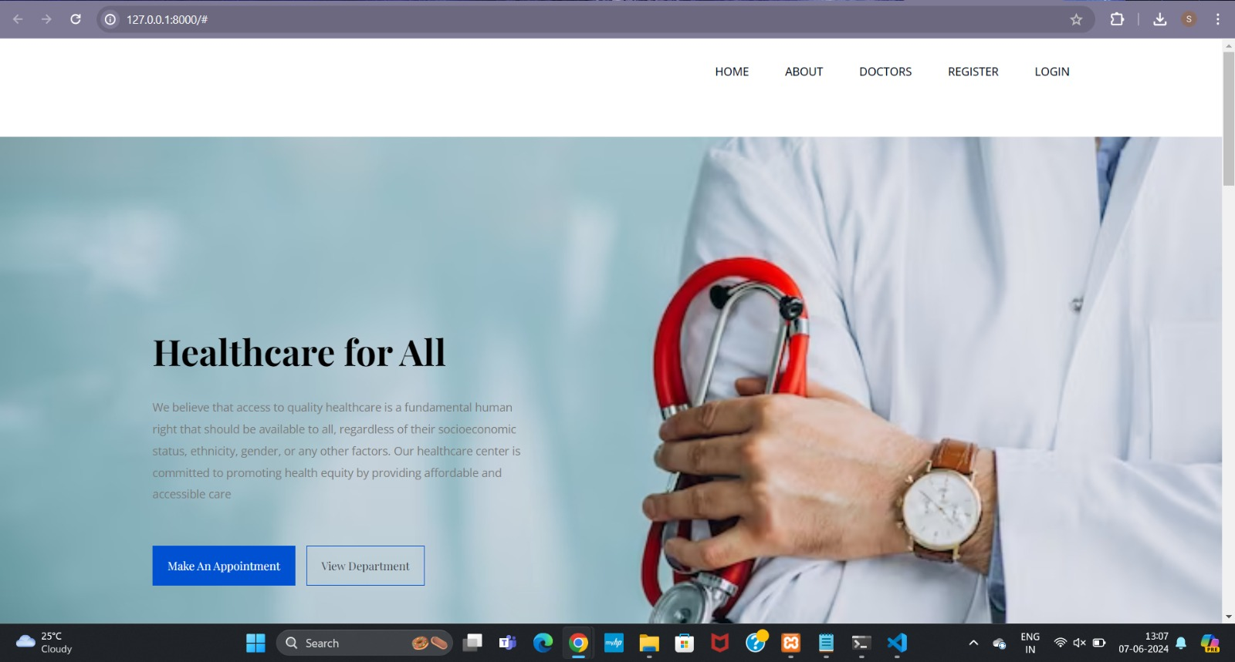

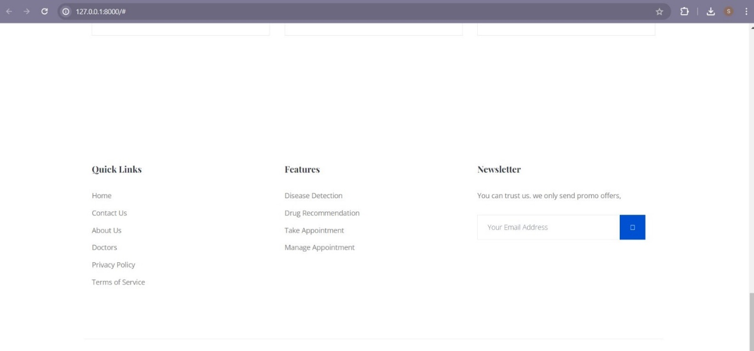

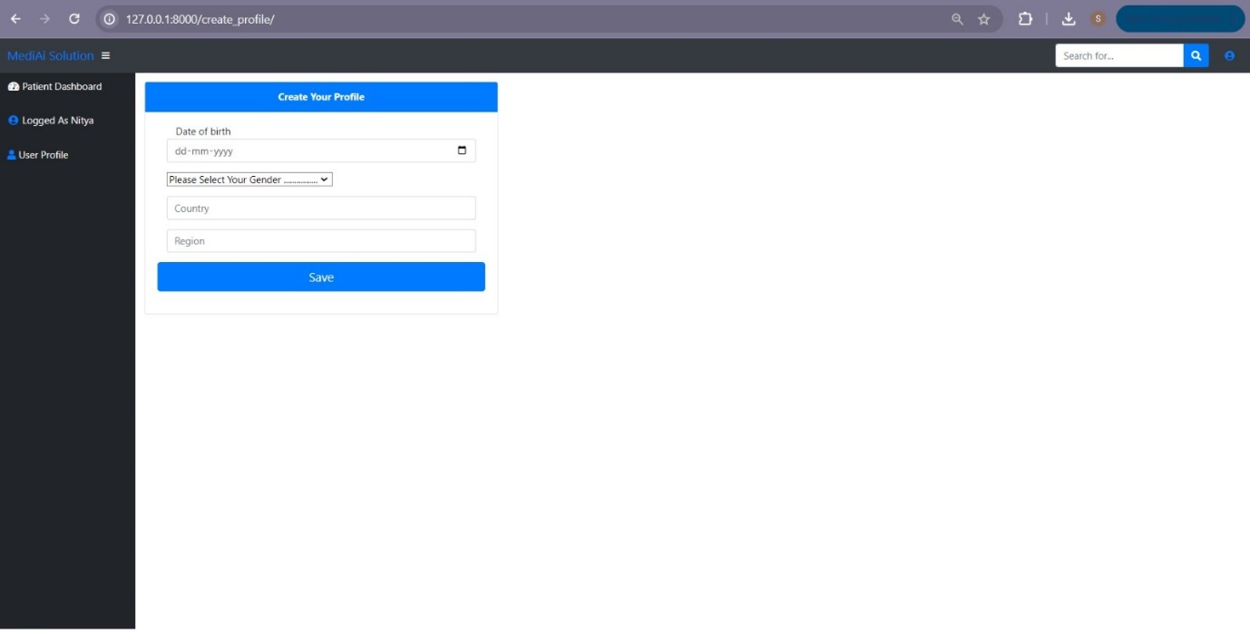

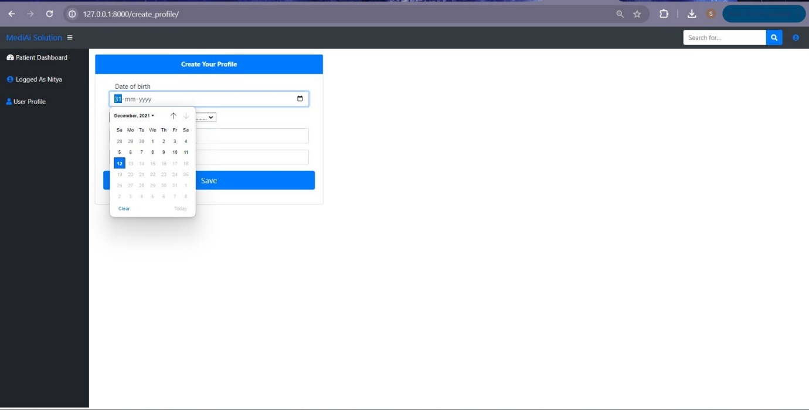

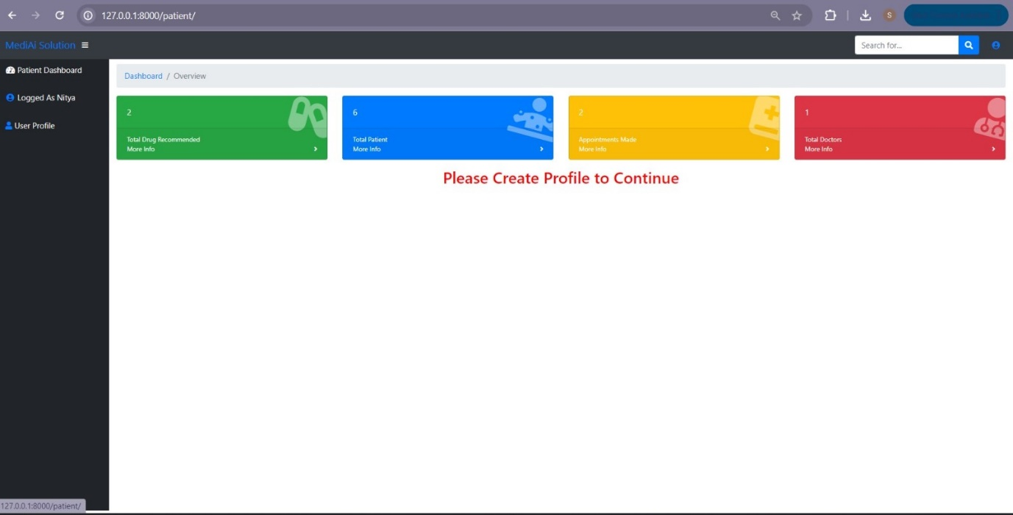

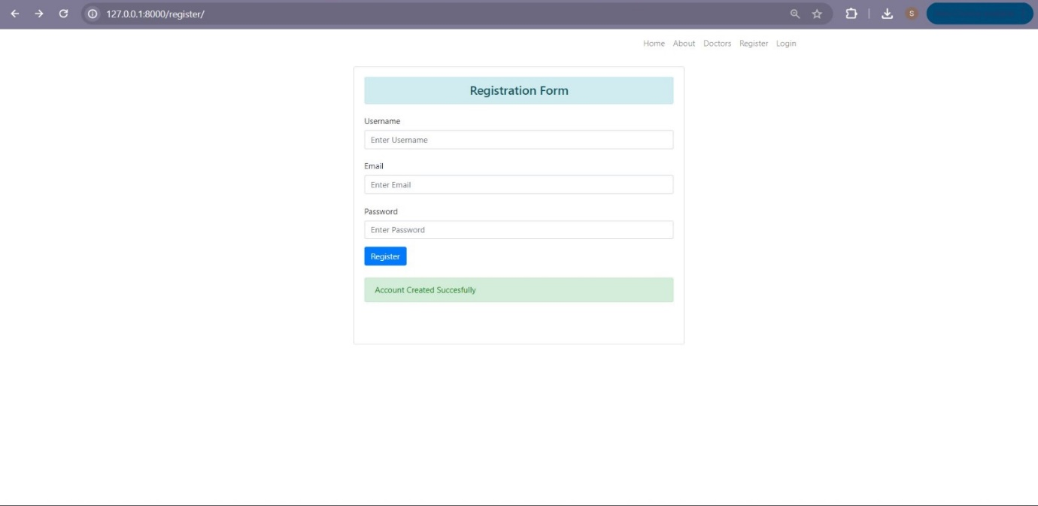

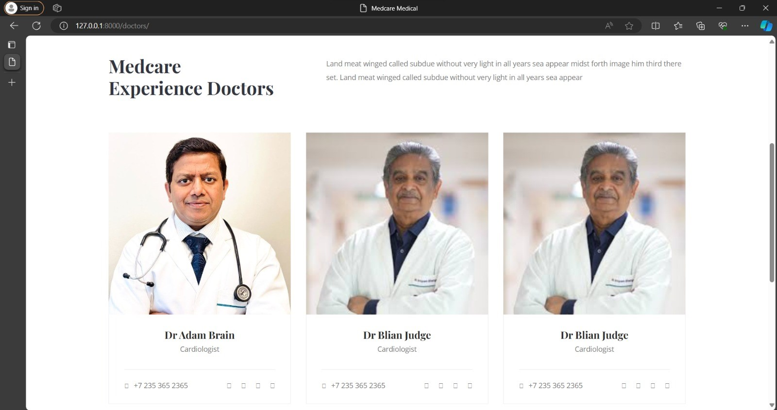

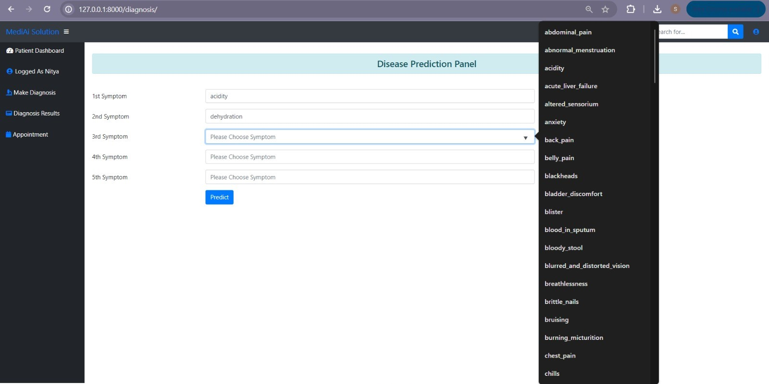

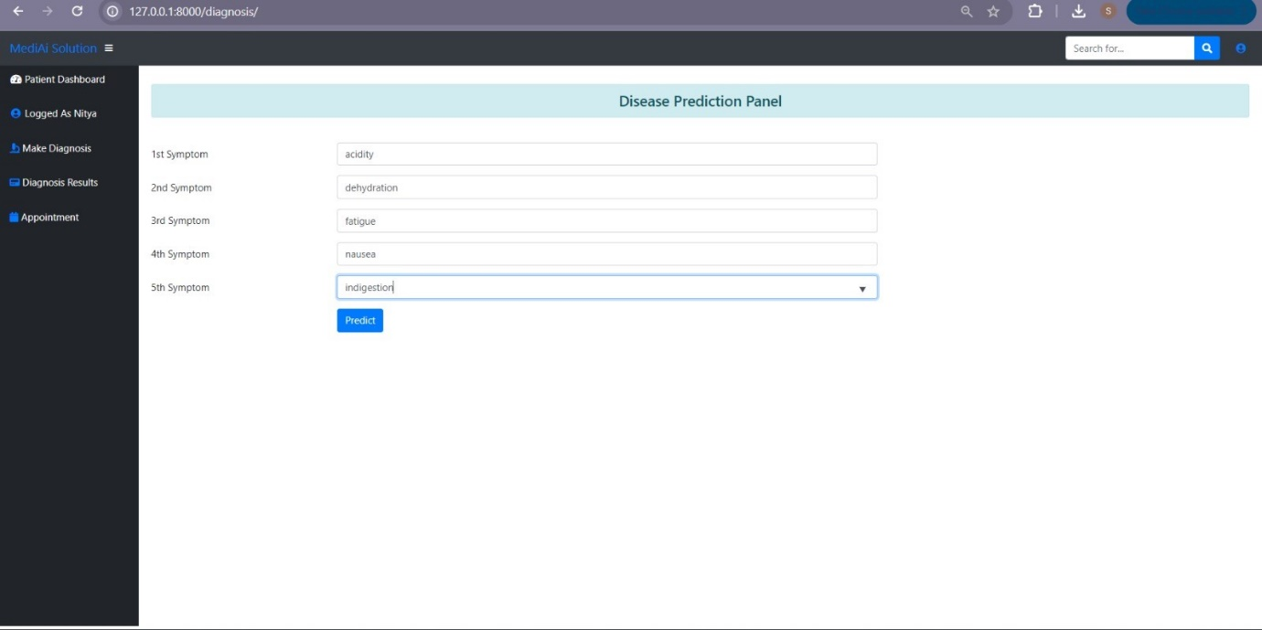

**AI ChatBot**



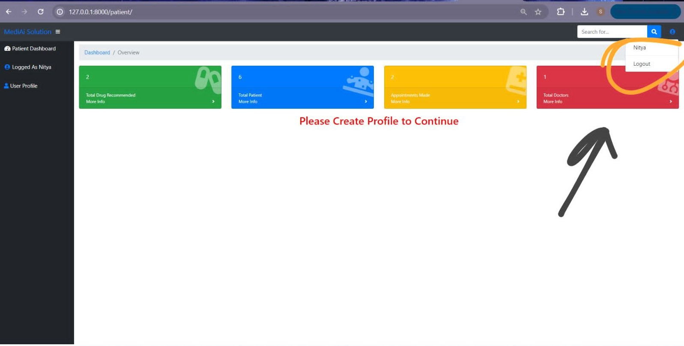

**URL for Website:**

https://github.com/positiveonly/healthcare

**Conclusion**

In summary, the MediAI project presents a transformative solution to the critical challenges of healthcare accessibility and efficiency. By integrating essential services such as, registration, appointment scheduling, symptom entry and AI chatbot into a cohesive, user-friendly platform, MediAI enhances the overall healthcare experience. This innovative approach ensures timely access to healthcare services, leading to improved health outcomes and heightened patient satisfaction. The platform stands out by offering comprehensive features that cater to diverse patient needs with unparalleled ease of use, setting it apart from other healthcare applications.

This project marks a significant stride towards addressing the gaps in healthcare accessibility and efficiency. MediAI’s dedication to improving patient care and promoting proactive health management positions it as a pivotal tool in modern healthcare, empowering users to take control of their health and wellness in an increasingly digital world

**Future Scope**

This project aims for broad applicability and impact, with future plans to improve AI capabilities within the web application through more accurate health prediction as well as diversification beyond pneumonia detection, implementing a telemedicine solution to allow consultation over longer distances while increasing data analytics available in order detect additional patient trends. The platform could also offer seamless health monitoring through wearable device integration and include multilingual support to accommodate more users. The AI algorithms will improve further and more learning curves shall be added, to provide personalized healthcare depending on the patient requests which change with every new discovery in medical sciences.

**References**

1. Balla Sahithya, Guru Prasad M S, Balla Sahithi, Madhu Krishna K, Ajay Charan Devarlla, Yashavanth T R, "Empowering Healthcare with AI: Advancements in Medical Image Analysis, Electronic Health Records Analysis, and AI-Driven Chatbots", *2024 3rd International Conference for Innovation in Technology (INOCON)*, pp.1-7, 2024.

2. I. Bouazzi, M. Zaidi, M. Usman, M. Z. M. Shamim, V. K. Gunjan and N. Singh, "Future trends for healthcare monitoring system in smart cities using LoRaWAn-based WBAN", Mobile Information Systems, 2022.

3. C. K. Gomathy and M. A. R. Naidu, "The prediction of disease using machine learning", International Journal of Scientific Research in Engineering and Management (IJSREM), vol. 5, no. 10, 2021.

4. Niyar R Barman, Krish Sharma, Ranjay Hazra, "A transformer-based approach to automate disease prediction from patient descriptions", *2023 IEEE 7th Conference on Information and Communication Technology (CICT)*, pp.1-5, 2023.