PROJECT REPORT
ON
Smart City Traffic Management Using Big Data

Subject Name: Big Data Analytics
Subject Code: BDA601
Submitted By: Submitted To:
Manvitha B M Ms. Surbhi
1AY23CD035

Table of Contents:

Task 1:- Big Data in Daily Life – Visual Storytelling
Topic | Page No:
1.About the Project | 3-5
2. About the Tools and Technologies  Used | 5-9
3. Detailed Description of My  Contribution  3.1 What is Done and How it is Done  3.2 Code Explanation | 9-11
4. Implementation Code | 11-14
5. Results | 14-15
6. Conclusion | 15
Figures:  1.1: Transformed Data  1.2: Dashboard | 16-17

TASK 2: BI vs Big Data – Role Play 17-19
TASK 3: Architecture Design Challenge 19-22
TASK 4: Analytics & Tool Match 23
Bonus Challenge 23-24

1.ABOUT THE PROJECT :

1.1 Background of Smart City Traffic Management Using Big Data:
Modern smart cities generate enormous volumes of traffic-related data every second. Every vehicle movement, signal change, toll payment, GPS ping, and CCTV capture creates digital records.
Sources of traffic data include:
- Traffic cameras (CCTV)
- GPS from vehicles and smartphones
- Toll booth transaction logs
- Public transport tracking systems
- Roadside IoT sensors
- Emergency service tracking
In large metropolitan cities:
- Millions of GPS records are generated per hour
- Gigabytes of video data are created daily
- Continuous real-time streaming data flows from sensors
Traditional traffic monitoring systems cannot store and process such massive and dynamic data efficiently.
This is where Big Data Analytics becomes essential.

1.2 Big Data in Smart City Traffic Management
– The 5V Model
- Volume
Traffic systems generate massive datasets:
- Millions of GPS records per day
- Continuous CCTV video streams
- Large amounts of sensor and toll data.
- Velocity
Traffic data is generated at high speed:
- Real-time GPS updates
- Instant congestion alerts
- Dynamic signal changes
Quick processing is required for effective traffic management.
- Variety
Traffic data comes in different formats:
- Structured data (vehicle count, speed, timestamps)
- Semi-structured data (JSON GPS logs)
- Unstructured data (CCTV footage, images)
Handling this variety requires Big Data technologies.
- Veracity
Traffic data may contain:
- GPS inaccuracies
- Missing or duplicate records
- Sensor errors
Data cleaning ensures reliable analysis.
- Value
Traffic analytics helps:

Detect congestion zones

Optimize signal timing

Predict accidents

Improve emergency response

Big Data converts raw traffic data into meaningful insights for smarter city operations.

1.3 Why Traditional BI Fails in Cybersecurity
Traditional BI tools like Excel and SQL databases have limitations:
- Designed mainly for structured tabular data
- Cannot handle streaming real-time data
- Limited storage capacity
- Not horizontally scalable
- Cannot process video data
- Suitable only for batch reporting
Traffic systems require:
- Real-time processing
- Distributed storage
- High scalability
- Fast decision-making
Hence, Big Data technologies are required.

2. ABOUT TOOLS & TECHNOLOGIES (DETAILED)

2.1 Power BI – Business Intelligence Layer
Power BI is used to create dashboards and reports.
In Smart Traffic:
- Displays congestion levels
- Shows peak-hour traffic
- Visualizes accident hotspots
- Compares average travel time
Power BI helps decision-makers understand complex traffic data visually.
Why Power BI is Important
Traffic data is huge and complex. Without visualization, it becomes difficult to interpret patterns. Power BI simplifies this by converting numerical data into graphical representations.
For example:
- A line graph can show traffic growth over time.
- Heatmaps can highlight areas with frequent congestion.
- Pie charts can represent the percentage of traffic by vehicle type.
Advantages
- Interactive dashboards.
- Real-time data visualization.
- Easy integration with big data sources.
- Helps decision-makers understand traffic trends.
Power BI acts as the presentation layer where analyzed data is displayed in a meaningful way.

2.2 Apache Hadoop – Distributed Storage
Hadoop is used for storing massive traffic data.
Key components:
- HDFS (Distributed storage system)
- MapReduce (Batch processing)
- YARN (Resource management)
Advantages:
- Stores large GPS datasets
- Fault-tolerant
- Scalable across multiple servers
HDFS (Hadoop Distributed File System):
- Stores large GPS and traffic datasets.
- Ensures data availability even if one server fails.
- Scalable storage across multiple nodes.

MapReduce:
- Map Phase → Processes small data chunks.
- Reduce Phase → Combines results.
YARN (Yet Another Resource Negotiator): YARN manages computing resources in Hadoop clusters. It ensures efficient task execution.
Use in Smart Traffic:
Traffic systems generate massive data from cameras, sensors, and GPS devices. Hadoop stores this data efficiently and allows future analysis.

2.3 Apache Spark – Real-Time Processing Apache Spark enables fast in-memory processing.
In traffic analytics:
- Detects congestion in real time
- Predicts traffic patterns
- Performs machine learning on travel data
Spark processes data much faster
Why Spark is Faster
- In-memory computation.
- Supports streaming data.
- Works with big data frameworks.
- Efficient for machine learning tasks.
Advantages
- Faster data processing.
- Real-time analytics.
- Supports large datasets.
- Integrates with Hadoop.
Spark is ideal for traffic systems where real-time decision-making is required.

2.4 NoSQL Databases – Flexible Storage
MongoDB is used for storing semi-structured GPS logs.
Advantages:
- Schema flexibilityHandles JSON and GPS logs.
- Horizontally scalable.
- Faster data retrieval.
Use in Traffic Data
Traffic data includes:
- GPS logs
- Sensor readings
- Camera feeds
- User travel history
Since this data varies in format, NoSQL databases are suitable.
Comparison with SQL
- SQL uses tables and fixed schemas.
- NoSQL stores documents and supports dynamic data.

Why NoSQL is Important
Smart traffic systems require flexible storage for diverse data sources. NoSQL databases provide this capability.

3. DETAILED DESCRIPTION OF CONTRIBUTION

3.1 What is Done and How it is Done
3.1.1 Data Understanding
Each traffic record may contain:
- Vehicle ID
- GPS coordinates
- Speed
- Timestamp
- Traffic signal ID
- Road segment
- Congestion status
Each row represents one vehicle movement event.

3.1.2 Data Preprocessing
Data cleaning includes:
- Removing null GPS values
- Converting timestamps
- Removing duplicate entries
- Standardizing speed units
- Handling missing records

3.1.3 Analytical Logic Applied
The dashboard logic focuses on
- Total Vehicles per Hour
- Average Speed per Road
- Congestion Percentage

3.2 Code Explanation

Congestion Ratio %
CongestionRatio%=
DIVIDE([Congested Vehicles], [Total Vehicles]) * 100 8
Explanation:
- DIVIDE() is used to avoid division by zero error.
- [Congested Vehicles] counts vehicles moving in congestion.
- [Total Vehicles] counts total vehicle records.
- The result is multiplied by 100 to convert into percentage.
This measure helps us understand how much traffic is congested in the city.

Total Vehicles
TotalVehicles=
COUNTROWS(Traffic_Data)
Explanation:
- COUNTROWS() counts the total number of rows in the dataset.
- Each row represents one vehicle movement record.
- This measure gives the overall traffic volume.
- It is used as a base metric for further calculations.

Congested Vehicles
CongestedVehicles=
CALCULATE(
COUNTROWS(Traffic_Data),
Traffic_Data[Congestion_Status]="Yes"
)
Explanation:
- CALCULATE() modifies the filter context.
- It filters only those records where Congestion_Status is “Yes”.
- This measure calculates total vehicles moving under congestion.
- It helps identify high-traffic conditions.

Average Speed
AvgSpeed=
AVERAGE(Traffic_Data[Speed])
Explanation:
- AVERAGE() calculates mean vehicle speed.
- Low average speed indicates heavy traffic.
- High average speed indicates smooth traffic.
This helps detect traffic slowdowns.

- IMPLEMENTATION OF CODE

  - Overview of Implementation
In this project:
- Traffic dataset was imported into Power BI.
- Data cleaning was performed.
- DAX measures were created.
- An interactive dashboard was built.
Each row in the dataset represents one vehicle record captured from GPS or traffic sensors.

  - Data Import and Preparation
The dataset was imported using:
Home → Get Data → Excel/CSV → Load
After loading:
- Data types were verified (Speed as numeric, Timestamp as Date/Time).
- Null values were checked.
- Duplicate records were removed.
- Congestion_Status column was verified.
The table used in the data model is:
Traffic_Data

  - DAX Measures Implementation

4.3.1 Total Vehicles
Total Vehicles = COUNTROWS(Traffic_Data)
This counts total vehicle records in the dataset.

4.3.2 Congested Vehicles
Congested Vehicles =
CALCULATE(
COUNTROWS(Traffic_Data),
Traffic_Data[Congestion_Status] = "Yes"
)
This counts only vehicles under congestion.

4.3.3 Congestion Ratio %
Congestion Ratio % =
DIVIDE([Congested Vehicles], [Total Vehicles]) * 100
This shows percentage of traffic congestion.

4.3.4 Average Speed
Avg Speed = AVERAGE(Traffic_Data[Speed])
This calculates average vehicle speed.
4.4 Dashboard Implementation Logic
The measures were connected to visuals:
- KPI Cards → Total Vehicles, Congestion %, Avg Speed
- Line Chart → Vehicles per Hour
- Bar Chart → Road-wise Congestion
- Map → Traffic Zones
- Slicers → Date, Road Segment
All visuals are connected to allow interactive filtering.

4.5 Summary of Implementation
The implementation demonstrates how raw traffic data collected from GPS devices and sensors can be transformed into meaningful insights using Power BI. After importing and cleaning the dataset, DAX measures such as Total Vehicles, Congestion %, and Average Speed were created to analyze traffic conditions. These measures were connected to interactive dashboard visuals like KPI cards, charts, and maps. The final dashboard enables effective monitoring of traffic patterns and supports better decision-making for smart city traffic management.

5.RESULTS ANALYSIS

5.1 Traffic Overview
The dashboard provides a clear overview of overall traffic conditions. The KPI indicators display total traffic volume, average traffic, and peak traffic levels. These metrics provide a quantitative understanding of congestion intensity. The analysis shows noticeable variations in traffic volume across different time periods, indicating peak and non-peak hours.

5.2 Traffic Pattern Analysis
The line chart reveals significant fluctuations in traffic over time. Certain time intervals show higher vehicle movement, indicating congestion periods. The bar chart comparing traffic volume across different weather conditions highlights that traffic is generally higher during clear weather and relatively reduced during rainy or cloudy conditions. This demonstrates the influence of environmental factors on traffic flow.

5.3 Weather-Based Behavior
Weather conditions play an important role in traffic movement. The dashboard indicates that clear weather conditions contribute to higher traffic density, while adverse weather conditions such as rain or snow slightly decrease traffic volume. This behavior suggests that drivers tend to reduce travel during unfavorable weather situations.

5.4 Trend-Based Insights
The time-series visualization identifies recurring traffic spikes during specific periods. These patterns assist in understanding congestion trends and help in planning better traffic management strategies. The interactive slicers further support detailed filtering and analysis, enabling more effective decision-making for smart city traffic systems.

6.Conclusion:
The Smart Traffic Analysis system demonstrates how big data technologies can be effectively used to analyze and manage urban traffic patterns. By utilizing Power BI for visualization and data analytics, large volumes of traffic data were processed and transformed into meaningful insights. The dashboard provides a clear understanding of traffic trends, congestion levels, and the impact of weather conditions on vehicle movement.
The implementation highlights the importance of data-driven decision-making in smart cities. Through interactive visualizations and KPI indicators, traffic authorities can monitor peak traffic periods and identify influencing factors. Overall, this project successfully showcases the application of big data analytics in improving traffic management and supporting sustainable urban development.

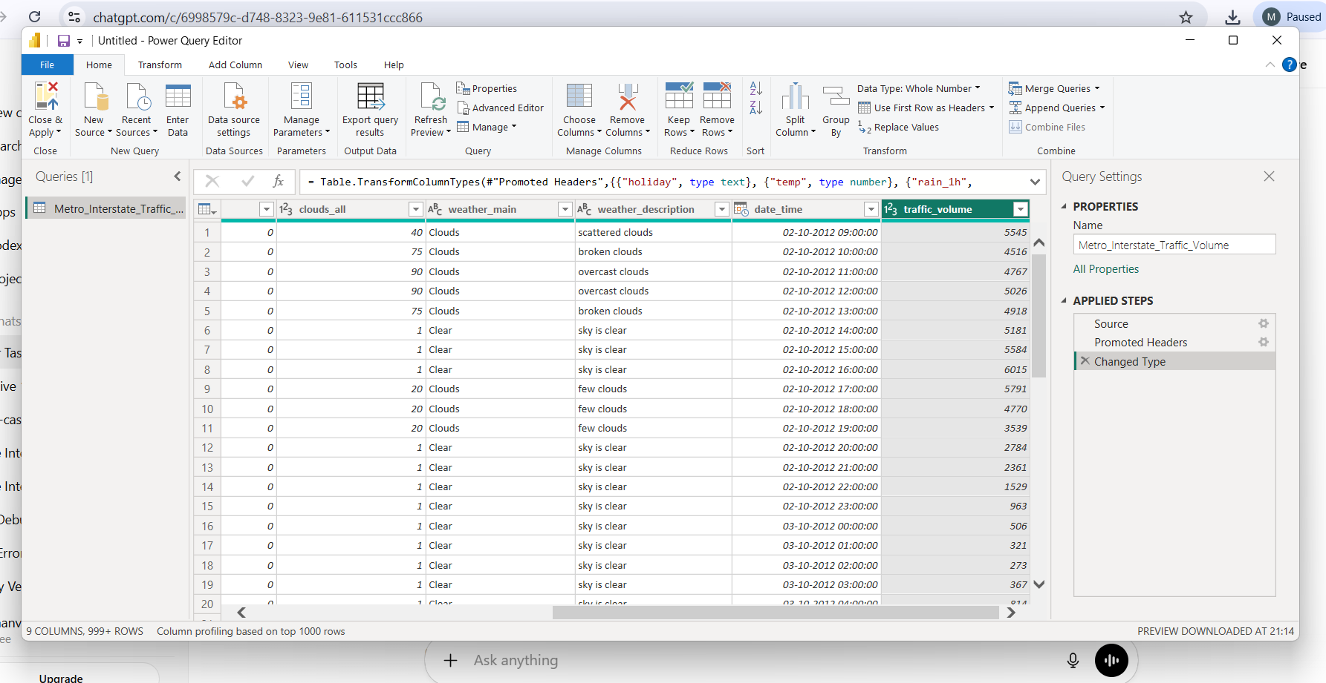
Figure1.1: Transformed Data used for visualizations
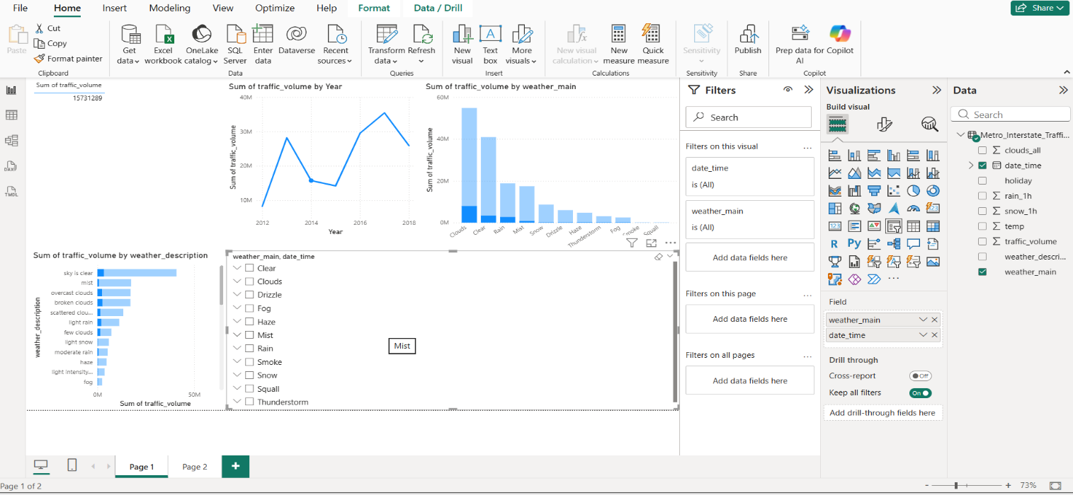

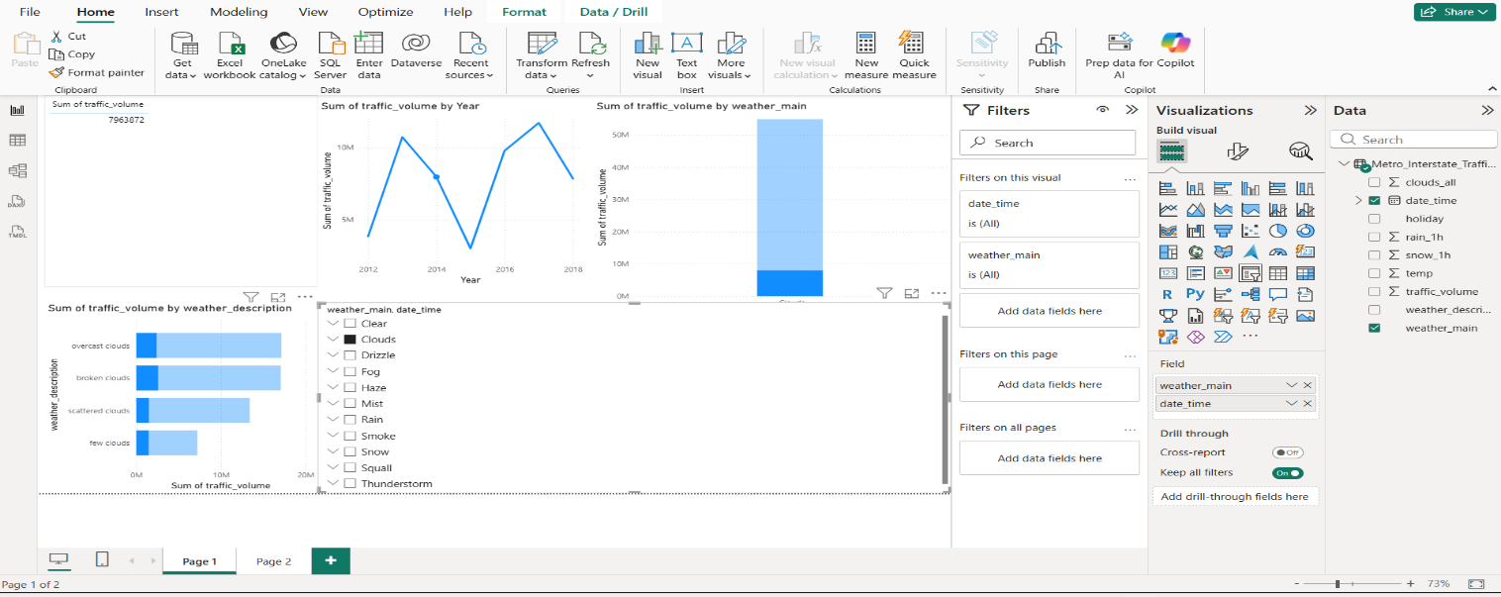
Figure 1.2 and 1.3: Interactive Dashboard using Power BI visualization tool
Data Set Used: https://archive.ics.uci.edu/ml/datasets/Metro+Interstate+Traffic+Volume

TASK 2: BI vs Big Data – Role Play
Scenario: Smart traffic management system

Manager: We have developed a Smart Traffic dashboard using Power BI. It shows traffic volume and congestion clearly. Why do we need Big Data?
Consultant: Business Intelligence helps analyze structured historical data and create dashboards. However, it is mainly used for reporting and visualization.

Manager: Then what is the role of Big Data in our project?
Consultant: Smart traffic systems generate massive real-time data from sensors, GPS devices, and cameras. Big Data technologies are required to store and process this high-volume data efficiently.

Manager: So how are BI and Big Data different?
Consultant: Big Data handles large-scale data storage and processing, while BI converts processed data into meaningful visual insights for decision-making.

Manager: Can BI work without Big Data?
Consultant: BI can work with small structured datasets, but for large and real-time smart city data, Big Data infrastructure is essential.

Manager: So bo

th are necessary for smart traffic management?
Consultant: Yes. Big Data ensures efficient handling of large datasets, and BI provides clear analytical reports. Together, they enable intelligent and data-driven traffic management.

Manager: Does Big Data also support prediction?
Consultant: Yes. Big Data technologies enable predictive analytics by processing large historical datasets to forecast future traffic congestion trends.

Manager: So what is the final benefit for smart cities?
Consultant: By combining Big Data and Business Intelligence, smart cities can monitor traffic in real-time, analyze patterns, and make informed decisions to reduce congestion and improve urban mobility.

Manager: What about cost? Isn’t Big Data expensive?
Consultant: Big Data frameworks are open-source. The cost of a data breach is far higher than investing in scalable security analytics.

Manager: So you’re saying BI is outdated?
Consultant: Not outdated — but limited. BI is excellent for structured reporting. Big Data is essential for high-volume, real-time cybersecurity monitoring.

TASK 3: Architecture Design Challenge
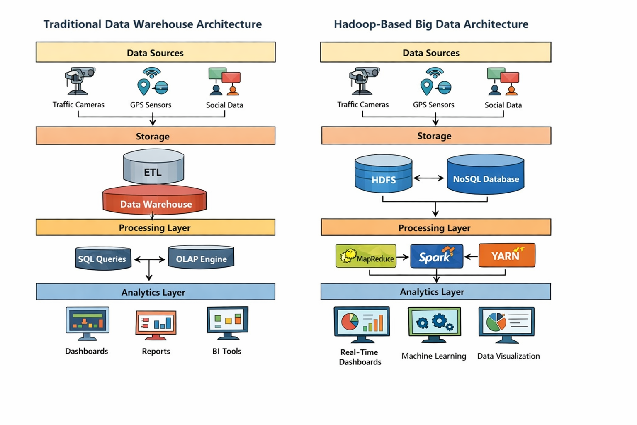
Figure1.4: Traditional data warehouse architecture vs Hadoop based big data architecture

Traditional Data Warehouse Architecture (Left Side Diagram):
This architecture is old method of storing and analyzing data. It is structured and works well with small and structured data.
Data Sources
Data comes from:
- Traffic cameras
- GPS sensors
- Social data
These sources generate traffic information.
Storage Layer
Data first goes to:
- ETL (Extract, Transform, Load)
ETL cleans and structures data.
- Then it is stored in a Data Warehouse
Data warehouse stores structured data in tables.
Processing Layer
- SQL Queries
Used to fetch data.
- OLAP Engine
Used for analysis.
Processing is batch-based, not real-time.
Analytics Layer
Results are shown using:
- Dashboards
- Reports
- BI Tools
This helps in understanding traffic patterns.

Hadoop-Based Big Data Architecture (Right Side Diagram):
This is modern architecture for big data and real-time analytics.
Data Sources
Same sources:
- Traffic cameras
- GPS sensors
- Social data
But data is big and unstructured.
Storage Layer
Data is stored in:
- HDFS(DistributedStorage)
Stores data across multiple machines
- NoSQLDatabase
Stores flexible and semi-structured data (like JSON).
Processing Layer
Tools used:
- MapReduce
Processes big data in parallel.
- Spark
Real-time and fast processing.
- YARN
Manages resources.
This layer handles both batch and real-time data.
Analytics Layer
Results are shown using:
- Real-time dashboards
- Machine learning
- Data visualization
It helps in predicting traffic and detecting congestion.

TASK 4: Analytics & Tool Match
Cybersecurity Version: -
Business Question | Analytics Type | Tool Used
What happened? | Descriptive Analytics | Power BI (Traffic Dashboard), SQL (Traffic Data)
Why did it happen? | Diagnostic Analytics | Power BI (Drill-down Reports), Traffic Logs, Sensor Data
What will happen next? | Predictive Analytics | Machine Learning Models, Apache Spark, Historical Traffic Data
What action should be taken? | Prescriptive Analytics | Automation Systems, Traffic Optimization Algorithms

Bonus Challenge
“Explain Big Data to a 10-year-old”
Big Data is like a huge box of information that computers collect and understand. For example, imagine an ice cream shop. Every time people buy ice cream, the shop notes which flavor they bought—chocolate, vanilla, strawberry, or mango. It also notes the time and day when people buy ice cream.
Now imagine the shop does this for many months and many customers. It collects thousands of records. If all ice cream shops in the city collect the same information, it becomes a huge amount of data. This is Big Data.
Big Data helps the ice cream shop understand patterns. For example, it can find out which flavor is most popular in summer or which time of day people buy the most ice cream. If chocolate is sold the most, the shop can make more chocolate ice cream. This helps the shop serve customers better.
Big Data is like a smart helper. It reads huge information and finds useful ideas. Even though the data is very large, computers use special tools to understand it.
So, Big Data is everywhere—schools, shops, and technology. It helps people make better decisions and improve services. Just like the ice cream shop learns what customers like, Big Data helps systems learn patterns and become smarter.

