Exploratory Data Analysis on a Cars Dataset
Clean, explore, visualise and explain patterns in used-car listings

Student name | Manvith M Gowda
Batch | AIML
Date | 26 October 2026
Project | Unlox Student Project - Cars EDA
Dataset source | YBI Foundation public datasets - github.com/ybifoundation/Dataset (Car Price.csv)
Tools used | Python, pandas, NumPy, Matplotlib, Seaborn

Objective
The purpose of this project is to carry out a complete Exploratory Data Analysis (EDA) on a used-car listings dataset: understand its structure, check and improve data quality, find patterns and outliers, and communicate the results with clear charts. No machine-learning model is built. The questions selected for analysis are:
  - Which brands and fuel types are most common?
  - How are car prices distributed?
  - How does vehicle age relate to price?
  - Does mileage (km driven) appear to influence price?
  - Do automatic and manual cars differ in price?
  - Which brands have the highest median price?
  - Which features are strongly correlated, and where are the important outliers?
Questions about horsepower and engine size were not explored because those columns are not in this dataset.

Dataset Overview
The dataset contains 4,340 rows and 9 columns; each row is one used car listing (Indian market, prices in INR). Source: YBI Foundation public datasets - github.com/ybifoundation/Dataset (Car Price.csv). Model years range from 1992 to 2020.
Column | Type | Description
Brand | Categorical | Manufacturer of the car
Model | Categorical | Model and variant name (text)
Year | Numerical | Year of manufacture
Selling_Price | Numerical | Listing / selling price in INR
KM_Driven | Numerical | Kilometres driven
Fuel | Categorical | Petrol, Diesel, CNG, LPG, Electric
Seller_Type | Categorical | Individual, Dealer or Trustmark Dealer
Transmission | Categorical | Manual or Automatic
Owner | Categorical (ordered) | Ownership history (First owner ... Test Drive Car)

Sample records (first 5 rows)

Brand | Model | Year | Price | KM | Fuel | Seller | Trans. | Owner
Maruti | Maruti 800 AC | 2007 | 60000 | 70000 | Petrol | Individual | Manual | First Owner
Maruti | Maruti Wagon R LXI Minor | 2007 | 135000 | 50000 | Petrol | Individual | Manual | First Owner
Hyundai | Hyundai Verna 1.6 SX | 2012 | 600000 | 100000 | Diesel | Individual | Manual | First Owner
Datsun | Datsun RediGO T Option | 2017 | 250000 | 46000 | Petrol | Individual | Manual | First Owner
Honda | Honda Amaze VX i-DTEC | 2014 | 450000 | 141000 | Diesel | Individual | Manual | Second Owner
Numerical variables: Year, Selling_Price, KM_Driven. Categorical variables: Brand, Model, Fuel, Seller_Type, Transmission, Owner.

Data Quality and Cleaning
Checks performed: missing values, duplicate rows, whitespace problems, inconsistent labels, implausible values and outliers. Each decision and its reason is listed below.
Check / issue | Finding | Decision and reason
Missing values | 0 in every column | Nothing to impute; no rows dropped.
Duplicate rows | 763 exact duplicates | Dropped - repeated listings would double-count cars and bias counts and medians.
Inconsistent labels | Brand 'Land' (Land Rover) and 'OpelCorsa' | Renamed to 'Land Rover' and 'Opel' (7 rows) so each maker has one label.
Whitespace in text | 0 problems | Trimmed anyway as a safe step.
Implausible values | 1 car aged 2+ years with 1 km driven | Removed as a probable entry error. Cars with 101 km that are 2020 models (test-drive cars) were kept.
Outliers | 170 price and 106 mileage outliers (1.5 x IQR rule) | Kept - they are real cars (luxury models, very high-mileage cars). Handled with medians and log scale rather than deletion.
Type / new columns | Text columns, no age or price in lakh | Created Car_Age (2020 - Year), Price_Lakh, Log_Price, Owner_Count; text columns converted to category.

Measure | Before cleaning | After cleaning
Rows x columns | 4,340 x 9 | 3,576 x 13
Missing values | 0 | 0
Duplicate rows | 763 | 0
Brand labels | 29 | 29
The cleaned dataset keeps 82.4% of the original rows. The extra columns after cleaning (Car_Age, Price_Lakh, Log_Price, Owner_Count) are derived features.

Descriptive Analysis

Numerical columns (cleaned data)

Column | Mean | Std | Min | 25% | Median | 75% | Max | Skew
Year | 2,013.0 | 4.2 | 1,992 | 2,010 | 2,013 | 2,016 | 2,020 | -0.79
Selling_Price | 473,975.2 | 509,359.3 | 20,000 | 200,000 | 350,000 | 600,000 | 8,900,000 | 5.45
KM_Driven | 69,269.9 | 47,572.5 | 101 | 36,000 | 60,104 | 90,000 | 806,599 | 2.55
Car_Age | 7.0 | 4.2 | 0 | 4 | 7 | 10 | 28 | 0.79
Selling price has a mean of Rs 4.74 lakh against a median of Rs 3.50 lakh and a skewness of 5.5, so it is strongly right-skewed. Kilometres driven is also right-skewed (skew 2.55). The typical car is about 7 years old.

Categorical columns

Column | Unique values | Most frequent | Share of rows
Brand | 29 | Maruti | 30.0%
Fuel | 5 | Diesel | 50.3%
Seller_Type | 3 | Individual | 79.2%
Transmission | 2 | Manual | 91.3%
Owner | 5 | First Owner | 62.0%
Maruti is the largest brand (30% of listings). Fuel is almost evenly split between diesel and petrol; manual cars are 91% of the data and individual sellers 79%.

Visual EDA
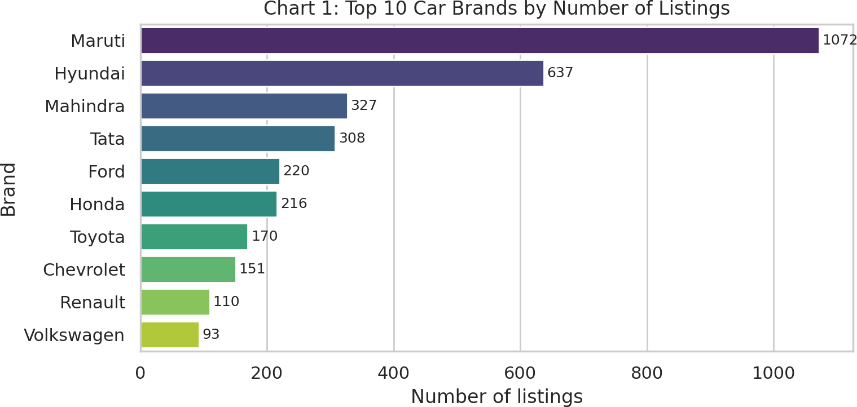
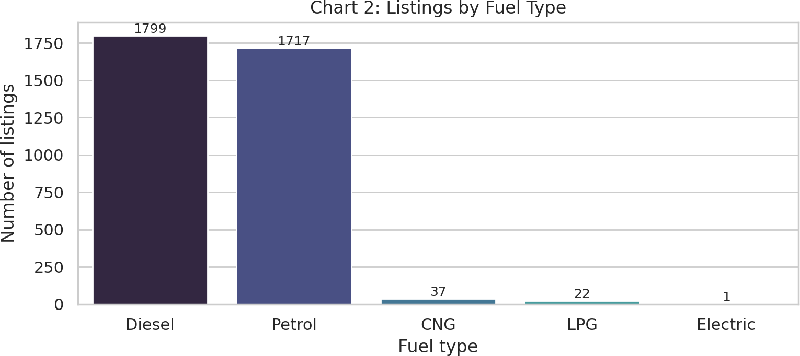
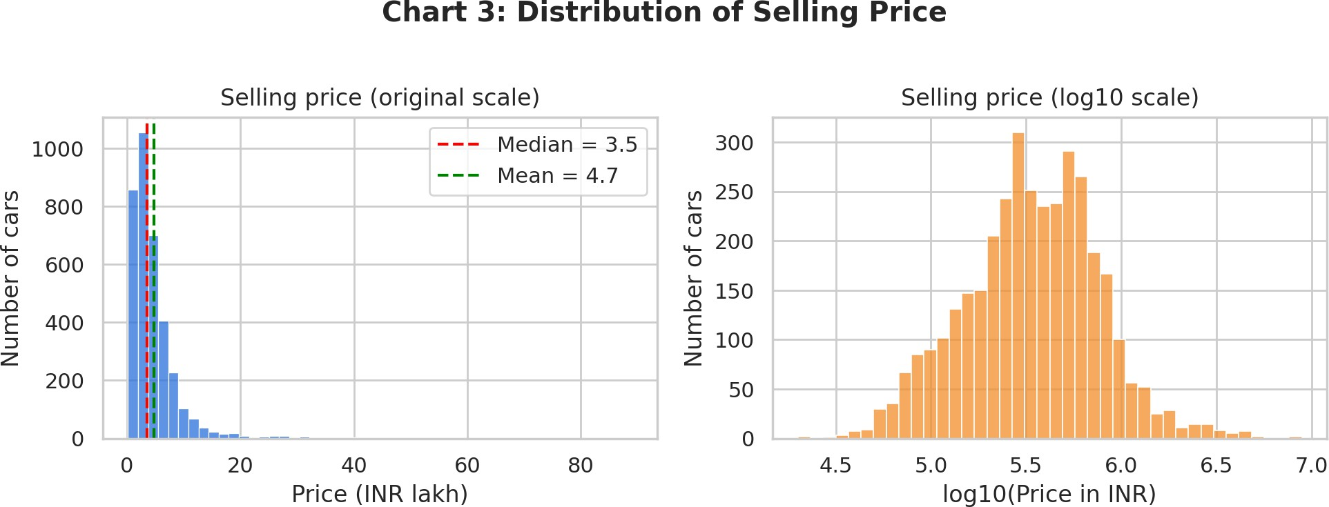
Observation: Maruti (1,072 listings) and Hyundai (637) lead by a wide margin, followed by Mahindra, Tata and Honda. The two largest brands account for 48% of the data, so overall averages mostly describe mass-market cars.
Observation: Diesel (1,799) and petrol (1,717) make up 98.3% of listings. CNG (37), LPG (22) and electric (1) are too small for reliable comparison.

Observation: The original-scale histogram is piled up at low prices with a long right tail, and the mean (Rs 4.7 lakh) sits above the median (Rs 3.5 lakh). On a log scale the distribution is much more symmetric, so the log scale is used in later price charts.

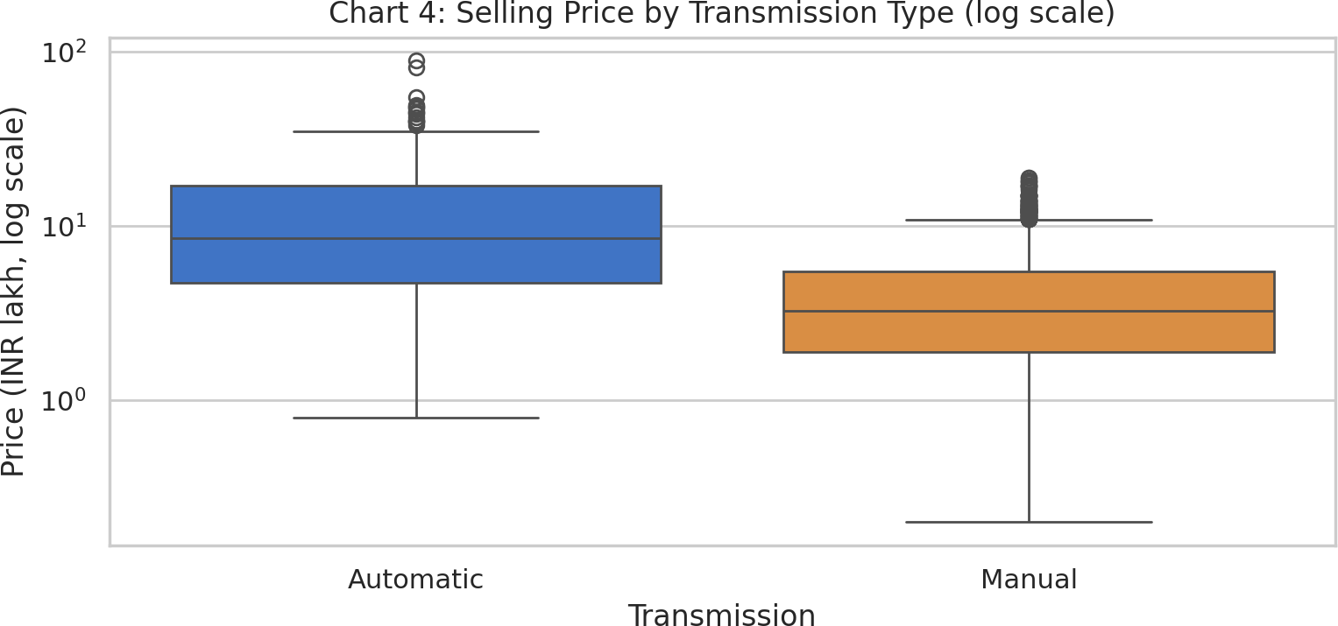
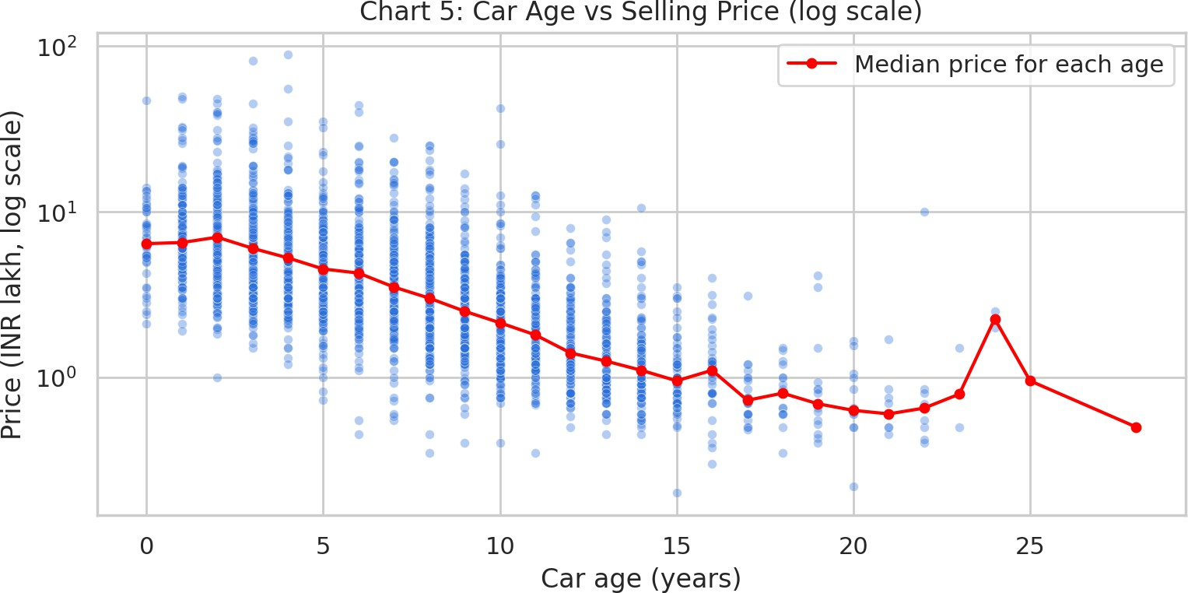
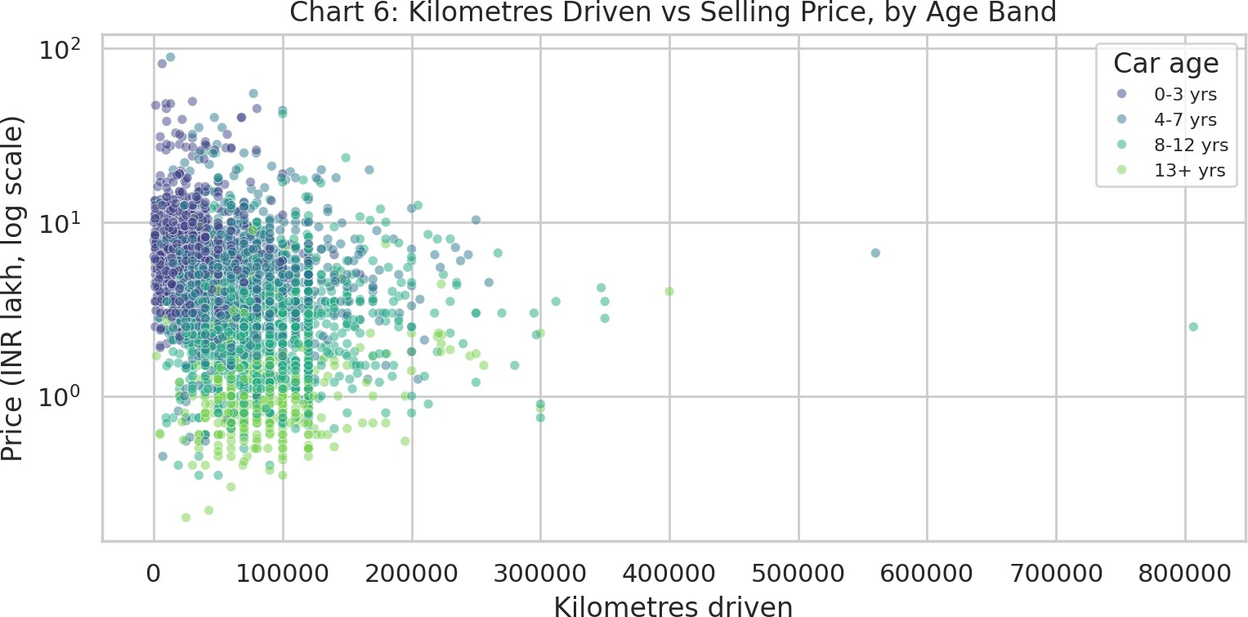
Observation: The automatic box sits well above the manual box (medians Rs 8.55 vs Rs 3.25 lakh) with little overlap in the middle 50%. Manual cars show many high-price outliers. Because automatics are newer and more often premium brands, this gap is not purely a transmission effect.
Observation: Price falls steadily as cars get older; the red median line drops from about Rs 6.5 lakh for new cars to about Rs 1.0 lakh for old ones. Newer cars show the widest spread because budget and luxury models are mixed.
Observation: The newest cars (darkest points, 0-3 years) cluster at low kilometres and higher prices, while older bands spread to higher kilometres and lower prices. Within a single colour band the slope is weak, which suggests much of the mileage effect is really an age effect.

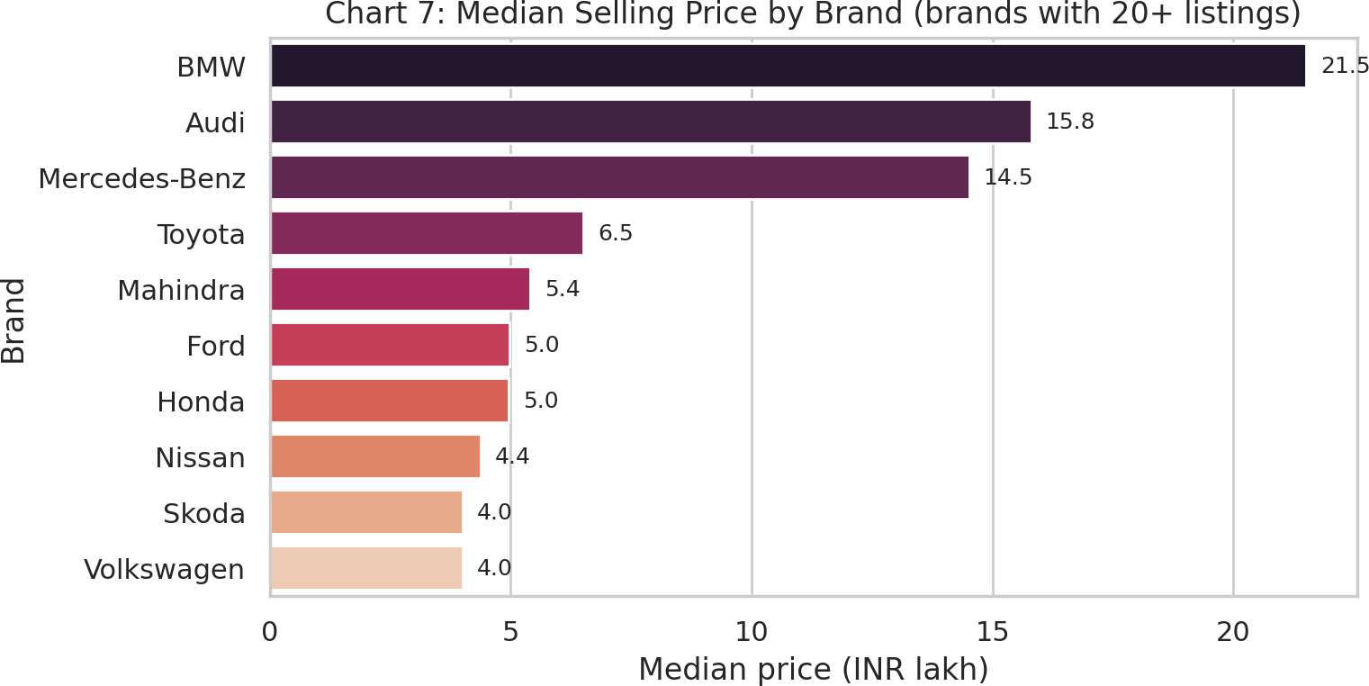
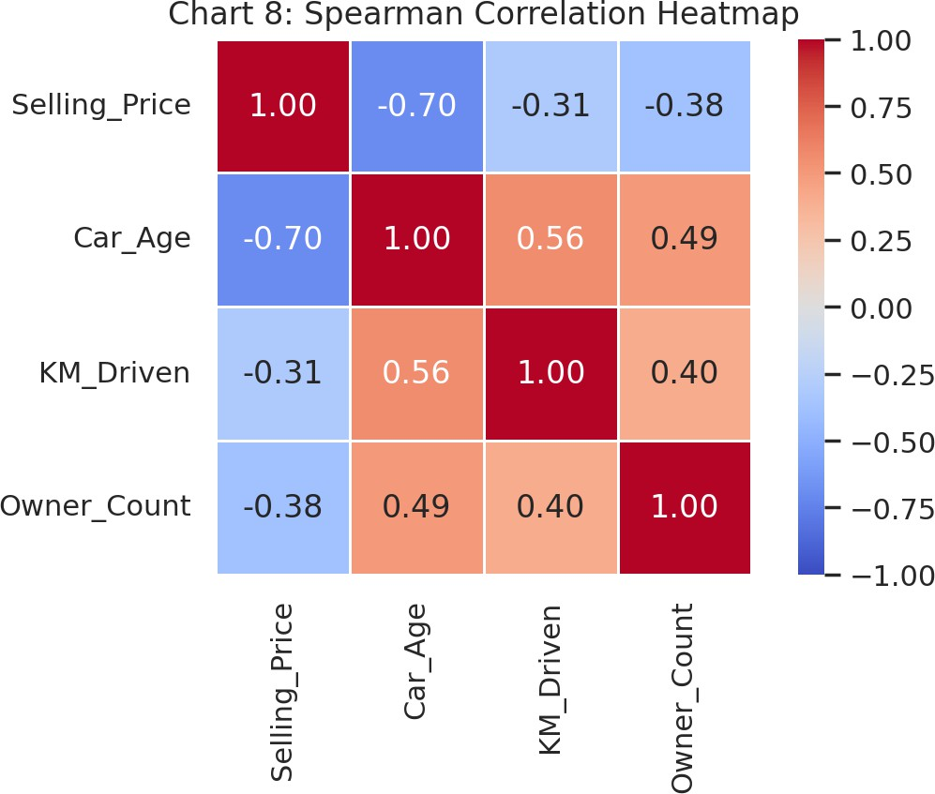
Observation: Among brands with 20+ listings, BMW (21.5 lakh), Audi (15.8) and Mercedes-Benz (14.5) have the highest median prices, with Toyota (6.5) the most expensive mass-market brand. Maruti, the most common brand, has a median of only 2.8 lakh.
Observation: Price is most strongly (negatively) correlated with car age (-0.70) and moderately with km driven (-0.31). Age and km are positively related (0.56). Owner count is only weakly linked to price. Spearman correlation is used because price and km are skewed.

Key Findings
- Market is concentrated: Maruti and Hyundai together make up 48% of listings, and petrol + diesel cars account for 98.3% of all cars (CNG, LPG and electric are each under 2%).
- Prices are strongly right-skewed: the mean price is Rs 4.74 lakh but the median is only Rs 3.50 lakh (skewness 5.5). Because of a few luxury cars, the median is a better 'typical price' than the mean.
- Car age is the strongest numerical link to price: Spearman correlation = -0.70. The median price falls from Rs
6.5 lakh for 0-3 year-old cars to Rs 1.0 lakh for cars older than 12 years.
- Mileage is only moderately related to price (correlation -0.31) and is itself tied to age (age vs km = 0.56), so part of its apparent effect is really an age effect. Among 4-7 year-old cars the km-price correlation is 0.07.
- Automatic cars have a much higher median price than manual cars (Rs 8.55 lakh vs Rs 3.25 lakh), but this is not a pure transmission effect: 29% of automatics are from premium brands against 0.2% of manuals, and

automatics are also newer (median age 4 vs 7 years).
- Brand matters: among brands with 20+ listings, BMW has the highest median price (Rs 21.5 lakh), while the best-selling brand Maruti has a median of Rs 2.8 lakh.
- Price outliers are genuine high-end cars rather than errors: 170 cars (4.8%) sell above Rs 12.0 lakh, their median age is only 3 years, and 43% belong to premium brands (the rest are mostly Toyota and Mahindra). They were therefore kept.

Limitations of the dataset
  - The dataset is a single snapshot of listings with no listing date or city, so price trends over time or by location cannot be studied.
  - Selling_Price is an asking/selling price of the listing, not a verified transaction price.
  - Important price drivers such as car condition, trim/variant details, engine size and horsepower are missing or only hidden in the Model text.
  - Car age depends on the assumed reference year (2020, the newest model year in the data).
  - Relationships shown are associations, not proof of cause and effect.
  - Several categories are very small (e.g. 1 electric car, a few brands with fewer than 10 listings) so conclusions about them are unreliable.

Conclusion
The cleaned dataset (3,576 listings) shows a market dominated by Maruti and Hyundai, with prices that are heavily right-skewed. Car age is the clearest driver of price among the numerical variables, brand and transmission add large differences, and mileage matters mostly through its link with age. Using medians and log-scale charts gave a more faithful picture than raw means.
Learning: checking duplicates and labels before analysing prevents double counting; skewed data needs medians and log scales; and correlated variables (age, km, transmission, brand) must be interpreted carefully so that associations are not mistaken for causes.
Challenges: 763 duplicate rows, two inconsistent brand labels, a heavily skewed price column, and very small categories (e.g. one electric car).
Future analysis: extract engine size and variant details from the Model text, compare depreciation curves for individual popular models, and (if listing dates or cities become available) study price trends by time and location. A regression model could then quantify each factor.
Dataset source: YBI Foundation public datasets - github.com/ybifoundation/Dataset (Car Price.csv). Analysis and charts were produced in Python (pandas, NumPy, Matplotlib, Seaborn).

