

**DM2295**

**Game Prototype Project**

**Team 04**

Submitted to:

Mr Andrew Lam

*Updated as at 16 Feb 2015*

Table of Contents

Relation To Theme 3

Introduction of Game 4-5

Features List6-7

1. **Units**
   * **AI\***
   * **Upgrades**
2. **Pathfinding\***
3. **Buildings\***
   * **Create units**
   * **Generate resource**
   * **Upgrades**
4. **Player AI\***
5. **User Interface\***
   * **Provide info (minimap, etc.)**
   * **Controls (units selection, etc.)**
   * **Sound**
6. **Power-ups**
7. **Fog of war**
8. **Animation / Sprites**
9. **Multiplayer mode\***
10. **Database(SQL)\***
11. **Levels**
12. **Resources (Gold)**

Draft plan & Mock Up8-9

**Team members**

1. **Tan Yan Xian, Raynold (133121W)**
2. **Lim Yong Jie, Ryan (133096A)**
3. **Tan Wei Jie (133060P)**
4. **Zoe Tan Hui Xian (131955C)**
5. **Gabriel Wenzel Goh Jun Ming (131781Z)**

**Relation to SG50:**

1. **World War 2**

* **Fighting against the Japanese. Blue team = Allies = British**
* **Red team = Soviet = Japanese**

**Game Objective:**

Build up your own army to fight against the Japanese.

|  |  |
| --- | --- |
| Title: | SG50 Alert |
| Genre: | Real-Time Strategy, Online & Off line |
| Platform: | Computer |
| Unique Selling Point | Real Time Strategy game with many different mechanics. |
| Target Audience: | Ages 12- 18 |
| High Concept Idea | Conquer the world. Fight through the enemy forces and dominate their base. Be the king of the world |
| Overview idea: | Play the role as British / Japanese in an attempt to defeat the other country. |
| Gameplay | In SG50 Alert, you’re playing as the role of a general, controlling and building units to help achieve peace for your country.  It is a 2.5D Real-Time Strategy game where players will control their army to fight through the enemy forces and defeat the enemy’s country.  Players will start of with an equal amount of cash and will only be able to earn cash through mining / fighting monsters.  Players will then build buildings to build units. Each building will have a different set of units which players could purchase from.  E.g. Building A could build melee units, Building B could build Range Units, and Building C could build Air Units. |
| **How to win** | Conquer the enemy’s base and defeat all enemy units. |

**Features List**

1. **Units**
   * **AI\***
   * **Upgrades**
2. **Pathfinding\***
3. **Buildings\***
   * **Create units**
   * **Generate resource**
   * **Upgrades**
4. **Player AI\***
5. **User Interface\***
   * **Provide info (minimap, etc.)**
   * **Controls (units selection, etc.)**
   * **Sound**
   * **Menus**
6. **Power-ups**
   * **Nuclear**
   * **Reinforcements**
7. **Fog of war**
   * **Hide areas of map not in unit’s FOV**
8. **Animation / Sprites**
9. **Multiplayer mode\***
   * **Login / Register**
   * **Game**
   * **Chat**
10. **Database (SQL)\***
    * **Accounts**
    * **Save files**
11. **Levels (Grids for pathfinding & fog)**
12. **Resources (Gold)**

**Mock Up**

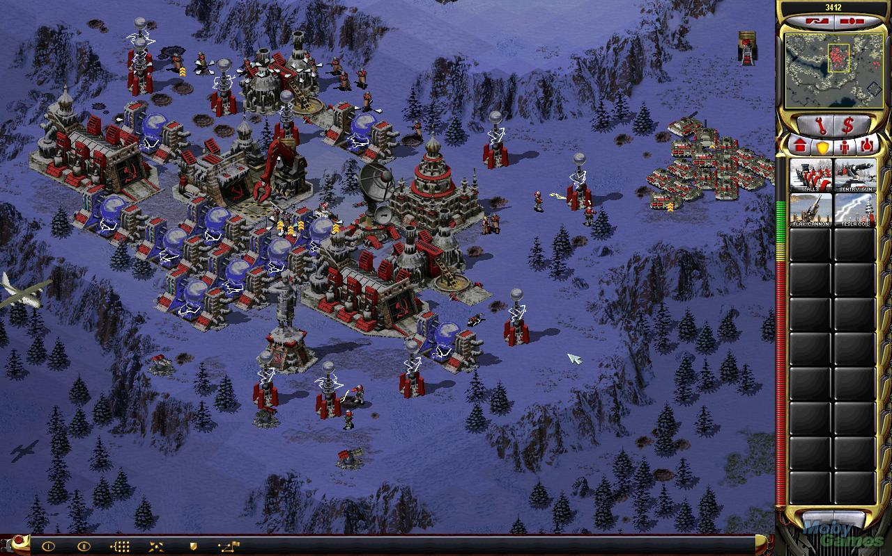 **-> Layout**

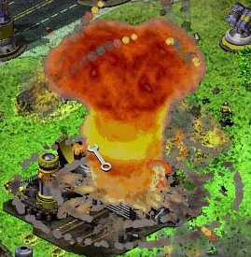 **-> Power ups**

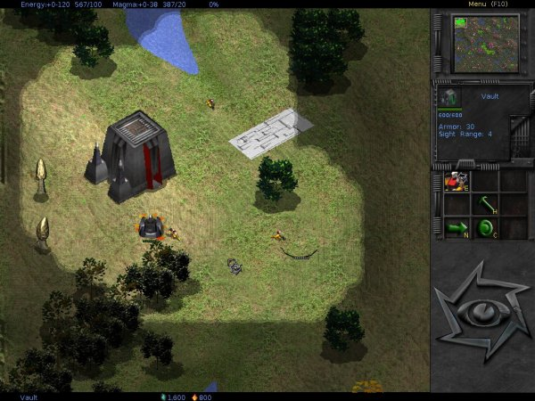 **-> Fog of war**

**Task List**

**Raynold:**

1. **Buildings* (3 days)**
2. **Multiplayer mode*(5 days)**

**Ryan:**

1. **Pathfinding*(6 days)**
2. **Fog of War(1 days)**
3. **Levels (1 days)**

**WeiJie:**

1. **Player AI* (6 days)**
2. **Animation / Sprites (2 days)**

**Zoe:**

1. **Units* (5 days)**
2. **Resources (Gold) (1 days)**
3. **Power-ups (2 days)**

**Gabriel:**

1. **User Interface* (5 days)**
2. **Database (SQL)* (3 days)**