AI Collections Tool — Comparison Tracker
Collections and Late Payers, March 2023 – December 2025
How the tracker is built: data flow, logic and Excel formulas, with a closing read of the results

1. Background & Objective
A subset of the managed residential portfolio was experiencing persistently low rent and charge collections. To address this, an AI-driven reminder tool was rolled out, beginning in March 2024, to a partial slice of the portfolio — the properties most affected by low collections and elevated late-payer counts. The tool's role is operational: it sends systematic, automated reminders to residents about rent and other recurring charges that are due or overdue, on a schedule, without staff having to manually track each account.
Because the tool was only implemented on part of the portfolio, the remaining properties act as a natural comparison group. The tracker workbook is built around this treatment-vs-control structure: every property in the portfolio is tagged as either “Implemented” (received the AI tool) or “Not Implemented” (did not), and every metric in the workbook is split and reported side by side for the two groups, month over month, from March 2023 through December 2025. This document explains, step by step, how that workbook is put together — its data layers, the join/classification logic, the exact formulas driving each output, and what the resulting charts show.
This document is drawn from a masked review copy of the tracker. Every property name, tenant name, owning entity/LLC name, fund name, region name, and the AI tool's own product name have been replaced throughout with sequential placeholders before any screenshot in this document was taken. Section 9 describes the masking approach in more detail.

2. Workbook Architecture
The workbook is organized in six tabs that fall into two layers: raw/reference data feeding the model, and the two reporting tabs that management actually reads.
Tab | Role | Approx. size
Lookup | Master reference data: property/entity master list, portfolio & fund mapping, and — critically — the Implemented / Not Implemented assignment per property, plus the GL charge-code inclusion table. | ~1,033,000 rows × 63 cols (mostly reference tables occupying a small used range; the row count reflects the sheet's formatted extent)
Rent | Charge-level detail exported from the property management system, used to identify late payers (any resident with an outstanding balance after the grace period). | ~537,700 rows × 29 cols
AR | Accounts-receivable ledger — charge and payment detail by transaction, used to compute how much of each month's charges were actually collected, and when. | ~916,200 rows × 28 cols
Date | Small helper tab holding the “as of” run date for the report. | 3 rows
Late payers | Reporting tab: monthly count and percentage of late payers, split Implemented vs. Not Implemented, with the headline combo chart. | ~292 rows × 28 cols
Collections | Reporting tab: daily cumulative collections percentage by month, split Implemented vs. Not Implemented, rolled up into a portfolio-level monthly view plus month-by-month small-multiple charts. | ~918 rows × 50 cols

Both raw data tabs (Rent, AR) are refreshed periodically as exports and are extended with a consistent block of helper columns (built once and copied down) that do all the classification work — state/portfolio/property lookups, the Implemented/Not Implemented tag, and the date parts used for monthly and daily aggregation. The two reporting tabs never touch the raw export columns directly; they read only from these helper columns, which keeps the reporting formulas simple and consistent regardless of how the raw export is formatted.

3. Step 1 — The Lookup Tab: Assigning Properties to Test vs. Control
Everything in the tracker depends on one classification made in the Lookup tab: for every property (identified by its masked property/entity code, e.g. “Property 42”), a two-column marker block records whether that property is part of the AI Tool rollout.
Column | Header | Meaning
AX | RM Property | Property identifier (join key), matched against Rent!H / AR!H after TRIM()
AY | Property Name | Masked property name
AZ, BA, BB | Fund, Region, Units | Portfolio attributes carried through to the reporting tabs
BG | “not” (Not Implemented) | Marked “x” if the property is in the control group
BH | “Implemented” | Marked “x” if the property received the AI tool

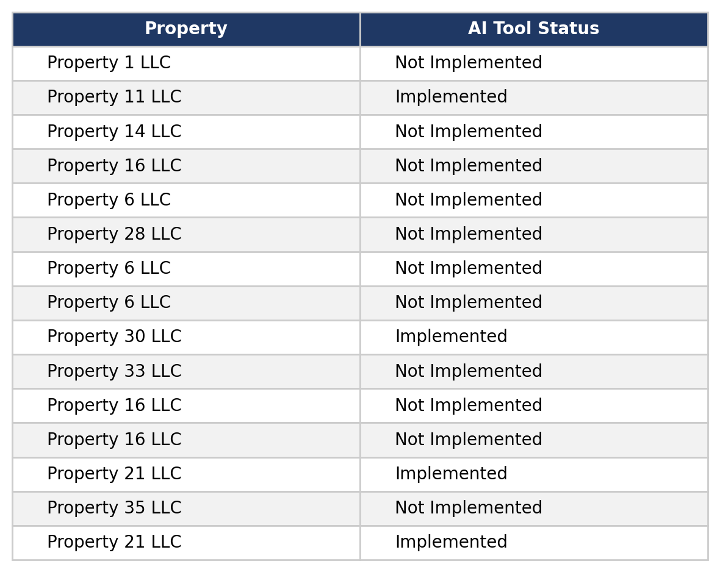
Figure 1 — Sample of the Implemented / Not Implemented marker block (Lookup!AX:BH), masked property names.
A second small reference table, Lookup!C3:N68, is the master property record: for every property it carries the masked property name and its aliases, the owning entity, unit count, AR code, fund and region. This is the table the Rent and AR tabs' VLOOKUPs read from.
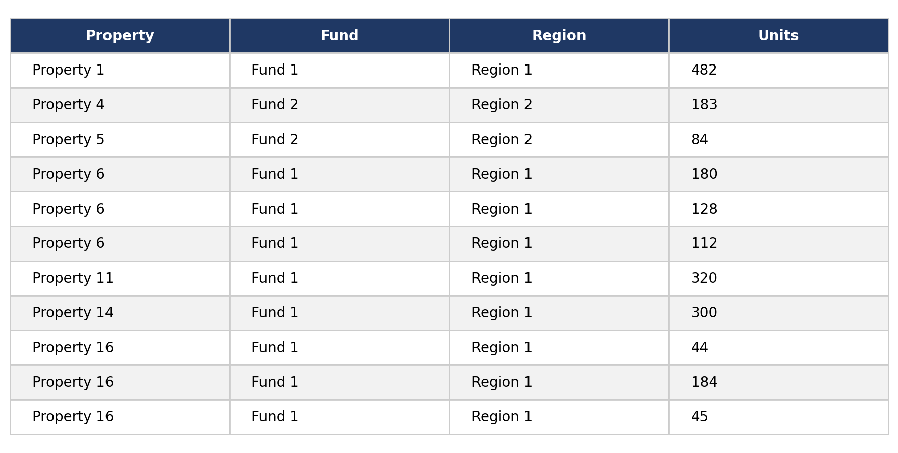
Figure 2 — Sample of the property master table (Lookup!B:N), masked.
A third small reference table, Lookup!C84:F346, maps each GL charge code (Name / Description / GL Account) to a Y/N flag indicating whether that charge type should be counted toward rent for late-payer and collections purposes. This is where the workbook encodes the business rule: rent-related charge types (RC, RCTAX, RCMTM, STAuto, LRR, Conces) are included, while Section 8 and other non-rent charge codes are excluded.

4. Step 2 — The Rent Tab: Classifying Late Payers
The Rent tab is the raw charge-level export, extended with a standard block of helper columns (built in row 9 and filled down the full ~537,700-row range) that do the classification. A masked sample of the export, after the helper columns are applied, looks like this:
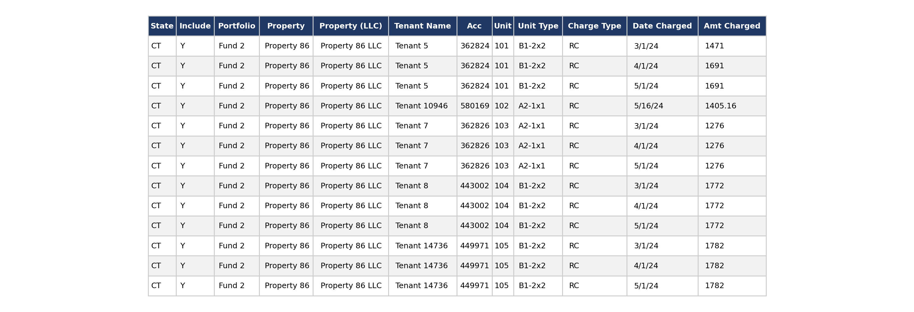
Figure 3 — Sample rows from the “Rent” tab after the helper columns are applied (masked).

4.1 Property, portfolio and state lookups
A9 (State) =VLOOKUP(TRIM(H9), Lookup!$C$3:$M$68, 11, FALSE)
F9 (Portfolio) =VLOOKUP(TRIM(H9), Lookup!$C$3:$I$68, 7, FALSE)
G9 (Property) =VLOOKUP(TRIM(H9), Lookup!$C$3:$L$68, 10, FALSE)

4.2 Include flag — is this charge type counted as rent?
B9 (Include) =VLOOKUP(M9, $AE$8:$AF$13, 2, FALSE)
where AE8:AF13 is a small on-sheet table:
RC -> Y, RCTAX -> Y, RCMTM -> Y, LRR -> Y, Conces -> Y, STAuto -> Y
(all other charge types, including Section 8, are excluded)

4.3 AI Tool assignment — Implemented vs. Not Implemented
S9 (AI Tool) =IF(VLOOKUP(TRIM($H9), Lookup!$AX$3:$BH$77, 10, 0)="x",
"Not Implemented",
IF(VLOOKUP(TRIM($H9), Lookup!$AX$3:$BH$77, 11, 0)="x",
"Implemented",
""))
This is the formula that tags every single charge row with the property's test/control status, purely by looking up the property against the two “x” marker columns in Lookup.

4.4 Date parts and the late-payer flag
C9 / D9 / E9 (Day/Month/Year charged) =DAY(N9) / =MONTH(N9) / =YEAR(N9)
T9 / U9 / V9 (Day/Month/Year paid) =DAY($P9) / =MONTH($P9) / =YEAR($P9)
W9 (End of month) =EOMONTH($N9,0)
X9 (Balance) =O9-Q9 (Amount Charged − Amount Paid)
Y9 (Month-Year charged, text) =TEXT(N9,"mmm-yyyy")
Z9 (Day charged, duplicate of C) =DAY(N9)
AA9 (Balance ≥ 1 flag) =IF(X9>=1,1,0)
Putting the pieces together, a resident is flagged as a late payer for a given month when, as of day 6 (the day after the standard grace period): the charge falls in that month (column Y), the charge date is on/after the 6th (column Z ≥ 6), there is still an outstanding balance of at least $1 (column AA = 1), the charge type is a countable rent charge (column B = “Y”), and the property is in the group being measured (column S = “Implemented” or “Not Implemented”).
Two more helper columns, AB (a concatenation of key fields) and AC (=COUNTIF($AB:$AB, AB9)>1), exist purely to flag duplicate export rows so they don't double-count a charge. The AR tab (used in Section 6) carries an identical helper-column pattern, one column further to the right (its duplicate-flag columns are AB/AC as well, built the same way).

5. Step 3 — The “Late payers” Tab: Monthly Roll-up & Chart
The Late payers tab turns the Rent tab's row-level flags into one row per month, from March 2023 through December 2025, with a rolling month header driven by a single seed date:
B4 =TEXT(DATE(2023,3,1),"mmm-yyyy") (seed: March-2023)
B5 =TEXT(EDATE(DATEVALUE("1-"&B4),1),"mmm-yyyy") (rolls forward one month at a time)
For each month row, four COUNTIFS formulas count late payers and total active tenants, split by AI Tool group:
D4 Count with AI Tool =COUNTIFS(
Rent!$Y:$Y, B4, ' this month
Rent!$Z:$Z, ">=6", ' on/after day 6 (post grace period)
Rent!$AA:$AA, "=1", ' still owes >= $1
Rent!$B:$B, "Y", ' countable rent charge
Rent!$S:$S, "Implemented")
E4 Count without AI Tool =COUNTIFS( ... same ... Rent!$S:$S, "Not Implemented")
F4 Total active tenants =COUNTIFS(
Rent!$Y:$Y, B4,
Rent!$S:$S, "Implemented",
Rent!$B:$B, "Y",
Rent!$O:$O, ">0") ' had a charge this month at all
G4 (same, Not Implemented)
H4 % with AI Tool =D4/F4
I4 % without AI Tool =E4/G4
These six columns (D–I) for every month are the exact series plotted in the tab's headline chart: two clustered bar series (Count with / without AI Tool) on the primary axis, and two dashed line series (% with / without AI Tool) on a secondary percentage axis.
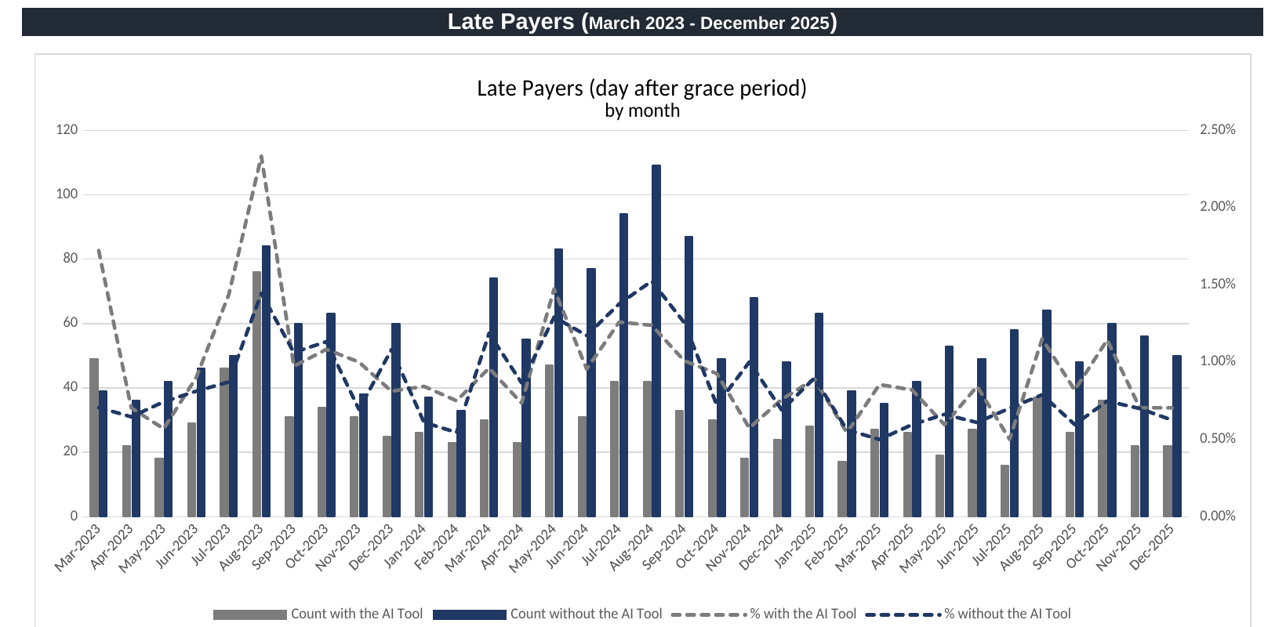
Figure 4 — “Late Payers” chart as built from columns D–I, March 2023 – December 2025 (live export from the masked workbook).

6. Step 4 — The AR Tab and the “Collections” Tab
The AR tab mirrors the Rent tab's helper-column pattern exactly (same VLOOKUP-based State/Portfolio/Property/AI Tool columns), but is used for a different purpose: instead of flagging balances, it carries the transaction-level Amount Charged (column O) and Amount Paid (column Q), each with its own Date Charged (N) and Date Paid (P). This is the ledger the Collections tab draws on.

6.1 Building the monthly axis
Row 22 (month-year) and rows 23–24 (year/month) roll forward exactly the same way as the Late payers tab, seeded from March 2023 and extended across columns B through AI — 34 months in total, through December 2025.

6.2 Daily cumulative collections % (the core calculation)
For the “with AI Tool” group, rows 26–56 compute, for every day 1–31 of every month, the percentage of that month's chargeable rent collected by that day — a running/cumulative collections curve:
B26 =IFERROR(
SUMIFS(AR!$Q:$Q,
AR!$S:$S, "Implemented",
AR!$B:$B, "Y",
AR!$N:$N, ">="&DATE(B$23,B$24,1),
AR!$N:$N, "<="&EOMONTH(DATE(B$23,B$24,1),0),
AR!$P:$P, "<="&DATE(B$23,B$24,$A26)) ' paid on/before day A26
/
SUMIFS(AR!$O:$O,
AR!$S:$S, "Implemented",
AR!$B:$B, "Y",
AR!$N:$N, ">="&DATE(B$23,B$24,1),
AR!$N:$N, "<="&EOMONTH(DATE(B$23,B$24,1),0)),
NA())
Rows 61–96 repeat the identical structure with AR!$S:$S = “Not Implemented” for the control group. Row 58 then takes the highest of the last four days of the month (=MAX(B53:B56)) as that month's headline Collections % for the AI Tool group, and row 98 does the same for the control group — matching the definition: “Collections % reflects the maximum collections achieved during the final four days of the month (28th–31st), computed as Amount Paid divided by Amount Charged.”
These two Max rows, across all 34 months, feed the Portfolio Collections % line chart at the top of the tab, and the same day-by-day cumulative rows (26–56 and 66–96) feed the month-by-month small-multiple charts underneath it (one panel per month, “% of Monthly Rent Collected” against “Day of the Month”).
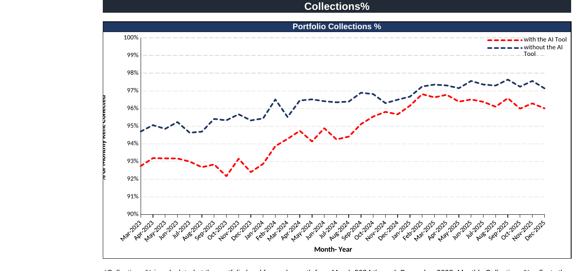
Figure 5 — “Portfolio Collections %” chart, the Max-of-last-4-days series for both groups, March 2023 – December 2025 (live export from the masked workbook).
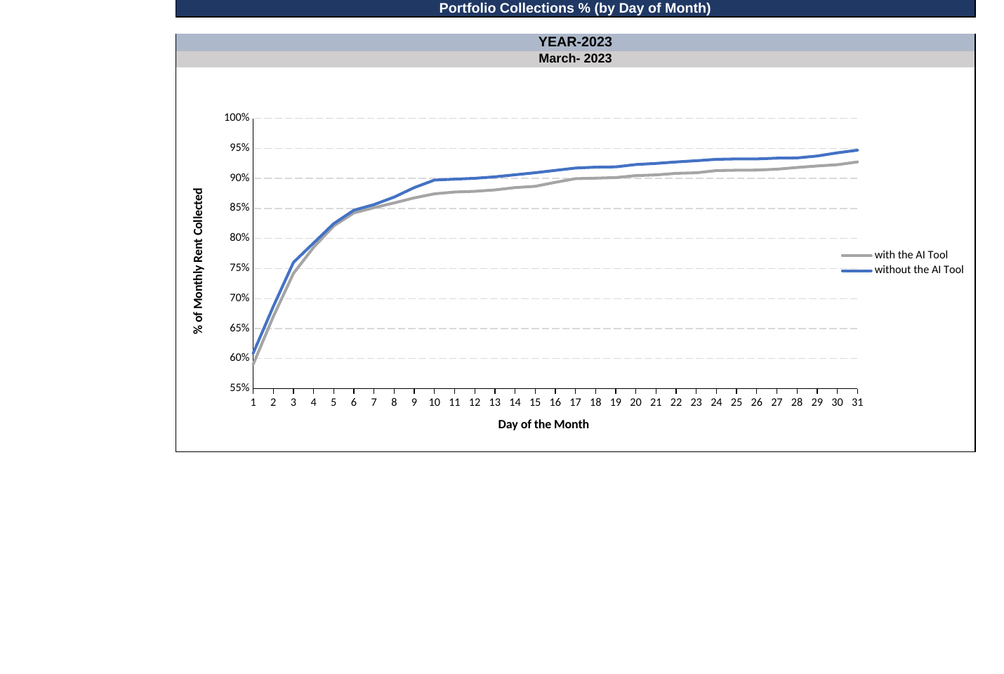
Figure 6 — One of the 34 day-of-month small-multiple panels (March 2023 shown) — the same style of panel repeats once per month in the tab.

7. Summary of the Build Process
- Tag every property once, in Lookup, as Implemented or Not Implemented, and map every charge code to Y/N for whether it counts as rent.
- Extend the raw Rent and AR exports with a fixed set of helper columns that pull that classification down to every transaction row via VLOOKUP, and derive the date parts needed for monthly/daily aggregation.
- On the Rent tab, flag any resident who still owes ≥$1 of countable rent on/after day 6 of the month as a late payer (AA/Z/B columns).
- On the Late payers tab, COUNTIFS those flags into a monthly count and percentage, split Implemented vs. Not Implemented, and chart the result as a combo bar/line.
- On the AR tab, carry Amount Charged and Amount Paid with their own dates; on the Collections tab, SUMIFS those into a day-by-day cumulative collections percentage per month, split the same way.
- Take the maximum of the last four days of each month as that month's Collections % headline figure, and chart both the 34-month portfolio trend and the day-by-day small multiples.

8. Final Analysis — What the Charts Show
The two dashboards are read together — Late Payers measures how many residents fall behind and by how much of the portfolio, while Collections measures how quickly and completely that month's rent is actually recovered, regardless of whether any individual resident was ever technically “late.” Both charts in this copy of the workbook are fully populated with real, aggregated figures, which allows a direct numerical read of both series.

8.1 Late payer counts and rates
- Both groups show the same seasonal shape — pronounced spikes in Aug-2023, mid-2024 and Aug-2024 — which suggests these are portfolio-wide seasonal or macro effects (e.g. holiday- and summer-period cash-flow pressure) rather than something either group is doing differently in isolation.
- Before the AI Tool went live (Mar-2023 – Feb-2024), the properties later selected for the tool already had a meaningfully higher average late-payer rate than the control group — about 1.09% versus 0.86% — consistent with the stated rationale that the tool was targeted at the properties suffering the worst collections performance, not a random sample.
- After go-live (Mar-2024 – Dec-2025), the AI Tool group's average late-payer rate fell to about 0.88%, while the control group's average was essentially flat at about 0.87% — so the roughly 0.23-point gap that existed before implementation had almost entirely closed, even though the treated properties started from a structurally worse position.
- In the most recent six months of the series (Jul–Dec 2025), the AI Tool group's rate (about 0.84%) is still a little above the control group's (about 0.69%), so the treated properties have converged toward — but not yet fully overtaken — the properties that never needed the tool in the first place.

8.2 Collections percentage
- Over the same pre-implementation window, the AI Tool group's average maximum monthly collections rate was about 92.9% versus 95.2% for the control group — a gap of roughly 2.3 percentage points, again consistent with these being the weaker-performing properties before the tool arrived.
- After go-live, both groups' collections improved, but the AI Tool group improved faster: its average rose to about 95.7% (versus 96.9% for the control group), narrowing the gap to roughly 1.2 percentage points — about half of what it was before implementation.
- Comparing the very first and very last months of the full series, the AI Tool group's collections rate rose from about 92.7% to about 96.0% (+3.3 points), versus the control group's rise from about 94.7% to about 97.1% (+2.5 points) — a larger absolute improvement for the group that received the tool, even though both groups benefited from the same broader upward trend across the three-year window.
- The day-by-day small-multiple panels show the same relationship playing out within each month: the control group's curve sits above the AI Tool group's curve for most of the month in the earlier panels, and the gap between the two curves visibly narrows in the more recent months' panels, indicating that AI Tool properties are not just catching up by month-end but collecting rent sooner in the month than they used to.

8.3 Overall inference
Taken together, the two dashboards tell a consistent story. The properties chosen for the AI Tool rollout were, by design, the weaker performers on both measures before March 2024. Since implementation, those properties have closed roughly half of their pre-existing collections gap and nearly all of their pre-existing late-payer gap relative to the properties that were already performing well and never received the tool. Because both groups also improved somewhat over the same period — pointing to a broader, portfolio-wide collections trend that isn't attributable to the tool alone — the fairest reading is that the AI Tool contributed a real, incremental improvement on top of that broader trend, disproportionately benefiting the weaker properties it was targeted at, rather than being the sole driver of the portfolio's overall improvement. Isolating the tool's precise incremental effect from the broader trend would require a more formal before/after or difference-in-differences comparison than the workbook's charts alone provide, but the direction and rough size of the effect are visible in both dashboards.

9. Notes & Limitations of This Write-Up
- This document is based on a masked copy of the tracker workbook, built specifically for this write-up. Every property name, tenant name, owning entity/LLC name, fund name and region name was replaced with a sequential placeholder (Property 1, Property 2, …; Tenant 1, Tenant 2, …; Entity 1, Entity 2, …; Fund 1, …; Region 1, …), and the AI tool's own product name was replaced with “the AI Tool”, everywhere it appeared — in cell values, in formula-cached results, in chart labels, and in the file's own internal metadata — before any screenshot in this document was captured.
- The Rent and AR tabs were also truncated to their first ~300 data rows for this masked copy (to keep the review file a manageable size); the Late Payers and Collections tabs, which are what this document's charts and figures are drawn from, were preserved with their full, original, un-truncated calculated results, so the chart figures and percentages quoted in Section 8 are the real, complete-dataset numbers, not figures computed from the truncated sample.
- All formulas quoted are transcribed directly from the live cells in the masked workbook (not retyped), and the chart images in Figures 4–6 are direct exports of those tabs' charts with their real cached figures.
- The Rent, AR and Lookup tabs contain 500,000–1,000,000+ rows in the source file; the reference tables and formulas shown in this document were verified against the live file's structure and cross-checked against the full, unmodified Late payers and Collections tabs.

