Rent Growth Analysis
2011 – 2024
Methodology Documentation

Asset Management – Analytics Team
CONFIDENTIAL — All property, entity, and tenant names have been masked.

1. Overview
This document explains how year-on-year rent growth (2011–2024) was calculated across the multifamily portfolio. The model draws annual rent roll snapshots, cleans and filters unit data, computes effective rents by property and unit type, and aggregates to fund and portfolio level. Two different methodologies were applied across the 14-year period, matching how figures were reported to investors.

1.1 Two Reporting Templates
The 14-year period is split across two distinct rent growth templates:

Template 1 — Historical Rent Growth (2011–2018)
Rent Roll Dates | January 1 of base year vs. January 1 of succeeding year (Jan 2011, Jan 2012, Jan 2013, Jan 2014, Jan 2015, Feb 2015, Jun 2015, Jan 2016, Jan 2017, Jan 2018, Jan 2019)
Avg Rent Matching | Matched by Property Name + Unit Type + Rent Roll Date
Rent Growth Formula | (Avg Rent Succeeding Year − Avg Rent Base Year) ÷ Avg Rent Base Year
Property Inclusion | Only properties owned for ≥ 10 months. Exceptions: Property25 and Region2 group (Property26, Property100, Property113, Property120, Property153). Property115 excluded (no linked data).
Weighting | Weighted average using the minimum unit count between the two years
Rent + S8 Components | Concessions, LRR, RC, RC PRE, RCMTM, RCPP, RCTAX, S8117, S856, S8-VCH, SCRADJ, SEC8, SEC8HP, S8TEMP
Non-Revenue Excluded | Model, Office, EMP DS

Template 2 — Rental Dashboard (2019–2024)
Rent Roll Dates | December 31 of base year vs. December 31 of succeeding year (e.g., Dec 31, 2018 vs Dec 31, 2019 for the 2018–2019 growth period)
Unit Inclusion | A unit qualifies if it meets Condition 1 OR Condition 2: • Condition 1: Lease Term > 6 months, Non-Revenue = 0, Rent+S8 > 0, Variance < 40% (Variance = |Period Avg – Unit Rent| ÷ Unit Rent) • Condition 2: Lease Term > 6 months, Non-Revenue = 0, Rent+S8 > 0, Unit is Stabilized
Ownership Criterion | Property must be acquired before Dec 31 base year and not disposed on or before Dec 31 succeeding year
Weighting | Weighted average using total active units in the succeeding year
Fund Exclusion | Region10 fund (Property25, Property28) excluded
Rent + S8 Components | LRR, Concessions, RC, RCTAX, S8TEMP, S8117, S856, SEC8, SEC8HP, S8-HAP, S8-VCH
Non-Revenue Excluded | Model, Office, EMP DS
Known Variance | ~0.7% variance remains for 2018–2019 vs. originally published investor figures

2. Workbook Structure
The analysis lives in a single workbook (Rent Growth Analysis (2011-2024).xlsx) with 12 sheets in four groups:

Sheet Inventory
INPUT DATA
RRs | Raw annual rent roll (2018–2024). ~164,000 rows. One row per unit per year-end date.
RR checks 2011 / 2012 | Historical baseline data predating the main RRs sheet. Feed into RG Annual for 2011–2013 growth periods.
PROCESSING
RR Combined | Master processing hub. Pulls from RRs, derives key flags and computes effective rent. Source for all downstream AVERAGEIFS/COUNTIFS.
Lookup | Reference table mapping entity names, short codes, regions, acquisition/disposition dates, and the stabilized unit list.
CALCULATION OUTPUT
RG (Annual) | Core output. One row per Property × Unit Type, columns per year: Total Units | Avg Rent | Rent Growth % | Active Units.
Average Rent | Alternate view — same structure as RG Annual but without outlier filtering (includes renovation-premium units).
Summary | Property-level aggregation (one figure per property per year, collapsing unit types).
Summary-fund wise | Highest-level output. Fund-level weighted averages with published values and variance comparison.
VALIDATION / OTHER
checks | Flags property-unit-type additions or removals between model updates.
Portfolio Dash | Dashboard showing acquisition details, region, and active/sold status per asset.
Sheet2 | Working/scratch sheet (sorted lists, exclusions). Not used in calculations.

3. Step 1 — Raw Data & Reference Setup

3.1 Raw Rent Roll (RRs Sheet)
Each year, a December 31 rent roll export is pasted into the RRs sheet — one row per unit per property. Key columns:
- Col A: RR Date (Dec 31 each year, 2018–2024)
- Col C: Property (entity name) · Col D: Tenant · Col F: Unit · Col G: Unit Type (e.g., A2-1x1 = Building A, Plan 2, 1 bed/1 bath)
- Cols M–AD: Rent charge columns broken out by type (LRR, Conces, RC, S8117, SEC8, S8-HAP, S8-VCH, Model, Office, EMP DS, etc.)
- Historical 2011–2012 data uses separate RR checks sheets (same structure, January 1 dates)

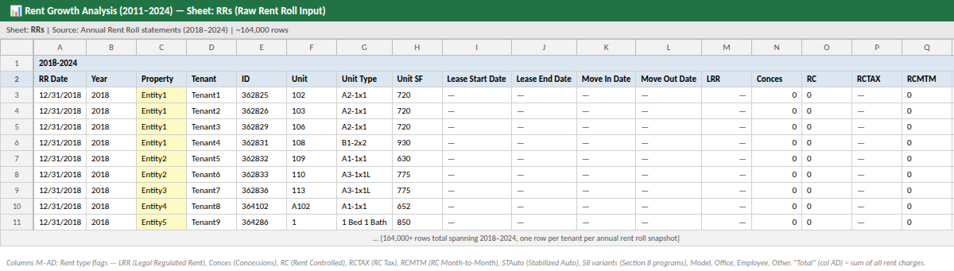
Figure 1 — RRs Sheet: Raw rent roll input. Charge types span cols M–AD; effective rent (Rent + S8) is computed in RR Combined from the revenue columns.

3.2 Lookup / Reference Table
The Lookup sheet is the master reference. Every other sheet calls VLOOKUP against it to get canonical property names, regions, acquisition/disposition dates, and the stabilized unit list.

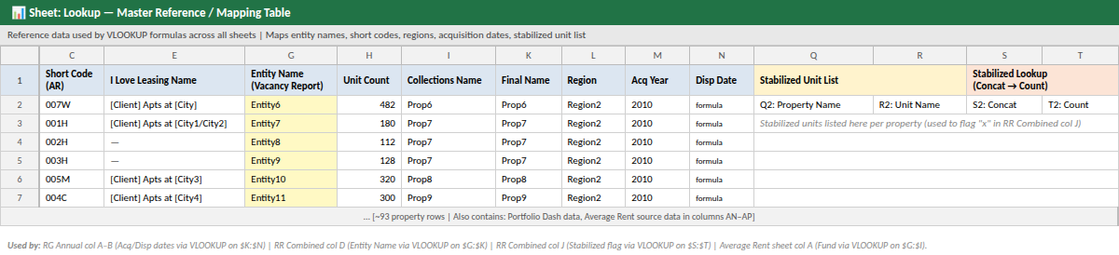
Figure 2 — Lookup Sheet: Maps entity legal names → final names, regions, and acquisition dates. Cols Q–T hold the Stabilized Unit List used to flag rent-controlled units in RR Combined.
- Col C: Short property code (used by Average Rent system)
- Col E: Leasing system name
- Col G–H: Entity name (legal LLC) + total unit count — VLOOKUP source for RR Combined
- Col K: Final (canonical) name — used across all output sheets
- Col L: Region (Region1–Region15)
- Col M–N: Acquisition year and disposition date
- Cols Q–T: Stabilized unit list — unit + property concat keys to flag rent-stabilized units

4. Step 2 — Data Processing (RR Combined Sheet)
RR Combined is the model's engine. It takes every row from RRs and derives a set of columns that determine whether a unit qualifies for the trimmed rent average. The qualifying flag (col AN = "x") is what all downstream sheets filter on.

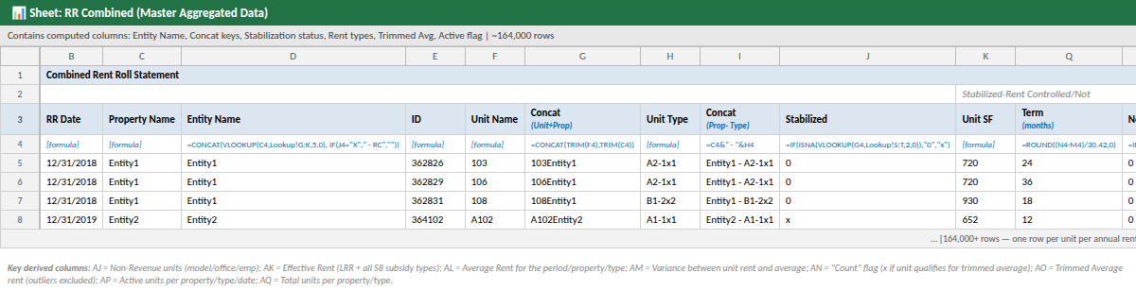
Figure 3 — RR Combined: Derived columns (D, G, I, J, Q, AJ–AO) transform raw rent roll rows into analysis-ready data with effective rent and outlier flags.

4.1 Key Derived Columns and Formulas

Col D — Final Property Name
Looks up the entity's canonical name from the Lookup sheet and appends "- Rent Controlled" if the unit is stabilized:
Col D | =CONCAT(IFERROR(VLOOKUP(TRIM(C4), Lookup!$G$1:$K$87, 5, FALSE), 0), IF(J4="X", " - Rent Controlled", ""))

Col G — Unit + Property Concat Key
Concatenates unit number and property name into a unique identifier. Used to look up the unit in the Stabilized Unit List (Lookup col S:T):
Col G | =CONCAT(TRIM(F4), TRIM(C4))

Col I — Property–Unit Type Key
Creates the primary match key used by all AVERAGEIFS/COUNTIFS downstream (e.g., "Entity1- A2-1x1"):
Col I | =C4 & "- " & H4

Col J — Stabilized Flag
Flags rent-stabilized units by checking if the unit's concat key (col G) exists in the Stabilized Unit List. Stabilized units bypass the variance filter and are always included:
Col J | =IF(ISNA(VLOOKUP(G4, Lookup!$S$2:$T$301, 2, FALSE)), "0", "x")

Col Q — Lease Term (months)
Calculates lease duration in months. Units with ≤ 6 months are excluded (short-term/transitional leases):
Col Q | =IFERROR(ROUND((N4 - M4) / 30.42, 0), 0)

Col AJ — Non-Revenue Flag
Sums Model (AE) + Office (AF) + EMP DS (AG) unit flags. A value > 0 means the unit is non-revenue and is excluded:
Col AJ | =IFERROR(SUM(AE4:AG4), "0")

Col AK — Effective Rent (Rent + S8)
Total effective rent = base rent + all Section 8 subsidy types. Concessions are included (typically negative, reducing the total):
Col AK | =IFERROR(SUM(R4:U4, X4:AD4), "0")

Col AL — Period Average Rent (Broad, for Variance Calculation)
Unfiltered average effective rent across all qualifying units for the same date — used only to compute the variance in col AM:
Col AL | =IFERROR(AVERAGEIFS($AK$4:$AK$164715, $B$4:$B$164715, $B4, $Q$4:$Q$164715, ">6", $AJ$4:$AJ$164715, 0, $AK$4:$AK$164715, ">0"), 0)

Col AM — Variance from Period Average
Measures how far a unit's rent deviates from the broad average. Units > 40% away are outliers (likely renovated units at premium rents) and are excluded from the trimmed average:
Col AM | =IF(AK4 * AL4 > 0, ABS((AL4 - AK4) / AK4), 0)

Col AN — Count / Qualifying Flag ← Core Filter
The most critical column. Set to "x" when the unit qualifies for inclusion. A unit qualifies if it meets Condition 1 OR Condition 2:
Col AN | =IFERROR(IF(OR(AND(Q4>6, AJ4=0, AK4>0, AM4<0.4), AND(Q4>6, AJ4=0, AK4>0, J4="x")), "x", 0), "")
- Condition 1 (market-rate): Lease > 6 months AND not non-revenue AND Rent+S8 > 0 AND variance < 40%
- Condition 2 (stabilized): Lease > 6 months AND not non-revenue AND Rent+S8 > 0 AND unit is rent-stabilized
Only units with AN = "x" are included in the rent growth calculation.

Col AO — Trimmed Average Rent
The clean average rent for this property/unit-type/date, computed only over qualifying units (AN = "x"):
Col AO | =IFERROR(AVERAGEIFS($AK$4:$AK$164715, $AN$4:$AN$164715, "x", $B$4:$B$164715, $B4, $C$4:$C$164715, $C4, $H$4:$H$164715, $H4), 0)

5. Step 3 — Rent Growth Calculation (RG Annual Sheet)
RG Annual is the core output: one row per Property × Unit Type (~640 rows), with 4 columns per year (2011–2024):
- Total Units — raw count of rows for that property/unit-type/date
- Avg Rent — trimmed average effective rent (units with AN = "x" only)
- Rent Growth % — year-over-year change
- Active Units — unit count shown only if property was held that year (blank otherwise)

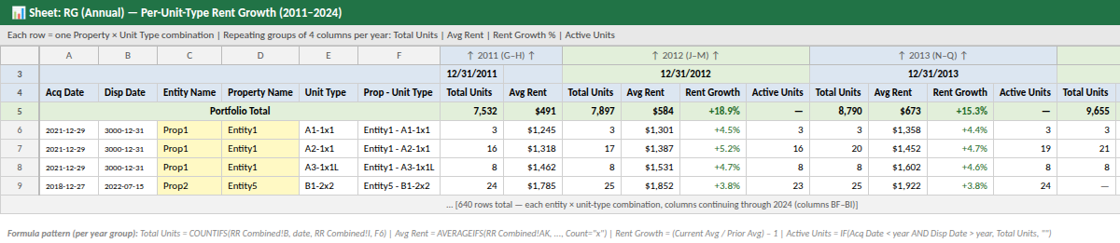
Figure 4 — RG Annual: Each row = one property × unit type. Columns repeat per year. Row 5 is the Portfolio Total. A blank Active Units cell means the property was not held in that period.

5.1 Row Setup Formulas (Cols A–F)
Acq Date (A) | =VLOOKUP($C6, Lookup!$K$1:$M$95, 3, FALSE)

Disp Date (B) | =VLOOKUP($C6, Lookup!$K$1:$N$95, 4, FALSE)
Col F holds the hardcoded key "EntityName- UnitType". Cols C, D, E are derived from it via LEFT/RIGHT/FIND formulas.

5.2 Per-Year Formulas (repeated for each year column group)

Total Units | =COUNTIFS('RR Combined'!$B$4:$B$1048576, G$3, 'RR Combined'!$I$4:$I$1048576, $F6)

Avg Rent | =IFERROR(AVERAGEIFS('RR Combined'!$AK$4:$AK$200000, 'RR Combined'!$I$4:$I$200000, $F6, 'RR Combined'!$AN$4:$AN$200000, "x", 'RR Combined'!$B$4:$B$200000, G$3), "")

Rent Growth % | =IFERROR(IF(AND(J6>0, G6>0), (K6/H6) - 1, ""), "")
Divides current-year Avg Rent by prior-year Avg Rent minus 1. Returns blank if either year has zero units.

Active Units | =IFERROR(IF(AND($A6 < EDATE(DATE(YEAR(G$3),12,31),0), OR($B6 > J$3, $B6 = "")), J6, ""), "")
Returns the unit count only if: (1) property was acquired before year-end, AND (2) property was not yet disposed. Blank = not held.

5.3 Portfolio Total (Row 5)
Sum Units | =SUMIF(G$6:G$645, "<>0", G$6:G$645)
Sums units across all rows, excluding zeros. Avg Rent for the total row uses an ArrayFormula AVERAGEIFS across all qualifying units.

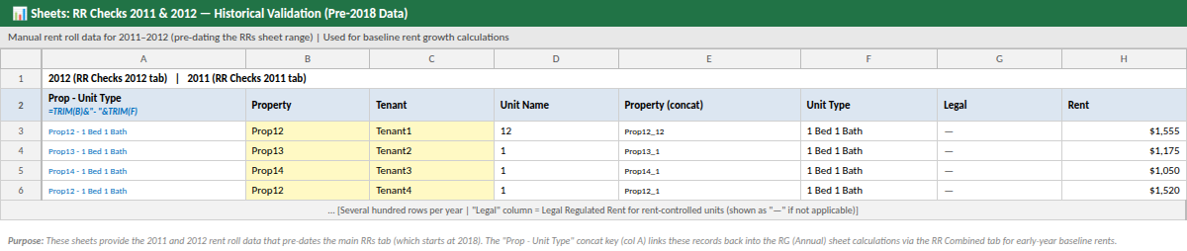
Figure 5 — RR Checks 2011 & 2012: Historical rent rolls providing the January 1 baseline for 2011–2018 Template 1 calculations. Col A (Prop - Unit Type) is used as the VLOOKUP key.

6. Steps 4 & 5 — Property and Fund Aggregation

6.1 Summary Sheet — Property-Level
Summary collapses unit-type level data into one rent growth figure per property per year. It uses ArrayFormulas that pull directly from RR Combined (not from RG Annual), computing weighted averages across all qualifying units at the property level.

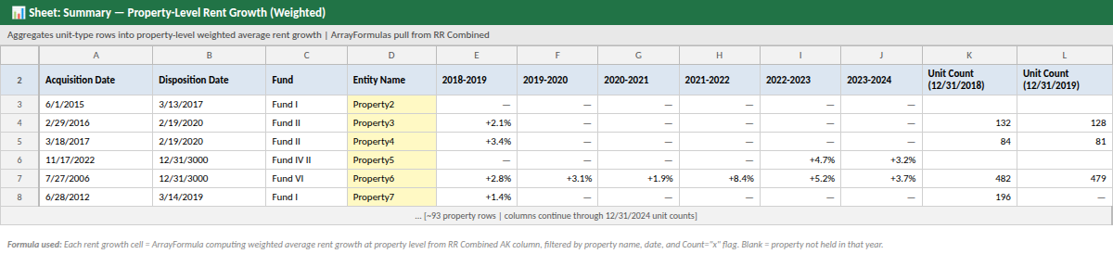
Figure 6 — Summary Sheet: One row per property. Annual rent growth from 2018–2019 onward. Acquisition/disposition dates and fund shown. Blank cells = property not held that year.

6.2 Summary-Fund Wise Sheet — Fund & Portfolio Level
Summary-Fund Wise is the final output, covering 2011–2024 across all funds. It has two key comparison rows: Published Values (hardcoded benchmark) and Variance (calculated vs. published).

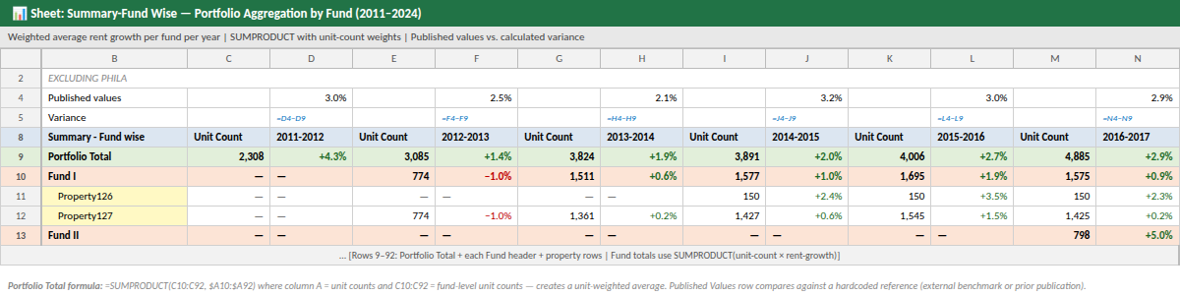
Figure 7 — Summary-Fund Wise: Portfolio and fund-level weighted averages. Row 4 = published benchmark values. Row 5 = variance between calculated and published. Region10 fund excluded.

6.3 Weighted Average — SUMPRODUCT Formula
Fund Total | =SUMPRODUCT(C10:C92, $A10:$A92) / SUMPRODUCT($A10:$A92)
Col A holds unit counts (weights). Cols C, E, G… hold rent growth % per year. The SUMPRODUCT formula ensures larger properties carry proportionally more weight than smaller ones.

6.4 Region10 Fund Exclusion
Region10 fund properties (Property25 and Property28) are excluded from all portfolio-level calculations in this sheet. They are tracked separately due to different regulatory and reporting dynamics.

7. Rent Charge Types
Each rent roll row tracks rent by charge code. The effective rent (Rent + S8) used in all calculations is the sum of revenue-generating columns only. Non-revenue columns are separately summed and used to exclude units from averages.

Revenue Charges — Included in Effective Rent (RR Combined col AK = SUM(R:U, X:AD))
LRR | Legal Regulated Rent — base contractual rent per the lease.
Conces | Concessions — rent discounts/free periods (typically negative).
RC / RCTAX / RCMTM / RCPP / RC PRE | Rent Controlled variants (base, tax pass-through, month-to-month, pre-payment, pre-RC).
S8TEMP / S8117 / S856 / SEC8 / SEC8HP / S8-HAP / S8-VCH / SCRADJ | Section 8 subsidy types — government subsidy paid directly to landlord on behalf of qualifying tenants.

Non-Revenue Charges — Excluded (summed in col AJ)
Model | Show/model unit used for tours. Typically $0 rent.
Office | On-site property management office unit.
EMP DS | Employee housing unit.

8. Validation & End-to-End Process Flow

8.1 Checks Sheet
checks compares the prior-version property-unit-type list against the current list. Items in col C ("MISSING IN OLD") are new additions; items in col D ("MISSING IN NEW") are removals. Any entry here needs analyst review — it may reflect a legitimate acquisition/disposition or a data issue.

8.2 Average Rent Sheet (Renovation-Inclusive View)
Average Rent uses the same structure as RG Annual but without the AN = "x" filter. This means renovated units commanding premium rents (which are excluded as outliers in the standard view) are included here. Use this sheet to understand the "full market" average including renovation premiums.
Avg Rent (no filter) | =IFERROR(AVERAGEIFS('RR Combined'!$AK$4:$AK$99590, 'RR Combined'!$I$4:$I$99590, 'Average Rent'!$C4, 'RR Combined'!$B$4:$B$99590, D$3), "")

8.3 End-to-End Process Flow

Annual Update Steps
Step 1 | Receive December 31 rent roll exports from property management system. Paste into the RRs sheet. For historical 2011–2017 data, see RR checks 2011 and 2012 (January 1 dates).
Step 2 | RR Combined auto-recalculates. All derived columns (D, G, I, J, Q, AJ, AK, AL, AM, AN, AO) update as rows are added.
Step 3 | Verify the Lookup table is current — update for any new acquisitions or dispositions.
Step 4 | RG Annual auto-updates. Run the checks sheet to identify any new or removed Property × Unit Type combinations.
Step 5 | Summary and Summary-Fund Wise auto-update. Manually update the Published Values row in Summary-Fund Wise when new benchmark figures are available. Review the Variance row.
Step 6 | Validate: confirm Portfolio Total, check for unexpected blanks, and review the checks sheet output.

8.4 Known Limitations
- 2011–2017 relies on RR checks sheets with fewer data quality controls than 2018+ data.
- Region10 fund properties are tracked separately and excluded from portfolio summaries.
- The 40% variance filter excludes renovation-premium units from the standard analysis; the Average Rent sheet provides the unfiltered view.
- A ~0.7% variance remains for the 2018–2019 period vs. originally published figures despite full methodological replication.
- Section 8 subsidy codes can change across years; a unit moving from one S8 code to another may create apparent rent changes that are purely administrative.

9. Glossary
Key Terms
Effective Rent (Rent + S8) | Sum of all revenue rent charges (LRR, concessions, RC variants, all S8 types). The unit-level figure used for all averages.
Trimmed Average | Average computed after excluding outlier units (rent > 40% from period mean) and non-revenue units. Stabilized units always included.
Count Flag (AN = "x") | A unit qualifies (counted in the trimmed average) when it has a lease > 6 months, non-revenue = 0, Rent+S8 > 0, and either variance < 40% OR is rent-stabilized.
Non-Revenue Unit | Model, office, or employee housing unit — excluded from all rent averages.
Stabilized Unit | Rent-stabilized or rent-controlled unit. Always included in averages regardless of variance. Flagged in RR Combined col J via the Stabilized Unit List in Lookup cols Q–T.
LRR | Legal Regulated Rent — the contractual base rent as set by the lease.
S8 / Section 8 | Federal Housing Choice Voucher Program. Government pays a portion of rent directly to landlord.
COUNTIFS / AVERAGEIFS | Excel functions that count or average values across rows matching multiple criteria simultaneously.
SUMPRODUCT (weighted avg) | Excel function used to compute unit-count weighted averages at fund/portfolio level: =SUMPRODUCT(rent_growth_array, unit_count_array) / SUM(unit_count_array).
Active Units | Unit count shown only if the property was held during the year (acquired before year-end and not yet disposed).

— End of Document —

