SIGN LANGUAGE INTERPRETER USING
DEEP LEARNING

Software Requirement Specifications (SRS)
Project Work Phase-I (EAI753)
Degree
BACHELOR OF TECHNOLOGY CSE (DS) (TCS)

PROJECT GUIDE:  Mr.Ajay Rastogi Sir | SUBMITTED BY:  Anushka Jain (TCA2265005)  Manya Jain (TCA2265023)

JULY 2025 - DECEMBER 2025



FACULTY OF ENGINEERING & COMPUTING SCIENCES
TEERTHANKER MAHAVEER UNIVERSITY, MORADABAD

Revision History
Author/ Changes made by | Date | Reason For Changes | Version
 |  | initial draft | 1.0 draft
 |  | baseline following changes after inspection | 1.0 approved

Approved by:
Project Guide Name: Dr. Ajay Rastogi

Signature:

Table of Contents

1 Introduction 4
1.1 Purpose 4
1.2 Scope of the Work 4
1.3 Definitions, Acronyms, and Abbreviations 4
1.4 References 5
2 Overall Description 7
2.1 Product Perspective 6
2.2 Product Functions 6
2.3 User Characteristics 6
2.4 General Constraints 7
2.5 Assumptions and Dependencies 7
3 Specific Requirements 14
3.1 <Name of Function 1> 8
3.1.1 Description 8
3.1.2 Inputs 8
3.1.3 Processing 8
3.1.4 Outputs 8
3.1.5 Error Handling 8
3.1.6 Test Cases for <Function 1> 8
3.2 <Name of Function 2> 8
3.2.1 Introduction 8
3.2.2 Inputs 8
3.2.3 Processing 8
3.2.4 Outputs 9
3.2.5 Error Handling 9
3.2.6 Test Cases for <Function 2> 9
3.3 Design Constraints 9

Appendix A: Data Flow Diagram (DFD)
Appendix B: Entity-Relationship Diagram (ERD)
Appendix C: Use-Case Diagram (UCD)
Appendix D: Data Dictionary (DD)
Appendix E: Screen Shots

1. Introduction

Sign language is the primary mode of communication for individuals who are deaf or hard of hearing. However, a significant communication barrier exists between sign language users and those who do not understand it. Traditional solutions include human interpreters and text-based communication, which may not always be readily available or efficient. This project introduces a deep learning-based Sign Language Interpreter that recognizes hand gestures through computer vision and converts them into text or speech in real-time. The system employs Convolutional Neural Networks (CNNs) or Recurrent Neural Networks (RNNs) to accurately interpret hand gestures without the need for additional hardware like gloves or sensors.

Purpose
A Sign Language Interpreter uses advanced technologies like Artificial Intelligence (AI), Machine Learning (ML), and Computer Vision to recognize and translate sign language into text or speech in real-time. This solution enables seamless communication between deaf individuals and those who do not understand sign language. How It Works:
1. Gesture Recognition – A camera captures hand movements and facial expressions.
2. AI & Machine Learning – The system processes the gestures using trained models.
3. Real-Time Translation – The recognized signs are converted into text or speech.
4. User-Friendly Interface – The tool can be integrated into mobile apps, smart devices, or assistive communication systems.

Scope of the Work
• The system aims to provide a real-time, cost-effective, and scalable solution for translating sign language.
• It can be used in educational institutions, workplaces, public service sectors, and healthcare to facilitate communication.
• The model can be trained on different sign language datasets (e.g., American Sign Language (ASL), Indian Sign Language (ISL)).
• The system can be implemented as a standalone software, mobile app, or web application for broader accessibility.
• The technology can be expanded to support gesture-based commands for smart homes and virtual assistants.

Definitions, Acronyms, and Abbreviations
Abbreviation | Description
CNN | Convolutional Neural Network - A Deep Learning network for Image classification
RNN | Recurrent Neural Network
ASL | American Sign Language
ISL | Indian Sign Language
BSL | British Sign Language
AWS | Amazon Web Services
SVM | Support Vector Machines
RoI | Region of Interest
MediaPipe | Google framework for real-time hand tracking
FPS | Frames per Second - Speed of real-time video processing
OpenCV | Open-source Computer Vision Library
ANN | Artificial Neural Network
LSTM | Long Short-Term Memory Network
ResNet | Residual Neural Network
PCA | Principal Component Analysis
JSON | JavaScript Object Notation
API | Application Programming Interface
GUI | Graphical User Interface
CV | Computer Vision
DBMS | Database Management System

References

Books & Research Papers
1. Goodfellow, Ian, et al. "Deep Learning." MIT Press, 2016.
2. Bishop, Christopher M. "Pattern Recognition and Machine Learning." Springer, 2006.
3. Jain, Anil K., et al. "Handbook of Biometrics." Springer, 2007.
Web References
1. TensorFlow Documentation: https://www.tensorflow.org/
2. OpenCV Documentation: https://docs.opencv.org/
3. Media Pipe by Google: https://developers.google.com/mediapipe
4. Scikit-Learn Documentation: https://scikit-learn.org/
Research Articles & Journals
1. "Sign Language Recognition using Deep Learning" – IEEE Transactions on Neural Networks, 2022.
2. "Computer Vision-Based Sign Language Interpretation" – International Journal of Computer Science, 2021.
Datasets Used
• Sign Language Dataset: Kaggle https://www.kaggle.com/datasets
• CelebA Dataset (For Face Detection): • http://mmlab.ie.cuhk.edu.hk/projects/CelebA.html

2. Overall Description

Communication barriers between the deaf and hearing communities create significant challenges in daily life. Many individuals who rely on sign language struggle to interact with those who do not understand it, leading to difficulties in education, employment, healthcare, and social interactions. Despite advancements in technology, there is still a lack of widespread, real-time translation tools that can accurately interpret sign language into text or speech. Existing solutions are often limited in accuracy, accessibility, and ease of use. To bridge this gap, there is a need for a Sign Language Interpreter that can efficiently recognize and translate sign language into spoken or written words, enabling seamless communication and fostering inclusivity for all.
A Sign Language Interpreter uses advanced technologies like Artificial Intelligence (AI), Machine Learning (ML), and Computer Vision to recognize and translate sign language into text or speech in real-time. This solution enables seamless communication between deaf individuals and those who do not understand sign language. How It Works:
1. Gesture Recognition – A camera captures hand movements and facial expressions.
2. AI & Machine Learning – The system processes the gestures using trained models.
3. Real-Time Translation – The recognized signs are converted into text or speech.
4. User-Friendly Interface – The tool can be integrated into mobile apps, smart devices, or assistive communication systems.

Product Perspective
• To develop a robust hand gesture recognition system using deep learning.
• To convert recognized gestures into readable text or speech in real-time.
• To provide a user-friendly graphical interface for seamless communication.
• To enable faster and more efficient sign language interpretation without additional hardware.
• To enhance accessibility for the hearing-impaired community and bridge the gap.
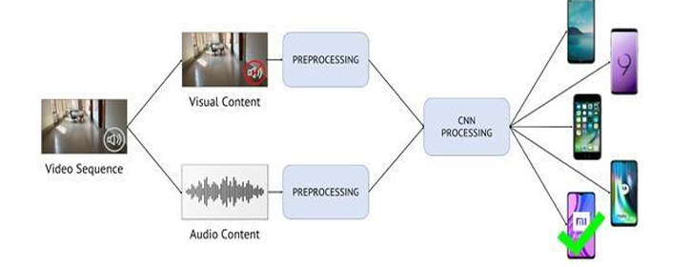
Existing System
The current methods of sign language translation mainly involve:
1. Human Interpreters: While effective, human interpreters are not always available, and hiring them can be costly.
2. Text-Based Communication: Deaf individuals often rely on written or typed messages, which is time-consuming.
3. Glove-Based Solutions: Some systems use sensor-equipped gloves, but these are expensive and not practical for everyday users.
4. Rule-Based Gesture Recognition: Some AI models rely on predefined hand poses, which limits flexibility.
Challenges with Existing Systems:
• Limited Availability of professional sign language interpreters.
• High cost of wearable-based solutions.
• Lack of real-time processing in existing software-based solutions.
Features and Modules
FEATURES | MODULES
Hand Gesture Recognition | Uses deep learning models to detect and identify different sign language gestures from images or video frames.
Real-Time Translation | Converts recognized gestures into text or speech instantly.
User-Friendly Interface | Provides an easy-to-use interface for users to interact with the system.
Dataset Training & Model Improvement | Uses large-scale sign language datasets to train the model and improve accuracy over time.
Offline Functionality | The system can work without an internet connection, making it accessible in remote areas.
Multi-Language Support (Optional) | It can be adapted to different sign languages such as ASL, ISL, and BSL.

Comparison of Existing vs Proposed System
Feature | Existing Methods (Traditional & ML-Based) | Proposed Deep Learning- Based System
Accuracy | Moderate (depends on handcrafted features) | High (leverages deep feature extraction)
Real-time Performance | Limited (lag due to feature extraction) | Faster (optimized for real-time detection)
Scalability | Limited to predefined gestures | Can adapt to new gestures with retraining
Feature Extraction | Manual feature engineering is required | Automatic feature extraction via CNNs
User Adaptability | Requires predefined sign templates | Can learn user-specific gestures
Hardware Requirements | Works on low-end devices | Requires a GPU for efficient training
Robustness | Sensitive to variations in lighting and background | More robust to environmental changes
Data Requirement | Small dataset sufficient | Requires a large dataset for training
Recognition Speed | Slower (depends on processing technique) | Faster due to end-to-end learning
Flexibility | Limited to fixed datasets | Can generalize better with large datasets

A comparison table between the existing methods and the proposed deep learning-based system, Proposed System

Product Functions
Project analysis is a crucial step in software development as it helps in planning, managing, and executing various tasks efficiently. It provides a clear roadmap for project completion, ensuring that development stays on track. In this chapter, we analyse the Sign Language Interpreter project by outlining the Gantt chart for project scheduling and discussing the project lifecycle, covering different phases from planning to deployment.
Gantt Chart – Project Timeline & Planning
A Gantt chart is a visual representation of a project’s schedule, showing the tasks, their start and end dates, and dependencies. It helps in monitoring progress, ensuring tasks are completed on time, and identifying potential delays.
Key Tasks & Their Timeline The following table outlines the key tasks in the project along with their estimated duration:
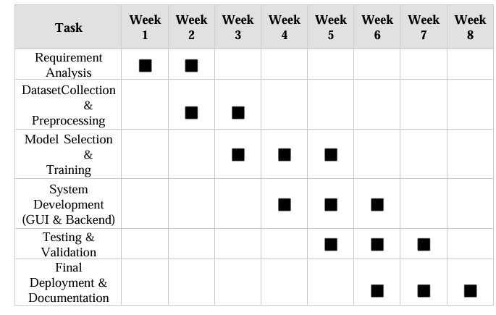
Gantt Chart Representation The Gantt chart below provides a graphical representation of the project schedule:
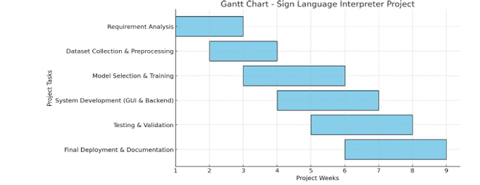
The proposed system overcomes the limitations of traditional sign language interpretation by leveraging computer vision and deep learning to recognize hand gestures using just a camera.
How It Works:
1. Gesture Capture: The system uses a camera to capture hand gestures in real-time.
2. Preprocessing: The input image is cleaned, resized, and enhanced for feature extraction.
3. Deep Learning Model: A CNN-based model processes the image and classifies it into a corresponding gesture.
4. Output Generation: The recognized gesture is converted into text (on screen) or speech (using a text-to-speech engine).
Advantages of the Proposed System:
1. No additional hardware required (only a camera).
2. Real-time processing for instant translation.
3. Higher accuracy due to deep learning-based recognition.
4. Can be trained on different sign languages (e.g., ASL, ISL, BSL).
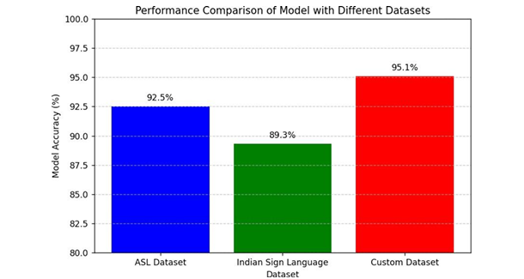

User Characteristics
- Improves Communication:
• Bridges the gap between hearing and non-hearing individuals.
• Enables real-time interaction with sign language users.

- User-Friendly Interface:
• Simple and intuitive UI for easy accessibility.
• Works with minimal technical knowledge.

- Real-Time Processing:
• Uses OpenCV and MediaPipe for fast hand gesture detection.
• Provides quick response time for accurate translations.

- Scalability & Flexibility:
• Can be expanded to include more gestures and languages.
• Can integrate with speech synthesis (Text-to-Speech, TTS) for better communication.

- Cost-Effective:
• Eliminates the need for expensive human interpreters.
• Open-source technologies reduce development costs.

- Cloud Integration:
• AWS support ensures cloud-based processing and storage.
• Enables remote access and real-time updates.

General Constraints
- Limited Gesture Recognition:
• Some complex gestures may not be recognized accurately.
• Multiple hand gestures or fingerspelling may require advanced processing.

- Dependency on Camera Quality:
• Low-resolution cameras may result in poor detection accuracy.
• Good lighting is required for optimal recognition.

- Performance Limitations:
• Real-time processing may be slow on low-end devices.
• High computational requirements for CNN-based training.

- Environmental Constraints:
• Background noise, lighting conditions, and hand occlusions can impact detection.
• May struggle with detecting gestures in crowded backgrounds.

- Language and Cultural Barriers:
• Different regions use different sign languages (ASL, BSL, ISL, etc.).
• Requires training for each language variation separately.

Project Lifecycle
The Project Lifecycle defines the different phases a project undergoes from its initiation to completion. For this Sign Language Interpreter, the software development lifecycle (SDLC) model followed is a Hybrid Waterfall-Agile Approach, ensuring structured yet iterative improvements.

Phases of the Project Lifecycle
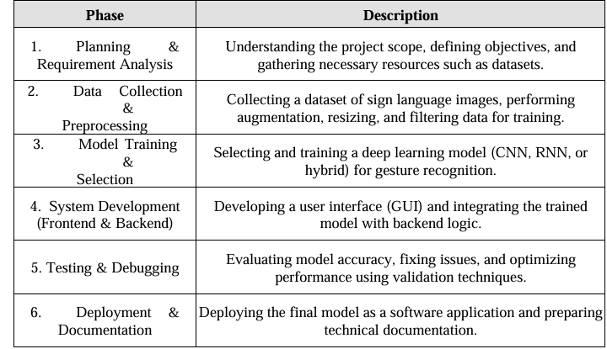
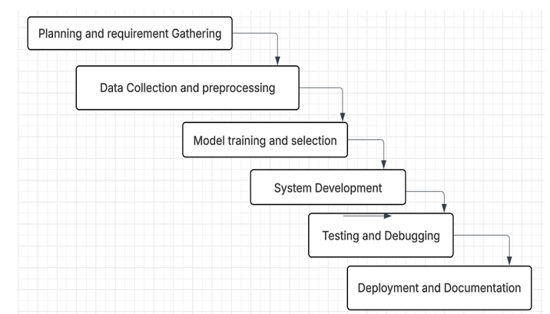

3. Specific Requirements

The Sign Language Interpreter project utilizes cutting-edge technologies to recognize hand gestures and translate them into meaningful text or speech. The primary technologies involved are:
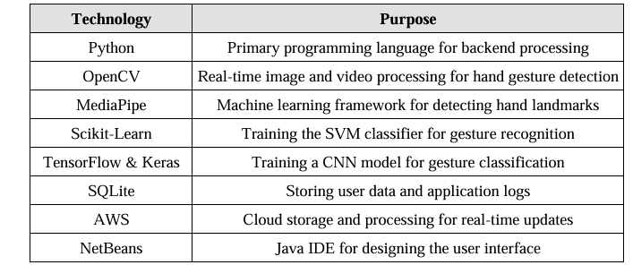
Project Implementation Technology:
The project follows a structured implementation approach:
Data Collection:
• The system captures hand gesture images using a webcam.
• Media Pipe extracts hand landmarks, which are stored as training data.
Model Training:
• The extracted hand landmark data is used to train an SVM classifier and a CNN model.
• SVM is used for real-time recognition, while CNN provides a more robust classification for larger datasets.
User Interface Development:
• The frontend is developed using Java in NetBeans, ensuring a user-friendly experience.
• The backend, written in Python, handles gesture processing and model inference.
Integration & Deployment:
• The trained model is integrated into the application.
• AWS is used to store gesture data and enable real-time updates.

Feasibility Report:
A feasibility study evaluates the project's viability based on multiple factors:
Technical Feasibility:
• The required technologies, such as OpenCV, MediaPipe, and TensorFlow, are available and well-supported.
• The system can run on mid-range hardware with a webcam, making it practical for real-world use.
Economic Feasibility:
• The project is cost-effective since it utilizes open-source libraries and free cloud storage.
• Minimal investment is required for hardware (webcam, laptop/PC).
Operational Feasibility:
• The system is designed for ease of use with a simple UI.
• It can assist hearing-impaired individuals in communication, making it highly beneficial.
Schedule Feasibility:
• The project is divided into clear phases (data collection, model training, integration, and testing).
• The estimated time for full implementation is around 3-4 months.

Appendix A
Data Flow Diagram (DFD)

The Data Flow Diagram (DFD) represents how data moves through the system.
DFD Levels:
• Level 0: Basic overview of how the system receives input and generates output.
• Level 1: Details the interaction between User, Model, and Database.
• DFD Level 0 & Level 1 for understanding data flow
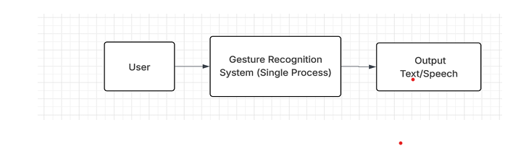

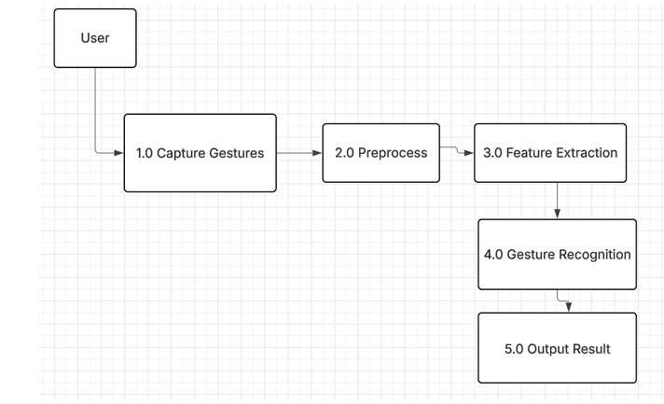

Appendix B
Entity-Relationship Diagram (ERD)

The ER Diagram represents the relationships between different entities in the system.
Key Entities:
• User: Registers and interacts with the system.
• Sign Dataset: Contains images/videos of hand gestures.
• Deep Learning Model: Processes the input and recognizes gestures.
• Interpreter Module: Converts recognized gestures into text/speech.

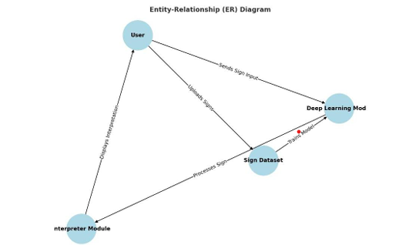

Appendix C
Use-Case Diagram (UCD)
(Optional)

The Use Case Diagram illustrates the different actions that a user can perform in the system. ‘
Main Use Cases:
• User uploads an image/video of sign language.
• System processes input and predicts output.
• Interpreted text/speech is displayed or played.
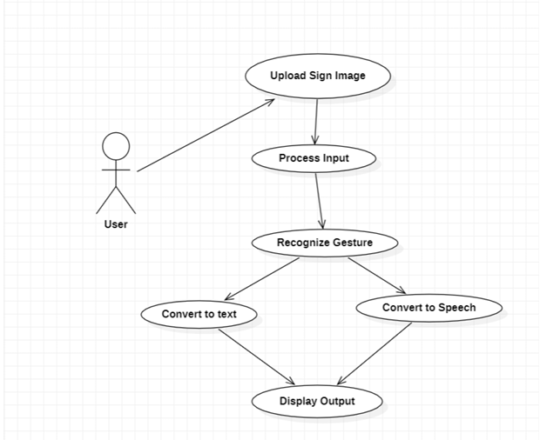
Sequence Diagram: The Sequence Diagram depicts the step-by-step interaction between the user and system components.
Interaction Flow:
• User uploads an image/video.
• System sends input to the model.
• Model processes the data and returns a result.
• The interpreted text/speech is displayed.
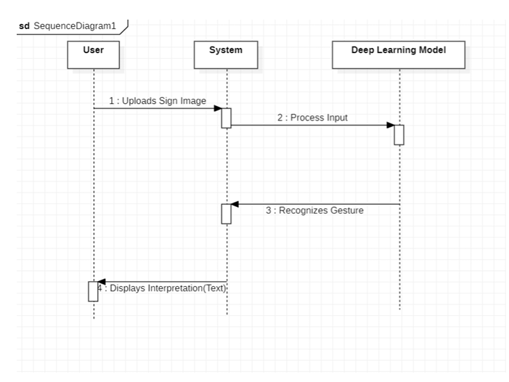
Activity Diagram: The Activity Diagram describes the flow of control and decision-making in the system.
Main Activities:
• User selects sign language input.
• The system processes the input through deep learning.
• The output is displayed as text or audio.
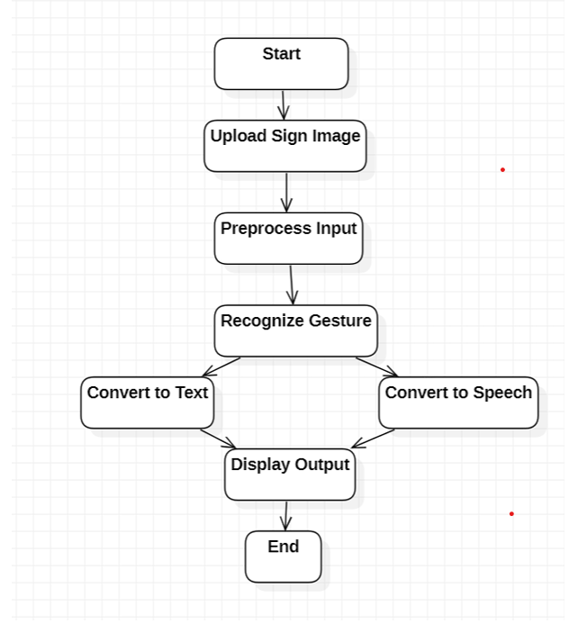

Class Diagram The Class Diagram represents the structure of the system using classes, attributes, and relationships.
Key Classes:
• User (Attributes: Name, ID, Preferences)
• Sign Processor (Methods: preprocess(), classify())
• Interpreter (Methods: convert_to_text(), convert_to_speech())
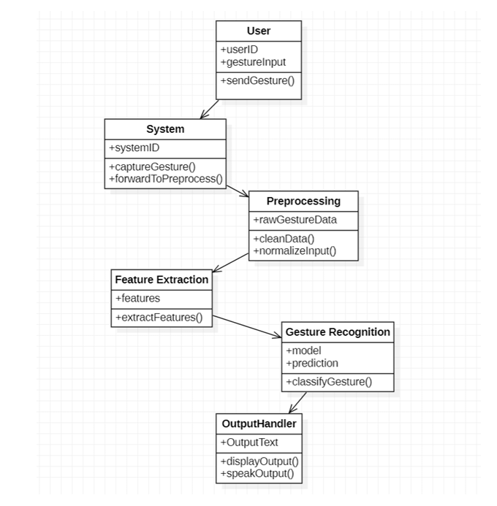
System Architecture The System Architecture Diagram shows how different components interact.
Architecture Components:
• User Interface (Frontend)
• Deep Learning Model (Backend)
• Database (Stores training dataset and results)
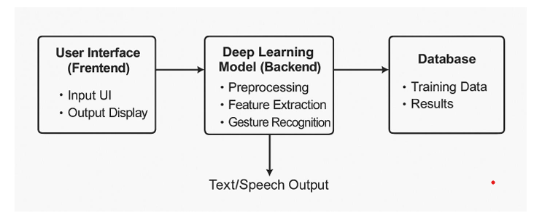

Appendix D
Data Dictionary (DD)
(Mandatory)

Example:
User Table
Column Name | Data type | Description
user_id | INTEGER (Primary Key) | Unique identifier for each
name | TEXT | Name of the user
email | TEXT | Email address of the user
created_at | DATETIME | Account creation timestamp
password | TEXT | Encrypted password

Model Accuracy Table
Column Name | Data type | Description
model_id | INTEGER (Primary Key) | Unique identifier for the trained model
accuracy | FLOAT | Accuracy percentage of the model
training_time | TEXT | Time taken for model training
model_path | TEXT | File path of the trained model

Gesture Data Table

Column Name | Data type | Description
gesture_id | INTEGER (Primary Key) | Name of the gesture (e.g., Hello, yes, No)
gesture_name | TEXT | Name of the gesture (e.g., Hello, yes, No)
data_path | TEXT | File path of saved training data
created_at | DATETIME | Timestamp when the gesture data was recorded
Appendix E
Screen Shots
Project Coding:

This section provides an in-depth explanation of the implementation of the Sign Language Interpreter using Deep Learning. The project is divided into the following coding modules:

1. Data Collection
2. Model Training
3. Real-time Detection
4. Graphical User Interface (GUI)

Data Collection Module:

The data collection module captures hand gestures using the Media Pipe Hands library and stores landmark coordinates.

Code for Data Collection:

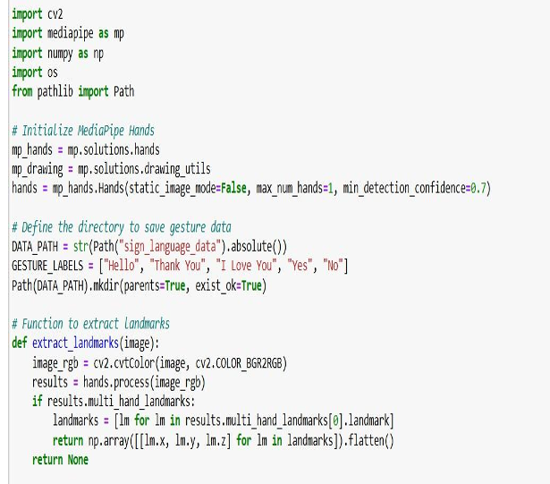
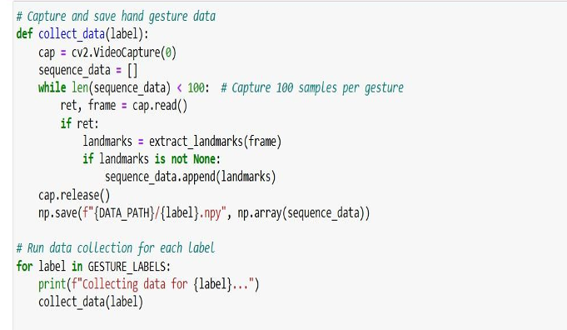
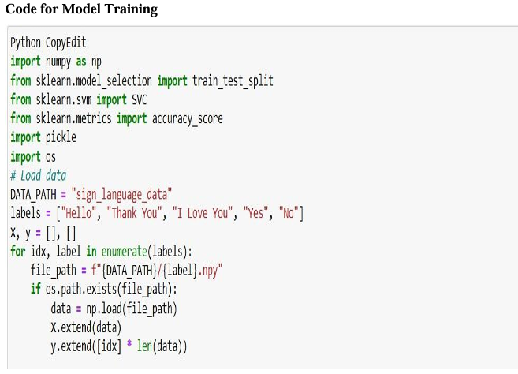
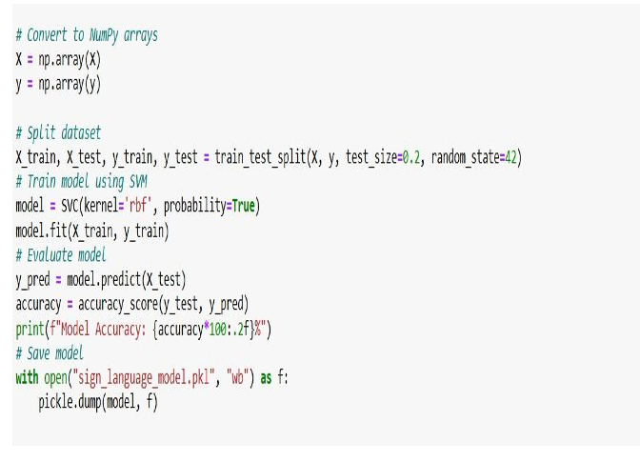

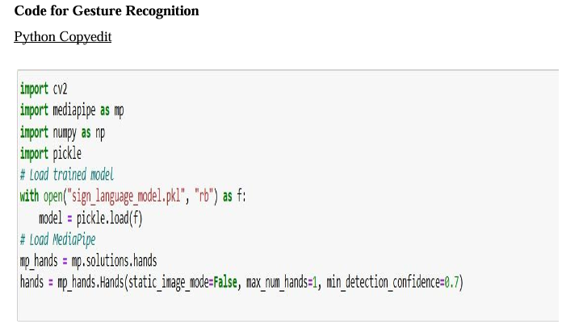
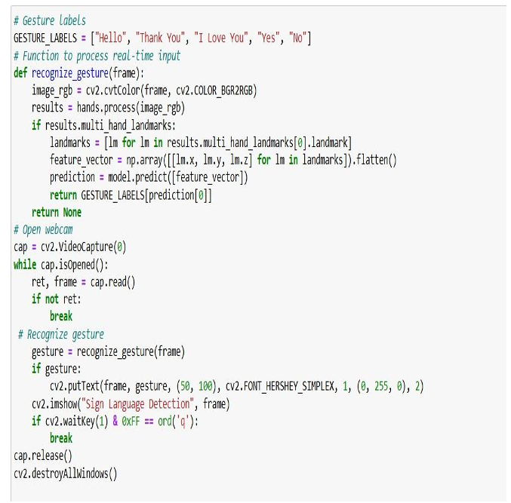
Graphical User Interface (GUI) The GUI provides an interface for gesture recognition using Gradio.

Code for GUI:
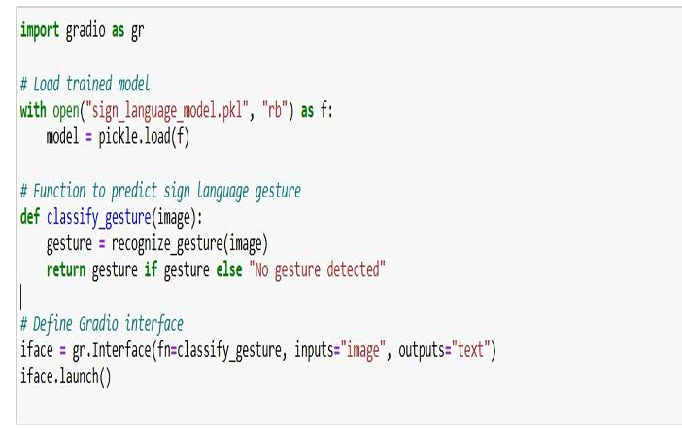
Project Snapshots:
This section includes the important screenshots taken during different phases of the project. These snapshots offer a visual representation of the system's implementation and operation.

Home Page of the Application:
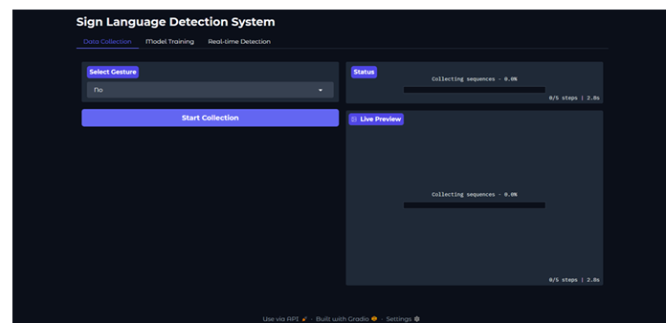

Data Collection Module:
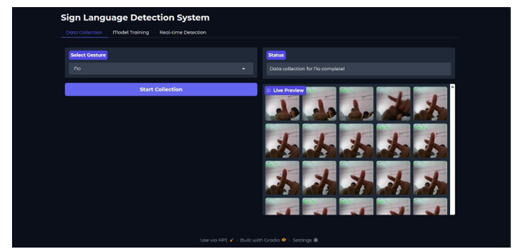

Model Training Process:
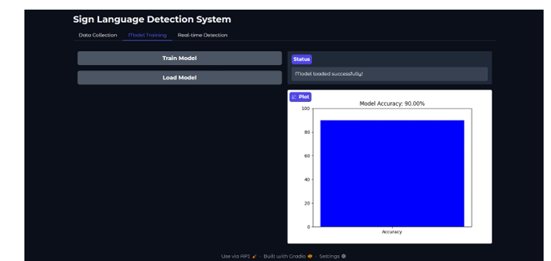

Sign Language Detection in Real-time:
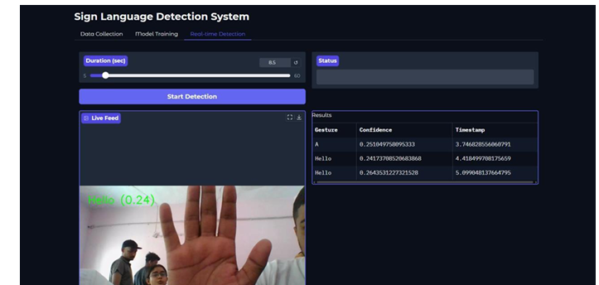

Final Output:
