Ice breaker – some pic??

What do we mean by fostering proficient delivery, what it means to us, what it takes us to deliver it

Look for relevant quote for each habit to be put in the slides

Will put all the habits against project management life cycle.

Come up with heat map ???

Emphasis on No Surprises

Customer experience

**Initiation**

We will explain what is proficient delivery, Put definition ??

In this 20 mins., we will walk you through the key traits we feel that will help us in achieving proficient delivery. Our speech is inspired from Stephen Covey’s 7 habits of highly effective people

If we look at Athletes while they train, they visualize themselves winning the race long before the game/match commences. *….reword/rephrase*

This is all about visualizing what we are going to achieve.

Same applies to projects we drive/lead

Having a clear picture of where we want to end up before we start the journey increases the chances that we will take the appropriate actions to reach our goal.

Once we have a sound understanding of what we want to accomplish, the road ahead gets easier to navigate

Our decisions/focus shift from "what do we have to get done today" to "what is going to get us closer to our end goal."

This gets us to the first trait - - **Begin with the end in mind**

What does it mean by Begin with…..

What is the project all about. What it means to all of us. What is the value this project will give to client. should have good pic on what is purpose and the end product going to be. Team should also be aligned towards this. E.g.

Archana Indy story : For Example during in Indy project **initiation**, we imagined our teams to be working like SDET’s who will take on any new challenge , new opportunity which comes our way and getting successful in this endeavor. Now if I look back we have done things like TIA implementation, New ADO add Ins, Apple Pay service validation, Performance testing for ApplePay services, Digital virtual assistant services validation for mobile, Migration of Java services to .Net for mobile etc. This list goes on.

TODO : Sunil directnet

1. Begin with the end in mind. – This habit is more relevant for initiation phase
   1. Project pre mortem- *don’t use this term*
   2. Visualize the end product

2. Put first things first

1. Time management
   1. Doing the most important thing first
   2. Time boxing
2. Prioritize

Quote “*The world is round and the place which may seem like the end may also be the beginning*.”

**Planning**

**Put first things first**

Now that we have an understanding of the end product/vision, we have to think through on what we should do towards reaching there.

In a research from University of Colorado it was found that , imagining that an event has already occurred or ***prospective hindsight*** , increases the ability to correctly identify reasons for future outcomes by 30%. Projects that fail , fails from planning phase.

This tells everyone involved where you’re going and how you’re going to get there. It involves creating a set of plans to help guide your team through the implementation and closure phases of the project. Create a realistic and well-defined project schedule.

Most of us try to do all the things which are required to accomplish our goal but, Doing the most important thing in the first place is the key. Follow the DO IT NOW mantra by considering the customer and project priorities. …**Put First things First**

By doing first things first, we are organizing and managing time and events according to the customer priorities, we established while visualizing the goal.

In order to master this trait, we have to understand Time management matrix. This helps us to break down activities in 4 quadrants sorted by urgency and Importance.

Project example : Sunil

For ex in project XXX, the first and foremost thing for a project is Resources availability, Infrastructure and access for the project. This is the most important and urgent activity. Later comes other things like ???? which are important not as urgent as previous things.

If we grasp the art of prioritizing the activities with respect to Urgency /Importance you got this trait right.



it's necessary for us to commit to continuous learning. we should be devoted to improving our number one asset: ourselves **Sharpen the Saw**

*“Give me six hours to chop down a tree and I will spend the first four sharpening the axe."- Abraham Lincoln*

Project example : Sunil

This will pave the way to coming up with the plan on how to achieve the goal ,plan for the right team /skilling the team , infrastructure needs. Have to make a checklist for the most important things to be done( bring up this slide - Put first things first) to be ready for

Most of us spend too much time on what is urgent and not enough time on what is important.  You have to decide what your utmost priorities are and should have the courage, confidence to say “no” to other things non apologetically.

Give an example of project and divide the planning activities in the below 4 quadrants:

Quote : Things that matter most must never be at the mercy of things that matter least

1. Sharpen the Saw
   1. upskill technically, process wise to be ready for upcoming delivery
2. Put first things first
3. Be proactive.
4. Seek first to understand, then to be understood

**Execution**

Now that we have a plan in place, and we are trying to do right things at the right time, next important thing is how we are proactively pursuing our plan. Question the status quo – ***Be Proactive.***

What do we mean by being proactive.. Ability to choose our response. Being Proactive is recognizing that it is our responsibility rather than attributing to external sources along with driving circumstances rather than being controlled by them.

We should keep all the stakeholders informed . This should be continuous and there should be no room for surprises

– *Response – able*. This means *taking responsibility* for our own actions rather than just watching how events unfold

“I am not a product of my circumstances. I am a product of my decisions.”

**DR. STEPHEN R. COVEY**

Be proactive.

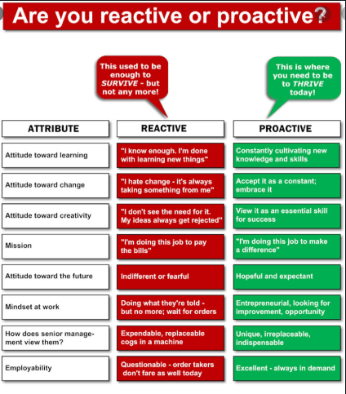

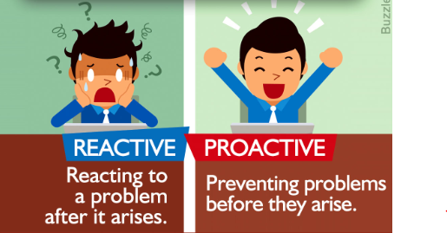

1. Seek first to understand, then to be understood
2. Put first things first
3. Synergize!
   1. teamwork
4. Think win-win.

**Synergize**

What is Synergy : Synergy is

Celebrating differences : Value differences as it brings out a different perspective

Teamwork : Work in team as Alone we are smart , together we are brilliant.

Open Mindedness : Be open to ideas of others rather than imposing your own.

Finding new and better ways : End up with an idea or a result that is better than what either of you started with

Synergy is working together as a team towards a common goal .

Its not my way or your way, its ***our*** way. doesn't just happen on its own. It's a process. Valuing differences is what really drives synergy. Do you truly value the mental, emotional, and psychological differences among people. Team that complements each other.

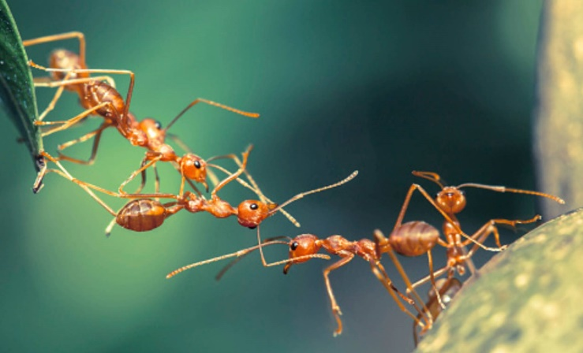

**Think win-win**

To go for win-win, you not only have to be empathic, but you also have to be confident. You not only have to be considerate and sensitive, you also have to be brave. To do that--to achieve that balance between courage and consideration--is the essence of real maturity and is fundamental to win-win

Paradigm of abundance

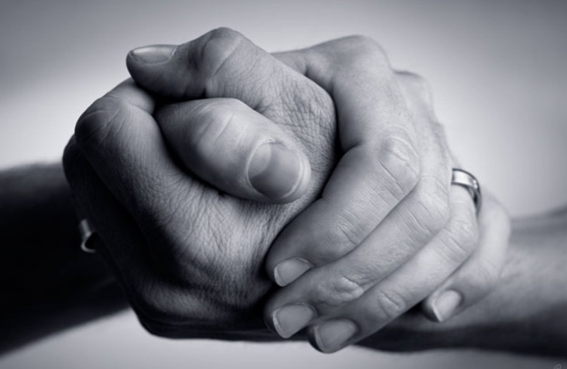

**Put First things first**

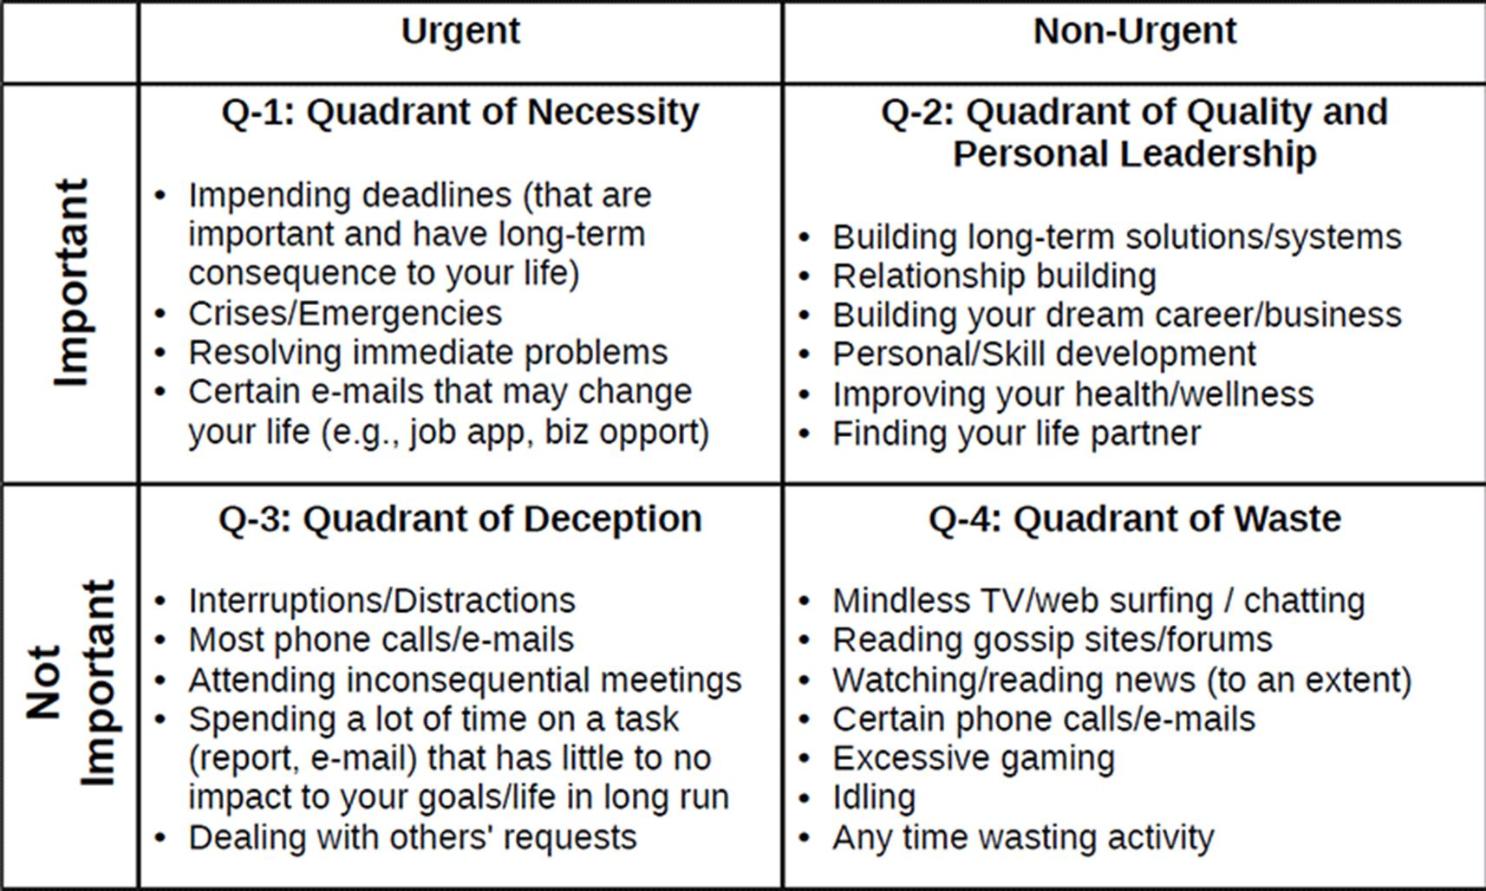

**Closure**

**First Think, Second Dream, Third believe, And finally Dare – Walt Disney**

1. Synergize!
   1. teamwork

**Closing speech**

All of us and our relationships are dominated by comparisons and competitions. We compete with our siblings, our friends , our colleagues it’s in our DNA.   
We think about succeeding in terms of someone else losing – if I win, you lose, if you win, I lose. Can we change it , we know its hard but can we TRY.

**Can we try** to seek mutual benefit from all human interactions instead of having winners on the one side and losers on the other.

**If we are able to apply Win Win ideology in our day to day interactions, we can earn TRUST. The more we trust others the more we earn it back.**

**To form a strong team, we must realize someone else’s strength as a complement to our weakness not a threat to us.**

**The Law of Win/Win says, “Let’s not do it your way or my way; lets do it the best way”.**

It’s all about people , end of the day not Competing and Comparing building our Emotional Bank Account. Our interactions with our stakeholders make deposits, or take withdrawals from our EBA (Emotional Bank Account). ..**Think Win-Win**

**…………….**

1- Be proactive.

in charge, be in driver’s seat

2 - Begin with the end in mind.

visualize the end product, delivery outcome even before the project starts

premortem – Uma’s example

3 – Put First things first.

Prioritize -………..

Doing the most important thing first

4 - Think win-win.

win/lose quadrant diagram

5 - Seek first to understand, then to be understood.

being listener,

6 - Synergize!

teamwork

**7** - Sharpen the Saw

upskill technically, process wise to be ready for upcoming delivery