Exploratory Data Analysis and Visualization of Apparel & Textiles Dataset

Submitted By: Manya Gupta
Week: Week 2
Domain: Data Analytics
Dataset: Dress Recommendation Dataset (OpenML)
Submission Date: (Enter today's date)

Table of Contents
- Introduction
- Objective
- Dataset Description
- Exploratory Data Analysis
- Data Visualization
- Key Findings
- Business Implications
- Challenges
- Limitations
- Conclusion
- References

1. Introduction
Exploratory Data Analysis (EDA) is the process of examining and summarizing datasets to understand their characteristics, identify trends, detect anomalies, and prepare the data for further analysis. In the apparel and textiles industry, EDA helps businesses understand consumer preferences, seasonal demand, pricing patterns, and product performance. This report analyzes a publicly available dress recommendation dataset to identify meaningful insights that can support better business decisions.

2. Objective
- Analyze the apparel dataset.
- Identify trends and patterns.
- Visualize important information.
- Generate business insights.

3. Dataset Description
Include:
- Dataset Name: Dress_Recommendation_Cleaned
- Source: OpenML
- File Format: CSV (cleaned version)
- Number of Rows
- Number of Columns
- Features
Screenshot 1: df.head()
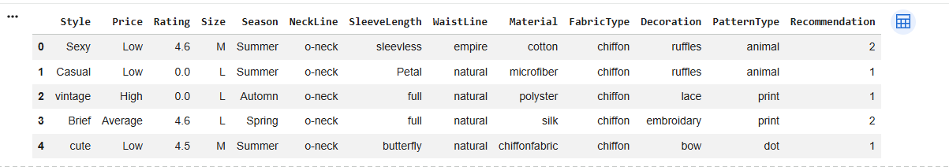
Screenshot 2: df.info()
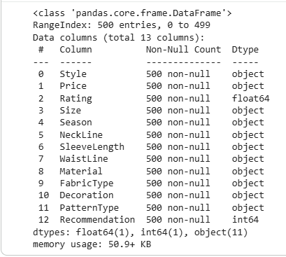

4. Exploratory Data Analysis
Describe:
- Dataset shape
- Data types
- Missing values
- Duplicate records
- Summary statistics
Include:
Screenshot 3: df.describe()
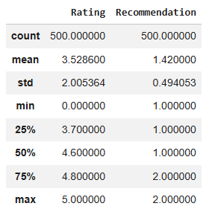
Screenshot 4: df.isnull().sum()
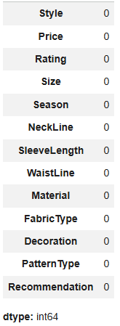

5. Data Visualization

Visualization 1 – Bar Chart
Title: Dress Style Distribution
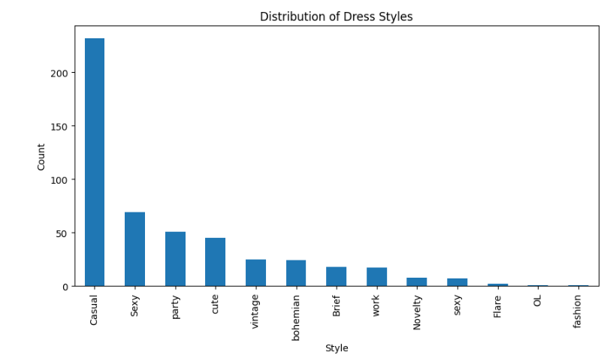
Observation:
- Casual and Sexy styles appear frequently.
Business Insight:
- These styles may represent popular customer preferences.

Visualization 2 – Pie Chart
Title: Season Distribution
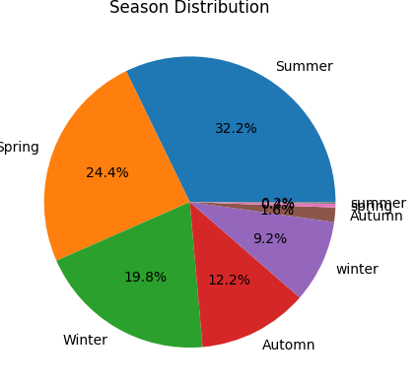
Observation:
- Summer dresses account for a large portion of the dataset.
Business Insight:
- Retailers should plan inventory before the summer season.

Visualization 3 – Histogram
Title: Rating Distribution
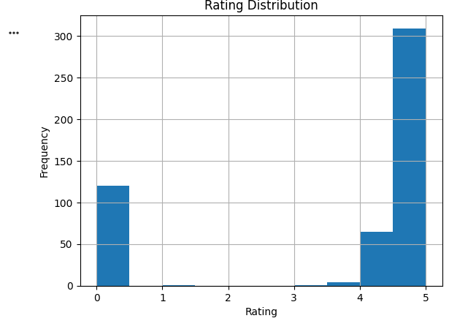
Observation:
- Most products have ratings between 4 and 5.
Business Insight:
- High-rated products should be promoted more aggressively.

6. Key Findings
Write in bullet points.
- Summer dresses dominate the dataset.
- Low-price products are more common.
- Most customer ratings are positive.
- Casual and Sexy styles are popular.

7. Business Implications
- Increase inventory for popular styles.
- Plan seasonal promotions before summer.
- Promote highly rated products.
- Review less popular categories for improvement.

8. Challenges
Mention:
- Missing values
- Byte-encoded text
- ARFF file format
- Categorical data cleaning

9. Limitations
- Public dataset
- No real-time sales information
- Limited geographical coverage
- Some missing attributes

10. Conclusion

Conclusion
This exploratory data analysis (EDA) successfully examined the Dress Recommendation Dataset to identify meaningful patterns, trends, and insights within the apparel and textiles industry. The dataset was analyzed using Python in Google Colab with the help of libraries such as pandas and Matplotlib. Initial data exploration included reviewing the dataset structure, verifying data types, handling missing values, removing duplicate records, and preparing the data for analysis.
Several visualizations, including bar charts, pie charts, and histograms, were created to better understand the distribution of dress styles, seasonal preferences, price categories, and product ratings. The analysis revealed that certain dress styles and seasons appeared more frequently than others, indicating variations in consumer preferences. The rating distribution also showed that many products received favorable ratings, suggesting generally positive customer feedback.
From a business perspective, these findings can help apparel companies improve inventory planning, optimize seasonal product launches, focus marketing efforts on popular product categories, and promote highly rated items. The analysis also highlighted the importance of maintaining clean and well-structured data, as accurate data preparation is essential for producing reliable insights.
Although the dataset has limitations, such as the absence of real-time sales data and limited market coverage, it provides a strong foundation for understanding consumer behavior and product characteristics. Overall, this project demonstrates how exploratory data analysis can transform raw data into valuable business insights and support informed decision-making in the apparel and textiles industry.

11. References
Include:
- OpenML
- Pandas Documentation
- Matplotlib Documentation
- Google Colab

