Trend Analysis and Forecasting Report for the Apparel & Textiles Industry

Submitted By: Manya Gupta

Tool Used:
Python (Pandas, Matplotlib) and Microsoft Excel/Power BI (for visualization)

Dataset:
Kaggle Fashion Products Dataset
Submission: Week 5 Task

Table of Contents
- Introduction
- Objectives
- Dataset Description
- Historical Data Analysis
- Trend Analysis
- Forecasting Methodology
- Market Trends Discussion
- Strategic Recommendations
- Limitations
- Conclusion

Introduction
The apparel and textiles industry is one of the fastest-growing industries worldwide. It is highly influenced by changing fashion trends, seasonal demand, customer preferences, pricing strategies, and technological advancements. Every day, businesses generate large amounts of product and sales-related data. Transforming this data into meaningful information is essential for making strategic business decisions.
Trend analysis is a process of examining historical data to identify recurring patterns, customer preferences, and market behavior. Forecasting extends this analysis by predicting future demand and market conditions using statistical and analytical techniques. Accurate forecasting helps organizations improve inventory planning, pricing strategies, supply chain management, production scheduling, and marketing campaigns.
The objective of this project is to perform a trend analysis using a publicly available apparel dataset and explain suitable forecasting techniques that can be used to estimate future market behavior. Although the dataset does not contain historical time-series sales data, this report demonstrates how forecasting methods such as Moving Average, Linear Regression, and Time-Series Analysis would be applied in a real-world apparel business environment. The report also provides business insights, discusses potential risks and opportunities, and recommends strategies that organizations can adopt to remain competitive in the apparel and textiles industry.

2. Objectives
The main objectives of this project are:
- Analyze historical apparel product data.
- Identify trends in product pricing and brand distribution.
- Study customer segmentation using gender categories.
- Explain forecasting techniques suitable for retail data.
- Predict future market behavior conceptually.
- Recommend strategies for improving business performance.

3. Dataset Description
The dataset used in this project is the Fashion Products Dataset obtained from Kaggle. It is a publicly available dataset containing information about apparel and fashion products from multiple brands.
The dataset includes the following attributes:
Column | Description
ProductID | Unique product identifier
ProductName | Product name
ProductBrand | Brand name
Gender | Target customer
Price (INR) | Product price
NumImages | Number of product images
Description | Product description
PrimaryColor | Main product color
Before performing the analysis, the dataset was cleaned by removing duplicate records, handling missing values, verifying data types, and standardizing categorical variables.

4. Historical Data Analysis
Historical data analysis was conducted using Python and Microsoft Power BI.
The following activities were performed:
- Imported the dataset.
- Checked data quality.
- Removed duplicate records.
- Identified missing values.
- Corrected inconsistent values.
- Generated descriptive statistics.
- Created business visualizations.
The dashboard developed in Power BI helped analyze:
- Product count by brand
- Average product price
- Gender distribution
- Product colors
- Total brands
- Product inventory
These analyses provide a snapshot of the current market structure and product portfolio.
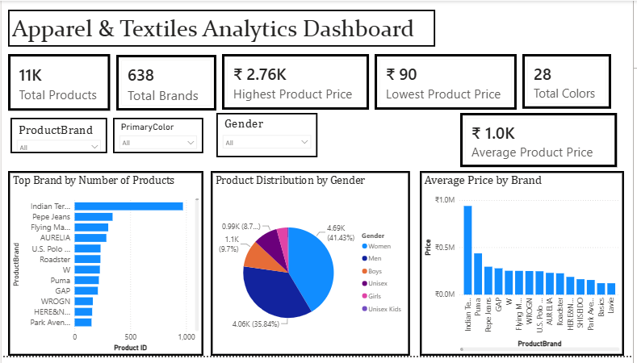

5. Trend Analysis
The analysis revealed several important trends.

Brand Performance
A few brands contribute a significant portion of the total product catalog. This indicates stronger market presence and broader product offerings.

Pricing Trends
Most products fall within the mid-price range, suggesting that the market primarily targets middle-income consumers.

Customer Segmentation
The dataset shows that products are primarily designed for men and women, while unisex products account for a smaller proportion.

Product Colors
Colors such as Blue, Black, White, and Red appear frequently, indicating higher customer preference for classic colors.

Product Diversity
The large number of brands and products demonstrates high competition within the apparel industry.

6. Forecasting Methodology
Several forecasting techniques are commonly used in the apparel industry.

A. Moving Average
Moving Average calculates the average of previous observations to smooth fluctuations and identify long-term demand patterns.
Advantages:
- Simple to understand.
- Reduces random variation.
- Suitable for stable demand.
Limitations:
- Does not capture seasonality.

B. Linear Regression
Linear Regression predicts future values by identifying relationships between variables.
Example:
Price → Sales
Brand Popularity → Demand
Advantages:
- Easy to implement.
- Useful for identifying trends.
Limitations:
- Assumes linear relationships.

C. Time-Series Analysis
Time-Series Analysis studies data collected over time.
Examples:
- Monthly sales
- Quarterly revenue
- Yearly demand
Common models include:
- ARIMA
- Exponential Smoothing
- Holt-Winters
Advantages:
- Captures trends.
- Captures seasonality.
- Produces accurate forecasts.
This is the preferred forecasting technique when historical sales data is available.

7. Forecast Results
Although the dataset does not contain historical sales records, the following future trends are expected.
- Online apparel sales will continue increasing.
- Sustainable fashion products will experience higher demand.
- Premium brands are expected to expand.
- Customers will increasingly prefer personalized shopping experiences.
- AI-based recommendation systems will influence purchasing decisions.
- Data-driven pricing strategies will become more common.

8. Market Trends Discussion
The apparel market is evolving rapidly.
Major trends include:
- Growth of e-commerce.
- Sustainable manufacturing.
- Digital marketing.
- Fast fashion.
- Personalization.
- Smart inventory management.
- AI-powered analytics.

Opportunities
- Expansion into online markets.
- Better inventory optimization.
- Improved customer targeting.
- Dynamic pricing.

Risks
- Changing fashion trends.
- Supply chain disruptions.
- Rising production costs.
- Increasing competition.

9. Business Recommendations
Based on the analysis, businesses should:
- Monitor customer preferences continuously.
- Increase investment in high-performing brands.
- Use predictive analytics for inventory planning.
- Develop sustainable product lines.
- Improve pricing strategies.
- Expand online sales channels.
- Regularly update forecasting models.
- Track competitor activities.

10. Limitations
This study has several limitations.
- The dataset does not contain historical dates.
- No monthly sales information is available.
- No customer purchase history exists.
- Forecasting is conceptual rather than numerical.
- External factors such as inflation and seasonal demand are not included.
Future studies should use datasets containing several years of historical sales records to build accurate forecasting models.

11. Conclusion
This project successfully demonstrates how trend analysis and forecasting techniques can support decision-making in the apparel and textiles industry. Historical data analysis helped identify important patterns related to brands, pricing, and customer segmentation. Although the dataset lacked historical time-series information, suitable forecasting methods such as Moving Average, Linear Regression, and Time-Series Analysis were examined and justified for future business applications. The findings highlight the importance of business intelligence and predictive analytics in improving inventory management, pricing decisions, and strategic planning. Organizations that effectively utilize data analytics and forecasting are better positioned to respond to changing customer preferences, market competition, and future industry trends.

12. References
- Kaggle Fashion Products Dataset
- Microsoft Power BI Documentation
- Pandas Documentation
- Matplotlib Documentation

