Table of Contents

Knowledge Distillation for Motion Prediction (HiVT) — Key Findings
Working report. Companion to the detailed log in kd_emb32_kl_comparison.md (full tables, glossary, reproduction commands). This document is the curated key-findings summary.

1. Recap / thesis narrative
The thesis is on motion prediction, motivated by hardware limitations: large models like HiVT-128 are accurate but expensive, so we ask how small a model can be made while retaining its predictive quality. We follow the knowledge-distillation (KD) path: take a pretrained HiVT-128 teacher and transfer its knowledge to a much smaller HiVT-32 student (and, next, HiVT-16).
The arc of the work:
- Naive index-aligned KD did nothing — because the teacher’s and student’s mixture modes do not correspond slot-for-slot (shown empirically in §3).
- A permutation-invariant KD loss (v1) fixed the correspondence problem and improved accuracy (minADE/FDE/MR) — but by discarding the teacher’s uncertainty, it made the student over-confident and worsened calibration.
- A distribution-matching KD loss (v2) distils the teacher’s full predictive distribution (not just its mode means), and recovers calibration while keeping the accuracy gain.
The remaining axis — central to the hardware motivation — is efficiency vs. accuracy/calibration vs. model size (§8).

2. Setup
Teacher | HiVT-128 (pretrained author checkpoint), 2.56 M params
Student | HiVT-32 (this work), 170 K params (15× smaller)
Next student | HiVT-16, 46 K params (55× smaller)
Data | Argoverse-1 motion forecasting, full val = 39,472 scenes
Recipe | bs=128, lr=3e-3, bf16, ~64 epochs (full data)
Teacher cache | teacher_outputs/train_fix.h5 (verified-good)
Metrics: geometry = oracle best-of-6 (minADE/minFDE/minMR); probability-aware = brier-minFDE (official Argoverse-1 ranking metric); full-distribution = mixNLL; calibration diagnostics = b_scale (predicted Laplace sharpness), calib_err, coverage cov_p*, pi_entropy. (Full glossary in the companion doc.)

3. Why a permutation-invariant loss — the mode-correspondence diagnostic
HiVT trains its mixture modes with a winner-takes-all objective, which is symmetric under relabelling of the modes. So which slot specialises to which behaviour (“turn left”, “keep straight”, …) is arbitrary per training run. Two independently trained models (HiVT-128 teacher, HiVT-32 student) therefore have no reason to share slot ordering — and a naive index-aligned KD loss (compare student-mode-k to teacher-mode-k) compares unrelated trajectories.
We tested this directly (KD/kd_mode_permutation_test.py, 500 scenes):
quantity | value | meaning
identity (index-aligned) is optimal in | 0.0% of scenes | slots never line up
greedy accidental alignment rate | 0.108 (chance = 0.167) | ≈ chance
mean pairing distance, identity | 5.165 m | index-aligned cost
mean pairing distance, optimal (Hungarian) | 1.817 m | best matching
identity / optimal cost ratio | 3.98× (median 3.31×) | index-alignment is 4× worse
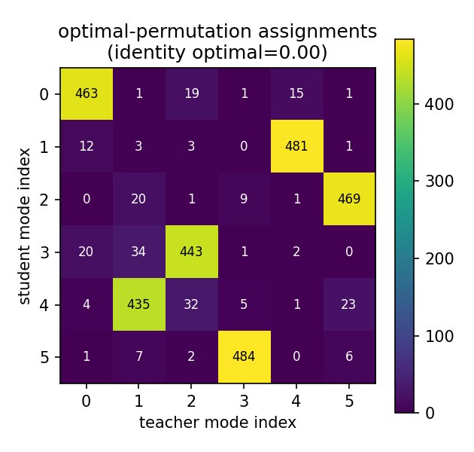
optimal-permutation assignments
Reading the figure: under optimal (Hungarian) matching, each student mode (row) maps strongly to exactly one teacher mode (column) — a stable correspondence exists across the dataset — but it is not the diagonal (student 1→teacher 4, 2→5, 3→2, 4→1, 5→3). Compare the greedy/accidental version (mode_perm_greedy_fde_n500.png), which is diffuse.
Conclusion: mode slots do not correspond across the two models, so index-aligned KD is ill-posed. The fix is a loss that is invariant to mode ordering.

4. The two KD losses (KD/kd_loss.py)
Both losses score teacher targets under the whole student K-mode mixture (logsumexp over student modes), so they are permutation-invariant — no Hungarian matching needed, and student-K need not equal teacher-F. What differs is what is distilled.

v1 — mean-target distillation (--kd_mode mean)
Scores the teacher’s mode means μ_T as point targets, weighted by teacher confidence π_T; discards the teacher scales:
L_KD = − (1/HD) · Σ_f π_T(f) · log p_student( μ_T(f) )
Maximising density at the mean points is achieved by shrinking the student’s Laplace scales → the student becomes over-confident. Good best-of-K geometry, degraded full-distribution calibration.

v2 — distribution-matching distillation (--kd_mode dist)
Draws Monte-Carlo Laplace samples from each teacher mode (using the teacher scales b_T) and scores those under the student mixture:
L_KD = − (1/HD) · Σ_f π_T(f) · E_{y ~ Laplace(μ_T_f, b_T_f)}[ log p_student(y) ]
The student must now cover the teacher’s spread, so collapsing its scales no longer minimises the loss — the teacher’s uncertainty is transferred and calibration is restored. v2 reduces exactly to v1 in the zero-variance limit (b_T→0); it is the strict generalisation that adds the discarded scale information back in.
⚠️ λ is not directly comparable across v1 and v2: the loss magnitude differs at the same λ, so the same nominal λ is a different effective KD strength. Compare each loss at its own optimum, or as an explicit “drop-in swap at fixed λ” with that caveat stated.

5. KEY FINDING — v1 trades calibration for accuracy (full data)
Same KD harness/recipe, only λ_kl changes. Canonical full-data checkpoints (lkl0.0 ep46, lkl0.5 ep62), eval.py.
Metric | λ=0 (No KD) | v1 λ=0.5 (Mean) | Change
minADE | 0.7670 | 0.7264 | −5.3% | ✅
minFDE | 1.2293 | 1.1211 | −8.8% | ✅
minMR | 0.12895 | 0.11788 | −8.6% | ✅
brier_minFDE (official) | 1.8878 | 1.7924 | −5.05% | ✅
mixNLL | 28.739 | 34.658 | +20.6% | ❌
calib_err | 0.0313 | 0.1570 | 5.0× worse | ❌
b_scale (sharpness) | 0.4356 | 0.3021 | −30.6% | (shrinkage)
cov_p90 | 0.903 | 0.754 | over-confident | ❌
The central finding: at full convergence, v1 KD improves geometry by ~5–9% but degrades full-distribution calibration — mixNLL +20.6%, calib_err 5×, and the predicted 90% interval captures only 75% of ground-truth points (vs 90% for no-KD). The no-KD baseline is already well-calibrated (cov_p90 ≈ 0.90), so v1 KD trades calibration away to buy accuracy. v2’s job is to keep the accuracy and recover the calibration.
Thesis statement: Mean-target mixture distillation improves geometric accuracy and the official Argoverse ranking metric (brier-minFDE) but degrades full-distribution calibration (mixNLL), because it transfers the teacher’s mode locations and weights while discarding its predictive variance, producing overconfident student mixtures.

6. KEY FINDING — the mechanism is scale shrinkage, not mode collapse
The over-confidence lives entirely in the per-mode Laplace scales, not in mixture-weight collapse.
Diagnostic | λ=0.0 | λ=0.5 | Verdict
b_scale (chosen mode) | 0.4356 | 0.3021 | ✅ −30.6% (smoking gun)
b_scale_all (all modes) | 0.4985 | 0.3387 | ✅ −32.1%
calib_err | 0.0313 | 0.1570 | ✅ 5.0× worse
pi_entropy (mode-weight) | 1.7398 | 1.7579 | ❌ ~equal — no collapse
Reliability curve (empirical coverage vs nominal p) — under-covered at every level:
nominal p | 0.10 | 0.30 | 0.50 | 0.70 | 0.90
λ=0.0 | 0.075 | 0.247 | 0.452 | 0.682 | 0.903
λ=0.5 | 0.047 | 0.160 | 0.303 | 0.493 | 0.754
Mode diversity (independent corroboration) — visualisation_other_tests/measure_mode_diversity.py, all 39,472 val scenes, pairwise final-endpoint spread between the 6 modes:
stat (m) | kl=0.0 | kl=0.5
mean | 8.548 | 10.686 (+25%)
90th pct | 21.694 | 29.511 (+36%)
The KD student’s modes are more spread apart, not collapsed — so neither the mixture weights nor the mode geometry collapse. The over-confidence is purely the per-mode scales: “distil means, discard variance” confirmed precisely.

7. v1 λ dose-response (triage)
Re-evaluated the four v1 triage checkpoints (25% data, 15 ep, lr=3e-3), each judged on the full val set.
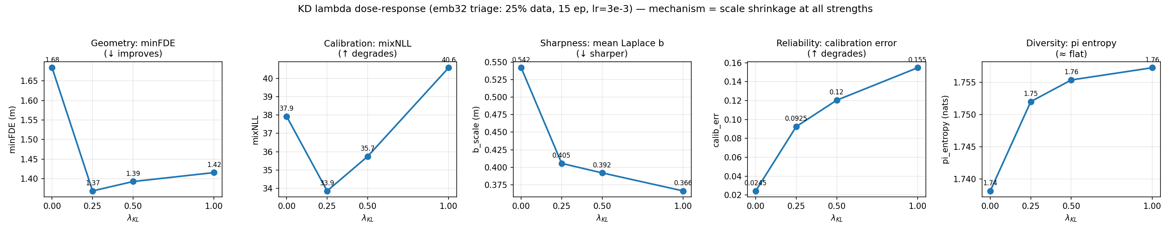
KD lambda dose-response (v1)
λ | minFDE | minADE | mixNLL | b_scale | calib_err | π-entropy
0.0 | 1.683 | 0.925 | 37.93 | 0.5420 | 0.0245 | 1.7382
0.25 | 1.369 | 0.823 | 33.86 | 0.4055 | 0.0925 | 1.7520
0.5 | 1.393 | 0.835 | 35.74 | 0.3919 | 0.1204 | 1.7554
1.0 | 1.416 | 0.844 | 40.59 | 0.3662 | 0.1547 | 1.7573
- Scale shrinkage and calibration damage are monotone in λ (b_scale ↓, calib_err ↑ at every dose) — confirming the mechanism across the whole λ axis.
- Geometry is NOT monotone — it peaks at λ≈0.25. A little KD captures essentially all the displacement gain; more only over-distills.
- No mode collapse at any dose (π-entropy flat / slightly rising).
Caveat: on triage, mixNLL is U-shaped (min at λ=0.25) because the undertrained λ=0 baseline makes KD’s geometry gain dominate; on full data this sign flips (λ=0.5 mixNLL worse than λ=0, §5). Trust the geometry-agnostic diagnostics (b_scale, calib_err, coverage) — those degrade monotonically regardless.

8. v2 (distribution-matching) — triage results
v2 beats v1 and shifts the λ optimum upward. Triage (25% data, 15 ep proxy):
run | minFDE | minADE | minMR | calib_err
v1 best (kl=0.25) | 1.360 | 0.842 | 0.153 | ~0.09
v2 kl=0.5 | 1.287 | 0.805 | 0.142 | ~0.023
v2 kl=1.0 | 1.279 | 0.805 | 0.135 | ~0.025
- Both v2 operating points beat every v1 run on accuracy while keeping calib_err near the well-calibrated no-KD baseline (~0.024) — i.e. v2 recovers the calibration v1 sacrificed.
- Between v2 kl=0.5 and kl=1.0: kl=1.0 is marginally sharper on accuracy (minMR/minFDE), kl=0.5 is slightly better calibrated; the accuracy gap is within seed noise. (kl=0.75 not worth testing — flat region.)
Full-data v2 confirmation is in progress (KD/run_full_v2.sh, kl=0.5, 64 ep) to verify v2 keeps v1’s accuracy and recovers baseline calibration at full scale.

Teacher gold-standard (the v2 calibration target)
(full data) | b_scale | calib_err | cov@p90 | mixNLL
student kl=0.0 (well-cal) | 0.436 | 0.031 | 0.903 | 28.74
student kl=0.5 (v1 KD) | 0.302 | 0.157 | 0.754 | 34.66
teacher HiVT-128 | 0.358 | 0.047 | 0.894 | 21.05
The teacher is sharper than the well-calibrated student (b 0.358 < 0.436) yet stays calibrated — because its modes are accurate enough to earn small scales. The v1 student over-shot below the teacher (b 0.302). So “match the teacher’s b” is not the right v2 target: the less-accurate student needs a larger b than the teacher to be calibrated. Pre-registered v2 expectation: b ↑ toward the teacher, calib_err ↓ toward ~0.05 — partial, not necessarily full, recovery (mixNLL 21.05 is the teacher’s ceiling; no emb32 student will reach it).

9. Efficiency axis (hardware motivation)
KD/profile_efficiency.py. Parameter counts (architecture-determined, exact):
model | embed | params | vs teacher
teacher-128 | 128 | 2,559,993 | 100% (1×)
student-32 | 32 | 170,073 | 6.6% (15× smaller)
student-16 | 16 | 45,929 | 1.8% (55× smaller)
Accuracy recovered at 6.6% of the parameters: v1 KD narrows the HiVT-32→HiVT-64 minFDE gap by ~38% at zero inference cost; KD kl=0.5 beats the original standalone HiVT-32 (minFDE −4.8%).
⏳ Latency + peak-memory pending a clean measurement (deferred until the GPU is free — measuring during the v2 training run gives contended, unusable numbers; a first contended CPU pass already showed an impossible row). Param counts are the reliable cost numbers for now.

10. Status & next steps
Done / confirmed: - Permutation-invariance is empirically justified (§3). - v1 KD: accuracy↑, calibration↓ via scale shrinkage — quantified at full data (§5–6). - v2 (triage): beats v1 and recovers calibration (§8). - Param efficiency: 15×/55× smaller (§9).
In progress / next: 1. v2 full-data run (kl=0.5, running) — confirm calibration recovery at scale. 2. HiVT-16 student — does the KD benefit grow as the student shrinks? (Re-triage LR first; keep kl=0 and kl=0.5 arms.) This is the strongest remaining contribution. 3. Efficiency latency/memory — clean GPU + CPU measurement for the cost frontier. 4. Seeding — 2–3 seeds on the final chosen config only (not the whole sweep) to make the headline deltas defensible.
Open question for the supervisor: is this scope (v2 full confirmation + HiVT-16 transfer + efficiency frontier + seeding) the right 2-week plan, and is there a defined success metric (pure accuracy vs. calibrated uncertainty) to optimise toward?

Figure / artifact index
artifact | what it shows
KD/diagnostics/mode_perm_optimal_fde_n500.png | Hungarian mode matching — stable but non-identity correspondence (§3)
KD/diagnostics/mode_perm_greedy_fde_n500.png | greedy/accidental matching — diffuse (§3)
docs/figures/kd_lambda_sweep.png | v1 λ dose-response, 5 panels (§7)
kd_emb32_kl_comparison.md | full tables, glossary, reproduction commands
W&B: groups full-emb32-distv2 (v2 full), v1/baseline full runs, triage λ/LR sweeps | training curves

