TRANSFER FUNCTION

%For input = Unit Impulse function
syms s t;
Num = [4,1];
Den = [4,4,1];
Transfer = tf(Num, Den)
Tfun = (4*s+1)/(4*s^2+ 4*s +1);
TRes(t) = ilaplace(Tfun)
t1 = [0:0.1:100];
subplot(1,2,1)
plot(t1,TRes(t1))
%For input = Unit step function
syms s t;
Num = [4,1];
Den = [4,4,1,0];
Transfer = tf(Num, Den)
Tfun = (4*s+1)/(4*s^3+ 4*s^2 +1*s);
TRes(t) = ilaplace(Tfun)
t1 = [0:0.1:100];
subplot(1,2,2)
plot(t1,TRes(t1))

Experiment – 1
Aim –
To study the time response of type 0, 1 and 2 systems.
Que 1, Obtaining the step response & impulse of a type ‘0’ system
Code –
% Step & impulse response of type '0'
% G(s) = 1/ s^2 +s +4
num=[1];
den=[1 1 4];
g=tf(num,den);
t=feedback(g,1);
subplot(1,2,1);
step(t,'r');
subplot(1,2,2);
impulse(t,'r');

Output –
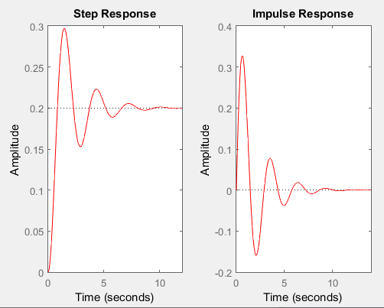

Que 2, Obtaining the step response & impulse of a type ‘1’ system
Code –
% Step response & impulse response of type '1'
% G(s) = 1/ s(s^2 +s +4)
num=[1];
den=[1 1 4 0];
g=tf(num,den);
t=feedback(g,1);
subplot(1,2,1);
step(t,'r');
subplot(1,2,2);
impulse(t,'g');

Output –
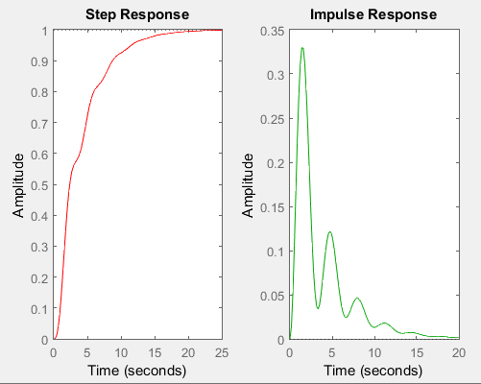

Que 3, Obtaining the step response & impulse of a type ‘2’ system
Code –
% Step response & impulse response of type '2'
% G(s) = 1/ s^2(s^2 +s +4)
num=[1];
den=[1 1 4 0 0];
g=tf(num,den);
t=feedback(g,1);
subplot(1,2,1);
step(t,'r');
subplot(1,2,2);
impulse(t,'r');

Output –
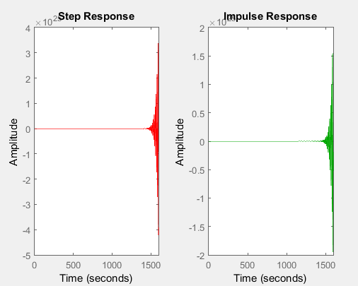

Que 4
% USe of the command stepinfo(sys)
num=[16];
den=[1 1.6 16]
sys=tf(num,den);
S=stepinfo(sys)
load ltiexamples
ltiview

output –
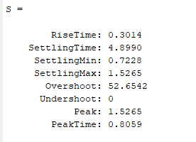
Experiment – 2
Aim –
To study the frequency response of 1st order and 2nd order system.
Apparatus –
MATLAB Software.
Code-
- Pole zero diagram.
% pole zeroes diagram
num=[1 4 3];
den=[1 9 27 35];
g=tf(num,den)
[z,p,k]=tf2zp(num,den)
pzmap(g)

output –
polezeroplot -
g =
s^2 + 4 s + 3
-----------------------
s^3 + 9 s^2 + 27 s + 35
Continuous-time transfer function.
z =
-3
-1
p =
-5.0000 + 0.0000i
-2.0000 + 1.7321i
-2.0000 - 1.7321i
k =
1

Output –
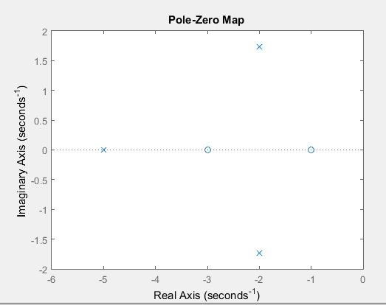

Aim –
To Plot Pole-Zero diagram.
Code –
% Program for Pole-zero configuration in s-plane
% Set up for zeros
z=[j;-j]

%Set up vector for poles
p=[-1;.5+.5j;.5-.5j];
figure(1);
zplane(z,p);
title('Pole/Zeros Plot')

Output –
polezeroplot
z = 0.0000 + 1.0000i
0.0000 - 1.0000i
Graph –
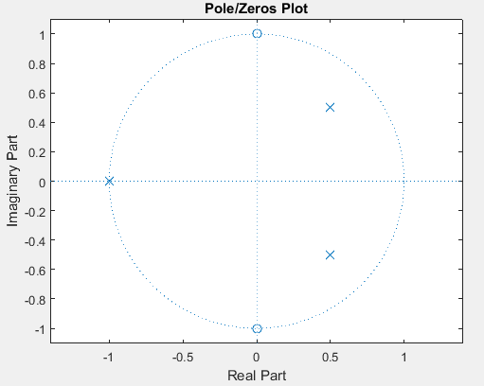

Code –
% to obtain transfer function
p=[-2 1];
z=[-1];
k=7;
[num,den]=zp2tf(z',p',k);
g=tf(num,den)

Output –
>> tfpzd
g =
7 s + 7
-----------
s^2 + s - 2
Continuous-time transfer function.
Aim –
To find the bode plotter.

Code –
% Program to find bode plot
clc
num=input('Enter the value of numerator:')
den=input('Enter the value of denominator:')
fun=tf(num,den)
bode(fun)
grid on

Output –

Enter the value of numerator:[1 4]
num =
1 4
Enter the value of denominator:[4 6 8]
den =
4 6 8

fun =
s + 4
---------------
4 s^2 + 6 s + 8

Continuous-time transfer function.

Graph –
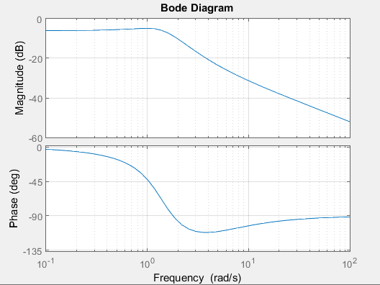
Aim –
To find transfer function and plot pz map.
Code –
% Program to plot pole zero configuration of transfer function
% h(s) = 2s^2 + 5s + 1 / s^2 + 3s +5 ;
n=[2 5 1];
d=[1 3 5];
sys=tf(n,d)
pzmap(sys)

Output – tfmap
sys =
2 s^2 + 5 s + 1
---------------
s^2 + 3 s + 5
Continuous-time transfer function.

Aim –
To find transfer function and plot the graph.
Code –
% Program to plot pole zero configuration of tranfer function
clc;
clear all;
n1=input('Enter the numerator : ');
d1=input('Enter the denominator : ');
sys=tf(n1,d1)
pzmap(sys)

Output –

1. Enter the numerator : [1]
Enter the denominator : [1 1]
sys =
1
--------
s + 1
Continuous-time transfer function.
Graph –
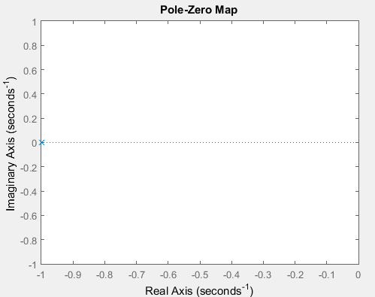

2. Enter the numerator : [1]
Enter the denominator : [1 10]
sys =
1
-----
s + 10
Continuous-time transfer function.
Graph –
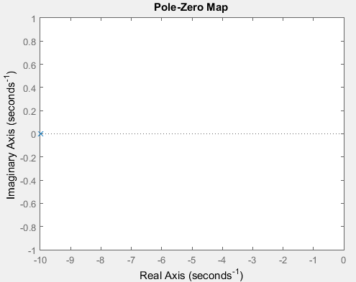
3.
Enter the numerator : [1 1]
Enter the denominator : [1 4 4]
sys =
( s + 1) / (s^2 + 4 s + 4)
Continuous-time transfer function.
Graph –
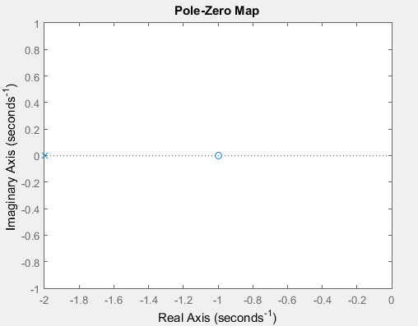
Experiment – 3
Aim –
To study the time response (rise time, delay time, %maximum overshoot, settling time) of second order control system for step response.
Code –
% Program for unit step response to find rise time and delay time
clc
n=input('Enter the numerator :');
d=input('Enter the denum :');
sys=tf(n,d)
S=stepinfo(sys,'RiseTimeLimits',[0.05,0.95])
step(sys)
grid on

Output –
- H(s)=(2s/s^2+6s+25)
Enter the numerator :[2]
Enter the denum :[1 6 25]
sys =
2
--------------
s^2 + 6 s + 25
Continuous-time transfer function.

S =
RiseTime: 0.4400
SettlingTime: 1.1887
SettlingMin: 0.0774
SettlingMax: 0.0876
Overshoot: 9.4773
Undershoot: 0
Peak: 0.0876
PeakTime: 0.7829
Graph –
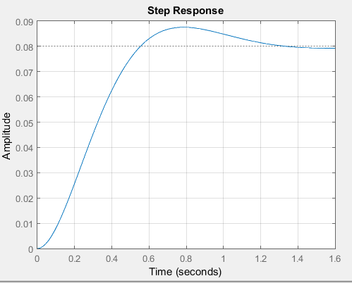
2.
H(s)= (1/ s^2 +0.2s+1)
Enter the numerator :[1]
Enter the denum :[1 0.2 1]
sys =
1 / s^2 + 0.2 s + 1
Continuous-time transfer function.
S = RiseTime: 1.3030
SettlingTime: 38.3730
SettlingMin: 0.4685
SettlingMax: 1.7292
Overshoot: 72.9156
Undershoot: 0
Peak: 1.7292
PeakTime: 3.1416
Graph –
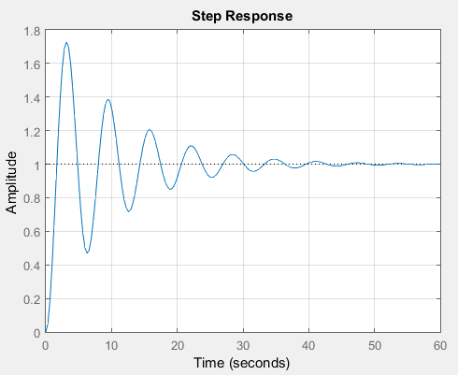
3.
h(s) = 2s + 1 / s^2 + s +1;
Enter the numerator :[2 1]
Enter the denum :[1 1 1]
sys =
2 s + 1 / s^2 + s + 1
Continuous-time transfer function.
S = RiseTime: 0.5412
SettlingTime: 7.3836
SettlingMin: 0.8860
SettlingMax: 1.6991
Overshoot: 69.9080
Undershoot: 0
Peak: 1.6991
PeakTime: 1.8421
Graph –
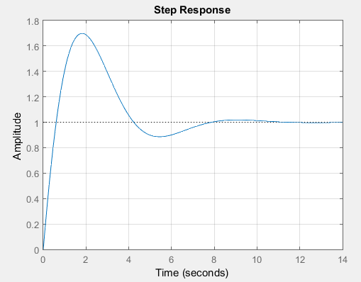

Aim –
To find rise time and delay time for unit step response.
Code –
% Program for unit step response to find rise time and delay time
clc
sys=tf([8 18 32],[1 6 14 24])
S=stepinfo(sys,'RiseTimelimits',[0.05,0.95])
step(sys)
grid on

Output –
sys =
8 s^2 + 18 s + 32
-----------------------
s^3 + 6 s^2 + 14 s + 24
Continuous-time transfer function.
S =
RiseTime: 0.2393
SettlingTime: 3.4972
SettlingMin: 1.1956
SettlingMax: 1.6871
Overshoot: 26.5302
Undershoot: 0
Peak: 1.6871
PeakTime: 0.5987

Graph –
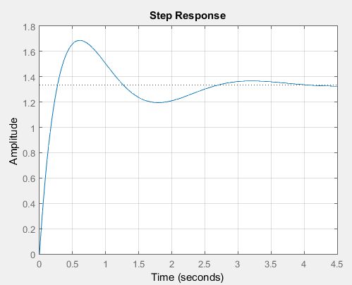

Experiment – 4
Aim –
Study of P, PI, PD and PID Controller.
Apparatus Required –
MATLAB Software
Theory –
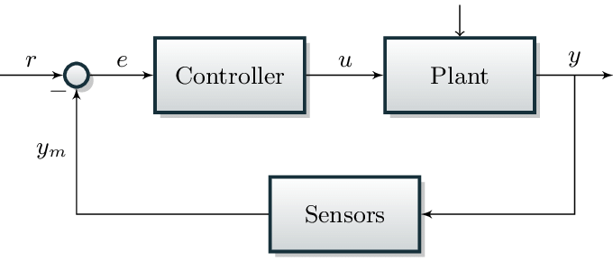
When the plant’s performance isn’t as per the system’s requirements, a closed loop control system can be handy, instead of a new plant. The error between the actual and the required outputs derived the controller. This controller in turn produces the necessary correcting actions upon the plant pulling the actual output towards the required one. The easiest approach is to produce the actuating signal u proportional to the error, the more is the error, the higher will be the actuating signal magnitude. This allows the actual output to follow the required output. This is the Proportional controller. This controller is useful when the error is under some limit.
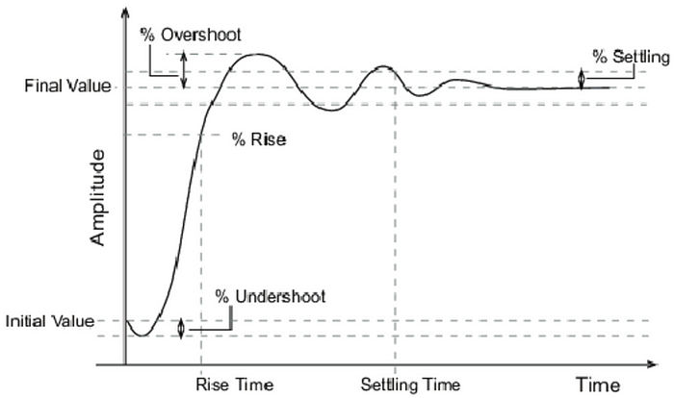

PD Controller
Practically, no single controller can serve the purpose. It needs multiple controllers work together to meet the requirements. Whenever, it’s needed to speed up the transient period, we add proportional control and the overshoot and the oscillatory problems need the derivative control. This calls for Proportional- Derivative controller (PD Controller). Special care must be taken to ensure that the signals are noiseless, else the noise can get amplified by the derivative actions and creates stability problems to the plant.

PI Controller
This helps in the situation where proportional control is necessary to speed up the settling and integral control to reduce the error that is constant over time. This is Proportional Integral controller (PI controller).

PID Controller
More general case would be to address all the above discussed problems with a single solution. In this case all the three controllers are used in parallel will appropriately chosen gains. Adjusting these gains, any combination of P,I,D controllers can be obtained and hence a more robust one.
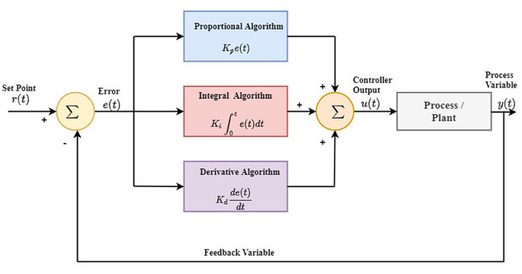
The three gains — Kp, Ki and Kd for the Proportional, Integral and Derivative controller actions can decide the contribution of each one in the final controller action.

Code –
% Open loop step reponse
num = 1;
den = [1 10 20];
plant = tf(num,den);
step(plant)
title('open loop step response')

% Proportional control
Kp= 300;
contr = Kp;
sys_cl = feedback(contr*plant,1);
t=0:0.01:2;
step(sys_cl,t)
title('Poportional Control')

% Proportional-Derivative control
Kp=300;
Kd=10;
contr=tf([Kd Kp],1);
sys_cl=feedback(contr*plant,1);
t=0:0.01:2;
step(sys_cl,t)
title('Poportional-Derivative Control')

% Proportional-Integral control
Kp=30;
Ki=70;
contr=tf([Ki Kp],[1 0]);
sys_cl=feedback(contr*plant,1);
t=0:0.01:2;
step(sys_cl,t)
title('Proportional-Integral control')

% Proportional-Integral-Derivative control
Kp=350;
Ki=300;
Kd=50;
contr=tf([Kd Kp Ki],[1 0]);
sys_cl=feedback(contr*plant,1);
t=0:0.01:2;
step(sys_cl,t)
title('Proportional-Integral-Derivative control')
Output –

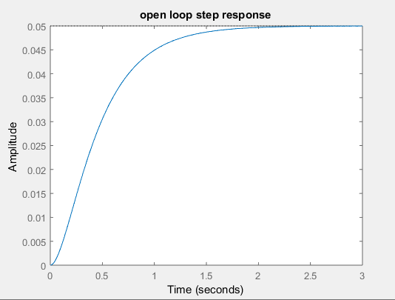

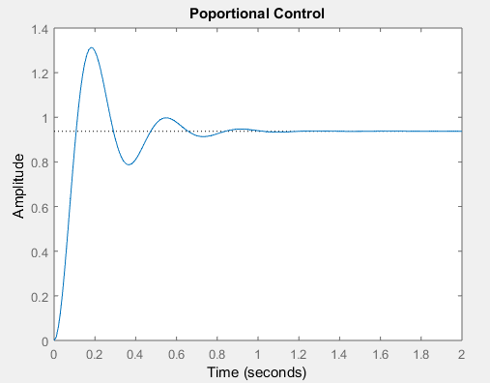
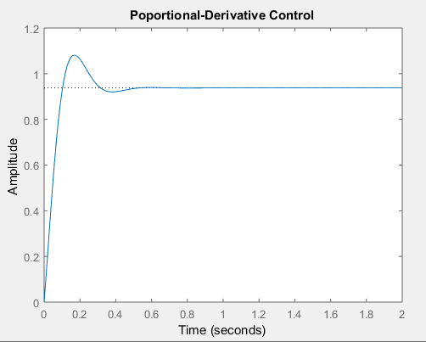

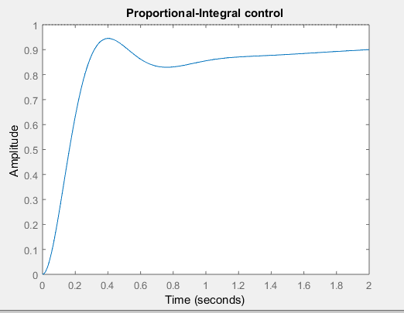
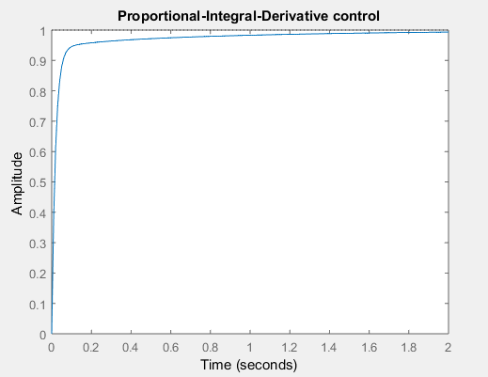

Result –
We have successfully drawn the characteristics of P, PI, PD and PID Controller.

