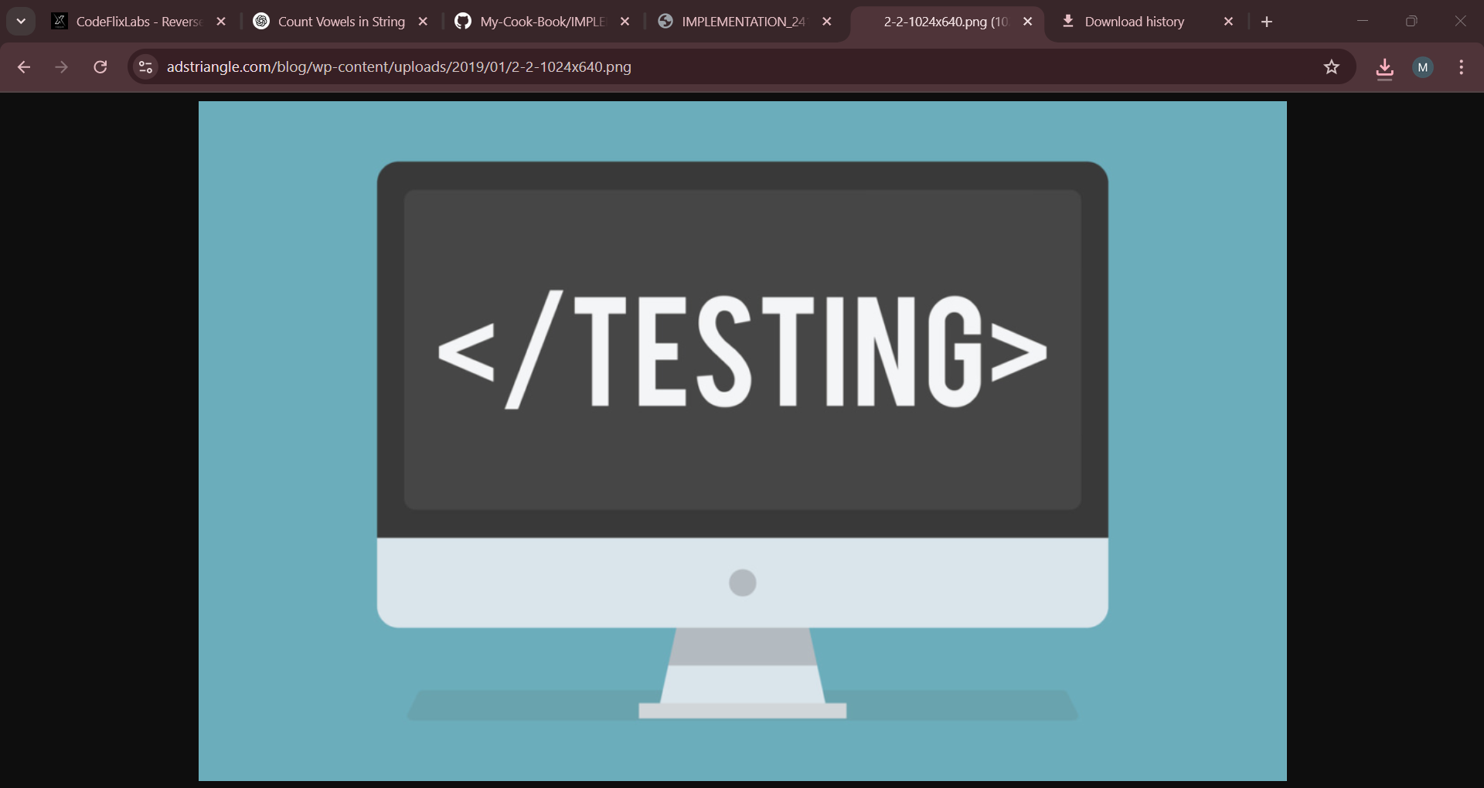

TESTING

QUality assurance through systematic web testing

Kanika – 2410991389

Mahima Arora – 2410991393

Manisha- 2410991400

Mansi- 2410991407

Manya- 2410991412

# **✅ Testing Report for "My Cook Book"**

**🧱 1. Unit Testing (Small Parts of Code)**

| **Component** | **Tested** | **Working?** | **Comments** |
| --- | --- | --- | --- |
| Navbar | ✅ | ✅ | Fully working, responsive |
| Search Bar | ❌ | ❌ | Present but no JavaScript logic added |
| Recipe Cards | ✅ | ✅ | Cards display recipes correctly |
| Modals (View Recipe) | ✅ | ✅ | Opens recipes in modal view |
| Forms (Signup/Login) | ✅ | 🟡 | Fields exist, but logic for real login missing |
| Footer | ✅ | ✅ | Static footer, loads well |

**🔄 2. Integration Testing (Components Together)**

| **Integration** | **Working?** | **Notes** |
| --- | --- | --- |
| Cards + Modals + Navbar | ✅ | Everything loads correctly |
| Navigation between pages (home, signup, login, contact) | ✅ | Works if file names are correct |
| Search + Card Filtering | ❌ | No code linked to #search-input or button |
| Forms + Redirects | 🟡 | Buttons use <a href="home.html"> inside submit, which is wrong |

**3. Form Validation Testing**

**✅ Signup Page**

| **Field** | **Validation Present** | **Test Passed?** | **Suggestion** |
| --- | --- | --- | --- |
| Name | [A-Za-z\s]+ | ✅ | Good |
| Phone | \d{10} | ✅ | ✅ |
| Email | HTML5 type | ✅ | ✅ |
| Pincode | \d{6} | ✅ | ✅ |
| Password | Regex (upper, lower, digit, 8+) | ✅ | Well done |
| Submit Button | onsubmit="return validateForm()" | ✅ | JS validation is there |

**🟡 Login Page**

| **Issue** | **Fix** |
| --- | --- |
| Button wraps <a href="home.html">Sign Up</a> inside submit | ❌ Not correct HTML |
| ✅ Fix: Use only <button type="submit">Login</button> and handle redirection via JS or backend logic |  |

**📱 4. Responsive Testing (Mobile + Tablet + Desktop)**

| **Device** | **Result** | **Comments** |
| --- | --- | --- |
| Desktop | ✅ | Layout looks good |
| Mobile | 🟡 | Navbar collapses nicely but recipe cards may stack oddly |
| Tablet | ✅ | Good balance between layout and card spacing |

* ✅ Use **Chrome DevTools → Toggle Device Toolbar** to check yourself too

**🧩 5. Code & Layout Issues**

| **Problem** | **Fix** |
| --- | --- |
| id="#punjabi" etc. | ❌ IDs can't have #. Use id="punjabi" instead |
| Multiple id="cards-container" | ❌ All IDs should be unique |
| Some **image paths may be broken** | ✅ Double check that all files like images/matar.jfif, images/samosa.jpg exist in folder |
| Minor spelling/grammar issues | E.g., “letin” instead of “lentil”, “cummin” → “cumin” |

**🛠️ 6. Functional Suggestions**

| **Feature** | **Suggestion** |
| --- | --- |
| 🔍 Search Bar | Add JS to filter recipe cards live (I can help you with the code!) |
| 📝 Login/Signup | Connect backend or use localStorage to store user data temporarily |
| 🍽 Modal Recipes | Consider grouping recipes using tags or filters in future |
| 📦 Assets | Organize all images and JS/CSS in respective folders before hosting |

**📋 Final Suggestions to Polish the Project**

* ✅ Fix broken IDs and image paths
* ✅ Remove <a> inside <button> in forms
* ✅ Add functional JavaScript for search
* ✅ Make layout fully mobile friendly
* ✅ Use GitHub to track issues if collaborating