**Bug Report Template**

|  |  |
| --- | --- |
| ID number | #1 |
| Bug Summary | In calculator app. It is possible to write simbols and letters |
| Reporter | ManyakGabrielyan |
| Submit Date | 27/10/2021 |
| Platform | Windows |
| Operating System | Windows 10 |
| Browser | Google Chrome 94.0.4606.81 |
| Severity | Critical |
| Priority |  |
| Status | open |
| Assigned to | QA/Developer/BA |
| Version | 4.0 |
| Environment | https://qwallity4.herokuapp.com/calculator |
| Component/tag |  |
| Screenshot/video | Screenshots are attached |

**Description**

In lines number1 and number 2 we can write symbols and letter, It is’t show the massege, that anything is wrong, but after click “calculate” butten feautered an <<500 internal server error>>

**Steps to reproduce**

1. Open the calculator application
2. In line “number1” write simbols and/or letter
3. In line “number2” write simbols and/or letter
4. Choose the operation
5. Click on button calculate

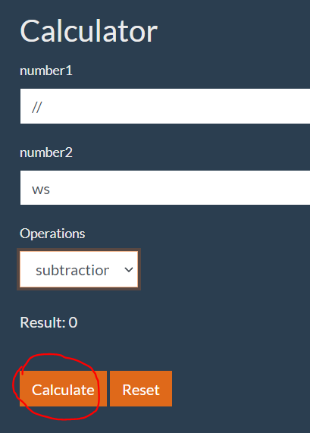

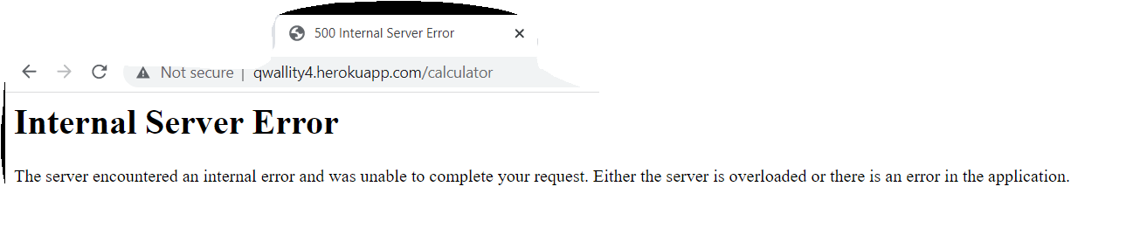

**Expected result**

It should not allow to write symbols or letters in calculator app.

**Actual result**

In fields number 1 and number 2 it’s possible to write simbols or/and letter. Itis’t show the notification, that it’s impossible. And after click “calculate” , show error.

**Bug Report Template**

|  |  |
| --- | --- |
| ID number | #2 |
| Bug Summary | The multiplication operation calculate is wrong in any cases |
| Reporter | ManyakGabrielyan |
| Submit Date | 27/10/2021 |
| Platform | Windows |
| Operating System | Windows 10 |
| Browser | Google Chrome 94.0.4606.81 |
| Severity | Critical |
| Priority |  |
| Status | open |
| Assigned to | QA/Developer/BA |
| Version | 4.0 |
| Environment | https://qwallity4.herokuapp.com/calculator |
| Component/tag |  |
| Screenshot/video | Screenshots are attached |

**Description:**

When we use fractional numbers, the multiplication operation calculate is wrong in any cases

**Steps to reproduce**

1. Open the calculator application
2. In field number1 fill for ex. 236.1 or 236.75
3. In field number2 fill for ex.26 or 26.2
4. Choose the operation multiplication
5. Click the button ‘calculate’

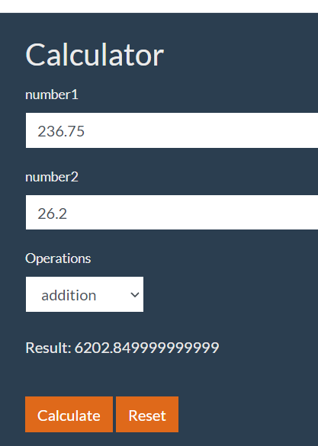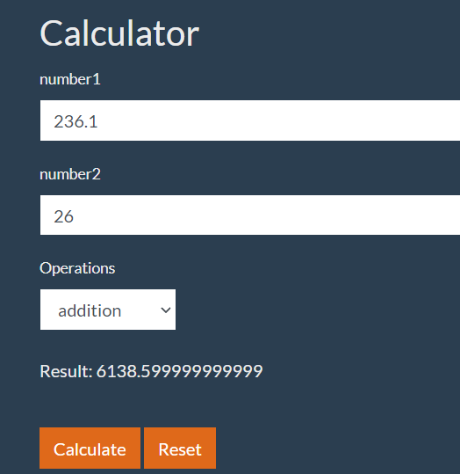

**Expected result**

It’s should be received exact result /6138.6 and 6202.85/.

**Actual result**

The result is wrong. 236.1*26 = 6138.6 but in this calculato multiplication received result is 6138.599999999