BCSE497J – PROJECT-I
INTELLIGENT CAREER GUIDANCE AND RESUME OPTIMIZATION PLATFORM USING AI
Submitted by
MANYA KOTHARI ([REGISTRATION NUMBER])
Under the Supervision of
[GUIDE NAME]
[GUIDE DESIGNATION]
B.Tech.
in
Computer Science and Engineering
[SPECIALIZATION, IF APPLICABLE]
School of Computer Science and Engineering (SCOPE)
September 2026

ABSTRACT
Career preparation for students is commonly distributed across disconnected resume tools, job descriptions, skill-practice resources, and assessment portals. Intelligent Career Guidance and Resume Optimization Platform Using AI addresses this fragmentation through a secure, student-centric web platform that links profile and resume management with explainable career-preparation workflows. The implemented system uses a React and TypeScript progressive web interface, a Spring Boot modular-monolith backend, PostgreSQL persistence, Flyway migrations, and JWT-based access control. Resume documents are validated, stored locally for development, parsed, and evaluated using deterministic ATS-oriented rules. Gemini provides qualitative writing feedback when available, while retry, live model fallback, and graceful partial-result behavior preserve deterministic findings during provider failures.
For role preparation, resumes are compared with job descriptions through skill coverage, TF-IDF/cosine keyword similarity, experience, education, and an optional semantic component. Required, preferred, and optional skill contexts are retained so missing high-priority skills are surfaced clearly. The assessment module provides technical, aptitude, role-oriented, and placement mock tests. Exactly ten questions are selected from stored banks, snapshotted per attempt, timed server-side, graded deterministically, and summarized by skill and difficulty. Students may start assessments immediately or schedule, reschedule, cancel, start, and continue their own scheduled examinations.
At the Review-2 milestone, the integrated platform is substantially implemented and verified through automated backend tests, packaging, Flyway V12, and frontend builds. Advanced personalization, notifications, proctoring, deployment, and final interface polish remain planned. The evidence supports an overall completion estimate of approximately 72%, within the required Review-2 implementation band.
Keywords—Career intelligence, resume analysis, applicant tracking system, job matching, skill gap, assessment engine, Gemini.

TABLE OF CONTENTS
Section | Contents
1 | Introduction
2 | Project Description and Goals
3 | Technical Specification
4 | Design Approach and Details
5 | References

1. INTRODUCTION
1.1 Background
Students preparing for placements must interpret job descriptions, improve resumes, identify missing skills, practise technical and aptitude questions, and track results. These activities are frequently split across unrelated services. The resulting context switching makes progress difficult to measure and leaves students without a coherent explanation of how resume quality, role fit, and assessment performance relate. The official project provides a unified student workspace where these activities share authenticated ownership, persistent history, and consistent feedback.
1.2 Motivation
The project is motivated by the need for an explainable and practical preparation workflow rather than an opaque hiring decision system. Deterministic scores remain inspectable and independent of generative AI, while Gemini is limited to qualitative resume feedback with safe degradation. This hybrid design supports repeatable local results and useful language assistance without making provider availability a prerequisite for core operation.
1.3 Scope of the Project
Current scope includes authentication, profile and skills, resume upload/parsing/history, deterministic and Gemini-assisted resume analysis, job-description matching, skill-gap classification, assessment catalogues and timed attempts, result analytics, placement mocks, and student-owned scheduling. Planned scope includes personalized recommendations, notifications, proctoring controls, a combined readiness score, optional coding-platform integration, deployment, and final usability testing. These planned items are not presented as completed.

2. PROJECT DESCRIPTION AND GOALS
2.1 Literature Review
Research demonstrates strong methods for individual parts of employability support, but also exposes limitations in reciprocity, maintainability, bias, and fragmentation. The selected studies below directly inform resume screening, job matching, competency-gap analysis, and career recommendation.
Reference | Year | Problem | Method | Contribution | Limitation
[1] Reusens et al. | 2018 | Labor-market recommendation | Search/recommender evaluation | Reciprocity matters beyond predictive accuracy | Does not integrate preparation and assessment
[2] Colombo et al. | 2021 | Skill-to-occupation recommendation | Embeddings and graph database | Large-scale skill-driven occupation matching | Focuses on recommendation, not student workflow
[3] Kadam et al. | 2022 | Resume screening | NLP extraction and feature matching | Ranks resumes against role needs | Recruiter-centric; limited preparation feedback
[4] CoBERT study | 2023 | Student employability profiles | Contextual BERT recommendation | Uses student skills for contextual recommendations | Does not connect resume revision and timed practice
[5] ICSSAS study | 2023 | Resume analyser and job recommendation | GNN, NER, TF-IDF, cosine similarity | Combines resume screening and recommendations | Different architecture; assessment loop absent
[6] JobEdKG study | 2024 | Career skills and course recommendation | Knowledge graph and link confidence | Connects roles, skills, and learning resources | No integrated resume and assessment evidence loop
[7] CARIA | 2024 | Career and competency-gap recommendation | Modified Euclidean similarity | Personalized top-career and gap analysis | Questionnaire/domain constrained
[8] AI & Society study | 2025 | Bias in generative recruitment | NLP and prompt-based screening audit | Shows generative systems may reproduce gender bias | Reinforces need for transparent, bounded AI use
2.2 Research Gap
The literature offers effective solutions for resume ranking, occupation recommendation, and competency analysis, but these are commonly evaluated as separate systems. A defensible gap is the lack of a student-owned, explainable workflow that connects resume evidence, job-specific comparison, prioritized skill gaps, timed practice, scheduling, and persistent performance feedback. Intelligent Career Guidance and Resume Optimization Platform Using AI addresses this integration gap at project scale. It does not claim to replace career counsellors or production recruitment systems.
2.3 Objectives
• Build a secure student-centric career intelligence platform.
• Produce deterministic ATS-oriented resume feedback and optional Gemini writing feedback.
• Quantify resume–job compatibility and identify prioritized skill gaps.
• Provide technical, aptitude, role-oriented, and placement mock assessments.
• Grade attempts server-side and persist skill/difficulty analytics.
• Allow students to schedule and manage their own assessment attempts.
• Maintain explainable histories and graceful provider fallbacks.
2.4 Problem Statement
Students lack a single, evidence-driven environment for moving from resume preparation to role matching, skill improvement, assessment practice, and scheduling. The problem is to design and implement a secure platform that joins these stages while keeping scoring explainable, ownership enforced, answer keys protected, and optional AI failures non-destructive.
2.5 Project Plan
Phase | Work | Review-2 status
1 | Foundation, authentication, profile | Completed
2 | Resume management and parsing | Completed
3–4 | Deterministic analysis and Gemini integration | Substantially completed
5 | Job matching and skill gaps | Completed
6 | Assessments and placement mocks | Completed
7A | Student self-scheduling | Substantially completed
Remaining | Recommendations, notifications, proctoring, deployment, polish | Planned
Cross-cutting | Testing and documentation | In progress

3. TECHNICAL SPECIFICATION
3.1 Requirements
3.1.1 Functional
• FR1 Register, authenticate, refresh sessions, and reset passwords.
• FR2 Manage student profile and skills.
• FR3 Upload, validate, parse, list, download, and delete owned resumes.
• FR4 Generate deterministic resume analysis and optional Gemini feedback.
• FR5 Create immutable job matches and classify skill gaps.
• FR6 Browse assessment and placement-mock catalogues.
• FR7 Start timed attempts with ten persisted, non-duplicated question snapshots.
• FR8 Submit answers for deterministic server-side grading and analytics.
• FR9 View owned attempt history and results.
• FR10 Schedule, reschedule, cancel, start, and continue owned examinations.
3.1.2 Non-Functional
• Security: JWT authentication, BCrypt password hashing, role rules, ownership checks, and environment-based secrets.
• Reliability: deterministic results survive Gemini unavailability; provider calls use bounded retry/fallback.
• Data integrity: Flyway-managed constraints, immutable submitted attempts, and persisted question snapshots.
• Maintainability: modular-monolith packages separate controllers, services, repositories, entities, DTOs, and integrations.
• Usability: responsive React workspace, explicit unavailable states, timers, history, and feedback.
• Extensibility: provider interfaces and modular domains permit later embedding, notification, and proctoring capabilities.
3.2 Feasibility Study
3.2.1 Technical Feasibility
Java 21, Spring Boot 3.5.5, Maven, React, TypeScript, PostgreSQL 16, Docker, Flyway, and Gemini are supported technologies with mature tooling. The modular monolith reduces distributed-system overhead while preserving domain boundaries. Local Docker PostgreSQL and environment profiles make development reproducible.
3.2.2 Economic Feasibility
The principal stack is open source and runs locally. Development costs are therefore dominated by time, hardware already available for academic work, and optional Gemini usage. No unsupported production cost estimate is claimed.
3.2.3 Social Feasibility
The platform supports student self-improvement and explains component scores rather than making employment decisions. Privacy, bias, and over-reliance on generative feedback remain important constraints; sensitive resume data should be retained only as needed and AI outputs should be reviewed by users.
3.3 System Specification
3.3.1 Hardware Specification
Component | Recommended development requirement
Processor | Modern 64-bit dual/quad-core CPU
Memory | 8 GB RAM minimum; 16 GB preferred
Storage | At least 5 GB free for dependencies, containers, and uploads
Network | Internet access only for Gemini and dependency retrieval
GPU | Not required by the current application
3.3.2 Software Specification
Layer | Verified technology
Frontend | React 19, TypeScript, Vite 7, Tailwind CSS, React Router, TanStack Query, Axios, Recharts, Framer Motion
Backend | Java 21, Spring Boot 3.5.5, Maven, Spring Web/Security/Data JPA/Validation/Actuator
Database | PostgreSQL 16 with pgvector image; Flyway migrations V1–V12
Development | Windows, Docker Compose, Git
External AI | Google Gemini; configured model with live discovery fallback
API documentation | Springdoc OpenAPI / Swagger UI

4. DESIGN APPROACH AND DETAILS
4.1 System Architecture
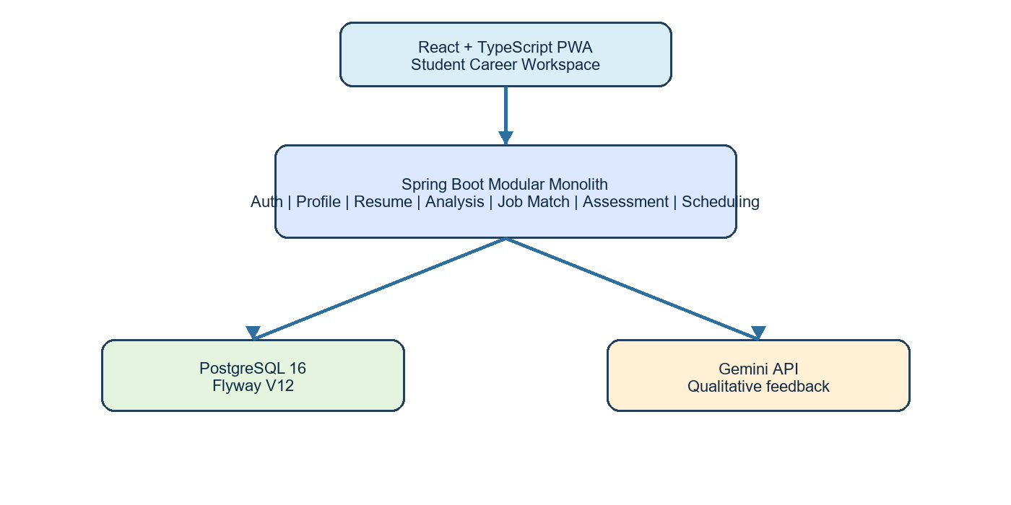
Fig. 1. Official project system architecture
The browser communicates through REST/JSON using JWT bearer authentication. Domain services enforce ownership and persist state through Spring Data JPA. Flyway evolves the PostgreSQL schema. Gemini receives bounded resume text and a structured prompt only when AI is enabled; deterministic ATS scoring is computed independently.
4.2 Design
4.2.1 Data Flow Diagram
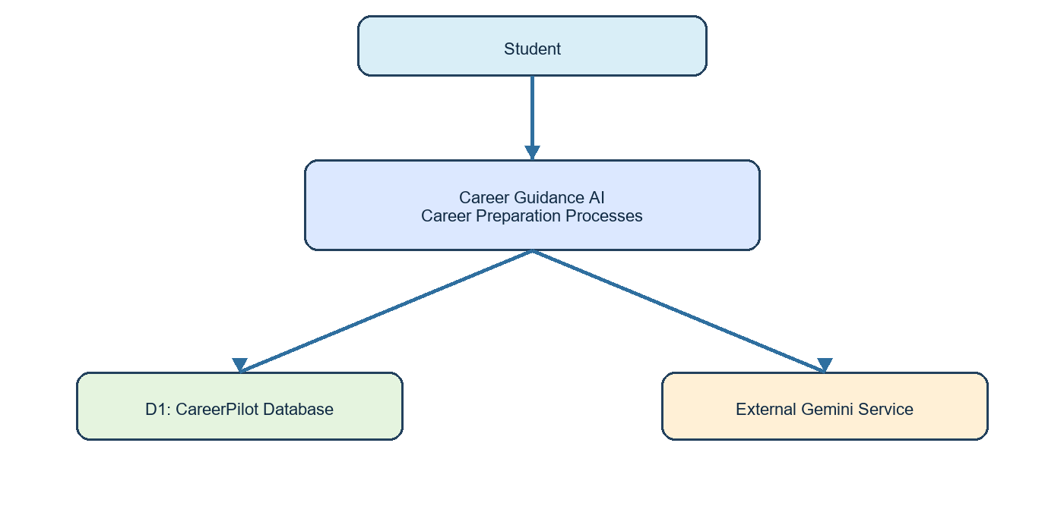
Fig. 2. DFD Level 0 / context view
Level-1 processes comprise authentication/profile, resume processing, resume intelligence, job matching, assessment management, scheduling, and result analysis. Persistent stores retain owned domain history; Gemini is an external, optional qualitative-feedback provider.
4.2.2 Use Case Diagram
Actor | Current use cases
Student | Register/login; manage profile; upload and analyse resume; create job match; view skill gaps; browse/start assessments; schedule/reschedule/cancel; submit; view results/history
Gemini API (external) | Return structured qualitative resume feedback when enabled and available
Administrator | Authentication role exists, but current scheduling routes are student-owned; legacy V11 assignment structures are not the active workflow
4.2.3 Major Domain Relationships
Parent | Relationship | Child
User | owns | Profile, Resume, JobMatch, AssessmentAttempt, ScheduledExam
Resume | has history | ResumeAnalysis and AnalysisFinding
JobMatch | contains | JobMatchSkill
Assessment | contains | Question and Option banks
AssessmentAttempt | snapshots | AttemptQuestion and submitted Answer
ScheduledExam | links after start | AssessmentAttempt
ScheduledExam | audits | RescheduleHistory
4.3 Current Implementation and Review-2 Outcome
Module | Status | Evidence / verification
Authentication & profile | Completed | JWT, BCrypt, role security, ownership tests
Resume management | Completed | PDF/DOCX validation, parsing, storage, history
Resume intelligence | Substantially completed | Deterministic ATS plus Gemini retry/live fallback; graceful PARTIAL
Job matching | Completed | Skill coverage, TF-IDF/cosine, experience, education; semantic redistributes when unavailable
Assessments & mocks | Completed | Stored banks, randomized ten-question snapshots, timer, grading, analytics
Student scheduling | Substantially completed | Create/list/reschedule/cancel/start/continue; V12 ownership
Notifications/proctoring/deployment | Planned | No production implementation in current repository
Automated verification on 1 September 2026: Maven clean test and clean package passed with 62 tests, zero failures, zero errors, and three intentionally skipped live-provider tests. The frontend production build previously passed. Flyway validates twelve migrations and the live PostgreSQL schema is at V12. A stale local backend process caused one scheduling browser error; current source and V12 insert behavior were verified, and restarting the backend is required for final browser confirmation.
4.4 Algorithm and Security Notes
Resume scoring uses deterministic section (30), keyword (20), action-verb (20), quantification (15), and readability (15) components. Gemini qualitative findings are parsed, validated, grounded against resume text, retried for transient failures, and may use a live-discovered Flash fallback. Job matching is configured for skill 40, keyword 20, semantic 25, experience 10, and education 5; unavailable components are excluded and remaining weights normalized. Required skill importance outranks preferred and optional. Assessment answer keys and explanations are omitted before submission, timing and grading are server-authoritative, and submitted attempts are immutable.
4.5 Evidence-Based Progress
Area | Status | Approx. completion
Core platform/security | Completed | 95%
Resume intelligence | Substantially completed | 85%
Job matching/skill gap | Completed | 90%
Assessments/placement mocks | Completed | 90%
Student scheduling | Substantially completed | 80%
Advanced personalization | Planned | 10%
Notifications/proctoring | Planned | 0%
Deployment/final polish | In progress | 20%
Weighted across the intended final project scope, the present evidence supports approximately 72% completion. This estimate is a Review-2 planning measure rather than a tested performance statistic.

5. REFERENCES
[1] M. Reusens, W. Lemahieu, B. Baesens, and L. Sels, “Evaluating recommendation and search in the labor market,” Knowledge-Based Systems, vol. 152, pp. 82–98, 2018, doi: 10.1016/j.knosys.2018.04.007.
[2] E. Colombo, F. Mercorio, and M. Mezzanzanica, “Skills2Job: A recommender system that encodes job offer embeddings on graph databases,” Applied Soft Computing, vol. 101, 107049, 2021.
[3] R. Kadam, G. Suhas, U. Mukri, and S. Khandare, “NLP-Based Resume Screening and Job Recruitment Portal,” in Data Intelligence and Cognitive Informatics, Springer, 2022, pp. 1–21, doi: 10.1007/978-981-16-6460-1_1.
[4] “CoBERT: A Contextual BERT model for recommending employability profiles of information technology students in unstable developing countries,” Engineering Applications of Artificial Intelligence, vol. 125, 106728, 2023, doi: 10.1016/j.engappai.2023.106728.
[5] “An Advanced Real-Time Job Recommendation System and Resume Analyser,” in 2023 International Conference on Self Sustainable Artificial Intelligence Systems, IEEE, 2023, doi: 10.1109/ICSSAS57918.2023.10331788.
[6] “JobEdKG: An uncertain knowledge graph-based approach for recommending online courses and predicting in-demand skills based on career choices,” Engineering Applications of Artificial Intelligence, 107779, 2024, doi: 10.1016/j.engappai.2023.107779.
[7] “CARIA: A personalized career recommendation system,” International Journal of Information and Communication Technology Education, vol. 20, no. 1, 2024, doi: 10.4018/IJICTE.356499.
[8] Spring Boot Documentation, https://docs.spring.io/spring-boot/ (accessed Sep. 1, 2026).
[9] React Documentation, https://react.dev/ (accessed Sep. 1, 2026).
[10] PostgreSQL Documentation, https://www.postgresql.org/docs/ (accessed Sep. 1, 2026).
[11] Flyway Documentation, https://documentation.red-gate.com/flyway (accessed Sep. 1, 2026).
[12] Google Gemini API Documentation, https://ai.google.dev/gemini-api/docs (accessed Sep. 1, 2026).

