LinkLift

UCS503 Software Engineering Project Report

Mid – Semester Evaluation

Submitted By:
Manya Kaur-102303038
Mansa Verma-102303039

BE Second Year – COE
Group No.: 3C12

Submitted to: Dr. Ashima Singh


TABLE OF CONTENTS

S. No. Page No.
1. Project Selection Phase
1.1 Software Bid 3
1.2 Project Overview 5
2. Analysis Phase
2.1 Use Cases 8
2.1.1 Use-Case Diagrams 10
2.1.2 Use Case Templates 11
2.2 Activity Diagram and Swimlane Diagrams 24
2.3 Data Flow Diagrams (DFDs)
2.3.1 DFD Level 0 26
2.3.2 DFD Level 1 27
2.3.2 DFD Level 2 28
2.4 Software Requirement Specification in IEEE Format 30
2.5 User Stories and Story Cards 43

1. PROJECT SELECTION PHASE

1.1 Software Bid
UCS 503- Software Engineering Lab
Group : 3C12 Dated: 22/08/2025

Team Name: LinkLift
Team ID (will be assigned by Instructor):

Please enter the names of your Preferred Team Members. : 2

• You are required to form a three to four person teams
• Choose your team members wisely. You will not be allowed to change teams.

Name | Roll No | Project Experience | Programming Language used | Signature
Manya Kaur | 102303038 | Emotion Recognition using AI, SQL Based Music Database | Python, SQL
Mansa Verma | 102303039 | Emotion Recognition using AI, SQL Based Music Database | SQL, Python

Programming Language / Environment Experience

List the languages you are most comfortable developing in, as a team, in your order of preference. Many of the projects involve Java or C/C++ programming.

1. Python
2. JavaScript
3. C/C++

Choices of Projects:

Please select 4 projects your team would like to work on, by order of preference: [Write at-least one paragraph for each choice (motivation, reason for choice, feasibility analysis, etc.)]

 | Project Name | Unique Selling Point
First Choice | Campus Ride Sharing - LinkLift  A student-exclusive platform that helps students connect, chat, and book common rides when traveling home or to nearby destinations. It enables easy ride matching, cost sharing, and real-time coordination, making commuting simpler, faster, and more affordable. | A student-exclusive ride-sharing platform that connects college students traveling to the same destination, enabling safe, affordable, and hassle-free commuting through ride matching, cost sharing, and in-app communication.
Second Choice | Peer Skill Exchange - SkillHive  An exclusive platform where students exchange skills like video editing, coding, photography, or music lessons instead of money, fostering collaboration and networking across the campus. | Encourages peer-to-peer value exchange, promotes networking, and bridges skill gaps across departments.
Third Choice | AI Powered Doubt Pool - Doubtify  Helps students submit doubts anonymously, faculty identify collective confusion areas, and management track subjects needing improvement. | Helps faculty identify collective confusion points, not just the doubts of a few vocal students.
Fourth Choice | AI Powered Lost and Found Tracker - LostLink  A digital campus Lost & Found system powered by AI that replaces cluttered mails. Students can upload photos or descriptions of lost items, while others can report found belongings. The system uses smart-matching algorithms to connect lost and found reports efficiently, minimizing delays and confusion. | Streamlines item recovery and systematic tracking, improving efficiency for students, faculty, and management.

Additional Remarks/ Inputs

Please tell us about any other factors that we should take into consideration (e.g., if you really would like to work on a project for some particularly convincing reason).

The project we are selecting is LinkLift – a secure ride sharing platform for students.

- Solves a Real, Frequent Problem: Addresses the high cost and inconvenience of student travel (campus to home/city).
- Unique & Targeted User Base: It's an exclusive platform for verified students, creating a trusted, closed network unlike public ride-sharing apps.
- Core Safety Focus: Primary motivation is enhancing student safety through mandatory verification and integrated SOS/live tracking features.
- Financial Value: Provides an affordable commute solution by automating the fair calculation and splitting of expenses.
- Technical Challenge: Requires development of a complex Smart Matching Algorithm and real-time systems, demonstrating advanced skills.

1.2 Project Overview

LinkLift – Smart Campus Ride Sharing

Executive Summary
Traveling between campus and hometowns is a recurring challenge for students. High cab fares, limited transport options, and poor coordination often lead to expensive and inconvenient journeys.
LinkLift is a student-exclusive ride-sharing platform that solves these issues by enabling students to connect, coordinate, and share rides with peers traveling to the same destination. With built-in safety features, automated fare-splitting, and real-time updates, LinkLift makes intercity and intracity commuting more affordable, safer, and sustainable.

Solution Overview
LinkLift provides:
Dedicated Platform: Students post travel plans and find peers heading in the same direction.
Smart Ride Matching: Intelligent filters suggest compatible travel partners based on time, date, and destination.
In-App Chat & Notifications: Streamlined coordination without external apps.
Automated Cost-Sharing: Transparent, hassle-free splitting of travel expenses.
Verified & Safe Community: Only authenticated students gain access, ensuring trust and safety.

Unique Selling Propositions (USPs)
- Campus-Exclusive Network: Unlike generic ride-sharing apps, LinkLift is exclusively for verified students.
- Trusted & Secure: Verification via student ID/email + optional background checks.
- Affordable Commute: Automated and fair cost-splitting reduces travel expenses.
- Smart Travel Sync: AI-powered matching optimizes ride grouping to maximize seat utilization.
- Community-First: Builds student connections and peer networks beyond just commuting.
- Eco-Friendly Travel: Fewer cabs on the road, contributing to reduced carbon emissions.
- Safety Enhancements: Real-time ride tracking, SOS button, and emergency contact alerts.
- Future Value-Add: Integration of loyalty points, student discounts, and partnerships with local cab services.

Objectives
- Reduce commuting costs for students.
- Simplify intercity and intracity travel planning.
- Enhance student safety and trust in shared commuting.
- Build a campus-centered mobility ecosystem.
- Encourage eco-conscious travel habits.

Methodology
1. Research & Requirement Analysis – Gather insights into student travel needs.
2. Design & Development – Build a mobile-first, intuitive, and minimalistic platform.
3. Key Modules:
- Registration & Student Verification
- Ride Posting & Smart Matching
- In-App Chat & Push Notifications
- Automated Cost Splitter
- Safety Features (SOS, live tracking)
4. Testing & Deployment – Beta launch in one campus, collect feedback, scale further.

Deliverables & Outcomes
- A fully functional web/app platform.
- Student-exclusive, secure login system.
- AI-based ride matching and automated fare-splitting.
- Enhanced safety with tracking & emergency features.
- Affordable, eco-friendly, and convenient student mobility.

Look & Feel (Product Design)

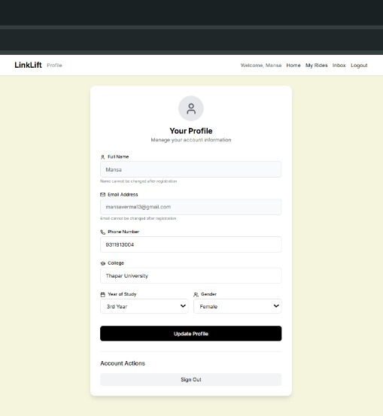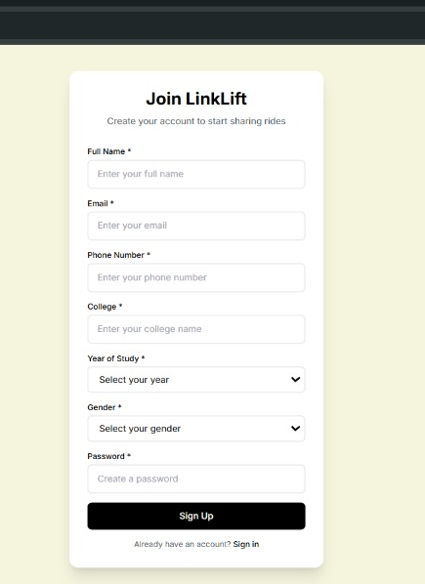
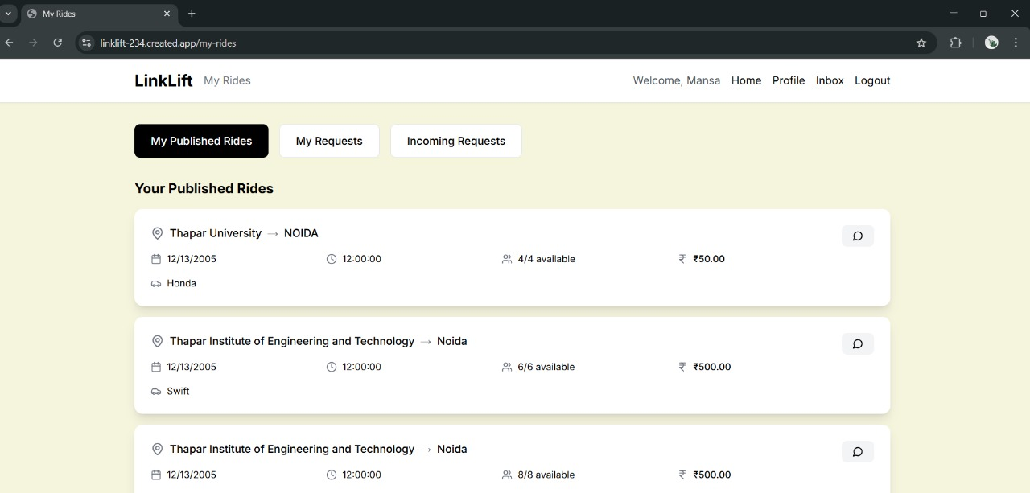

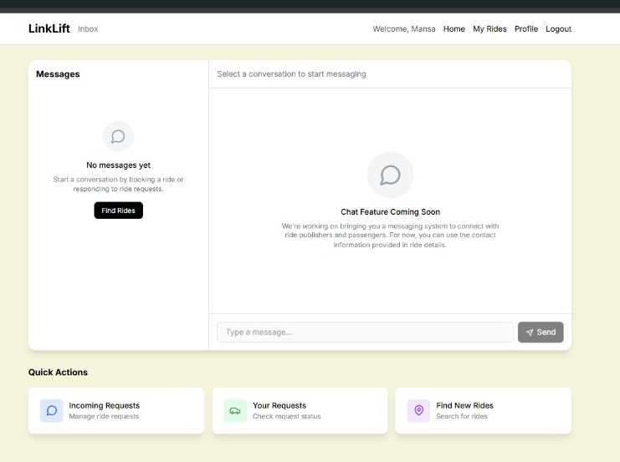

Scope of Application
- Primary: Intercity and intracity travel for students (home–campus).
- Future Expansion:
• Collaboration with cab aggregators for hybrid rides.
• Student discounts and reward-based loyalty programs.
• Expansion to inter-college networks across cities

2. ANALYSIS PHASE
2.1 Use Cases:
Use Case ID | Use Case Title | Description | Actors
1 | Login | Allows a registered user to log in using email or phone and password. | User
2 | Signup | Enables a new user to create an account by providing personal details. | User
3 | Update Profile | Allows a logged-in user to update their personal information. | User
4 | Logout | Ends the user session and redirects to login. | User
5 | Search Ride | Enables users to search available rides based on location and date. | User
6 | Filter Women Only | Filters search results to show rides published only by women. | User
7 | Request Seat | Allows a user to request a seat in a selected ride. | User
8 | Cancel Ride/Request | Enables users to cancel published rides or seat requests. | User
9 | View My Rides | Displays a list of the user’s current and past rides. | User
10 | View Ride Details | Shows detailed information about a selected ride. | User
11 | Chat/Inbox | Facilitates communication between requester and publisher. | User
12 | Rating and Feedback | Allows users to submit ratings and feedback after a ride. | User
13 | Forgot Password | Helps users recover their account password via email or phone verification. | User
14 | Verify Email/Phone | Verifies user email or phone during registration or updates using OTP/link. | System
15 | Create/Publish Ride | Enables users to publish new ride details. | User (Ride Creator)
16 | Manage Ride Requests | Allows publishers to approve or reject seat requests. | User (Publisher)
17 | Send Requester Notification | Sends notification to requester after publisher’s action. | System
18 | Send Notification | Sends system-generated notifications triggered by events. | System
19 | Validate Input Field | Validates mandatory input fields and formats during form submissions. | System
20 | Auto-complete Location | Suggests common locations during pickup/drop entry. | System
21 | SOS Emergency Contact | Allows users to trigger emergency alerts notifying contacts and admin. | User
22 | View Feedback Report | Enables admin to view and review ride feedback. | Admin
23 | Manage Interface | Allows admin to update/manage the system interface. | Admin
24 | View & Manage Flagged User Report | Enables admin to view and manage flagged users. | Admin

2.1.1 Use Case Diagram
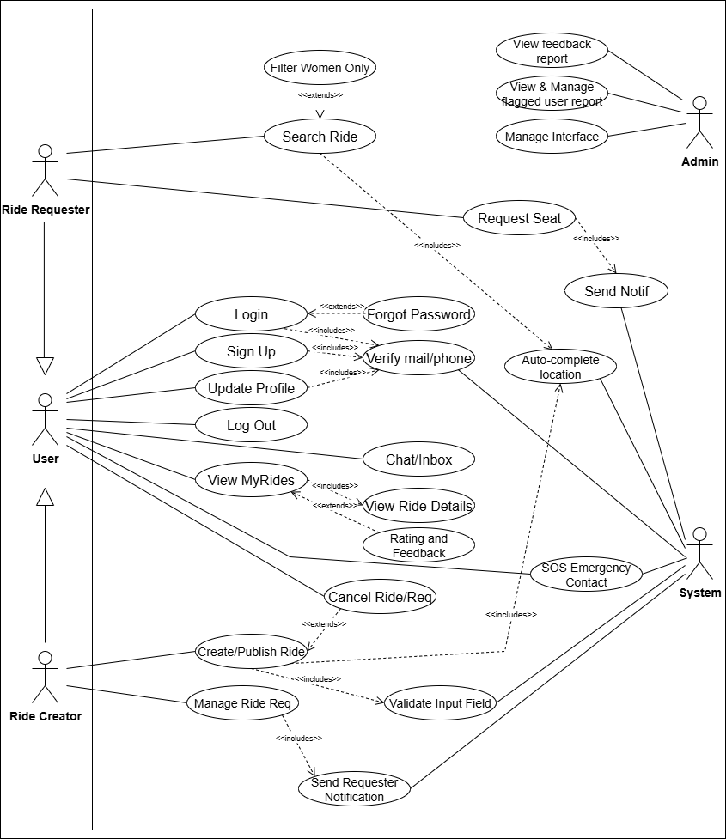

2.1.2 Use Case Templates
Use Case 1: Login
1. Use Case Title | Login
2. Abbreviated Title | Login
3. Use Case Id | 1
4. Actors | User
5. Description | Allows a registered user to login using email/phone and password.
5.1 Pre Conditions | User must be registered.  User must have valid credentials.
5.2 Task Sequence | 1. System displays login screen.  2. User enters email/phone and password.  3. System validates credentials.  4. If valid, user session starts and access is granted.  5. If invalid, system shows error.
5.3 Post Conditions | User successfully logged in.  Session created.
6. Modification History | Date 13-Oct-2025
7. Author | Mansa

Use Case 2: Signup
1. Use Case Title | Signup
2. Abbreviated Title | Signup
3. Use Case Id | 2
4. Actors | User
5. Description | Allows a new user to create an account in LinkLift.
5.1 Pre Conditions | User must not already have an account.
5.2 Task Sequence | 1. System displays signup form.  2. User fills Name, Year, Email, Phone, College, and Password.  3. System validates required fields.  4. System stores details in database.  5. System confirms account creation.
5.3 Post Conditions | Account created.  User can login.
6. Modification History | Date 13-Oct-2025
7. Author | Manya

Use Case 3: Update Profile
1. Use Case Title | Update Profile
2. Abbreviated Title | Update Profile
3. Use Case Id | 3
4. Actors | User
5. Description | Allows user to update personal information.
5.1 Pre Conditions | User must be logged in.
5.2 Task Sequence | 1. User navigates to profile settings.  2. User edits details.  3. System validates fields.  4. System updates details in database.  5. System confirms changes.
5.3 Post Conditions | Profile updated successfully.
6. Modification History | Date 13-Oct-2025
7. Author | Mansa

Use Case 4: Logout
1. Use Case Title | Logout
2. Abbreviated Title | Logout
3. Use Case Id | 4
4. Actors | User
5. Description | Ends the user session.
5.1 Pre Conditions | User must be logged in.
5.2 Task Sequence | 1. User clicks logout.  2. System ends session.  3. System redirects to login page.
5.3 Post Conditions | User logged out.  Session terminated.
6. Modification History | Date 13-Oct-2025
7. Author | Manya

Use Case 5: Search Ride
1. Use Case Title | Search Ride
2. Abbreviated Title | Search Ride
3. Use Case Id | 5
4. Actors | User
5. Description | Allows a user to search available rides.
5.1 Pre Conditions | User must be logged in.
5.2 Task Sequence | 1. System shows search form.  2. User enters Pickup, Drop, Date, Passengers.  3. Optional: select Women Only filter.  4. Click Search.  5. System validates input.  6. System fetches matching rides.  7. System displays results or 'No rides available'.
5.3 Post Conditions | Search results displayed.  User can request seat.
6. Modification History | Date 13-Oct-2025
7. Author | Mansa

Use Case 6: Filter Women Only
1. Use Case Title | Filter Women Only
2. Abbreviated Title | Filter Women Only
3. Use Case Id | 6
4. Actors | User
5. Description | Filters rides to show only women publishers.
5.1 Pre Conditions | User must be logged in.  Search criteria must be entered.
5.2 Task Sequence | 1. User selects Women Only option.  2. System applies filter to search results.  3. System displays filtered list.
5.3 Post Conditions | Filtered rides shown.
6. Modification History | Date 13-Oct-2025
7. Author | Manya

Use Case 7: Request Seat
1. Use Case Title | Request Seat
2. Abbreviated Title | Request Seat
3. Use Case Id | 7
4. Actors | User
5. Description | Allows a user to request a seat in a ride.
5.1 Pre Conditions | User must be logged in.  Ride must exist in search results.
5.2 Task Sequence | 1. User selects ride.  2. User clicks Request Seat.  3. System validates seat availability.  4. System sends notification to publisher.
5.3 Post Conditions | Seat request sent.  Publisher notified.
6. Modification History | Date 13-Oct-2025
7. Author | Mansa

Use Case 8: Cancel Ride/Request
1. Use Case Title | Cancel Ride/Request
2. Abbreviated Title | Cancel Ride/Request
3. Use Case Id | 8
4. Actors | User
5. Description | Allows a user to cancel a published ride or seat request.
5.1 Pre Conditions | User must be logged in.  User must have an active ride/request.
5.2 Task Sequence | 1. User selects ride/request.  2. User clicks Cancel.  3. System updates status in database.  4. System confirms cancellation.
5.3 Post Conditions | Ride/request cancelled.
6. Modification History | Date 13-Oct-2025
7. Author | Mansa

Use Case 9: View My Rides
1. Use Case Title | View My Rides
2. Abbreviated Title | View My Rides
3. Use Case Id | 9
4. Actors | User
5. Description | Displays user’s current and past rides.
5.1 Pre Conditions | User must be logged in.
5.2 Task Sequence | 1. User navigates to My Rides.  2. System retrieves rides from database.  3. System displays list.
5.3 Post Conditions | User can view all rides.
6. Modification History | Date 13-Oct-2025
7. Author | Manya

Use Case 10: View Ride Details
1. Use Case Title | View Ride Details
2. Abbreviated Title | View Ride Details
3. Use Case Id | 10
4. Actors | User
5. Description | Displays details of a selected ride.
5.1 Pre Conditions | User must be logged in.  Ride must exist.
5.2 Task Sequence | 1. User selects a ride.  2. System retrieves ride details.  3. System displays information.
5.3 Post Conditions | Ride details viewed.
6. Modification History | Date 13-Oct-2025
7. Author | Mansa

Use Case 11: Chat/Inbox
1. Use Case Title | Chat/Inbox
2. Abbreviated Title | Chat/Inbox
3. Use Case Id | 11
4. Actors | User
5. Description | Allows communication between requester and publisher.
5.1 Pre Conditions | User must be logged in.  Ride interaction must exist.
5.2 Task Sequence | 1. User opens Inbox.  2. System retrieves messages.  3. User sends/receives messages.
5.3 Post Conditions | Messages stored in database.  Chat updated.
6. Modification History | Date 13-Oct-2025
7. Author | Manya

Use Case 12: Rating and Feedback
1. Use Case Title | Rating and Feedback
2. Abbreviated Title | Rating and Feedback
3. Use Case Id | 12
4. Actors | User
5. Description | Allows users to give feedback after a ride.
5.1 Pre Conditions | User must have completed a ride.
5.2 Task Sequence | 1. User selects ride.  2. User submits rating and feedback.  3. System stores feedback in database.
5.3 Post Conditions | Feedback recorded.  Visible to admin/publisher.
6. Modification History | Date 13-Oct-2025
7. Author | Manya

Use Case 13: Forgot Password
1. Use Case Title | Forgot Password
2. Abbreviated Title | Forgot Password
3. Use Case Id | 13
4. Actors | User
5. Description | Helps user recover account when password is forgotten.
5.1 Pre Conditions | User must have registered email/phone.
5.2 Task Sequence | 1. User clicks Forgot Password.  2. System asks for email/phone.  3. User enters details.  4. System verifies and sends reset link/OTP.  5. User resets password.
5.3 Post Conditions | Password reset successfully.
6. Modification History | Date 13-Oct-2025
7. Author | Manya

Use Case 14: Verify Email/Phone
1. Use Case Title | Verify Email/Phone
2. Abbreviated Title | Verify Email/Phone
3. Use Case Id | 14
4. Actors | System
5. Description | Ensures authenticity of user email/phone.
5.1 Pre Conditions | User must be registering/updating details.
5.2 Task Sequence | 1. System sends OTP/email link.  2. User enters OTP/clicks link.  3. System validates entry.
5.3 Post Conditions | Email/Phone verified.
6. Modification History | Date 13-Oct-2025
7. Author | Mansa

Use Case 15: Create/Publish Ride
1. Use Case Title | Create/Publish Ride
2. Abbreviated Title | Create/Publish Ride
3. Use Case Id | 15
4. Actors | User (Ride Creator)
5. Description | Allows ride creator to publish new ride details.
5.1 Pre Conditions | User must be logged in.
5.2 Task Sequence | 1. System shows Publish Ride form.  2. User fills required details.  3. System validates fields.  4. System saves ride.  5. Ride published.
5.3 Post Conditions | Ride available for search.
6. Modification History | Date 13-Oct-2025
7. Author | Mansa

Use Case 16: Manage Ride Requests
1. Use Case Title | Manage Ride Requests
2. Abbreviated Title | Manage Ride Requests
3. Use Case Id | 16
4. Actors | User (Publisher)
5. Description | Allows ride publisher to approve/reject seat requests.
5.1 Pre Conditions | Publisher must have published rides.  Requests must exist.
5.2 Task Sequence | 1. Publisher views ride requests.  2. System shows pending requests.  3. Publisher accepts/rejects.  4. System updates status.
5.3 Post Conditions | Ride requests updated.  Requester notified.
6. Modification History | Date 13-Oct-2025
7. Author | Mansa

Use Case 17: Send Requester Notification
1. Use Case Title | Send Requester Notification
2. Abbreviated Title | Send Requester Notification
3. Use Case Id | 17
4. Actors | System
5. Description | System notifies requester about updates.
5.1 Pre Conditions | Requester must have an active request.
5.2 Task Sequence | 1. Publisher acts on request.  2. System generates notification.  3. System delivers to requester.
5.3 Post Conditions | Requester notified.
6. Modification History | Date 13-Oct-2025
7. Author | Mansa

Use Case 18: Send Notification
1. Use Case Title | Send Notification
2. Abbreviated Title | Send Notification
3. Use Case Id | 18
4. Actors | System
5. Description | Sends general system notifications.
5.1 Pre Conditions | Trigger event must exist.
5.2 Task Sequence | 1. System detects event.  2. System generates message.  3. Notification sent to user.
5.3 Post Conditions | User receives notification.
6. Modification History | Date 13-Oct-2025
7. Author | Mansa

Use Case 19: Validate Input Field
1. Use Case Title | Validate Input Field
2. Abbreviated Title | Validate Input Field
3. Use Case Id | 19
4. Actors | System
5. Description | Ensures required fields are correctly filled.
5.1 Pre Conditions | User must be filling a form.
5.2 Task Sequence | 1. User enters form details.  2. System checks mandatory fields.  3. System validates format (email, phone, etc.).  4. System accepts/rejects entry.
5.3 Post Conditions | Validated input accepted.
6. Modification History | Date 13-Oct-2025
7. Author | Mansa

Use Case 20: Auto-complete Location
1. Use Case Title | Auto-complete Location
2. Abbreviated Title | Auto-complete Location
3. Use Case Id | 20
4. Actors | System
5. Description | Suggests common locations during input.
5.1 Pre Conditions | User must be entering pickup/drop location.
5.2 Task Sequence | 1. User starts typing location.  2. System fetches suggestions (e.g., Gurugram, Noida, Thapar University).  3. User selects from suggestions.
5.3 Post Conditions | Location field auto-completed.
6. Modification History | Date 13-Oct-2025
7. Author | Manya

Use Case 21: SOS Emergency Contact
1. Use Case Title | SOS Emergency Contact
2. Abbreviated Title | SOS Emergency Contact
3. Use Case Id | 21
4. Actors | User
5. Description | Allows users to trigger emergency alert.
5.1 Pre Conditions | User must be logged in.  Ride must be active.
5.2 Task Sequence | 1. User clicks SOS button.  2. System notifies registered emergency contact and admin.  3. System shares location.
5.3 Post Conditions | Emergency contact alerted.
6. Modification History | Date 13-Oct-2025
7. Author | Manya

Use Case 22: View Feedback Report
1. Use Case Title | View Feedback Report
2. Abbreviated Title | View Feedback Report
3. Use Case Id | 22
4. Actors | Admin
5. Description | Allows admin to view ride feedback.
5.1 Pre Conditions | Feedback must exist.
5.2 Task Sequence | 1. Admin logs in.  2. Admin selects Feedback Report.  3. System displays feedback summary.
5.3 Post Conditions | Feedback reviewed.
6. Modification History | Date 13-Oct-2025
7. Author | Mansa

Use Case 23: Manage Interface
1. Use Case Title | Manage Interface
2. Abbreviated Title | Manage Interface
3. Use Case Id | 23
4. Actors | Admin
5. Description | Allows admin to update/manage interface.
5.1 Pre Conditions | Admin must be logged in.
5.2 Task Sequence | 1. Admin accesses settings.  2. System displays options.  3. Admin modifies interface.  4. System saves changes.
5.3 Post Conditions | Interface updated.
6. Modification History | Date 13-Oct-2025
7. Author | Mansa

Use Case 24: View & Manage Flagged User Report
1. Use Case Title | View & Manage Flagged User Report
2. Abbreviated Title | View & Manage Flagged User Report
3. Use Case Id | 24
4. Actors | Admin
5. Description | Allows admin to view/manage flagged users.
5.1 Pre Conditions | Users must have been flagged.
5.2 Task Sequence | 1. Admin selects flagged user report.  2. System displays flagged users.  3. Admin takes action (warn, block, delete).
5.3 Post Conditions | Flagged users managed.
6. Modification History | Date 13-Oct-2025
7. Author | Mansa

Normal Flow of Events:
- (SR) The LinkLift Web App displays the login/signup screen.
- (AA) The user selects Login or Signup.
- (AA) If Login is selected, the user enters email/phone and password.
- (SR) The Web App validates the login credentials.
- (SR) If credentials are valid, the user is logged in and redirected to the home page.
- (AA) If Signup is selected, the user fills in Name*, Year*, Email*, Phone*, College*, and Password*.
- (SR) The Web App validates signup details and creates a new user account.
- (SR) The user is logged in and redirected to the home page.
- (SR) The home page shows options: Publish Ride, Find Ride, Profile, Inbox, Logout.
- (AA) The user chooses to Publish a Ride.
- (AA) The user fills Pickup location*, Drop location*, Date*, Time*, Vehicle capacity*, Vehicle details*, Cost per person* (in INR), and optionally enables "Women Only" filter.
- (AA) The user enters passenger details: Name*, Year*, Gender* for each passenger.
- (SR) The Web App validates all required fields and publishes the ride.
- (SR) The published ride is visible to other users in Find Ride.
- (AA) Another user selects Find Ride, enters Pickup location*, Drop location*, Date*, Number of passengers*, and optionally "Women Only".
- (SR) The Web App suggests common Indian cities and university locations via smart autocomplete during pickup/drop entry.
- (SR) The system matches published rides with the user’s search criteria.
- (SR) Matching rides are displayed or "No rides available" if none match.
- (AA) The user selects a ride and sends a seat request to the ride publisher.
- (SR) The system sends a notification to the ride publisher about the request.
- (SR) The ride publisher accepts or rejects the seat request.
- (SR) Upon acceptance, the ride is booked and added to both users’ profiles under “Rides Booked” and “Published Rides”.
- (AA) The user can chat with the ride publisher through Inbox about ride details.
- (AA) The user can update their profile information anytime.
- (AA) The user can logout from the application.

Alternative Flow of Events:
4a. The user forgets their password and uses the "Forgot Password" option to reset it.
7a. The user cancels signup or closes the signup screen without completing the form.
10a. The user cancels publishing a ride before submission.
15a. The user modifies or clears the search criteria.
19a. The user cancels sending the seat request before confirmation.
24a. The user abandons profile update without saving changes.

Exception Flow of Events:
4b. Invalid login credentials cause an error message; user remains on login page.
7b. Signup fails if mandatory fields (*) are missing or email/phone is already registered.
13b. Publishing fails due to incomplete or invalid ride details; submission rejected.
18b. No matching rides found; system displays "No rides available".
20b. Notification to publisher fails due to network issues; user informed to retry.
21b. Publisher rejects the seat request; user notified of rejection.
23b. Chat message sending fails due to connectivity issues; user prompted to retry.

2.2 Activity Diagram
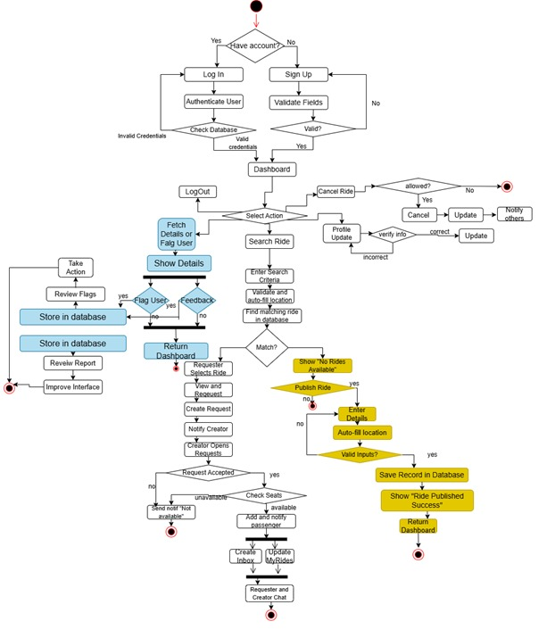

2.2 Swimlane Diagram
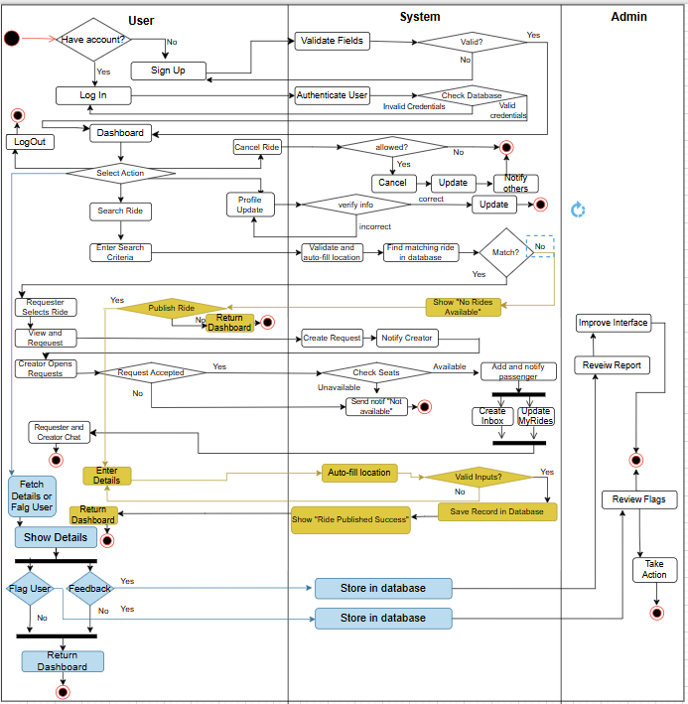

2.3 Data Flow Diagrams

2.3.1 Context Level DFD
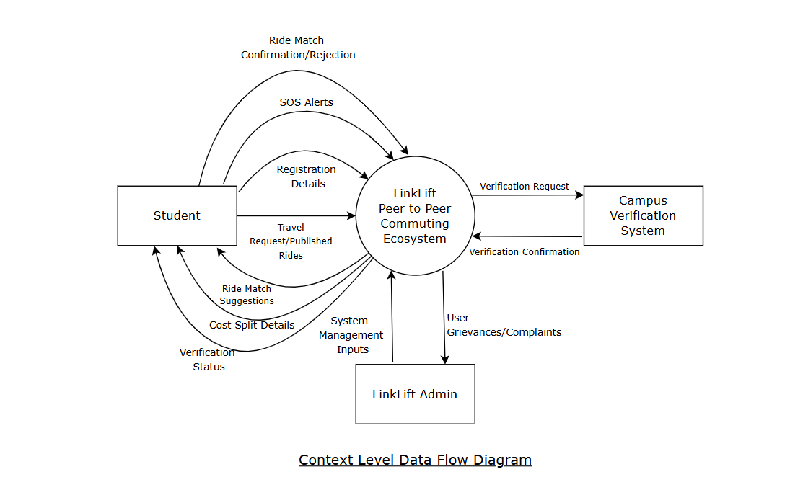

2.3.2 Level 1 DFD
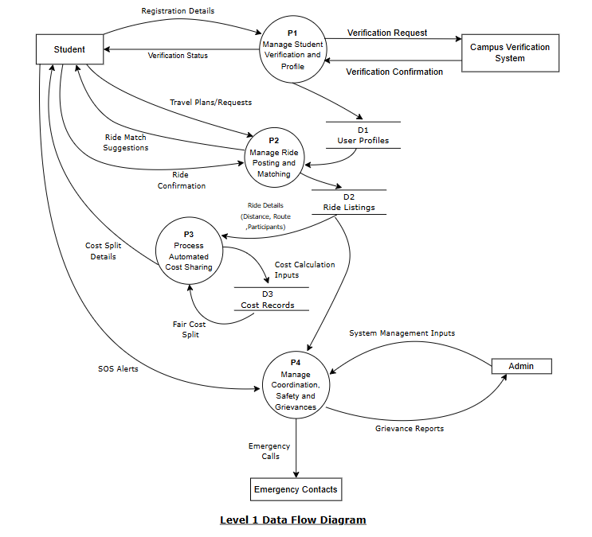

2.3.3 Level 2 DFD
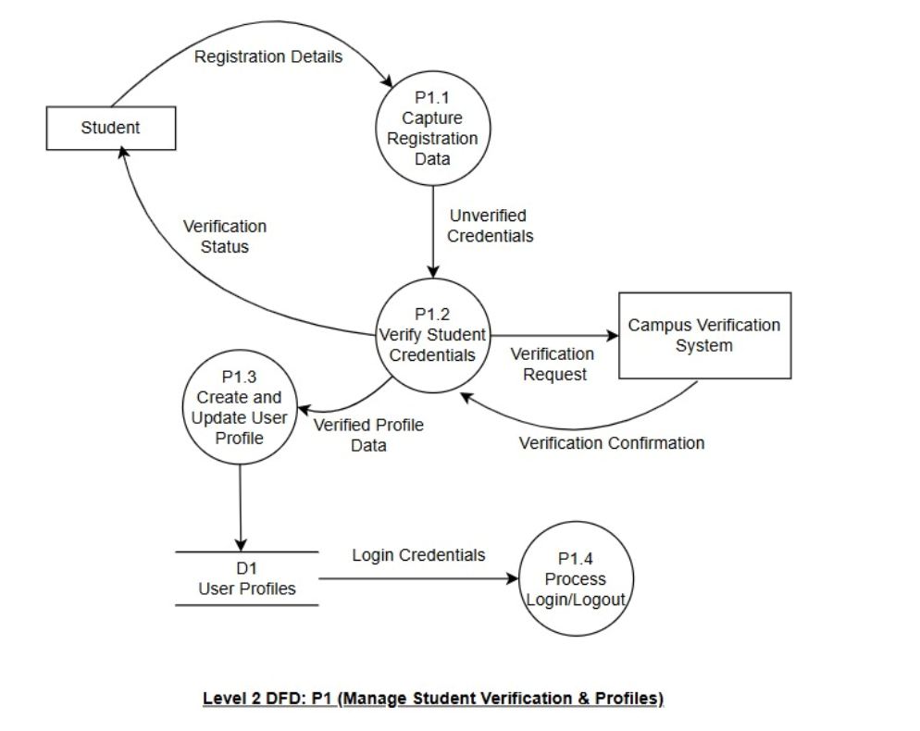

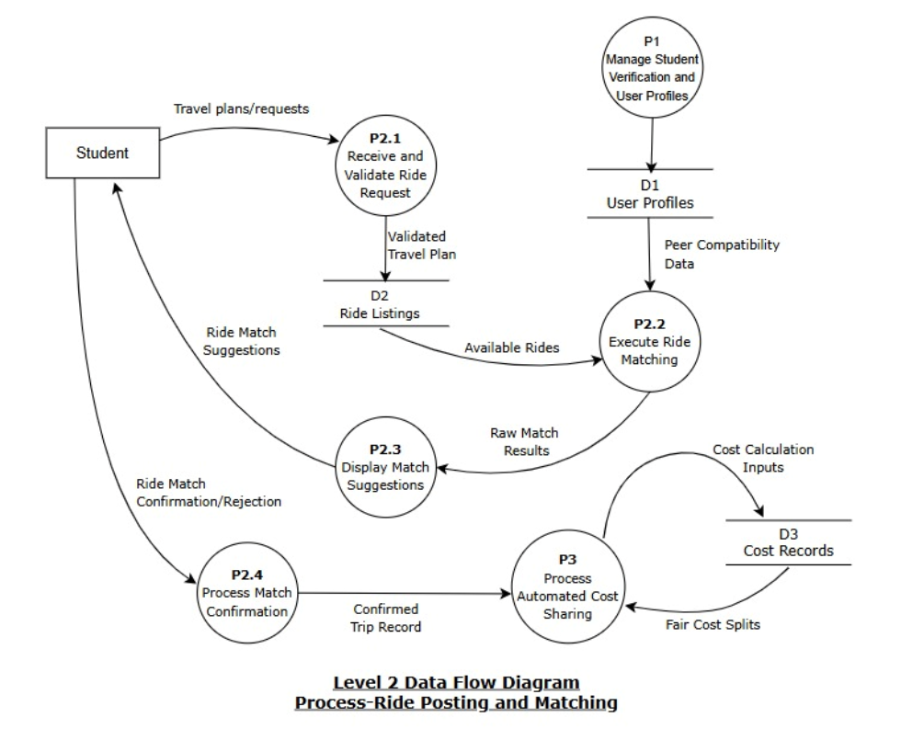
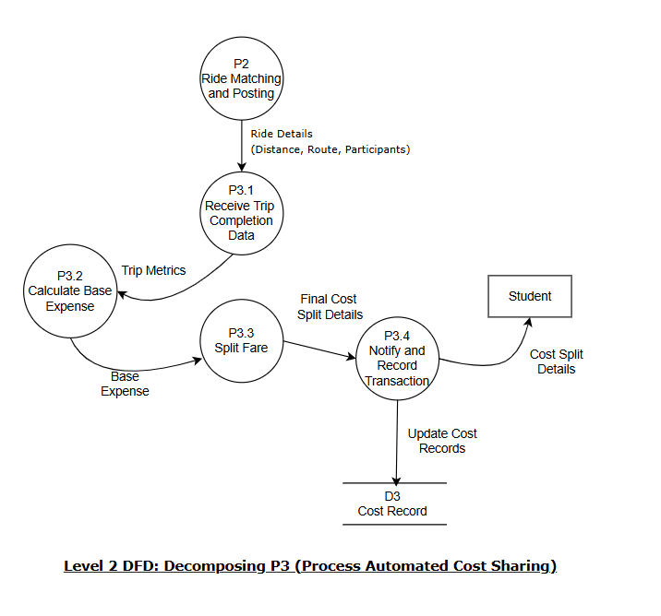
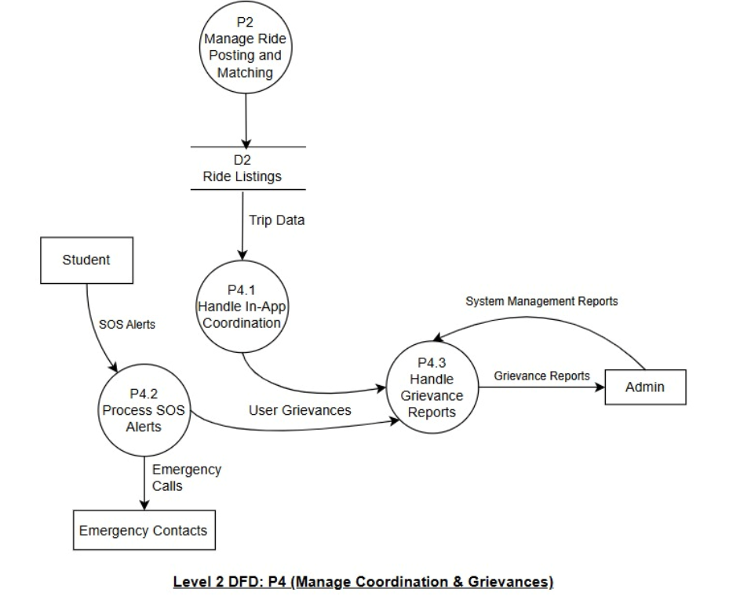

Software Requirements Specification
CONTENTS

S. No. | Topics | Page no.
1.  1.1  1.2  1.3  1.4  1.5 | Introduction  Purpose of this Document  Scope of the Development Project  Definitions, Abbreviations and acronyms  References  Overview | 31  31  32  32  32
2.  2.1  2.2  2.3  2.4  2.5 | Overall Description  Product Perspective  Product Functions  User Characteristics  General Constraints, Assumptions and Dependencies  Apportioning of the Requirements | 33  33  34  35  35
3.  3.1  3.2  3.3  3.4  3.5  3.6 | Specific Requirements  External Interface Requirements  Functional Requirements  Performance Requirements  Logical Database Requirements  Quality Attributes  Other Requirements | 37  38  40  41  41  42

1. Introduction:
1.1 Purpose of this Document
The purpose of this Software Requirements Specification (SRS) document is to present a detailed description of the LinkLift – Smart Campus Ride Sharing system.
It serves as a formal reference for project stakeholders, including developers, testers, system designers, and the client organization.
This document outlines the system’s purpose, features, interfaces, constraints, and performance expectations, ensuring that all stakeholders share a common understanding of the product.
The SRS will guide the software development lifecycle (SDLC)—from analysis and design to implementation and validation—by defining measurable requirements that the final product must satisfy.
Additionally, this document ensures that the product aligns with user needs such as affordability, safety, usability, and sustainability in campus travel.

1.2 Scope of the Development Project
LinkLift is a web-based ride-sharing platform designed exclusively for verified college students.
Its core purpose is to facilitate safe, affordable, and eco-friendly commuting between the campus and students’ hometowns.
The software enables students to:
- Post and search for rides to shared destinations.
- Use AI-based smart matching to find peers with similar travel times and routes.
- Communicate through in-app chat and notification features.
- Split travel costs automatically making travel hassle free.
- Ensure safety using SOS alerts, and verified user profiles.
The platform includes:
- Frontend (Web Portal) for students and administrators.
- Backend server managing user data, rides, and transactions.
- AI Matching Engine optimizing ride allocations.
The project aims to:
- Reduce travel costs for students.
- Improve convenience and coordination for student commutes.
- Foster community connection among verified students.
- Promote sustainable and environmentally responsible travel habits.
The software will be deployed initially on one campus and scaled to multiple universities after pilot testing.

1.3 Definitions, Abbreviations, and Acronyms
To ensure clarity and avoid ambiguity, this subsection provides definitions for terms, abbreviations, and acronyms used throughout this SRS document:
API | Application Programming Interface
SOS | “Save our souls” (a distress signal)
OTP | One Time Password
GDPR | General Data Protection Regulation
HTTPS | Hyper Text Transfer Protocol Secure
UI/UX | User Interface/User Experience
IT | Information Technology

1.4 References
1. TextBook – Sommerville
2. TextBook – Roger S. Pressman
3. https://www.geeksforgeeks.org/system-design/swim-lanes-in-activity-diagram/
4. https://draw.io/ (For UML purposes)

1.5 Overview
The remaining sections of this document provide a general description, including characteristics of the users of this project, the product's hardware, and the functional and data requirements of the product. General description of the project is discussed in section 2 of this document.
Section 2 gives the functional requirements, data requirements and constraints and assumptions made while designing the multi-utility system. It also gives the user viewpoint of product use.
Section 3 gives the specific requirements of the product. It also discusses the external interface requirements and gives detailed description of functional requirements.

2. Overall Description:

2.1 Product Perspective
LinkLift is a standalone yet integrative system that functions as a campus-exclusive mobility platform for students.
It provides web interfaces supported by a centralized backend server. The software forms a self-contained product but relies on several external services such as Google Maps API for route estimation, basic calculation methods for fare transactions, and university email servers for identity verification.
The system architecture comprises the following key components:
- User Interface Layer – The web portal where students interact with the system to post rides, join rides, chat, and access safety features.
- Application Logic Layer – Implements the AI-based matching engine, fare-splitting logic, and security modules.
- Database Layer – Maintains persistent records of users, rides, transactions, and safety logs.
- External Services Layer – Integrates third-party APIs for location and authentication.
External Interfaces
- University Email Servers: Authenticate student identity using institutional domain.
- Google Maps API: Provides route suggestions, distance, and travel-time.
- Notification Service: Handles real-time alerts, ride updates and confirmation of the calculated cost splits.
The system is designed for scalability and can operate as a cloud-hosted service supporting multiple campuses simultaneously.

2.2 Product Functions
The principal functionalities of LinkLift are summarized below:
- User Registration and Verification:
Users sign up with institutional credentials, verified through student email or ID upload.
- Ride Posting and Search:
Students create ride listings with details such as origin, destination, date, time, and available seats.
- AI-Based Ride Matching:
The system recommends compatible ride groups based on timing, route proximity, and preferences.
- In-App Communication:
Secure messaging and notification features allow participants to coordinate without leaving the platform.
- Automated Fare Splitting and Settlement Calculation:
The system accurately calculates the total estimated trip expense, divides the expense fairly (e.g., evenly or based on distance travelled) among all riders, and presents the final settlement amount owed by each rider to the ride creator/organizer.
- Safety and Tracking Module:
Real-time ride tracking, SOS button, and emergency contact alerts ensure student safety.
- Administrative Dashboard:
Admins manage user verification, monitor rides, handle reported incidents, and generate analytical reports.
Each of these functions is modular, enabling independent development and testing.

2.3 User Characteristics
The application targets a clearly defined user community consisting primarily of college students and a small set of administrative staff.
User Type | Description | Technical Proficiency | Access Privileges
Student User | Regular user posting and joining rides. | Basic mobile and web literacy. | Create/join rides, chat, pay, SOS.
Admin/Developer | Safety and Grievance coordinator. | Moderate technical experience. | Manage users, rides, and reports.
Campus Verification Authorities | System administrators ensuring verified student users | High technical proficiency. | Student Profile Access
Users are expected to:
- Possess smartphones or internet-enabled devices.
- Understand basic digital security (passwords, OTPs).
- Be comfortable using common mobile app interfaces.
No prior technical expertise in transportation systems is required.

2.4 General Constraints, Assumptions and Dependencies
Constraints:
- The system must operate under stable internet connectivity.
- Only verified student accounts may create or join rides.
- Compliance with GDPR and relevant data-privacy standards is mandatory.
- Real-time GPS tracking depends on device location services.
- The website must support Android 10+ and major modern browsers.
Assumptions:
- All participating institutions provide valid student email domains.
- Students will willingly share limited travel data for matching and safety purposes.
- Users will maintain updated profiles and accurate travel schedules.
- The university provides basic support for system onboarding.
Dependencies:
- Google Maps API – for routing and distance computation.
- Institutional Authentication System – for student verification.
System reliability and functionality are inherently dependent on the stability and availability of these services.

2.5 Apportioning of the Requirements
The implementation and deployment of LinkLift will occur in progressive phases to ensure scalability and quality assurance.
Phase 1 – Pilot Deployment
- Launch within a single university campus.
- Core modules: registration, ride creation, matching, and basic chat.
- Collect user feedback for usability improvements.
Phase 2 – Multi-Campus Expansion
- Extend coverage to multiple institutions under the same university network.
- Introduce automated cost-splitting.
- Strengthen backend for larger concurrent user volumes.
Phase 3 – Full Scale and Enhancement
- Add advanced features such as loyalty points, eco-impact tracking, and student discount integrations.
- Partner with verified cab services to provide hybrid commuting options.
- Continuous optimization using machine learning for better ride pairing.
Each phase maintains backward compatibility and builds upon the validated modules of the previous stage.
This incremental approach minimizes deployment risk and ensures continuous improvement based on real-world student feedback.

3. Specific Requirements
This section defines all the functional, interface, and performance requirements that form the basis for LinkLift’s design, implementation, and validation. It specifies what the system must do and how it should behave under different operating conditions.

3.1 External Interface Requirements
The external interface requirements define how LinkLift interacts with users, hardware devices, software components, and communication networks. These interfaces ensure smooth interaction between the app, external systems, and users.

3.1.1 User Interfaces
- Web Application:
A minimalistic, responsive interface providing features such as login, ride creation, matching suggestions, chat and SOS.
  - Clean dashboard displaying active rides and quick actions.
  - Colour scheme: fresh, youthful, and aligned with campus aesthetics.
  - User-friendly navigation flow with three-step ride posting.
- Admin Dashboard:
Provides management tools for monitoring rides, verifying students, viewing reports, and handling safety or misconduct cases.
- User friendly Design:
The UI/UX must be minimalistic, intuitive, and designed for a minimal learning curve. The interface must prioritize information transparency by clearly displaying essential elements for rapid decision-making:
Ride Suggestions: Display potential peers, route overlap percentage, and travel time.
Live Trip Data: Show real-time location, passenger manifest, and current status.
Cost Clarity: Clearly present the final calculated cost split (settlement amount) upon trip completion.
Safety Access: Maintain a highly visible and accessible SOS button on the trip screen.
3.1.2 Hardware Interfaces
- The application requires a GPS-enabled device for accurate route tracking.
- Internet connectivity is mandatory for all core functions.
- Server-side deployment will require standard cloud infrastructure with database and API hosting capabilities (e.g., AWS, Firebase).
3.1.3 Software Interfaces
- Google Maps API: For route optimization, distance, and estimated time of arrival (ETA) calculations.
- In – App Chat/Messaging: For push notifications and chat updates.
- Institutional Email Servers: For user authentication and verification.
3.1.4 Communication Interfaces
- All communication between client and server shall occur over HTTPS to ensure encrypted data transfer.
- WebSocket or Firebase Realtime Database shall be used for live chat and real-time ride status updates.
- RESTful APIs will enable standardized communication between frontend and backend modules.

3.2 Detailed Description of Functional Requirements
This section details the behaviour and responses of the system to specific user actions. Each functional requirement includes purpose, inputs, processing, and outputs.

3.2.1 Functional Requirement 1 – User Registration and Verification
Purpose:
Enable secure onboarding for verified students only.
Inputs:
Student name, institutional email, ID upload, and password or OTP.
Processing:
System verifies email domain, sends OTP, and confirms authenticity. Profile details are stored securely in the database.
Outputs:
Confirmation message and creation of a unique user account with verification status.

3.2.2 Functional Requirement 2 – Ride Posting
Purpose:
Allow users to create new ride offers.
Inputs:
Source, destination, date, time, available seats, cost per seat (optional).
Processing:
The backend validates fields, stores the ride details, and updates available ride listings.
Outputs:
Ride successfully posted notification; ride visible to matched users.

3.2.3 Functional Requirement 3 – Smart Ride Matching
Purpose:
Use AI to recommend suitable ride partners based on similarity of route and time.
Inputs:
Ride parameters of existing and new users.
Processing:
AI algorithm compares travel details and recommends the best matches based on location proximity and schedule overlap.
Outputs:
List of matched rides with relevance scores.

3.2.4 Functional Requirement 4 – In-App Chat and Notifications
Purpose:
Enable smooth and secure communication among matched users.
Inputs:
Text messages, ride updates, or system alerts.
Processing:
Chat requests and notifications are processed, ensuring real-time delivery.
Outputs:
Messages delivered instantly, with unread message indicators and notification badges.

3.2.5 Functional Requirement 5 – Automated Cost Splitting and Payment
Purpose:
Provide transparent fare division and settlement.
Inputs:
Total fare, number of passengers and any other relevant trip metrics.
Processing:
System divides the fare equally and records transaction details.

3.2.6 Functional Requirement 6 – Safety and SOS Module
Purpose:
Ensure student safety during travel through proactive features.
Inputs:
SOS button activation or automated alert.
Processing:
System sends alert message to predefined emergency contacts and the admin dashboard.
Outputs:
Emergency notifications and tracking link shared with contacts and campus authorities.

3.2.7 Functional Requirement 7 – Admin Monitoring
Purpose:
Allow campus administrators to oversee activities, resolve complaints, and maintain trust.
Inputs:
Admin login credentials and filter parameters (user ID, ride date, report type).
Processing:
System retrieves relevant data, displays analytics, and allows status updates on reports.
Outputs:
Dashboard visualizations and action logs.

3.3 Performance Requirements
The performance requirements ensure that LinkLift remains reliable, efficient, and responsive under varying usage conditions.
- The application must handle up to 10,000 concurrent users without degradation of performance.
- Average response time for any user action must not exceed 2 seconds under normal network conditions.
- Server uptime must remain at or above 99% per month.
- The system must maintain scalability to support multi-campus expansion with minimal configuration.

3.4 Logical Database Requirements
The LinkLift database will be relational (e.g., MongoDB / PostgreSQL) and normalized to ensure efficiency and data integrity.
Key Entities and Relationships:
Entity | Attributes | Relationships
User | User_ID, Name, Email, College_ID, Contact, Verification_Status | 1:N with Rides,
Ride | Ride_ID, Source, Destination, Date, Time, Available_Seats, Status | N:M with Users
Chat | Chat_ID, User_IDs, Message, Timestamp | 1:N with User
Emergency_Log | Alert_ID, User_ID, Location, Timestamp, Status | 1:1 with User
All critical data such as passwords will be stored in encrypted form using secure hashing and encryption algorithms.
Regular backups will be maintained to prevent data loss.

3.5 Quality Attributes
Usability
- Clean, minimal, and intuitive UI to ensure ease of use.
- Key operations (posting or joining a ride) achievable within three steps.
Reliability
- Auto-reconnect and retry mechanisms during network interruptions.
- Regular database backups and redundant storage.

Security
- Encrypted HTTPS communication.
- Two-factor authentication for login.
- Role-based access control for admin and users.
Portability
- Responsive design for all device types.
Scalability
- Will be extended to accommodate multi-campus use and growing student populations.

3.6 Other Requirements
- The system must adhere to data protection laws and university IT policies.
- Support accessibility features (e.g., text-to-speech for visually impaired users) in future phases.
- Localization support for regional language expansion in future phases.
- Integration with university transport data systems can be considered as a long-term enhancement.

2.5 User Stories and Story Cards

US01 – Search Ride (Front of Card)

Story ID: US01 | Feature: Search Ride
As a user, I want to search for available rides by pickup and destination, so that I can find and join a suitable ride.
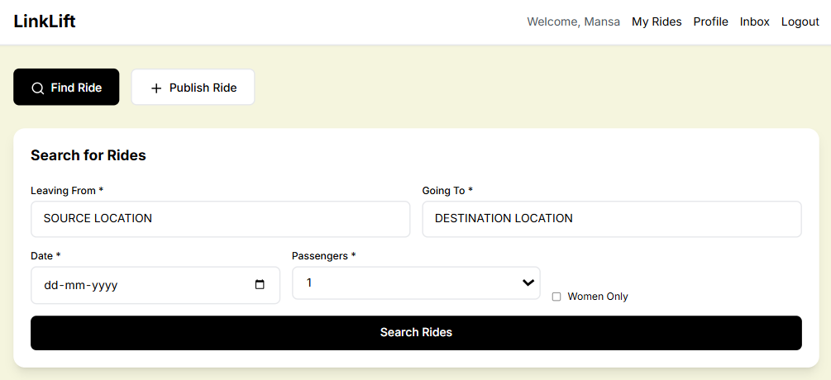

US01 – Search Ride (Back of Card)

Confirmation
Success:
a) Matching rides displayed with driver and cost.
b) System filters results within 3 seconds.
c) Option to sort by fare or departure time.
d) If no rides found → suggest 'Publish Ride'.
e) User receives updated ride list dynamically.
Failure:
a) Empty pickup or drop field → validation error.
b) No ride found → display 'No results' message.
c) Network issue → retry option visible.
d) Invalid date/time → prompt correction.
e) System timeout → reload search page.

US02 – Publish Ride (Front of Card)

Story ID: US02 | Feature: Publish Ride
As a user, I want to publish a new ride with my route and timing, so that others can join and share the cost.
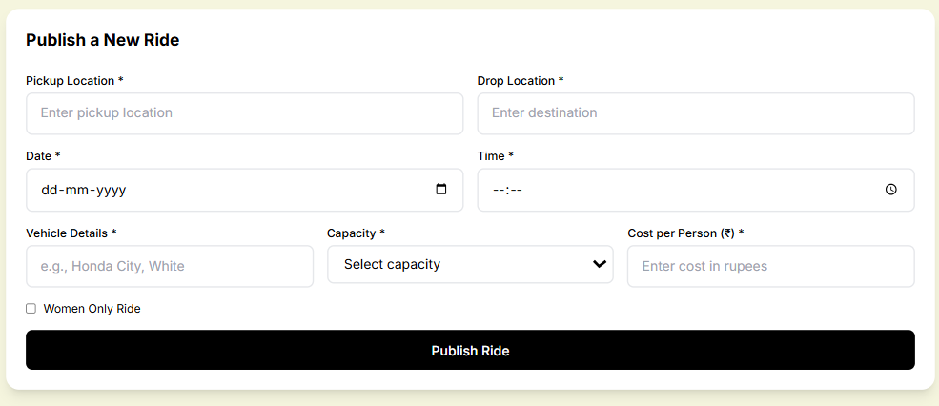

US02 – Publish Ride (Back of Card)

Confirmation
Success:
a) Ride published successfully message shown.
b) Ride details stored in database instantly.
c) Driver receives confirmation of posting.
d) Ride visible to all users within 5 seconds.
e) App displays 'Your ride is live now.'
Failure:
a) Missing pickup/drop → 'Enter all required fields.'
b) Invalid fare or seat number → reject form.
c) Network issue → 'Unable to publish ride.'
d) Duplicate ride detection warning shown.
e) Data not saved → user prompted to retry.

US03 – View Ride History (Front of Card)

Story ID: US03 | Feature: View Ride History
As a user, I want to see my past rides, so that I can track my travel records.
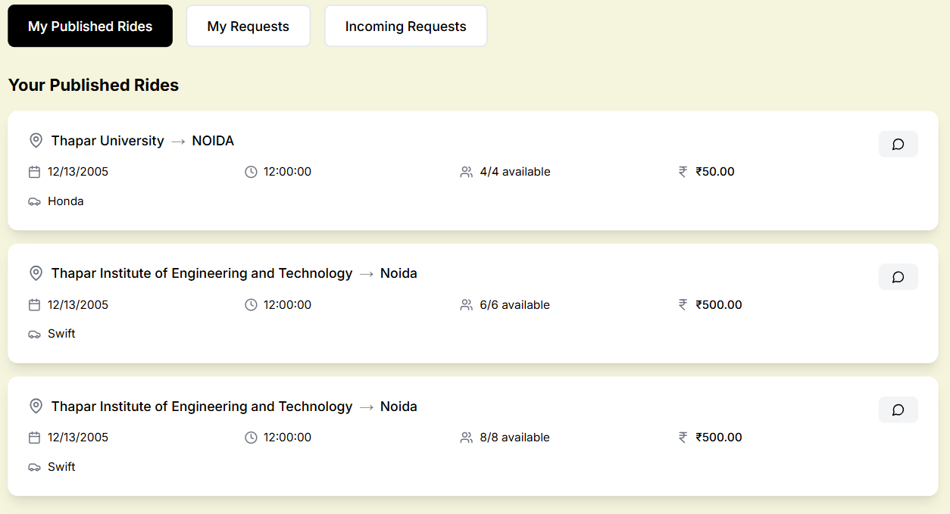

US03 – View Ride History (Back of Card)

Confirmation
Success:
a) All past rides displayed chronologically.
b) Filter by date or route works correctly.
c) Fare and ratings visible for each record.
d) Can export ride history as PDF.
e) Message shown: 'Ride history loaded successfully.'
Failure:
a) No rides found → empty history message.
b) Database fetch error → retry option shown.
c) Network issue prevents loading.
d) Partial data → prompt user to refresh.
e) Timeout → user advised to re-login.

