**AyurSense: An Intelligent Ayurvedic Recommendation System**

**Project Synopsis Report**

**Submitted in Partial Fulfillment of the Requirements for the Degree of**

**BACHELOR OF TECHNOLOGY**

**in**

**COMPUTER SCIENCE & ENGINEERING**

**By**

**Manya Thapliyal (2200950100048)**

**Prashant Bisht (2200950100059)**

**Under the Guidance of Mrs. Roovi Goswami**



**DEPARTMENT OF COMPUTER SCIENCE & ENGINEERING**

**MGM’s College of Engineering & Technology, Noida**

**TABLE OF CONTENTS**

1. **CERTIFICATE** ............................................................................................................. 3
2. **DECLARATION** ...........................................................................................................4
3. **ABSTRACT** .................................................................................................................. 5
4. **CHAPTER 1: INTRODUCTION** ............................................................................ 6-11
   1. Background of the Problem
   2. Motivation for the Project
   3. Literature Review
   4. Problem Definition
   5. Objectives of the Project
   6. Scope of the Project
   7. Proposed Modules
   8. Significance of the Project
5. **CHAPTER 2: SYSTEM ANALYSIS** ....................................................................12-16

5.1 Introduction   
5.2 Existing System  
5.3 Proposed System  
5.4 Feasibility Study

5.5 Requirement Analysis

5.6 System Requirements

5.7 Conclusion

1. **CHAPTER 3: SYSTEM DESIGN** .......................................................................17-22

6.1 Introduction

6.2 System Architecture  
6.3 Data Model  
  6.3.1 DFD   
  6.3.2 Use Case Diagram  
  6.3.3 Class Diagram

6.3.4 ER Diagram

1. **REFERENCES** ..........................................................................................................23

**CERTIFICATE**

This is to certify that Project Report entitled “**AyurSense: An Intelligent Ayurvedic Recommendation System** ” which is submitted by **Manya Thapliyal and Prashant Bisht** in partial fulfillment of the requirement for the award of degree B. Tech. in Department of  Computer Science and Engineering of MGM’s College of Engineering and Technology which is affiliated by AKTU Lucknow, is a record of the candidates own work carried out by them under my supervision. The matter embodied in this report is original and has not been submitted for the award of any other degree.

**Date: 26-08-2025 Supervisor Signature:**

**Name of Supervisor: Mrs. Roovi Goswami**

**Designation: Assistant Professor**

**DECLARATION**

I hereby declare that this submission is our own work and that, to the best of our knowledge and belief, it contains no material previously published or written by another person nor material which to a substantial extent has been accepted for the award of any other degree or diploma of the university or other institute of higher learning, except where due acknowledgment has been made in the text.

Signature:

Name: Manya Thapliyal

Roll No.: 2200950100048

Date: 26-08-2025

Signature:

Name: Prashant Bisht

Roll No.: 2200950100059

Date: 26-08-2025

**ABSTRACT**

AyurSense: Intelligent Ayurvedic Recommendation System is a web-based application designed to provide personalized Ayurvedic remedies, yoga asanas, and lifestyle suggestions based on user inputs. The application uses an interactive quiz to assess symptoms and health conditions, then generates recommendations by mapping these inputs to a pre-defined knowledge base of Ayurvedic treatments and wellness practices.

The main aim of this project is to create a user-friendly system that enables individuals to receive guidance for minor health issues without the need for immediate consultation with a medical professional, while also promoting natural and preventive healthcare practices. The system architecture includes a quiz interface, recommendation engine, and database management of symptoms, remedies, and yoga asanas.

AyurSense is developed using modern web technologies for frontend and backend integration, ensuring responsiveness and real-time user interaction. Future enhancements may include OCR-based symptom scanning, AI/ML-based personalized recommendations, and user history tracking for more accurate guidance.

This study demonstrates the potential of integrating technology with traditional Ayurvedic knowledge to provide accessible health solutions in an efficient and interactive manner.

**CHAPTER 1: INTRODUCTION**

**1.1 Background of the Problem**

In the modern era, lifestyle-related disorders such as obesity, diabetes, hypertension, and stress-induced illnesses have become increasingly common due to sedentary lifestyles, unhealthy diets, and rising stress levels. The **World Health Organization (WHO)** estimates that **lifestyle diseases account for nearly 60% of all deaths worldwide**, with India contributing a significant portion to this number.

While **allopathy** has been successful in providing quick relief, it often comes with notable side effects such as dependency on medicines, drug resistance, and high treatment costs. Additionally, allopathic treatments generally emphasize **curative approaches** rather than **preventive healthcare**.

On the other hand, **Ayurveda and Yoga** are ancient Indian sciences that focus on holistic healing, balancing the body, mind, and spirit. Ayurveda emphasizes natural remedies, herbal medicines, diet, and lifestyle regulation, while Yoga strengthens physical and mental health through asanas, pranayama, and meditation. Despite these benefits, their **awareness among youth remains alarmingly low**.

A recent survey indicates that:

* Only **15% of youth are fully aware** of Ayurveda and Yoga,
* About **20% have partial awareness**, and
* Nearly **65% remain unaware** or uninterested in these traditional practices.

This gap highlights the **urgent need for a digital platform** that integrates Ayurvedic wisdom and Yogic practices into a **personalized, interactive, and accessible format**. Existing health platforms and applications usually provide **generalized advice** rather than customized solutions, which limits their effectiveness. Hence, there is a strong motivation to develop **AyurSense**, an intelligent system capable of providing **personalized Ayurvedic recommendations** based on user health profiles.

**1.2 Motivation for the Project**

The motivation behind this project arises from the growing realization that **preventive and holistic healthcare** must be prioritized in today’s society.

1. **Growing demand for holistic healthcare** – Modern patients are increasingly seeking natural alternatives to avoid the side effects of allopathic medicines. Ayurveda and Yoga together can provide cost-effective, side-effect-free, and sustainable healthcare practices.
2. **Digital India initiatives** – With the government actively promoting Ayurveda and Yoga at both national and global platforms, there is an opportunity to **revive traditional medicine systems** through digital solutions. A web-based platform aligns with India’s vision of making healthcare more accessible.
3. **Preventive healthcare using IT solutions** – By using **quiz-based assessments and intelligent recommendation engines**, technology can bridge the gap between ancient knowledge and modern accessibility. This not only contributes to individual well-being but also reduces the overall healthcare burden on society.

Thus, the project is not just about building another health-related website, but about **creating a bridge between ancient traditional wisdom and modern technology**. AyurSense intends to instill awareness among youth, promote preventive healthcare, and reduce the over-dependence on costly treatments. In the long run, it can encourage healthier communities, reduce the burden on healthcare infrastructure, and revive the essence of Ayurveda and Yoga globally.

**1.3 Literature Review**

Several studies and existing applications highlight the **gaps** in the current ecosystem:

**Existing Ayurvedic apps** such as e-Charaka and Ayurveda App primarily provide **generalized remedies** for common conditions. However, they lack **personalization** based on user-specific health conditions.

**Yoga apps** such as Daily Yoga and Asana Rebel focus mainly on physical exercises but fail to integrate **dietary advice, herbal remedies, or holistic guidance**.

Academic research papers emphasize the **potential of AI in healthcare**, suggesting that machine learning and expert systems can be used to enhance **diagnosis, recommendation, and personalization**.

From the literature, it is clear that there exists a **scope for AI-driven Ayurvedic advisory systems** that provide **integrated, customized, and user-friendly solutions**. AyurSense aims to fill this gap by combining **Ayurvedic remedies, Yoga practices, and dietary recommendations** into a single platform.

Most of the existing platforms either restrict themselves to **generic remedies** or **exercise-only approaches**, thereby missing the **personalization** and **integration aspect**. Some research also emphasizes that gamified or quiz-based approaches increase user engagement, which supports the design choice of AyurSense. Thus, this project attempts to combine three aspects often found in isolation — **Diagnosis (Quiz), Recommendation (Ayurveda & Yoga), and Preventive Guidance (Diet & Lifestyle)** — into a single, accessible platform.

**1.4 Problem Definition**

The problem lies in the **lack of personalized Ayurvedic digital platforms**. While Ayurveda and Yoga are gaining global recognition, the available platforms provide **generic advice** that fails to cater to **individual user needs**.

The absence of:

* **Interactive quizzes** to assess health conditions,
* **Intelligent recommendation engines** for mapping user inputs to remedies, and
* **Integrated solutions** combining Yoga, Ayurveda, and diet plans,

makes it difficult for users to receive accurate and practical guidance.

Hence, **AyurSense** is proposed as a **quiz-based intelligent system** that analyzes user health profiles and delivers **personalized Ayurvedic and Yogic recommendations**.

Additionally, there is a lack of **trustworthy platforms** that provide scientifically backed Ayurvedic recommendations. Users often rely on unverified sources like social media, which may result in misinformation. AyurSense aims to resolve this by offering structured, validated, and logically derived recommendations, ensuring that users receive **safe and authentic guidance**.

**1.5 Objectives of the Project**

The objectives of AyurSense are as follows:

1. **Interactive Health Quiz** – Design and implement a dynamic quiz module to collect user data related to lifestyle, symptoms, and health conditions.
2. **Recommendation Engine** – Develop an AI/logic-driven system that interprets user responses and provides tailored Ayurvedic remedies.
3. **Holistic Solutions** – Suggest **Yoga asanas, herbal medicines, and diet plans** for preventive and curative health.
4. **User-Friendly Interface** – Ensure the platform is accessible, easy to navigate, and available as a **web-based system** compatible with both desktops and smartphones.

These objectives ensure that AyurSense not only provides solutions but also educates users about preventive care. The ultimate aim is to transform healthcare from being **treatment-centric** to **prevention-centric** by enabling individuals to take control of their lifestyle and choices.

**1.6 Scope of the Project**

The scope of the project defines its **application areas** and **future expansion possibilities**:

* The platform is useful for **students, yoga practitioners, and the general public** who want natural and preventive healthcare advice.
* It can be extended into a **mobile application** to reach a larger audience.
* The system can be further integrated with **vaidya (Ayurvedic doctors) consultations** for advanced health guidance.
* Future enhancements can include **AI-based predictions, multilingual support, and cloud integration** to improve reach and accuracy.
* **Educational Institutions** – introducing Ayurveda and Yoga awareness among students.
* **Corporate Wellness Programs** – reducing stress and lifestyle disorders among employees.
* **Rural Healthcare** – where access to doctors is limited, the system can provide initial preventive advice.  
  This makes the scope of AyurSense highly scalable and adaptable across different segments of society.

**1.7 Proposed Modules**

To achieve its objectives, the system will consist of the following modules:

1. **User Registration & Login** – Secure authentication, user profile creation, and data management.
2. **Health Quiz Module** – A dynamic questionnaire collecting health-related data like symptoms, diet, and lifestyle patterns.
3. **Recommendation Engine** – Processes user inputs and maps them to Ayurvedic remedies, Yogic asanas, and diet plans.
4. **Ayurvedic Remedies & Yogic Asanas Module** – Displays curated solutions based on quiz results.
5. **Result Display & Feedback** – Provides users with a summarized report of recommendations and allows feedback for improvement.
6. **User Registration & Login** – Provides secure authentication, maintains personal health profiles, and ensures data privacy. Users can revisit their history and track progress over time.
7. **Health Quiz Module** – A set of dynamic questions covering lifestyle habits, dietary patterns, stress levels, and existing health conditions. Questions can be adaptive (change based on previous answers) to provide more accuracy.
8. **Recommendation Engine** – The core of the system, which applies rule-based logic or AI models to match user responses with Ayurveda principles like Prakriti (body constitution) and Dosha imbalance. It ensures each user gets a customized set of suggestions.
9. **Ayurvedic Remedies & Yogic Asanas Module** – Curated remedies including herbal solutions, diet charts, and specific yoga asanas with descriptions and images/videos for clarity.
10. **Result Display & Feedback** – Generates a personalized health summary report for the user, highlighting remedies, preventive tips, and lifestyle changes. A feedback mechanism allows users to share their experience, which can be used for further improvement of the system.

**1.8 Significance of the Project**

The significance of AyurSense lies in its ability to **combine ancient wisdom with modern needs**:

* Helps users adopt a **preventive lifestyle** rather than waiting for illnesses to worsen.
* Encourages **youth engagement** with Ayurveda and Yoga using an interactive quiz approach.
* Supports **Digital India’s vision** of promoting indigenous knowledge systems globally.
* Reduces healthcare costs by providing **low-cost natural remedies**.
* Creates a platform that can evolve into a **research and awareness tool** for Ayurveda scholars and practitioners.

**CHAPTER 2: SYSTEM ANALYSIS**

**2.1 Introduction**

System analysis is the process of studying and understanding the problem domain, identifying user needs, and determining the requirements for building a new system. For the proposed project **AyurSense**, system analysis helps in understanding:

* Why existing Ayurvedic and Yoga platforms are insufficient,
* What new features need to be introduced,
* How the system can bridge the gap between traditional knowledge and modern digital platforms.

AyurSense is designed to act as a **personalized healthcare recommendation system**, focusing on Ayurveda and Yoga. Unlike existing apps, it will integrate **quiz-based data collection, Ayurvedic remedies, Yoga asanas, and dietary advice** into a **single web-based solution**.

**2.2 Existing System**

Several digital healthcare solutions already exist, but they have limitations:

1. **General Ayurvedic Apps (e.g., Ayurveda App, e-Charaka):**
   * Provide **general remedies** for common health conditions.
   * Lack **personalization** based on user profiles.
   * Do not combine diet, lifestyle, and Yoga together.
2. **Yoga-Based Applications (e.g., Daily Yoga, Asana Rebel):**
   * Focus mainly on **physical exercises**.
   * Rarely provide **holistic health solutions**.
   * Do not consider Ayurveda-based remedies or dietary recommendations.
3. **Allopathic Health Apps (e.g., Practo, 1mg):**
   * Provide medicine details and doctor consultations.
   * Do not focus on **preventive care** or natural remedies.

**Limitations of Existing Systems:**

* Generic solutions (no personalization).
* Lack of integration between Ayurveda, Yoga, and diet.
* Limited awareness among youth.
* No intelligent recommendation engine.

**2.3 Proposed System**

To overcome these limitations, AyurSense proposes a **holistic, intelligent, and personalized digital platform**.

**Key Features of AyurSense:**

* Quiz-based health data collection.
* Recommendation engine mapping symptoms to Ayurvedic remedies.
* Suggestions of Yogic asanas, herbal medicines, and diet plans.
* Simple and user-friendly web interface.
* Secure login and personalized profile management.

**Advantages of Proposed System:**

* Personalized recommendations instead of generic ones.
* Combines **Ayurveda + Yoga + Diet** in one platform.
* Promotes preventive healthcare in line with **Digital India initiatives**.
* Easy accessibility to all users, especially youth.

**2.4 Feasibility Study**

Before developing any project, a feasibility study is conducted to determine whether the system is **technically, economically, and socially viable**.

**2.4.1 Technical Feasibility**

* The project will be developed using widely available technologies such as **HTML, CSS, JavaScript (Frontend)** and **Java/Python with Flask/Django (Backend)**.
* Databases like **MySQL / SQLite** will be used for storing user data.
* Can be deployed on **low-cost hosting servers**.  
  Hence, it is technically feasible.

**2.4.2 Economic Feasibility**

* Development requires minimal cost (open-source technologies).
* No expensive hardware or software is required.
* The only costs are domain and hosting charges, which are affordable.  
  Hence, it is economically feasible.

**2.4.3 Operational Feasibility**

* The system is simple, with a **quiz interface** that anyone can use.
* Recommendations are easy to understand.
* Requires **no prior knowledge of Ayurveda/Yoga** from users.  
  Hence, it is operationally feasible.

**2.4.4 Social Feasibility**

* The system promotes **traditional Indian knowledge systems (Ayurveda & Yoga)**.
* Helps reduce dependency on allopathy for minor health issues.
* Aligns with **Digital India** and **Ayushman Bharat** initiatives.  
  Hence, it is socially feasible.

**2.5 Requirements Analysis**

**2.5.1 Functional Requirements**

The functional requirements define **what the system will do**. For AyurSense:

1. **User Registration & Login** – Users should be able to sign up and log in securely.
2. **Health Quiz** – System should collect user input (symptoms, lifestyle, health issues).
3. **Recommendation Engine** – Must map quiz results to Ayurvedic remedies, Yoga asanas, and diet plans.
4. **Result Display** – Summarize recommendations clearly in an easy-to-read format.
5. **Feedback Module** – Allow users to give feedback on recommendations.

**2.5.2 Non-Functional Requirements**

Non-functional requirements define **system quality attributes**:

1. **Usability** – The interface should be simple, responsive, and user-friendly.
2. **Performance** – Recommendations should be generated quickly.
3. **Scalability** – Should support multiple users simultaneously.
4. **Security** – User health data should be stored securely.
5. **Reliability** – The system should work consistently without errors.

**2.6 System Requirements**

**2.6.1 Hardware Requirements**

* **Processor:** Intel i3 or higher
* **RAM:** Minimum 4GB
* **Storage:** 250 GB or higher
* **System:** Any OS (Windows/Linux/Mac)

**2.6.2 Software Requirements**

* **Frontend:** HTML, CSS, JavaScript, Bootstrap
* **Backend:** Java (Spring Boot) or Python (Flask/Django)
* **Database:** MySQL/SQLite
* **Tools:** VS Code, GitHub, XAMPP/WAMP for testing
* **Hosting:** GitHub Pages / Netlify (frontend) + Heroku / Render (backend)

**2.7 Conclusion**

The system analysis highlights that there is a **strong need** for a digital Ayurvedic and Yogic healthcare platform. The **proposed system** is technically, economically, and socially feasible. By meeting both **functional and non-functional requirements**, AyurSense will serve as an **intelligent, personalized healthcare guide** for users, bridging the gap between traditional knowledge and modern technology.

**CHAPTER 3: SYSTEM DESIGN**

**3.1 Introduction**

System design is the process of **transforming the requirements (from Chapter 2) into a structured model** that will guide the development of the application. It focuses on:

* How the system components interact,
* How data flows between modules,
* The database structure,
* The overall architecture of the system.

In AyurSense, system design ensures that the application is **user-friendly, scalable, and efficient** while supporting personalized Ayurvedic and Yoga recommendations.

**3.2 System Architecture**

The proposed system follows a **three-tier architecture**:

1. **Presentation Layer (Frontend):**
   * Developed using **HTML, CSS, JavaScript, Bootstrap**.
   * Provides a **quiz interface** and displays recommendations.
2. **Application Layer (Backend):**
   * Implemented using **Java (Spring Boot)** or **Python (Flask/Django)**.
   * Processes user inputs, runs the recommendation engine, and fetches remedies.
3. **Database Layer (Storage):**
   * Uses **MySQL/SQLite** for storing user profiles, quiz responses, Ayurvedic remedies, Yoga asanas, and diet charts.

**3.3 Data Model**

**3.3.1 Data Flow Diagram**

**Context Level DFD (Level 0)**

* Shows the interaction of the **user** with the system.
* User provides symptoms → System processes → Outputs Ayurvedic remedies & Yoga suggestions.

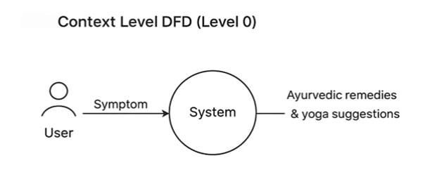

**Level 1 DFD**

Expands the system into modules:

1. **User Management** (login/register)
2. **Health Quiz**
3. **Recommendation Engine**
4. **Result Display**
5. **Feedback Module**

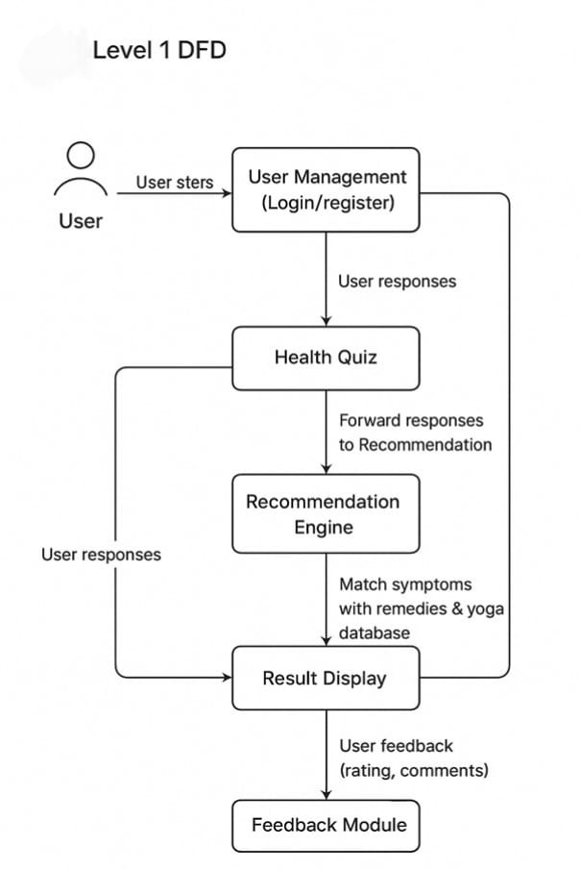

**3.3.2 Use Case Diagram**

The **Use Case Diagram** shows the interaction between the user and the system.

**Actors:**

* User (patient)
* System (AyurSense)

**Use Cases:**

* Register/Login
* Attempt Health Quiz
* Get Personalized Recommendations
* View Remedies & Yoga Asanas
* Submit Feedback

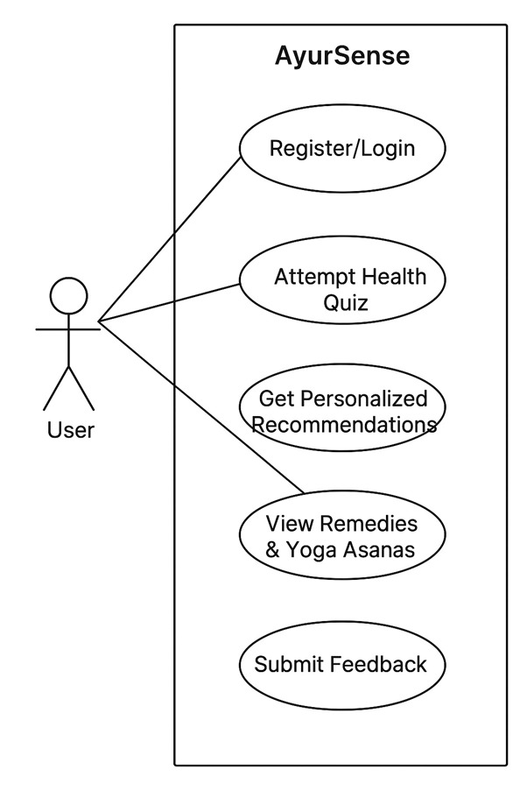

**3.3.3 Class Diagram**

The class diagram represents the **object-oriented structure** of the system.

**Main Classes:**

1. **User** (UserID, Name, Age, Gender, Email, Password)
2. **Quiz** (QuizID, Questions, Answers)
3. **RecommendationEngine** (InputSymptoms, OutputRemedies, OutputYoga, OutputDiet)
4. **Remedy** (RemedyID, HerbName, Usage, Precautions)
5. **YogaAsana** (AsanaID, Name, Steps, Benefits)
6. **DietChart** (DietID, FoodItems, Benefits)
7. **Feedback** (FeedbackID, UserID, Comments, Rating)

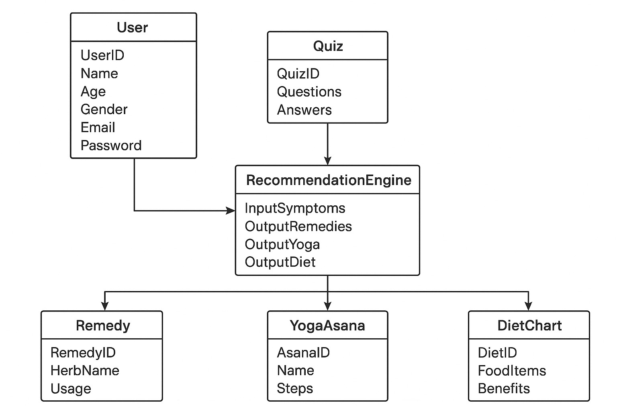

**3.3.4 Entity Relationship Diagram**

The ERD shows how data is stored and related in the database.

Entities & Relationships:

* User (UserID, Name, Age, Gender, Email, Password)
* Quiz (QuizID, Question, Answer)
* Remedy (RemedyID, Herb, Usage, Benefit)
* YogaAsana (AsanaID, Name, Steps, Benefits)
* Feedback (FeedbackID, UserID, Comments, Rating)

Relationships:

* One User → Many Quizzes
* One Quiz → Many Recommendations
* One Recommendation → Multiple Remedies, YogaAsanas
* One User → Many Feedbacks

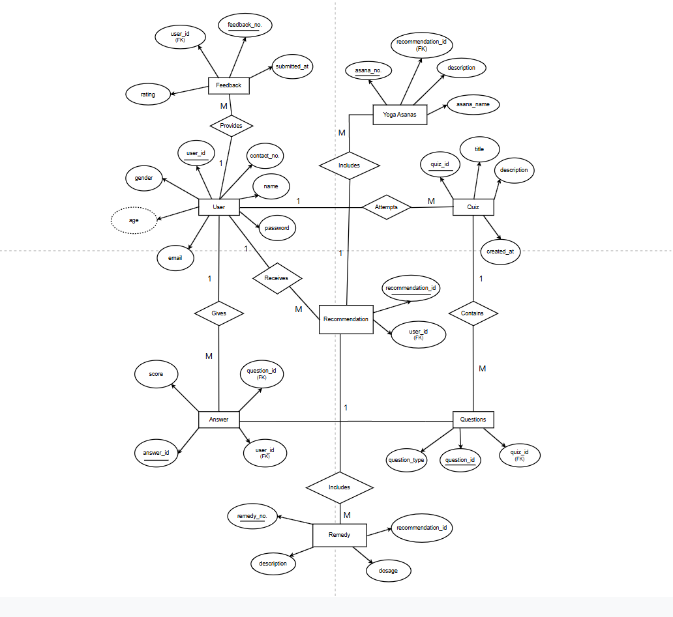

**References**

1. Lad, Vasant. *The Complete Book of Ayurvedic Home Remedies*. Harmony Books, 2002.
2. Frawley, David. *Ayurveda and the Mind: The Healing of Consciousness*. Lotus Press, 1997.
3. Sharma, P. V. *Charaka Samhita – English Translation of Ayurveda Classic*. Chaukhamba Orientalia, 2014.
4. Tiwari, Premvati. *Ayurveda for Women: A Guide to Vitality and Health*. Motilal Banarsidass, 2012.
5. World Health Organization (WHO). *Global Report on Traditional and Complementary Medicine 2019*. WHO Press, 2019.
6. Ministry of AYUSH, Government of India. *Ayush Systems – An Overview*. https://www.ayush.gov.in
7. Ministry of Health & Family Welfare, Government of India. *National Health Profile 2022*. https://www.cbhidghs.nic.in
8. Narayanasamy, A. (2015). "Ayurveda and Yoga: A Holistic Approach to Health." *Journal of Traditional Medicine & Clinical Naturopathy*, 4(2).
9. Patel, M. & Desai, S. (2020). "A Review on Artificial Intelligence Applications in Ayurveda." *International Journal of Ayurveda Research*, 11(4), 45-52.
10. Joshi, R., & Dwivedi, R. (2018). "Integrating Ayurveda with Modern Digital Platforms for Lifestyle Disease Management." *International Journal of Health Sciences and Research*, 8(6), 221–227.
11. Google Scholar Database – Research on “AI in Ayurveda Recommendation Systems”. https://scholar.google.com
12. Indian Council of Medical Research (ICMR). *Lifestyle Diseases Statistics Report 2021*. https://www.icmr.gov.in
13. Ministry of Electronics & Information Technology (MeitY). *Digital India Initiative*. https://www.digitalindia.gov.in