

AYURSENSE: AN INTELLIGENT AYURVEDIC RECOMMENDATION SYSTEM
Using Dosha Profiling & Digital Diagnostics

Manya Thapliyal, Prashant Bisht
Advisor: Mrs. Roovi Goswami
Department of Computer Science and Engineering,
Mahatma Gandhi Mission's College of Engineering & Technology, Noida, Sector 62

Abstract:- Understanding a person's Tridosha constitution—Vata, Pitta, and Kapha—is essential to Ayurveda, an ancient Indian holistic health approach that emphasizes individualized wellness. However, it is difficult for contemporary digital health systems to convert this individualized Ayurvedic approach into organized, technologically assisted wellness models. This study introduces AyurSense, a digital platform that offers individualized lifestyle, nutrition, herbal, and wellness advice by fusing traditional Ayurvedic concepts with cutting edge software design. To assist users in comprehending and balancing their Dosha profile, the platform makes use of a structured Dosha questionnaire, a weighted scoring model, rule-based recommendations, and an intuitive user interface. A thorough literature review, methodology, system design, user testing, and a comparison with other platforms are all included in the study. The findings indicate better lifestyle choices, increased user awareness, and positive usability comments.

- INTRODUCTION

Background of Ayurveda & Dosha Theory
The foundation of the 3000-year-old medical discipline of Ayurveda is harmony and balance between the body, mind, and environment. The Tridosha Theory, which holds that all people have three biological energies, forms the basis of Ayurveda.

- Vata: controls breathing, circulation, movement, and creativity
- Pitta: controls metabolism, digestion, and transformation
- Kapha: controls immunity, lubrication, and stability

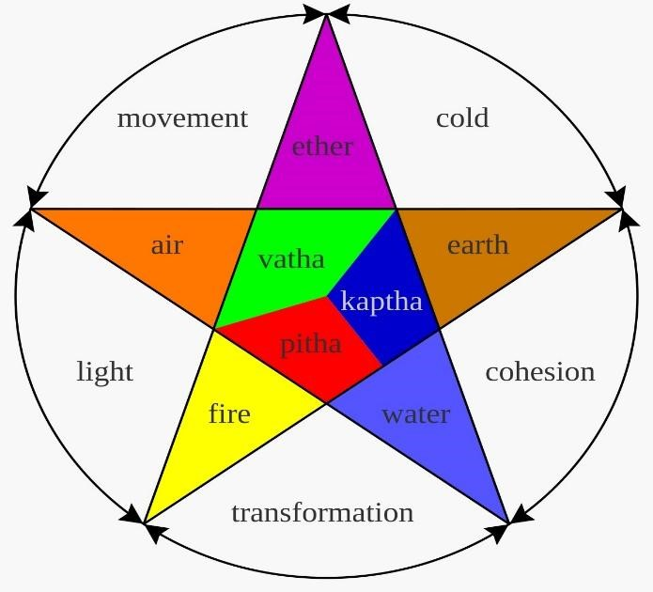
diagram of dosha
Prakriti, or constitution, is the distinct dosha mix that each individual possesses. Disease is caused by an imbalance in these doshas, known as Vikriti. This basic idea is the foundation of AyurSense.

Need for Digital Ayurveda

Ayurvedic or herbal wellness products are used by 46% of Indians in rural areas and 53% in urban areas, according to reports, and the global Ayurveda market is worth more than $15 billion. Despite this need, current apps are unable to provide genuine, organized, and customized Ayurvedic advice. A contemporary platform that transforms traditional Ayurvedic knowledge into useful, data-driven tools is required.

Problem Statement

Present-day digital Ayurvedic platforms face several challenges that reduce their effectiveness and user satisfaction. Common issues include general and impersonal advice and inaccurate Dosha evaluation, which fail to reflect an individual’s unique body constitution. In addition, many platforms show low user engagement due to limited interactive features, weak or inadequate integration of scientific models, and the absence of mechanisms for long-term wellness and progress tracking. These limitations make existing systems less reliable and less useful for users seeking consistent and personalized Ayurvedic guidance.

AyurSense addresses these challenges through a customized wellness dashboard combined with a systematic and structured Dosha evaluation engine. By improving accuracy, personalization, engagement, and continuous tracking, the platform aims to provide a more reliable and user-focused digital Ayurvedic solution.

Motivation

The motivation behind the development of AyurSense is to make Ayurveda simple, accessible, and easily understandable for young users through a modern digital approach. The platform aims to present traditional Ayurvedic knowledge using a contemporary and user-friendly UI/UX, ensuring better engagement and clarity. By promoting preventive lifestyle practices and offering personalized health guidance, AyurSense seeks to encourage proactive wellness rather than reactive treatment. Overall, the project is motivated by the need to bridge the gap between conventional Ayurvedic wisdom and modern digital health technologies.

- Objectives and Scope of the Study

This study focuses on the design and development of AyurSense as a digital platform for Ayurvedic wellness assessment and guidance. The primary objective is to create a scientifically structured digital Dosha evaluation model that can analyze user inputs and generate meaningful insights. Based on the evaluated Dosha profile, the system aims to provide personalized lifestyle, dietary, yoga, and herbal recommendations. In addition, the platform includes informative Ayurvedic explanations to improve user awareness and understanding. It also supports monitoring of daily activities and fitness progress, while user testing and comparative analysis are employed to evaluate the effectiveness, usability, and overall performance of the platform.

The scope of this study is limited to the technical and analytical aspects of the AyurSense system. It mainly covers the design of Dosha-based quizzes, scoring algorithms, and the recommendation system, along with the overall platform architecture. User feedback and experience analysis, as well as comparison with existing similar platforms, are also included to assess system efficiency and improvement areas. However, clinical diagnosis, medical treatment, and therapeutic interventions are beyond the scope of this research, as the platform is intended solely for wellness guidance and educational purposes.

Overview of AyurSense Platform

AyurSense is made up of:
- The Dosha Quiz Engine
- The Dosha Scoring Algorithm
- Customized Dashboard
- Lifestyle and Dietary Plans
- Advice on Yoga and Meditation
- The Progress Monitoring System

Significance
The reason the study is important is that it

- Changes traditional Ayurveda through digital means
- Provides individualized wellness planning
- Promotes healthy lifestyle choices
- Participates in the ecosystem of digital wellness in India

LITERATURE REVIEW

Dosha Theory & Scientific Correlation

According to recent research, Prakriti kinds differ biologically. According to a government published summary (PIB), Ayurvedic Prakriti classifications and genetic markers are correlated, suggesting biological significance.

Existing Digital Ayurveda Platforms

Vedix: customization depending on products
Jiva Ayurveda: therapies and teleconsultations
MyUpchar: health information and medication supply.

The gap Finding: No platform provides daily tracking, ongoing, individualized advice, and a scored Dosha assessment.

Need for Tech-Ayurveda Integration
Preventive treatment, personalization, and digital tracking are preferred in today's health trends. Ayurveda is a perfect fit, but it requires organized digitization, which AyurSense offers.

METHODOLOGY

System Architecture
A three-layer architecture is used by AyurSense:

Front-end:

JavaScript, HTML, and CSS
Dashboards that are responsive

Backend (API for Flask):

User database operations; Dosha computation and recommendation generation

Database

User profiles
Dosha scores
Recommendation datasets are all stored in the database.

Dosha Assessment Model

The Dosha Assessment Model in AyurSense is designed as a structured questionnaire consisting of approximately 40–60 questions distributed across multiple categories. These questions evaluate physical body characteristics, appetite and digestion patterns, emotional tendencies and behavioral traits, as well as hair, skin, and sleep habits. In addition, the model considers food cravings and overall energy levels to achieve a balanced and comprehensive understanding of an individual’s Dosha constitution. This multi-dimensional approach helps in generating a more accurate and reliable Dosha assessment.

Weighted Scoring System
Each Dosha (Pitta, Kapha, and Vata) is assigned a weight of 0–3.
The final score indicates:
1.Dosha principal
2.Secondary Dosha; signs of imbalance

Recommendation Engine
Ayurvedic literature are mapped into a rule-based algorithm used by the recommendation system:

- Body type → Dietary strategy
- Signs → Treatments
- Rituals of lifestyle by season
- Yoga techniques → Dosha score

For instance, warm, greasy foods and grounding yoga are examples of high Vata.
- Cooling meals; meditation; high Pitta
- High Kapha → Energizing exercises and light, spicy cuisine

Data Sources
Primary classical sources:

1.Sushruta Samhita
2.Charaka Samhita
3.Publications of the Ayush Ministry

Secondary references: -

Interviews with Ayurvedic practitioners; research articles on digital health

AYURSENSE PLATFORM FEATURES

Dosha Assessment Engine
1.Charts and visualizations
2.Instantaneous Prakriti and Vikriti outcomes

Personalized Dashboard
- Dosha dominance
- Daily routine
- Suggested herbs
- Dietary preferences
- Lifestyle modifications are all displayed.

Daily Routine Planner
- Reminds users of their wake-up time,
- Yoga,
- Meditation,
- Meals,
- Nightly routine

Wellness Tracking and Ayurveda Knowledge

AyurSense provides a wellness tracking feature that allows users to monitor key health aspects such as mood, sleep, digestion, symptoms, and energy levels on a regular basis. This helps users understand their lifestyle patterns and track improvements over time, supporting better self-awareness and preventive wellness practices.

Along with tracking, the platform includes an Ayurveda Knowledge section that explains traditional Ayurvedic concepts in a simple and modern way. This combination of practical monitoring and easy-to-understand knowledge helps users apply Ayurvedic principles effectively in daily life.

RESULTS & ANALYSIS

Testing Sample (30 Users)

>Pitta dominance is 43%
>While Vata dominance is 33%.
>24% of people are Kapha.

- User Feedback:
Recommendations were helpful, according to 82% of users.
- 65%: Learnt more about their body type
- 70%: An improved daily schedule
- 90%: Found the interface to be very user-friendly.

- Discussion
Strengths:

- Preventive health-oriented
- Extremely personalized
- Scientifically planned
- The interface is easy to use

The following are some of its limitations:
- A small starting dataset
- Not a medical diagnosis tool
- User honesty affects accuracy
- Inadequate integration of seasonal changes

CONCLUSION

AyurSense efficiently transforms traditional Ayurvedic information into a well-organized and intuitive digital health solution. It offers lifestyle and nutrition planning, personalized Dosha analysis, and progress tracking for users. Customers improved their habits and developed a greater grasp of their body type, according to the research. With additional developments like wearable integration and stress analytics, AyurSense has the potential to become a completely sophisticated digital Ayurvedic environment.

REFERENCES
- Charaka Samhita
- Samhita Sushruta
- AYUSH Publications Ministry
- Press Information Bureau (PIB) Report on Ayurvedic-Genome Correlation
- AYU Journal: Prakriti Research Articles
- The Global Wellness Report of the WHO
- Innovation Studies in Digital Health

