**SQL (Structured Query Language)**

SQL, or Structured Query Language, is a domain-specific programming language designed for managing and manipulating data stored in relational database management systems (RDBMS). It is the standard language used to interact with databases like MySQL, PostgreSQL, Oracle Database, and SQL Server.

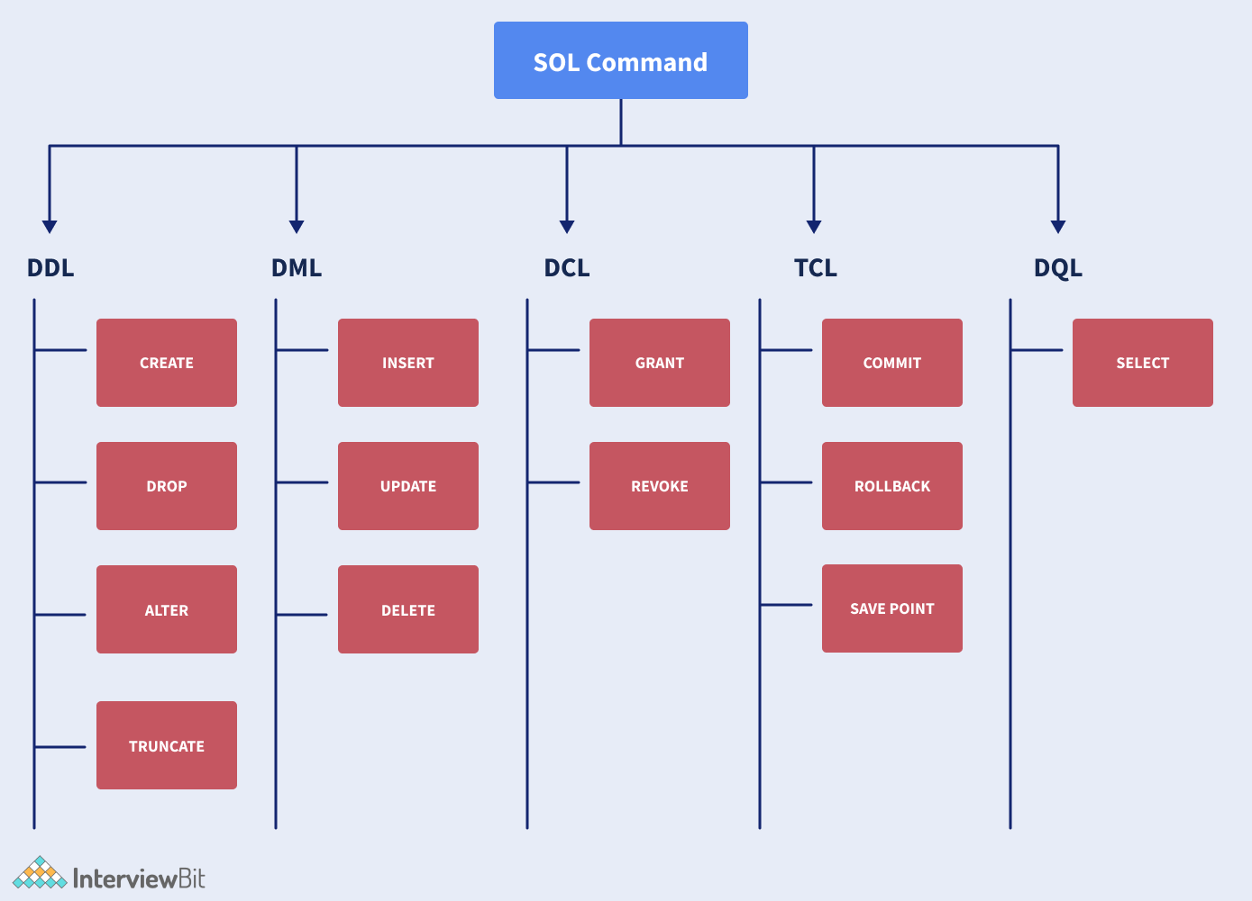

DISTINCT – To retrieve unique items

ORDER BY – To sort, in case of multiple items first value will be prefered and in case of same first value then second value will be checked.

SELECT ProductKey, EnglishProductName, Color

from DimProduct

Order by 2,3;

Comments:

Single Line = --

Multi Line = /* */