BIS402 Multimedia TECHNOLOGIES

Unit1: Introduction in Multimedia:

Multimedia concepts - research, design and planning; multimedia applications for education and training, business applications, home entertainment; multimedia authoring software; Multimedia production cycle

Unit2: Multimedia in Networks:

Multimedia in Legacy networks, FDDI , ATM, Wireless networks, Real Time protocols-RSVP, RTP, RTCP, RTSP etc.

Unit3: Multimedia components:

Text: Types of information, Hypertext and Hypermedia

Sound: Audio capture and representation - fundamentals of audio and perception; Digital sound and characteristics, Sampling variables, Sound Card layout, Compression, Loss less compression of sound, loss compression & silence compression, Synthesis of sounds, Difference between waveform and synthesized audio, Sound Formats- WAV, MPEG, MIDI , MIDI computer systems; frequency and dynamic ranges; basic sound editing, Music editors ,Lab Exercises in VB

Graphics: Still image manipulation - still image capture, creation and representation; file resolution, file sizing and portability; Image Compression-LZW compression, Huffman Coding, Graphic adapters, Graphic file formats and characteristics, GIFF,TIFF, JPEG, Web graphics, Incorporating multimedia elements in web pages. 2D graphical image manipulation in layer based images; applying special effects, such as transformations, text effects, filters, 3D graphics, Lab exercises in Adobe Photoshop

Animation: Fundamentals of Animations, Formats of animation files, Animation software, 3D-animation-Lab exercises in Visual Basic, Macromedia flash, Macromedia Director.

Video: Fundamentals, Compression, Video capture cards, Formats, MPEG standards, MHEG Standard recent development in Multimedia, Digital Camcorders and Camera.

UNIT I – INTRODUCTION TO MULTIMEDIA

MULTIMEDIA CONCEPTS

1. Introduction
Everyone have their own impression of what multimedia is. Some think of it as a slideshow, others an interactive kiosk and some as a video game on the TV. Multimedia may look like ALL of these things. There is no right or wrong definition -- it is a continuum of applications and technologies that allow for a wide range of experiences.
Multimedia concerns the representation of mixed modes of information - text, data, image, audio, and video - as digital signals. Multimedia enhances the way people work, learn, play, and most importantly communicate. In it's most basic definition, multimedia can be thought of as applications that bring together multiple types of media: text, illustrations, photos, sounds, voice animations and video. A combination of these with some user interactivity is deemed multimedia computing.

The term multimedia in the summarized sense is:

”Multimedia is a combination of several computer output media, of which at least one is a dynamic medium, used in interactive computer presentations in an integrated manner.”

The power and promise of multimedia is that it gives control to the end user - hence the term interactive. Once content in various media forms is combined, it can be made interactive. User can begin to navigate and choose relevant information for them.

Multimedia can be applied to three different conceptual components of information systems:

*To the contents of information, where the user is supported in understanding the meaning of the
(application-dependent) information through appropriate presentations;
*To the human-computer interaction, where the user is supported in navigating through the
(application-independent) information on the system's state by providing him with hints and
Feedback;
*To the human-human interaction, supporting several users of the same application system to
Communicate with each other in real time through various computer-supported communications
Channels

Ideally all of these three aspects should be integrated in application systems in order to support, not only requirements of the application, but also user-specific needs; this through various media and their combinations employ different effects of information presentation and communicate different types of meanings as shown in table 1.1 .

Multimedia is at the heart of this customisation with options and interfaces that allow consumers to interactively control the content they want to view. 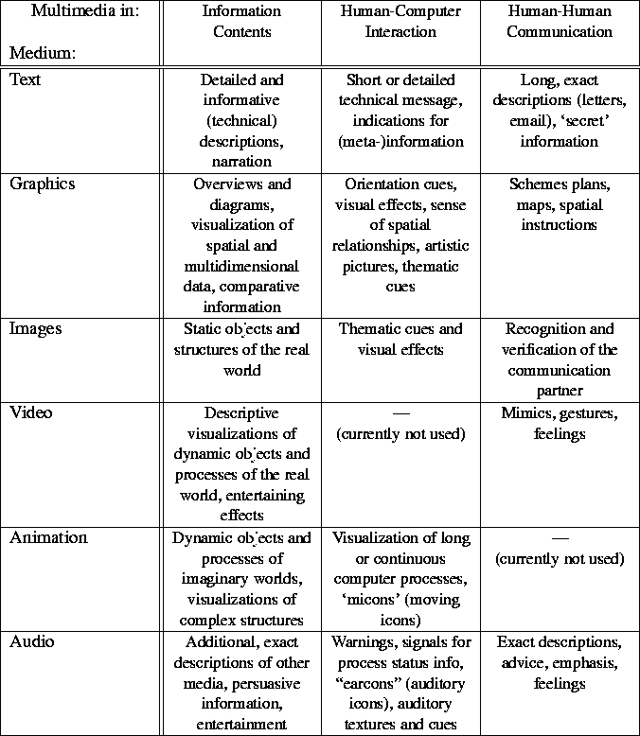

Table 1.1: Uses of different media with respect to different components of application systems

2. MULTIMEDIA APPLICATIONS

- Education and Training
- Business applications
- Home Entertainment
- Digital video editing and production systems
- Electronic Newspapers/Magazines
- Games
- Groupware
- Home shopping
- Interactive TV
- Multimedia courseware
- Video conferencing
- Video-on-demand
- Virtual reality

3. MULTIMEDIA AUTHORING SOFTWARE

Multimedia Authoring software can be used to create anything from simple slide shows to full-blown games and interactive applications. There are literally thousands of uses for this type of software: computer-based training, surveys, quizzes and tests, encyclopedias, games, interactive kiosks, interactive presentations, screen savers, CD-ROM/DVD content creation, and advertisements to name a few.
It supports a wide variety of multimedia file formats including images, video, and sound. High-end products in this category will offer database support for data-driven content. Although it's not required for all software in this category, much of it involves learning advanced programming and scripting languages to utilize its full capabilities.
Content is definitely intended for distribution and the software generally has some means of exporting projects to self-running, self-installing files. Many products in this category allow you to export your content as screen savers as well.

Some publishers of Multimedia Software
Adobe
The premier publisher of multimedia software. Products include Adobe Director (multimedia authoring), Dreamweaver (web publishing), PhotoShop (photo editing), and more.
www.adobe.com
Dazzler
{Win} software products for producing interactive multimedia presentations, training courses, product catalogues and kiosk systems.
www.dazzlersoft.com
Flying Popcorn
[Win] New computer users can create multimedia contents with 3D sound effects, images, geometrical shapes, and text and movie files. Also, professional users will find abundant application potentials and dazzling transformation capabilities to develop sophisticated contents.
www.parasys.net
GraFX Saver Pro
Create and distribute your own professional screen savers with over 30 image, video, and audio formats.
www.grafxsaver.com
HyperStudio
[Win, Mac] classroom multimedia authoring program.
www.hyperstudio.com
MediaBlender
[Win, Mac] easy to use multimedia authoring package. Access Media Blender from any computer with Internet access, host the software on your own servers for better performance, and load a stand-alone application on your computer for use without an Internet connection.
www.tech4learning.com
Misty Media
[Win] all-in-one software for conversion, editing, recording, burning, playback, and more for nearly all audio, video, and graphics formats.
www.mystikmedia.com
Movie Works
[Win, Mac] combines simple-to-use video, sound, animation, paint and image editing tools with a powerful time-based, object-oriented sequencing and authoring program. The five integrated Movie Works Deluxe production applications work together seamlessly, making it easy to incorporate analog or digital video, buttons, photos, graphics, animations, 3D, narration, MIDI, MP3, CD music, text and titling, and even virtual reality movies into stunning, professional-quality multimedia productions.
www.movieworks.com

4. THE MULTIMEDIA PRODUCTION CYCLE

A multimedia producer who takes on a project and jumps into the deep end without prior project planning and organization will end up with an unsuccessful product. A little foresight and planning can go a very long way.

6.1 MULTIMEDIA PROJECT PLANNING
Planning a multimedia project is quite similar to most any project-planning task. The primary difference is planning for technology. There is a software application that can greatly assist the multimedia developer in planning called as Allen Communications Designers Edge.
The problem with planning and then following that plan is that it can take all of the spontaneity out of the work.

6.2 STORYBOARDING
The term storyboarding refers to the visual layout of a production story line in a comic-strip fashion. Figure below shows part of a typical storyboard in the making.
A storyboard allows the developer to test the overall concept for completeness and visually define all the aspects of a project that can be anticipated. It also allows for good visual communication among development team members so that all understand the parameters of the project.

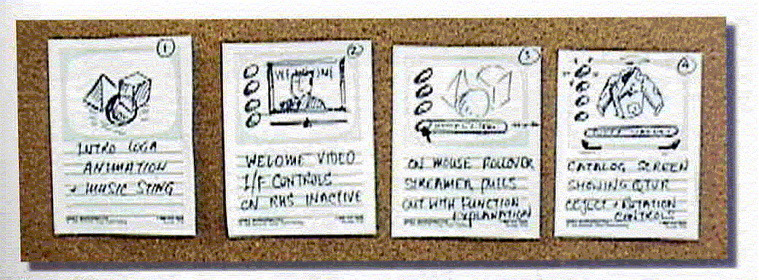
Figure: 1.4 Storyboarding
Additionally, a good storyboard is an invaluable tool for communicating with clients and getting their input. It is better to get this feedback early at storyboard time, than toward the end of the project.

6.3 MEDIA COMPONENTS
The media components of your project, such as video clips, interface back plate, button graphics, sound bites, animations, or applets, are just building blocks for the whole application you are creating.
By classifying your media components and listing them, you can then judge which items are sequential and depend on another item being completed before you can work on it.
For instance, a video clip that incorporates an animation sequence cannot be done until the animation is completed. Designing interactivity usually requires the controls and buttons to be designed first.

6.4 PREPRODUCTION
Preproduction is preparing to produce the media component in question. Perhaps an image has to be converted to 24-bit color to accommodate the special effects you wish to apply, and then has to be converted back to 8-bit color depth. An animated object may require a special material or logo painted on its surface in the animation, and these images may have to be created before the animating can start. If sound files are supplied on videotape, they will need to be digitized before you can edit them and crop sequences to suit the application.

6.5 PRODUCTION AND POSTPRODUCTION
There is often more to the production process than just using the software tool to get the job done. For instance, you may be animating a space scene that shows a spacecraft flyby and then docking into a rotating space station. For this example, the same principles apply animating a box of soap for a commercial.
Postproduction techniques involve using another application to add additional features and effects to the media component after it has been created.

6.6 TESTING
The testing phase of any project is critical. It absolutely cannot be over-looked. Always allow a nice chunk of time toward the end for testing, revision, and repair of any problems that testing exposes. Once a bug is encountered and fixed, it must be tested again to verify that it is fixed at the point in the application where it was encountered and anywhere else in the product. Sometimes repairing one bug introduces a different bug, and then that one has to be fixed. Cycling through the debugging process can take quite some time, especially when it depends on outside testers to get back to you in a timely manner.

6.7 PRODUCT DELIVERY

For the multimedia project delivery, the development processes is required for the media components of your multimedia application, whether it is to run on a CD-ROM, on a DVD-ROM, on a Web site, or over an intranet. Consider your multimedia development skills interchangeable over projects. Deciding on your delivery format will determine the final authoring and wrapping up of the project. Subsequently, this delivery format choice may require specialized skills, techniques, and content formatting for the chosen delivery vehicle. The delivery system will also have performance considerations that you will have to plan for. For example, a DVD-ROM will do a far superior job of presenting video than will a Web site. Plan for the delivery system you intend to use, and format your media components to suit.

UNIT II: MULTIMEDIA in Networks

Multimedia communications concern the technology required to manipulate, transmit, and control these audiovisual signals across a networked communications channel. For net workers, multimedia networking is to build the hardware and software infrastructure and application tools to support multimedia transport on networks so that users can communicate in multimedia.

1. The real-time challenges:

However, multimedia networking is not a trivial task. We can expect at least three difficulties.

First, compared with traditional textual applications, multimedia applications usually require much higher bandwidth. A typical piece of 25-second 320x240 QuickTime movie could take 2.3MB, which is equivalent to about 1000 screens of textual data. This is unimaginable in the old days when only textual data is transmitted on the net.

Second, most multimedia applications require the real-time traffic. Audio and video data must be played back continuously at the rate they are sampled. If the data does not arrive in time, the playing back process will stop and human ears and eyes can easily pick up the artifact. In Internet telephony, human beings can tolerate a latency of about 250 millisecond, If the latency exceeds this limit, the voice will sound like a call routed over a long satellite circuit and users will complain about the quality of the call. In addition to the delay, network congestion also has more serious effects on real-time traffic. If the network is congested, the only effect on non-real-time traffic is that the transfer takes longer to complete, but real-time data becomes obsolete and will be dropped if it doesn’t arrive in time. If no proper action is taken, the retransmission of lost packets would aggravate the situation and jam the network.

Third, multimedia data stream is usually bursty. Just increasing the bandwidth will not solve the burstiness problem. For most multimedia applications, the receiver has a limited buffer. If no measure is taken to smooth the data stream, it may overflow or underflow the applications buffer. When data arrives too fast, the buffer will overflow and the some data packets will be lost, resulting in poor quality. When data arrives too slow, the buffer will underflow and the application will starve.

Contrary to the high bandwidth, real-time and bursty traffic of multimedia data, in real life, networks are shared by thousands and millions of users, and have limited bandwidth, unpredictable delay and availability. How to solve these conflicts is a challenge multimedia networking must face.

The possibility of answering this challenge comes from the existing network software architecture and fast developing hardware.
- Fast networks like Gigabit Ethernet, FDDI, and ATM provide high bandwidth required by digital audio and video.
- The design of real-time protocols for multimedia networking becomes imperative to solve the problem.

2 Multimedia in legacy Networks:

We will examine different networks with respect to their multimedia transmission capabilities
2.1) Local Area Networks (LANs):
a) Ethernet
Ethernet is the most widely used LAN. Ethernet offers bandwidth of at least 10 Mbps. The communication of continuous data requires guarantees of a maximal end-to-end delay and a minimal jitter. In principle, Ethernet cannot guarantee these requirements. However, there are several possibilities for using this type of LAN for audio and video transmission. They are:
Dynamic Adaptation: To avoid the errors due to a high network load, continuous data transmission can be dynamically adapted to the network load. This means that if the network load is high, the data rate of continuous media can be reduced dynamically. This is possible with the help of scaleable coding, but here again, transmission error is possible.
Dedicated Ethernet: Another possibility for the transmission of audio/video data is to dedicate a separate Ethernet LAN to the transmission of continuous data. This solution requires compliance with a proper additional protocol. Further, end-users need at least two separate networks for their communications: one for continuous data and another for discrete data. This approach makes sense for experimental systems, but means additional expense in the end-systems and cabling.
Hub: Most of the Ethernet cables are not installed in the form of a bus system. They make up a star (i.e., cables radiate from the central room to each station. In this central room, each cable is attached to its own Ethernet interface. Hence, each station has the full Ethernet bandwidth available, and a new network for multimedia transmission is not necessary. Additional cost is created by the usage of the hub.
b) Fast Ethernet
Fast Ethernet, known as 100base-T offers throughput speed of up to 100Mbits/s, and it permits users to move gradually into the world of high-speed LANs.
Full-duplex operation requires a switch, which allows individual nodes to transmit and receive data simultaneously. Full-duplex fast Ethernet switches will effectively increase network throughput speeds to 200Mbps and supports multimedia traffic.
c) Token Ring
The Token Ring is a LAN with 4 or 16Mbps throughput. All station are connected to a logical ring. Each station receives, reads and sends frames circulating in the ring according to the Token Ring MAC Sublayer Protocol (IEEE standard, 802.5). The IEEE Standard 802.5 protocol includes an elaborate scheme for handling multiple priority schemes. The existing priority mechanism, without modification of any communication components, allows for the use of these LANs for continuous media transmission. The continuous data streams all get the same higher priority than discrete media streams. However, with a high share of continuous media in the Token Ring traffic, undesirable delays of data frames occur. To achieve good performance, a simple form of bandwidth management is to limit the number of active multimedia sessions on a Token Ring segment.

d) FDDI
The Fiber Distributed Data Interface (FDDI) is a high-performance fiber optic LAN, which is configured as a ring. It is often seen as the successor of the Token Ring IEEE 802.5 protocol.
Compared to the Token Ring, FDDI is more a backbone than a LAN only because it runs at 100Mbps over distances up to 100km with up to 500 stations. FDDI supports different transmission modes, which are important for the communication for multimedia data. The synchronous mode allows a bandwidth reservation; the asynchronous mode behaves similar to the Token Ring protocol.
e) FDDI-II
FDDI-II is a hybrid High-Speed Local Area Network (HSLAN). It integrates circuit switched services (isochronous services) for delay-sensitive applications. For isochronous data transmissions, the channel bandwidth is centrally allocated on a demand basis, using a connection-oriented service. The station wishing to establish an isochronous connection must send a connection setup request to the cycle master prior to a conversation. Then it must issue a termination request upon finishing the conversation. The signaling, required for setting up isochronous connections, would normally be carried out in-band over the packet data channels. Consequently, using such a connection-oriented and centralized access control, FDDI-II is able to fairly and accurately provide bandwidth access and control for multimedia applications.
f) Local ATM Networks
The Asynchronous Transfer Mode (ATM) is a cell (packet) switching concept with minimal function in network. The ATM concept uses a fixed length packet (cell) of size 53 bytes - 48 bytes of user data and a 5 byte header .ATM allows the systems to operate at a much higher rate than usual packet switching systems. The high rate is achieved because of the following characteristics:
- No error protection or flow control on a link-to-link basis.
If a link of the connection, either the user-to-network link or a link between two ATM switches, introduces an error during transmission, or is temporarily overloaded thereby causing the loss of packets, no special action is taken on that link (e.g., no request for retransmission is made on that link, as is common in packet switching). It means nothing is done to correct errors inside the network. The ATM network relies on end-to-end protocols.
- ATM operates in a connection-oriented mode.
Before data are transferred from a multimedia terminal to the network, a logical/virtual connection setup phase must allow the network to perform a reservation of the necessary resources. If no sufficient resources are available, the connection is refused and the requesting terminal is notified. After the end of the data transfer phase, the allocated resources are released. This connection-oriented mode allows the network to provide (in all cases) a minimal packet loss ratio.
- The header functionality is reduced
To guarantee fast processing in the network, the ATM header has a very limited function. Its main function is the identification of the virtual connection by an identifier, which is selected at a call setup time and is guaranteed a proper routing of each packet in the network. In addition, it allows an easy multiplexing of different virtual connections over a single link.
In addition to the Virtual Connection Identifier (VCI), a very limited number of functions are support by the header, mainly related to maintenance. Due to the limited functionality of the header, the implementation of the header processing in the ATM nodes is simple and can be done at very high speeds (150Mbps up to Gbps). This results in low processing and queuing delays.
- The information field length is relatively small.
To reduce the internal buffers in the switching nodes, and to limit the queuing delays in those buffers, the information field length is kept relatively small. This assures a small end-to-end delay caused by the packetization of audio and video data into ATM cells.
The ATM concept guarantees the possibility of transporting any data independent of its characteristics such as the bit rate, its quality requirements or its bursty nature. This means that the ATM networks are suitable, with their speed and bandwidth characteristics, to offer a transmission service for the multimedia traffic with different quality requirements.
ATM Cell /header Information:
ATM services and capabilities are achieved using information in the ATM cell header. Hence, we describe some header information, which is important for the support of multimedia data transmission:
- Virtual Connections
Functions such as the source, destination address and sequence number are not required to be part of an ATM cell. Every virtual connection is identified by number, which has only a local significance (per link). The virtual connection is identified by two subfields of the header: Virtual Channel Identifier (VCI) and Virtual Path Identifier (VPI).
- Virtual Channels
  - Since the ATM network is connection-oriented, a VCI is assigned to each connection during the connection setup procedure. A VCI has only a local significance at the link between two ATM nodes. If the connection is released, the VCI values of the involved path are released and can be reused by other connections.
  - An interesting advantage of this VCI principle is the use of multiple VCI values for multicomponent services (e.g., video telephony, TV etc.). For example, a video telephone call may use three communication streams: voice, video and data, each of which will be transported over a separate VCI. It allows the network to add or remove streams during transmission. This means that the video telephony service can start with voice only (single VCI) and the video stream can be added (and removed) over a separate VCI later on. The signalling for managing the particular connections is transported over a separate VCI.
- Virtual Path
  - Future broadband networks will support semi-permanent connections between end-points. This concepts is known as a virtual path or a virtual network. To perform this virtual network, another field is defined in the header Virtual Path Identifier.
- Priorities
The ATM header supports a differentiation of logical connections through different priorities. Two types of priorities exist: time priority and semantic priority. In the time priority system, it is assumed that some cells may remain longer in the network than others. In a semantic priority system, some cells have a higher probability of being lost, giving rise to a higher cell loss ratio.
Priorities can either be assigned on a per connection basis (per VPI or per VCI), or on a per cell basis.
- Maintenance
To maintain the overall network and to provide performance monitoring (which implies a monitoring of the media quality) of the ATM connections, some additional bits are useful. The Payload Type Identification (PTI) distinguishes, using the PTI information field, which type of data (e.g., video, data, control, ...) is carried in the ATM cell.
- Multiple Access
In addition, to allow multiple terminals (users) to be connected to the same physical link, a point-to-multipoint protocol is specified. This protocol is useful, for example, for video-conferencing applications. To perform this point-to-multipoint function, the Generic Flow Control (GFC) field in the ATM header is used. GFC provides the possibility to negotiate shared access to the network at the User-Network Interface (UNI), i.e., how to multiplex the shared network among the cells of the various ATM connections.
- Header Error Protection
The header of the ATM cell is the most sensitive part to be protected against corruption. Therefore, it should be protected against single bit errors and, if possible, also against burst errors. To protect the header, a coding principle based on a generalization of Hamming codes is very suitable, namely the BCH codes (Bose-Chadhuri-Hocquenghem).

REAL TIME PROTOCOLS:
The Internet has been used primarily for the reliable data transmission with minimal or no delay constraints. The TCP/IP protocols were designed for this type of traffic and work very well in this context. However, multimedia traffic, which constitutes of a significant portion of potential multicast traffic, possesses different characteristics and hence requires the use of different protocols to provide the necessary services.
For example, if a receiver has to wait for a TCP retransmission, there can be a noticeable and unacceptable delay in playout of the real-time data, whether audio, video, or something else. In addition, the "slow start" TCP congestion-control mechanism can interfere with the audio and video "natural" playout rate. Since there is no fixed path for datagrams to flow across the Internet, there is no mechanism to make sure that the bandwidth needed for multimedia is available between the sender and receiver(s), so quality of service cannot be guaranteed. Additionally, TCP doesn't provide timing information, a critical requirement for multimedia support. So in order solve the problems the solution is as follows:

The solution:

The solution for multimedia over IP is to classify all traffic, allocate priority for different applications and make reservations. The Integrated Services working group in the IETF (Internet Engineering Task Force) developed an enhanced Internet service model called Integrated Services that includes best-effort service and real-time service.
The real-time service will enable IP networks to provide quality of service to multimedia applications. Multimedia applications usually do not need the complexity of TCP and, instead, use a simpler transport framework. Most playback algorithms can tolerate missing data way better than long delays caused by retransmission. They don't require guaranteed in-sequence delivery either. Certain protocols have been developed to enhance the Internet and improve support of applications like audio, video and interactive multimedia conferencing. The main protocols are Resource Reservation Protocol (RSVP), together with Real-time Transport Protocol (RTP), Real-Time Control Protocol (RTCP), Real-Time Streaming Protocol (RTSP), provides a working foundation for real-time services.

a) RSVP --- Resource ReSerVation Protocol

RSVP is the network control protocol that allows data receiver to request a special end-to-end quality of service for its data flows. Real-time applications use RSVP to reserve necessary resources at routers along the transmission paths so that the requested bandwidth can be available when the transmission actually takes place. RSVP is a main component of the future Integrated Services Internet which can provide both best-effort and real-time service.

How does RSVP work?
RSVP is used to set up reservations for network resources. When an application in a host (the data stream receiver) requests a specific quality of service (QoS) for its data stream, it uses RSVP to deliver its request to routers along the data stream paths. RSVP is responsible for the negotiation of connection parameters with these routers. If the reservation is setup, RSVP is also responsible for maintaining router and host states to provide the requested service.

Each node capable of resource reservation has several local procedures for reservation setup and enforcement (see Figure 1).
Policy control determines whether the user has administrative permission to make the reservation. In the future, authentication, access control and accounting for reservation will also be implemented by policy control.
Admission control keeps track of the system resources and determines whether the node has sufficient resources to supply the requested QoS.

The RSVP daemon checks with both procedures. If either check fails, the RSVP program returns an error notification to the application that originated the request. If both checks succeed, the RSVP daemon sets parameters in the packet classifier and packet scheduler to obtain the requested QoS.

The packet classifier determines the QoS class for each packet and
The packet scheduler orders packet transmission to achieve the promised QoS for each stream.

RSVP daemon also communicates with the routing process to determine the path to send its reservation requests and to handle changing memberships and routes.

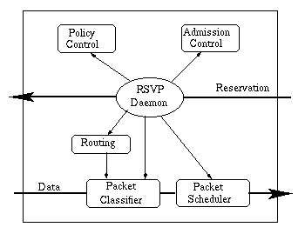

Figure 1: reservation at a node on the data flow path

This reservation procedure is repeated at routers along the reverse data stream path until the reservation merges with another reservation for the same source stream.

The reservation states RSVP builds at the routers are soft states. The RSVP daemon needs to send refresh messages periodically to maintain the reservation states. The absence of refresh message within a certain time will destroy the reservation state. By using soft states, RSVP can easily handle changing memberships and routes.

The receivers initiate the reservation requests. They do not need to travel all the way to the source of the sender. In stead, it travels upstream until it meets another reservation request for the same source stream, then merges with that reservation. Figure 2 shows how the reservation requests merge as they progress up the multicast tree.
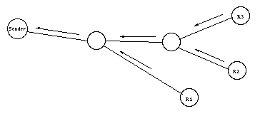
Figure 2: reservation merging.

This reservation merging leads to the primary advantage of RSVP: scalability---a large number of users can be added to a multicast group without increasing the data traffic significantly. So RSVP can scale to large multicast groups and the average protocol overhead decreases as the number of participants increases.

The reservation process does not actually transmit the data and provide the requested quality of service. But through reservation, RSVP guarantees the network resources are available when the transmission actually takes place.

Although RSVP sits on top of IP in the protocol stack, it is not a routing protocol, but rather an Internet control protocol. Actually, RSVP relies on the underlying routing protocols to find where it should deliver the reservation requests. RSVP is also intended to cooperate with unicast and multicast routing protocols. When the RSVP-managed flow changes its path, the routing module will notify the RSVP module of the route changes. Therefore, RSVP can quickly adjust the resource reservation to new routes.

RSVP Features:

RSVP flows are simplex.

RSVP distinguishes senders and receivers. Although in many cases, a host can act both as a sender and as a receiver, one RSVP reservation only reserves resources for data streams in one direction.

RSVP supports both multicast and unicast, and adapts to changing memberships and routes. A host can send IGMP (Internet Group Management Protocol) messages to join a multicast group. Reservation merging enables RSVP to scale to large multicast groups without causing heavy overhead for the sender.

RSVP is receiver-oriented and handles heterogeneous receivers.

- RSVP has good compatibility. Efforts have been made to run RSVP over both IPv4 and IPv6. It provides opaque transport of traffic control and policy control messages in order to be more adaptive to new technologies.

b) RTP --- Real-time Transport Protocol

RTP is the Internet-standard protocol for the transport of real-time data, including audio and video. It can be used for media-on-demand as well as interactive services such as Internet telephony. RTP consists of a data and a control part. The latter is called RTCP.
The data part of RTP is a thin protocol providing support for applications with real-time properties such as continuous media (e.g., audio and video), including timing reconstruction, loss detection, security and content identification.
RTP is designed to work in conjunction with the auxiliary control protocol RTCP to get feedback on quality of data transmission and information about participants in the on-going session.

How does RTP work?
Internet is a shared datagram network. Packets sent on the Internet have unpredictable delay and jitter. But multimedia applications require appropriate timing in data transmission and playing back. RTP provides time stamping, sequence numbering, and other mechanisms to take care of the timing issues. Through these mechanisms, RTP provides end-to-end transport for real-time data over datagram network.

Time stamping is the most important information for real-time applications. The sender sets the timestamp according to the instant the first octet in the packet was sampled. Timestamps increase by the time covered by a packet. After receiving the data packets, the receiver uses the timestamp to reconstruct the original timing in order to play out the data in correct rate. Timestamp is also used to synchronize different streams with timing properties, such as audio and video data in MPEG. However, RTP itself is not responsible for the synchronization. This has to be done in the application level.

UDP does not deliver packets in timely order, so sequence numbers are used to place the incoming data packets in the correct order. They are also used for packet loss detection. Notice that in some video format, when a video frame is split into several RTP packets, all of them can have the same timestamp.
So just timestamp is not enough to put the packets in order.

The payload type identifier specifies the payload format as well as the encoding/compression schemes. From this payload type identifier, the receiving application knows how to interpret and play out the payload data.

Another function is source identification. It allows the receiving application to know where the data is coming from. For example, in an audio conference, from the source identifier a user could tell who is talking.
The above mechanisms are implemented through the RTP header.
Payload type
Timestamp
Sequence number
Synchronization Source Identifier
Miscellaneous fields

RTP Header
RTP is typically run on top of UDP as shown in figure 2 to make use of its multiplexing and checksum functions. TCP and UDP are two most commonly used transport protocols on the Internet. TCP provides a connection-oriented and reliable flow between two hosts, while UDP provides a connectionless but unreliable datagram service over the network.
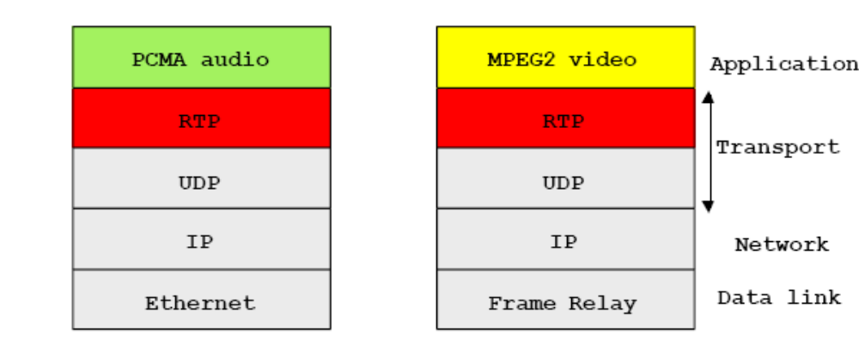
Figure 2: RTP data in an IP packet

Application Layer
In practice, RTP is usually implemented within the application. Many issues, such as lost packet recovery and congestion control, have to be implemented in the application level.
Transport Layer
The protocol supports the use of RTP-level translators and mixers. Mixer is an intermediate system that combines RTP streams from different sources into a single stream as shown in figure 3.
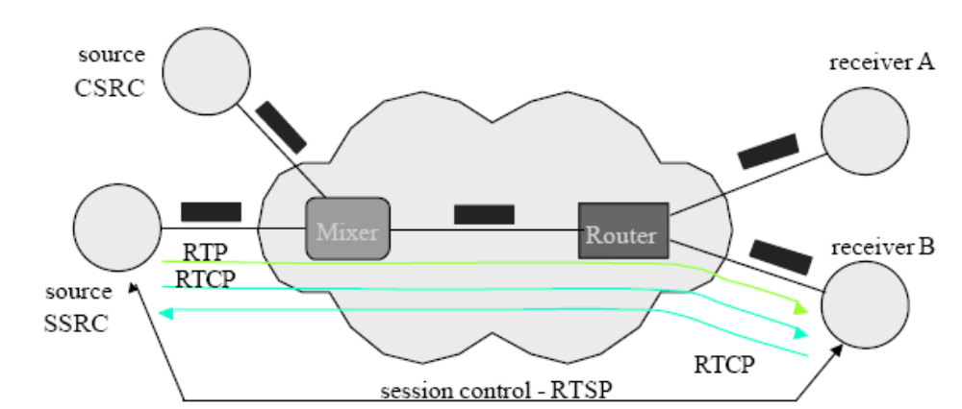
Figure 3

UDP was chosen as the target transport protocol for RTP because of two reasons.
First, RTP is primarily designed for multicast; the connection-oriented TCP does not scale well and therefore is not suitable.

Second, for real-time data, reliability is not as important as timely delivery. Even more, reliable transmission provided by retransmission as in TCP is not desirable. For example, in network congestion, some packets might get lost and the application would result in lower but acceptable quality. If the protocol insists a reliable transmission, the retransmitted packets could possibly increase the delay, jam the network, and eventually starve the receiving application.

RTP does not address the issue of resource reservation or quality of service control; instead, it relies on resource reservation protocols such as RSVP.
Applications:
It is frequently used in streaming media systems (in conjunction with RTSP) as well as videoconferencing and push to talk systems (in conjunction with H.323 or SIP), making it the technical foundation of the Voice over IP industry.

c) RTCP---Real-Time Control Protocol

RTCP is the control protocol designed to work in conjunction with RTP. It is standardized in RFC 1889 and 1890. In an RTP session, participants periodically send RTCP packets to convey feedback on quality of data delivery and information of membership. RFC 1889 defines five RTCP packet types to carry control information. These five types are:

RR: receiver report. Receiver reports are generated by participants that are not active senders. They contain reception quality feedback about data delivery, including the highest packets number received, the number of packets lost, inter-arrival jitter, and timestamps to calculate the round-trip delay between the sender and the receiver.
SR: sender report. Sender reports are generated by active senders. In addition to the reception quality feedback as in RR, they contain a sender information section, providing information on inter-media synchronization, cumulative packet counters, and number of bytes sent.

SDES: source description items. They contain information to describe the sources.
BYE: indicates end of participation.
APP: application specific functions. It is now intended for experimental use as new applications and new features are developed.
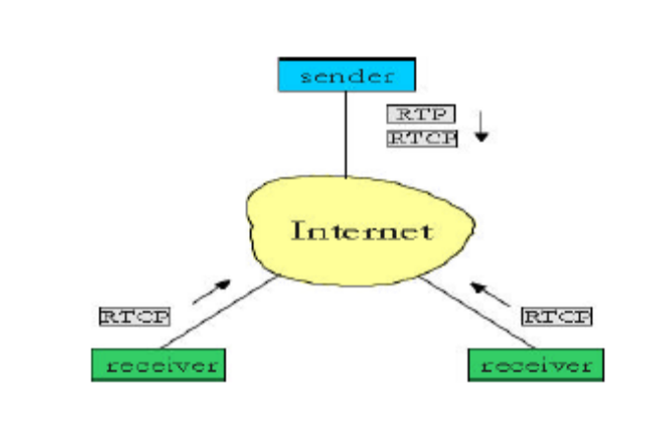
Through these control information packets, RTCP provides the following services:

QoS monitoring and congestion control: This is the primary function of RTCP. RTCP provides feedback to an application about the quality of data distribution. The control information is useful to the senders, the receivers and third-party monitors. The sender can adjust its transmission based on the receiver report feedback. The receivers can determine whether congestion is local, regional or global. Network managers can evaluate the network performance for multicast distribution.

Source identification: in RTP data packets, randomly generated 32-bit identifiers identify sources. These identifiers are not convenient for human users. RTCP SDES (source description) packets contain textual information called canonical names as globally unique identifiers of the session participants. It may include user's name telephone number, email address and other information.

Inter-media synchronization: RTCP sender reports contain an indication of real time and the corresponding RTP timestamp. This can be used in inter-media synchronization like lip synchronization in video.

Control information scaling: RTCP packets are sent periodically among participants. When the number of participants increases, it is necessary to balance between getting up-to-date control information and limiting the control traffic. In order to scale up to large multicast groups, RTCP has to prevent the control traffic from overwhelming network resources. RTP limits the control traffic to at most 5% of the overall session traffic. This is enforced by adjusting the RTCP generating rate according to the number of participants.

d) RTSP---Real-Time Streaming Protocol

What is Streaming?
Streaming media is media that is consumed (read, heard, viewed) while it is being delivered. Streaming is more a property of the delivery system than the media itself. The distinction is usually applied to media that are distributed over computer networks; most other delivery systems are either inherently streaming (radio, television) or inherently non-streaming (books, video cassettes, audio CDs).

RTSP overview
Instead of storing large multimedia files and playing back, multimedia data is usually sent across the network in streams. RTSP takes advantage of streaming which breaks data into many packets sized according to the bandwidth available between client and server. When enough packets have been received by the client, the user's software can be playing one packet, decompressing another and downloading the third. The user is able to start listening almost immediately without having to get the entire media file. Both live data feeds and stored clips can be the sources of data.The idea in RTSP are that it acts as a "network remote control" for multimedia servers.
RTSP is an application-level protocol designed to work with lower-level protocols like RTP, RSVP to provide a complete streaming service over Internet. The Real Time Streaming Protocol is more of a framework than a protocol. It's meant to control multiple data delivery sessions, provide a way to choose delivery channels such as UDP, TCP and IP-multicast. The delivery mechanisms are based solely on RTP. RTSP has been designed to be on top of RTP to both control and deliver real-time content. Thus RTSP implementations will be able to take advantage of RTP improvements, such as RTP header compression. Although RTSP can be used with unicast, its use might help to smoothen the change from unicast to IP multicasting with RTP. Real Time Streaming Protocol can also be used with RSVP to set up and manage reserved-bandwidth streaming sessions.

The properties of RTSP
The Real Time Streaming Protocol boasts of very many properties. It is clear that IPv6 has been considered in these:
- Extendable (new methods and parameters are easy to add)
- Easy to parse (standard HTML or MIME parser can be used)
- Secure (HTTP authentication methods, transport and network layer security mechanisms applicable)
- Transport-independent (protocols such as UDP, RDP and TCP applicable)
- Multi-server capable (there can be media streams from different servers in one presentation)
- Control of recording devices (both playback and recording control possible)
- Separation of stream control and conference initiation (The only requirement is that the conference initiation protocol either provides or can be used to create a unique conference identifier)
- Suitable for professional applications (frame-level accuracy through SMPTE time stamps is supported to allow remote digital editing)
- Presentation description neutral (no particular format imposed, the presentation description must contain at least one RTSP URI, however)
- Proxy and firewall friendly (protocol should be readily handled by both application and transport-layer firewalls)
- HTTP-friendly (RTSP reuses HTTP concepts, where sensible)
- Appropriate server control (i.e. servers should not start streaming to clients in such a way that clients cannot stop the stream)
- Transport negotiation (transport method can be negotiated just before streaming)
- Capability negotiation(client must have a way to find out if some of the basic features are disabled in the server)

RTSP supported operations
The following operations are supported by RTSP protocol:
- Retrieval of media from media server
- Invitation of a media server to a conference (media server can be "invited" to join an existing conference, either to play back media into the presentation or to record media in a presentation)
- Addition of media to an existing presentation
- RTSP requests may be handled by proxies, tunnels and caches as in HTTP/1.1.
The full power of these protocols can be harnessed when IPv6 becomes the basis of Internet architecture. However, RTSP can already used also by the end-user by using Real Networks RealPlayers and/or RealMedia SDK. They implement the RTSP protocol as it is in the proposed standard.

