实训报告说明（此页不打印）
1、《2016级软件工程实训成绩单》为实训报告第一页，自己录入个人信息，成绩由指导教师填写。
2、实训任务书实训项目的目的和意义由企业指导教师填写（同一个项目目的意义可言一样），其余部分由学生填写，每个学生的“实训项目的主要内容”和“实训时间安排”应该有所不同。
3、电子版实训报告以实训区分组为单位上交实训红旗岗同学。

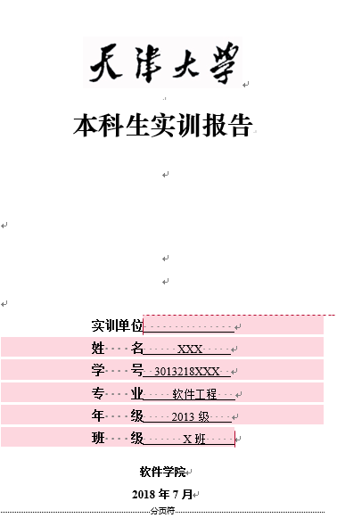
4、实训红旗岗同学负责统一装订成册，将第二页作为封皮，封皮颜色（深绿）。打印店：赛可优，以实训区为单位打印，到打印店后和我联系，18622203238。不需要付款。
实训封皮页 实训封皮颜色
5、刻盘：每个实训区1张光盘，包含实训报告（按实训分组存放），数据代码（企业允许的前提下），实训报告命名方式：姓名学号；
6、实训报告装订好后上交校内指导教师，由教师统一评分（分数取整），并于7月1日前完成成绩填写，并将所有实训材料上交学部。

2016级软件工程实训成绩单
姓名 | 梁哲粼 |  | 学号 | 3016218146
课程性质 | 必修 |  | 课程类别 | 专业核心
课程编号 | 2180110 |  | 课程名称 | 软件工程实训
课程学分 | 8 |  | 实训单位 | Ple Universitaire Leonard de Vinci, Franch
开课日期 | 2019年5月5日-2018年6月28日
考核项目 |  | 分项 |  |  | 得分
考勤 20% |  | 出勤情况
平时表现 30% |  | 团队合作
 |  | 表达能力
 |  | 遵守纪律
项目完成情况 50% |  | 项目文档
 |  | 个人工作量
 |  | 代码规范程度
 |  | 项目完成度
 |  | 系统演示
总分
备注
校内指导教师签字：

天津大学智能与计算学部
实训任务书

实训题目：
姓 名： | 梁哲粼
学 号： | 3016218146
实训单位： | Ple Universitaire Leonard de Vinci, Franch
企业导教师： | Nistor Grozavu
校内导教师： | 章亦葵
实训时间： | 2019年4月25-2019年6月28日

一、实训项目目的和意义(Training purpose and significance)
The goal of this project is to develop an application (desktop or web) in order to collect, to clean and to extract the knowledge from a dataset. Also practice and understand the importance of software engineering process, project management and teamwork.
The application should has a multiple language user interface, at least implement for 3 country languages: French, English and Chinese. The Application can detect the user location or OS language setting and can automatically show the appropriate language. The Project should contains the following Steps by providing to the teacher a presentation for each part:
I. Initialization step
1. Study the problem context by choosing the data you want to mine;
2. Elaborate the Use-case diagram and detailed description of the most
important cases
3. Define the global architecture of the Project
II. Elaboration step
1. Detailed architecture of the Project by describing all the
functionalities and the employed languages;
2. Scraping and collect the data
3. Data cleaning and transformation
4. Analysis of the dataset
III. Construction step
1. Integration of all the cases defined in the elaboration step.
2. Machine Learning
3. Visualization of the dataset
4. Program the application and make the main tests
IV. Deployment and Reporting
1. Deploy the project if possible in the defined environment
2. Prepare a detailed report
3. Presentation
二、实训项目的主要内容(Training purpose and main contents)
In the following, you will find more indications for the Project steps:
I. Initialization step
Choose and analyze the dataset and the domain application. Point out the context and the difficulties. It is better to use different data sources
Example: Use the following link:
https://lipn.univ-paris13.fr/~grozavu/DW/dataProject/
You are free to choose another database from (or other sources): https://archive.ics.uci.edu/ml/datasets.html
II. Elaboration step: Analysis of the dataset:
In order to analyze the dataset, you have to extract some statistical information from the given dataset, for example: the type of data, the missing values, outliers, the correlation between variables, etc. This part should contain also the analysis of the domain application and explain the goal of the Project.
III. Construction step
Machine Learning:
1. Use the Regression Line to predict values for some variables, you can choose any variable as a target. Compute the errors.
2. Use a machine learning method in order to predict the class of a new set of objects. You can use the methods as K-Nearest Neighbours (K-NN), Support Vector Machine (SVM), Decision trees, Neural Networks, etc. The obtained results should be validated using some external indexes as Prediction Error or others. The obtained results should be analyzed in the report and provide a solution to ameliorate the results.
Visualization:
You can visualize the knowledge extracted from the classification (prediction) in order to present the results i.e. scatter plots using predicted colors, decision trees, etc.
Theoretical details:
Give the algorithmically (mathematical) formalism of the method which give the best results. Explain all the parameters of the used method and their impact on the results.
Some comparison should be made to conclude the project.
The report should contain all these parts, and you should explain the motivation of the used methods, and discuss the obtained results.
Please note that you can use AWS, Python, R and/or Matlab and/or Knime for the experimentations and C++/Java/C#/other language for user interface.
The application software should be verified and validated. software test cases should included in the final project report. The report should clarify the team member and their respective contributions to the whole project.
三、实训时间安排(Time arrangements)
第1周(1st Week):
Software project initialization: Project team construction, chose the data set and present the project proposal.
第2周(2nd Week):
Elaborate the Use-case diagram and detailed description of the most important cases. Define the global architecture of the Project.
1st mile stone: presentation and peer review.
第3周(3rd Week):
Describe all the functions .Collect and scrap subsidiary data to replenish the main data set. Analyze data set’s construction and the correlation among the variables. Clean and transform data set to useful state.

第4周(4th week):
Design the initial Graphical user interface. Draft coding specification documents and choose the machine learning models.
Write reports to show the process of data transaction with visualization.
第5周(5th week):
Build models about clustering, classification and regression and encode them. Train models. Analyze the effect and improve models.
2nd mile stone: finishing ML process and allocating the tasks of next step.
第6周(6th week):
Deploy the application’s environment. Finish the development of GUI. Finish the documents.
第7周(7th week):
Encode the backend code. Integrate the project and get the intact application. Prepare the sample of test.
第8周(8th week):
Software testing P/D/C/A. Improve the project. 3rd mile stone: accomplish the whole project. Clear up the file for this learning trip.
第9周(9th week):
Finishing final report and conclusion. Do the final presentation.

指导教师签字： 2019年6月27日


本科生实训报告

实训单位 Ple Universitaire
Leonard de Vinci, France
姓 名 梁哲粼
学 号 3016218146
专 业 软件工程
年 级 2016级
班 级 四班

智能与计算学部软件学院
2019年6月
目 录

第一章 团队介绍 1
一、 团队成员介绍 1
二、 团队成员工作重点 1

第二章 系统需求分析 1
一、 XXXXXXXX 1
二、XXXXXXXXX 1
第三章 系统概要设计 Error: Reference source not found
一、 XXXXXXXX Error: Reference source not found
二、XXXXXXXXX Error: Reference source not found
第四章 系统详细设计 Error: Reference source not found
一、 XXXXXXXX Error: Reference source not found
二、XXXXXXXXX Error: Reference source not found
第五章 系统实现 Error: Reference source not found
一、 XXXXXXXX Error: Reference source not found
二、XXXXXXXXX Error: Reference source not found
第六章 系统测试 Error: Reference source not found
一、 XXXXXXXX Error: Reference source not found
二、XXXXXXXXX Error: Reference source not found
第七章 系统安装手册 Error: Reference source not found
一、 XXXXXXXX Error: Reference source not found
二、XXXXXXXXX Error: Reference source not found
第八章 系统用户手册 Error: Reference source not found
一、 XXXXXXXX Error: Reference source not found
二、XXXXXXXXX Error: Reference source not found
第九章 项目总结报告 Error: Reference source not found
一、 XXXXXXXX Error: Reference source not found
二、XXXXXXXXX Error: Reference source not found

第一章 团队介绍
1.1 团队成员介绍

There are a total of four members of our team, namely He Yuxuan, Huo Xinzhi, Liang.
Zhelin and Ma Li. Among them, Huo Xinzhi and Liang Zhelin are responsible for data
processing, analysis and analysis and display of prediction results, respectively.
He Yuxuan and Ma Li Responsible for the classification and regression of the machine
learning part of the data.

1.2 团队成员工作重点

Huo Xinzhi：
Statistics and analysis part:
(1) Learning the corresponding knowledge.
(2) Complete the main analysis target and send the data to the front end.
(3) Perform correlation analysis and set prediction targets.
Ma Li：
Data regression：
(1) Select several models to calculate and compare their performance.
(2) Regression training: This is a regression problem, we may use random forest and
try Xgboost. We will select the number of trees in the forest (n_estimators) and the
best combination. The scoring metric we will use is RMSE.
(3) Clustering (K-mean): Let's try to see if we can focus our customers (User_IDs)
based on the products and other features they buy. We slightly changed our functionality
to be more suitable for clustering. First, we will cluster users instead of
transactions, so we should group transactions by User_ID and create our functionality
based on this. Then choose The number of clusters (K). We will use the elbow method
to select one and draw different distance sums for different numbers of clusters.
He Yuxuan：
Data Classification:
(1) Using KNN (K Nearest Neighbors) algorithm, SVM (Support Vector Machine) and
decision tree classify data into different types.
(2) Classification is performed by measuring the distance between different feature
values. If the sample has a majority of the k nearest neighbors belonging to a certain
category in the feature space, the sample also belongs to the category.
(3) We hope to use the decision tree algorithm to decompose the data set into smaller
and smaller subsets and gradually develop the relevant decision tree.
Liang Zhelin：
Visualization
(1) Front-end style sheet design:
* Design user interface using LTE template and bootstrap library.
* Design charts using the Echarts Library.
* Dynamically modify the display language according to the browser language.
* Use jQuery to interact with the backend for data
(2) Display the results of data analysis, such as purchase volume analysis, purchase
comparison analysis. And the analysis of combined data results: such as item relevance,
combined analysis of different marital status and gender, analysis results of different
cities and years of residence, etc.
(3) In the forecasting part, the forecast is divided into purchasing power forecasting
and gender prediction and marital status forecasting. One is the regression problem,
and the other is the classification problem. The result is analyzed and predicted by
the given input data. Finally shown.

第二章 系统需求分析

第六章 系统测试

6.1 系统测试代码编写

The system test is the part of the project to check for missing, and it is a method
to check whether the project has a bug or a logical error. Here, we use the Java test
jar package selenium and junit to test the project.
Test Purpose: Check if the project button is available, that is, whether it can be
clicked.
Test method: use java and java jar package selenium and junit portable test code, carry
on automated test, check project errors.

The core code is as follows:

@Before
public void setUp() throws Exception {
String driverPath ="/Users/maomao/Desktop/France/Project/jar_package/geckodriver";
System.setProperty("webdriver.gecko.driver", driverPath);
driver = new FirefoxDriver();
baseUrl = "http://localhost:8080/BigData/index.html?_ijt=11lebdfo1ukent93mpbuvf421q";
driver.manage().timeouts().implicitlyWait(30, TimeUnit.SECONDS);
}
@Test
public void testBaidu() throws Exception {
/* analyze */
driver.get(baseUrl + "/");
WebElement test = driver.findElement(By.id("test1"));
test.click(); // product purchase
test = driver.findElement(By.id("test11"));
test.click(); // product category
test = driver.findElement(By.id("li1"));
test.click(); // gender li
test = driver.findElement(By.id("test3"));
test.click(); // gender purchase
test = driver.findElement(By.id("test4"));
test.click(); // gender category
test = driver.findElement(By.id("li2"));
test.click(); // age li
test = driver.findElement(By.id("test5"));
test.click(); // age purchase
test = driver.findElement(By.id("test6"));
test.click(); // age category
test = driver.findElement(By.id("li3"));
test.click(); // occupation li
test = driver.findElement(By.id("test7"));
test.click(); // occupation purchase
test = driver.findElement(By.id("test8"));
test.click(); // occupation category
test = driver.findElement(By.id("li4"));
test.click(); // city li
test = driver.findElement(By.id("test9"));
test.click(); // city purchase
test = driver.findElement(By.id("test10"));
test.click(); // city category
test = driver.findElement(By.id("li5"));
test.click(); // stay li
test = driver.findElement(By.id("test11"));
test.click(); // stay purchase
test = driver.findElement(By.id("test12"));
test.click(); // stay category
test = driver.findElement(By.id("li6"));
test.click(); // marital li
test = driver.findElement(By.id("test13"));
test.click(); // marital purchase
test = driver.findElement(By.id("test14"));
test.click(); // marital category
test = driver.findElement(By.id("li7"));
test.click(); // combine li
test = driver.findElement(By.id("test15"));
test.click(); // combine m&g
test = driver.findElement(By.id("test16"));
test.click(); // combine c&s
test = driver.findElement(By.id("test17"));
test.click(); // combine relation
test = driver.findElement(By.id("test18"));
test.click(); // prediction

/* predict */
// prediction purchase
WebElement name = driver.findElement(By.id("Name"));
name.sendKeys("maomao");
WebElement gender = driver.findElement(By.id("Male"));
gender.click();
WebElement Marital_Status = driver.findElement(By.id("Marital_Status"));
Marital_Status.click();
WebElement city = driver.findElement(By.id("City"));
city.click();
WebElement age = driver.findElement(By.id("Age"));
age.click();
WebElement occupation = driver.findElement(By.id("Occupation"));
occupation.sendKeys("3");
WebElement stay = driver.findElement(By.id("Stay_In_Current_City_Years"));
stay.click();
test = driver.findElement(By.id("test19"));
test.click();
// prediction gender
name = driver.findElement(By.id("Name"));
name.sendKeys("maomao2");
Marital_Status = driver.findElement(By.id("Marital_Status"));
Marital_Status.click();
city = driver.findElement(By.id("City"));
city.click();
age = driver.findElement(By.id("Age"));
age.click();
occupation = driver.findElement(By.id("Occupation"));
occupation.sendKeys("12");
stay = driver.findElement(By.id("Stay_In_Current_City_Years"));
stay.click();
WebElement ProductId = driver.findElement(By.id("Product_ID"));
ProductId.sendKeys("P00345542");
WebElement Category_1 = driver.findElement(By.id("Category1"));
Category_1.sendKeys("2");
WebElement Category_2 = driver.findElement(By.id("Category2"));
Category_2.sendKeys("5");
WebElement Category_3 = driver.findElement(By.id("Category3"));
Category_3.sendKeys("16");
WebElement money = driver.findElement(By.id("Purchase"));
money.sendKeys("5526");
test = driver.findElement(By.id("test20"));
test.click();
// prediction marital
name = driver.findElement(By.id("Name"));
name.sendKeys("maomao3");
gender = driver.findElement(By.id("Gender"));
gender.click();
city = driver.findElement(By.id("City"));
city.click();
age = driver.findElement(By.id("Age"));
age.click();
occupation = driver.findElement(By.id("Occupation"));
occupation.sendKeys("18");
stay = driver.findElement(By.id("Stay_In_Current_City_Years"));
stay.click();
ProductId = driver.findElement(By.id("Product_ID"));
ProductId.sendKeys("P00345542");
Category_1 = driver.findElement(By.id("Category1"));
Category_1.sendKeys("2");
Category_2 = driver.findElement(By.id("Category2"));
Category_2.sendKeys("5");
Category_3 = driver.findElement(By.id("Category3"));
Category_3.sendKeys("16");
money = driver.findElement(By.id("Purchase"));
money.sendKeys("5526");
test = driver.findElement(By.id("test21"));
test.click();
}

@After
public void tearDown() throws Exception {
driver.quit();
String verificationErrorString = verificationErrors.toString();
if (!"".equals(verificationErrorString)) {
fail(verificationErrorString);
}
}

private boolean isElementPresent(By by) {
try {
driver.findElement(by);
return true;
} catch (NoSuchElementException e) {
return false;
}
}

private boolean isAlertPresent() {
try {
driver.switchTo().alert();
return true;
} catch (NoAlertPresentException e) {
return false;
}
}

private String closeAlertAndGetItsText() {
try {
Alert alert = driver.switchTo().alert();
String alertText = alert.getText();
if (acceptNextAlert) {
alert.accept();
} else {
alert.dismiss();
}
return alertText;
} finally {
acceptNextAlert = true;
}
}
}

6.2 系统测试结果

After writing the system test code, we tested the project.
(1) The first test result:
In the first test, we found that some of the buttons could not be clicked, and some
of the jump links pointed to the wrong path and the page could not be displayed
correctly. We will modify this.
(2) The second test result:
The second test has correctly eliminated the erroneous results of the first test check,
but at the same time found some new errors: the predicted feedback information could
not be received correctly after the data was filled in the prediction section and sent.
Checked because the front and rear end of the send port is inconsistent.
(3) The third test result:
After modification, no errors affecting system operation were found in the third test,
and the results were correct. The results are shown in the following figure.

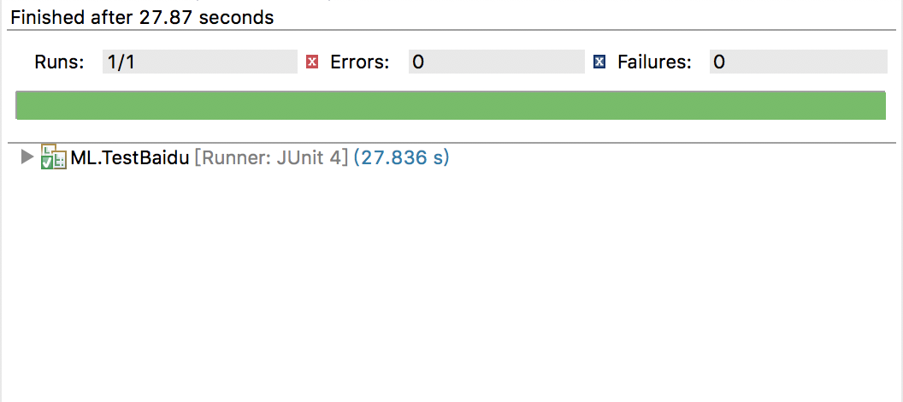

第七章： 系统部署
7.1 前端部署

Since our projects are deployed locally, the front and back ends can be deployed
separately. The front end uses webstorm to deploy the project. When connecting to the
backend, you only need to access the backend server url+ port through the http get
post head delete and update methods, and transfer the data, and finally get the result
and display it.

7.2 后段部署

第一章□□☆☆☆☆☆（居中、小三号、黑体）
1.1□☆☆☆（四号、黑体、顶格）
1.1.1□☆☆☆（四号、黑体、顶格）
□□☆☆☆☆☆☆☆☆☆正文（小四号、宋体） 宋体五号，居中，位于表上
表1-3□□☆☆☆
 | ××× | ×××
××× | ××× （宋体五号，垂直居中） | ×××
××× | ××× | ××
（表与正文空一行）
□□☆☆☆☆☆☆☆☆☆☆☆☆☆

第一章□□☆☆☆☆☆（居中、小三号、黑体）
1.1□☆☆☆（四号、黑体、顶格）
1.1.1□☆☆☆（四号、黑体、顶格）
□□☆☆☆☆☆☆☆☆☆正文（小四号、宋体） 宋体五号，居中，位于表上
表1-3□□☆☆☆
 | ××× | ×××
××× | ××× （宋体五号，垂直居中） | ×××
××× | ××× | ×××
（表与正文空一行）
□□☆☆☆☆☆☆☆☆☆☆☆☆☆
（下一章另起一页）
第二章□□☆☆☆☆☆（居中、小三号、黑体）
2.1□☆☆☆（四号、黑体、顶格）
2.1.1□☆☆☆（四号、黑体、顶格）
□□☆☆☆☆☆☆☆☆☆正文（小四号、宋体、空两格）
总经理
经营科
后勤中心
销售科
质量检测科
设备科
副总经理
秘书室
办公室

图2-5□□×××组织结构图
宋体五号居中，位于图下
图名与下文空一行
正文开始标注页码：
位置：页面底端（页脚）；
正文单独排页码, 阿拉伯数字（宋体小五号）连续编排，居中书写。
对齐方式：居中

