**Lab Report**

Title: Lab 2 part 2

Notice: Dr. Bryan Runck

Author: Maochuan Wang

Date: Jan 16, 2023

**Project Repository:**

**Google Drive Link:**

**Time Spent:** 5 hours

**Abstract**

The part 2 of lab 2 focuses on building a cost surface model given preferences and model weights. The central part of this lab is not the ETL but instead, the logic behind how to accurately build cost surface models by using arc gis pro geospatial tools. All the processes were done using arcpy from ArcGIS tools.

**Problem Statement**

Sustainable modeling was the main topic that we went through the class. There are two types of suitability modeling called Boolean suitability analysis and weighted linear combinations. This lab utilizes both suitability modelings and map algebra to create a cost surface model for an imaginary person named Dory, and to understand how uncertainty in model weights impacts that cost surface.

Table 1. <Data>

| **#** | **Requirement** | **Defined As** | **(Spatial) Data** | **Attribute Data** | **Dataset** | **Preparation** |
| --- | --- | --- | --- | --- | --- | --- |
| 1 | Mn DEM | DEM for Minnesota | DEM |  | [Mn GeoSpatial Commons](https://gisdata.mn.gov/dataset/trans-roads-mndot-tis) |  |
| 2 | Mn counties | Minnesota Counties shapefile | shapefile | polygon | [Mn GeoSpatial Commons](https://gisdata.mn.gov/dataset/trans-roads-mndot-tis) |  |
| 3 | NLCD roads and bridges | Roads and bridges shapefile | shapefile | Lines and points and polygons | [Mn GeoSpatial Commons](https://gisdata.mn.gov/dataset/trans-roads-mndot-tis) |  |
| 4 | Streams | Streams shapefile | Shapefile | lines | [Mn GeoSpatial Commons](https://gisdata.mn.gov/dataset/trans-roads-mndot-tis) |  |
| 5 | MN NLCD | Minnesota NLCD file | File |  | [Mn GeoSpatial Commons](https://gisdata.mn.gov/dataset/trans-roads-mndot-tis) |  |

**Methods**

In order to create, I first input the MN counties shapefile and then used the feature class to feature class function to select only Winona, Olmstead, Wabasha counties. After the 3 counties are selected, I used the Merge tool to merge 3 counties as 1 big county but with three boundaries. Then, I used the dissolve tool to make the study extent that consists of 1 big polygon of 3 counties. The next big step is to use Extract by Mask tool to set the study extent for impervious roads, Mn NLCD, MN DEM, and MN stream (Clip). After the study extent is set, the next step is to use reclassify tool to set the importance of the criteria that are listed in the lab, such as close to water, slope, bridge…etc. After all the layers have been reclassified, I used the Weighted overlay tool to weigh each layer according to its reclassified value. The next step is to use the cost distance tool to re-run the cost surface raster at different weights so we get the cost distance surface and cost direction layer. Lastly, with the given lat and long coordinates, we can get the picnic area, which is the destination, and then I used the Cost path tool to get the optimal route by using the cost distance surface, cost direction, and picnic area layer to get it.

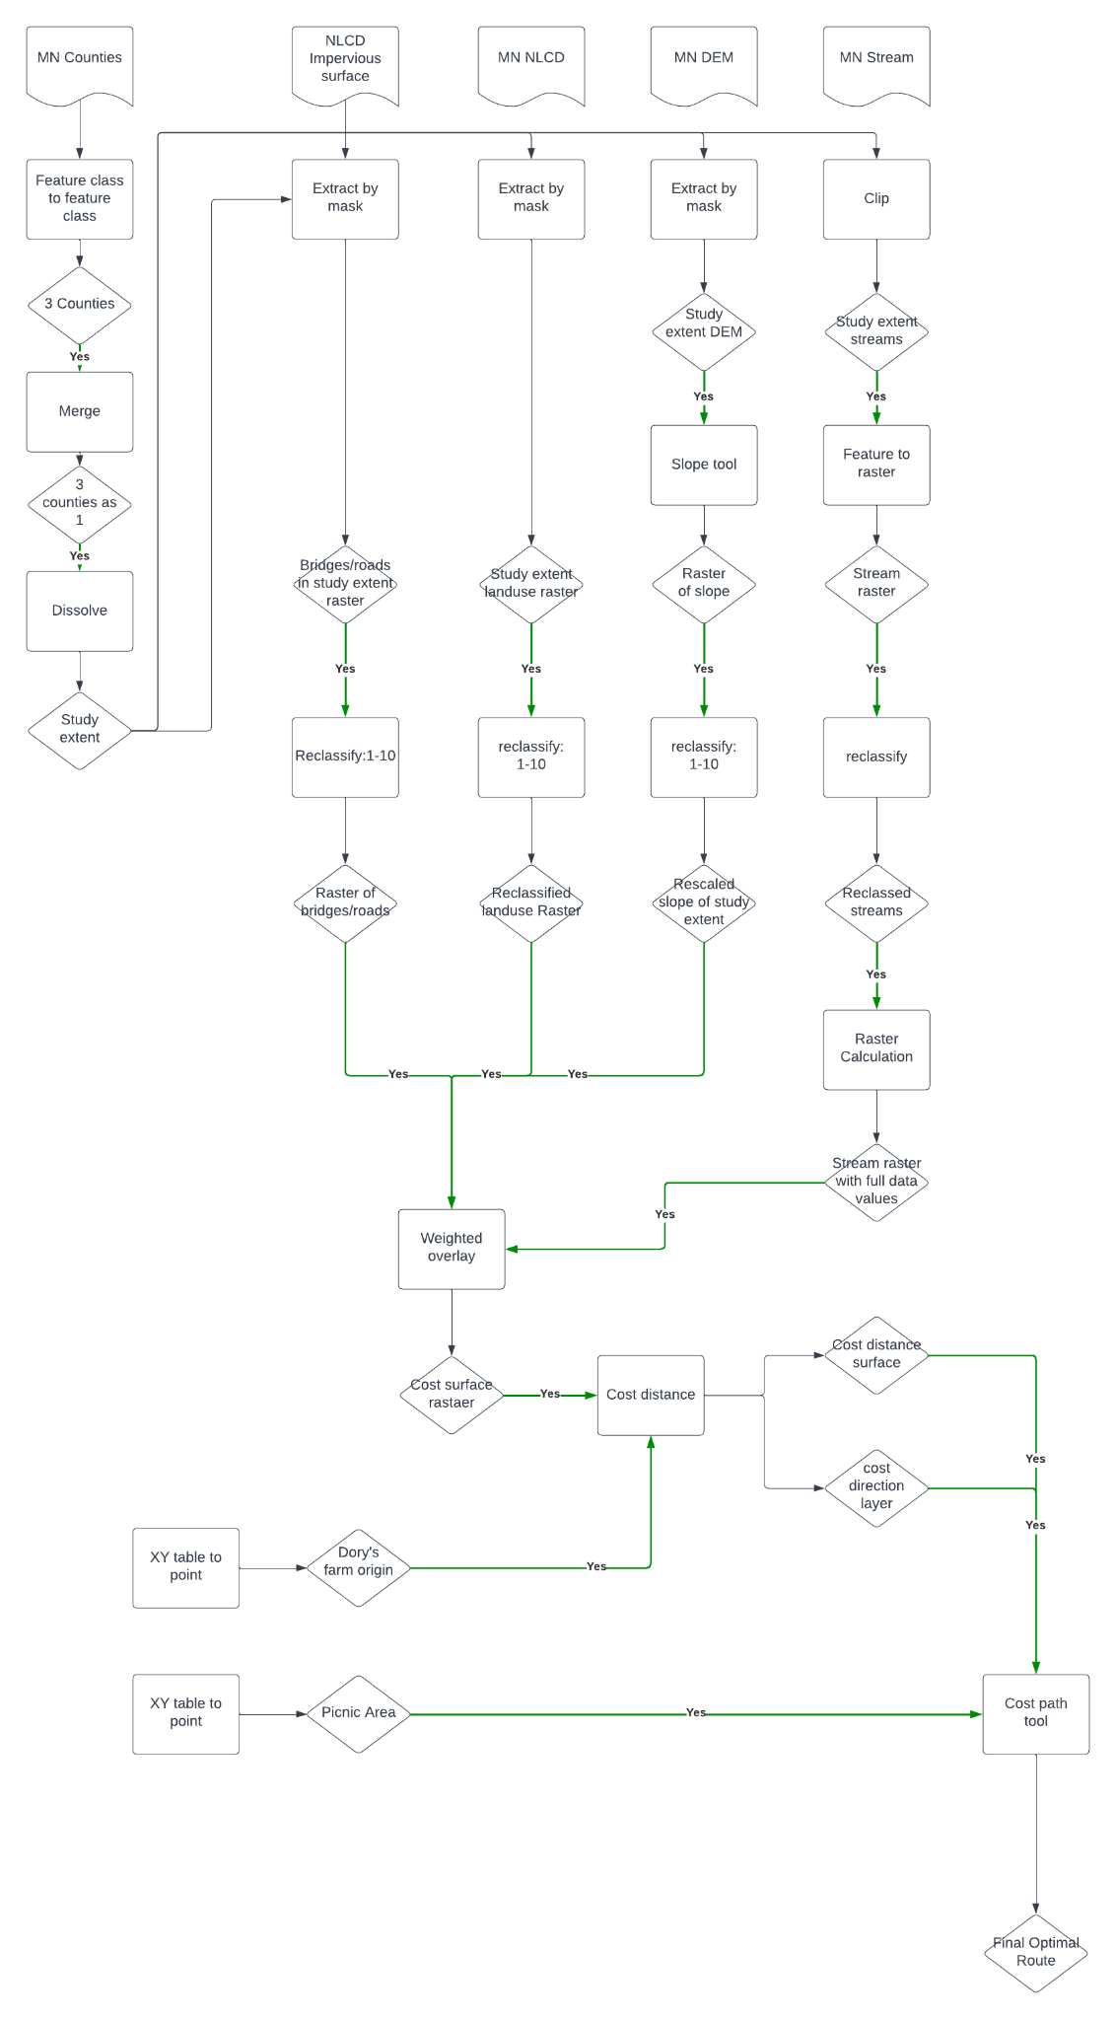

**Results**

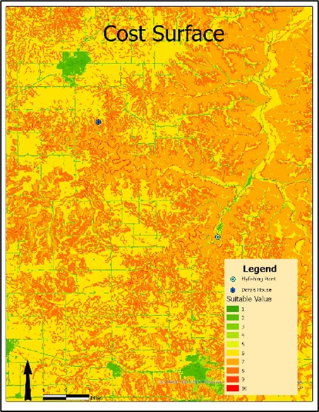

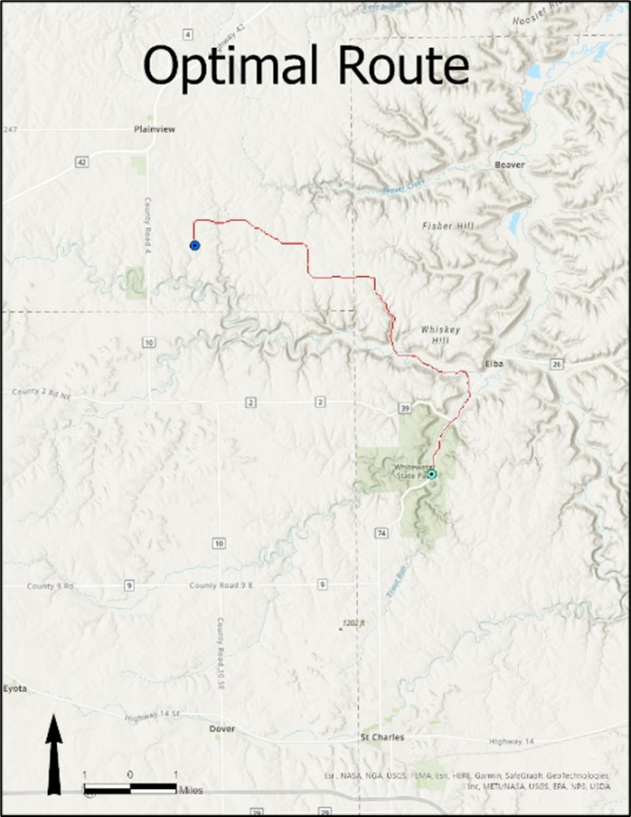

The result of this lab is shown in the maps above. The first one is the cost surface model that is generated by using given criteria. Each color represents the weighted overlay. The second map is the final optimal route generated by using the cost path tool.

**Results Verification**

I believe the result I got for this lab is accurate because as shown in the flow chart in the method section, I used the right tools and input the correct parameters for each layer to get the weighted overlay, and the use cost distance and cost direction tool to generate the layers for the final optimal route. However, there can be different results based on the recclassified layers. I use 1-10 as the parameters for each weighted layer, and there could be different results for example for the land use raster, I could give urban as a 3 and bare land as a 6, then the result could be vastly different than the one shown above. But overall, I believe that the results I got from this lab is accurate and sound.

**Discussion and Conclusion**

The part 2 of this lab focuses on how to use various sustainable modellings techniques to calculate optimal path given the criteria. Not much programming were involved but the lab was mostly focused on the logic behind how to build a model that can find the optimal path. The results looked promising and it seemed like everything worked out fine. However, I think a lot of improvement can be done in the work flow shown in the flow chart above, such as having a more meaningful weighted value for each shapefile and layers so the result would be more accurate.

**References**

*Use a common format*

**Self-score**

| **Category** | **Description** | **Points Possible** | **Score** |
| --- | --- | --- | --- |
| **Structural Elements** | All elements of a lab report are included **(2 points each)**:  Title, Notice: Dr. Bryan Runck, Author, Project Repository, Date, Abstract, Problem Statement, Input Data w/ tables, Methods w/ Data, Flow Diagrams, Results, Results Verification, Discussion and Conclusion, References in common format, Self-score | 28 | **28** |
| **Clarity of Content** | Each element above is executed at a professional level so that someone can understand the goal, data, methods, results, and their validity and implications in a 5 minute reading at a cursory-level, and in a 30 minute meeting at a deep level **(12 points)**. There is a clear connection from data to results to discussion and conclusion **(12 points)**. | 24 | **24** |
| **Reproducibility** | Results are completely reproducible by someone with basic GIS training. There is no ambiguity in data flow or rationale for data operations. Every step is documented and justified. | 28 | **28** |
| **Verification** | Results are correct in that they have been verified in comparison to some standard. The standard is clearly stated **(10 points)**, the method of comparison is clearly stated **(5 points)**, and the result of verification is clearly stated **(5 points)**. | 20 | **20** |
|  |  | 100 | **100** |