**Lab Report**

Title: Lab 2 part 1

Notice: Dr. Bryan Runck

Author: Maochuan Wang

Date: January 15, 2023

**Project Repository:** *<if applicable weblink to public repository>*

**Google Drive Link:** *<if applicable with data, notebooks, etc.>*

**Time Spent:** 5 hours

**Abstract**

The part 1 of this lab focuses on using ETL to extract data from MN DNR and Prism. Data used were LAS file from DNR, and BIL files from Prism. For the DNR data, we needed to convert the LAS into a TIN and DEM by using arcpy. For the prism data, we had create a time series by creating a space time cub that could utilize BIL file into a time series.

**Problem Statement**

Using ETL to extract data is the main theme of this class. From last lab 1, we learned how to extract data by using ETL from various sources. But for this lab, we not only learn how to extract data by using ETL, we also learn how to conver the data into something useful. Such as using LAS file to create DEM and TIN. And using .BIL file to create a time series. All the conversion steps were done by using Arcpy and ArcGIS Pro geospatial tools.

*Table 1. <Data>*

| **#** | **Requirement** | **Defined As** | **(Spatial) Data** | **Attribute Data** | **Dataset** | **Preparation** |
| --- | --- | --- | --- | --- | --- | --- |
| 1 | LAS file | Raw input dataset from MN DNR | Lidar point cloud data |  | [MN DNR](https://resources.gisdata.mn.gov/pub/data/elevation/lidar/) |  |
| 2 | BIL File | Weather precipitation data from PRISM | Precipitation data |  | [Prism](https://prism.oregonstate.edu/normals/) |  |
| 3 |  |  |  |  |  |  |
| 4 |  |  |  |  |  |  |

**Input Data**

*Table 2. <Input Data>*

| **#** | **Title** | **Purpose in Analysis** | **Link to Source** |
| --- | --- | --- | --- |
| 1 | MN DNR LAS File | Raw input dataset for creating the DEM and TIN files | [Mn GeoSpatial Commons](https://gisdata.mn.gov/dataset/trans-roads-mndot-tis) |
| 2 | Prism Bil File | Precipitation data used to create time series cube | [Prism](https://prism.oregonstate.edu/normals/) |
| 3 |  |  |  |
|  |  |  |  |

**Methods**

For the MN DNR LAS data. I first built an ETL that can download the LAS data from MN DNR website by defining an function that could mass download .las file from an url. And then I used the arcpy conversion to convert the lidar point cloud data into an DEM. Same goes for TIN file, I just used an arcpy function to convert it.The whole process was straight forward. In the end, I just had to use another arcpy function to export the file in a pdf format.

For the Prism data, it was a bit more complicated compared to mn dnr data. First because there is not a direct download link that we can extract the data from. So, after playing around with the website I found that there is a server that host all the Prism data. I used that server’s website url as the base ETL, and then built a function that can extract .zip file from that website, and loaded the data into arcgis pro. After that, I basically just followed the arcpro website instructions on how to make a time series by first creating a mosaic dataset, and then add the raster file to the mosaic dataset, and then calculate field by adding an attribute that can hold the date information for the time series cube, and then geocode the date format into something arc pro can read in order to create the time cube, and then building multidimensional info tool to create info, and then create the multidimensional raster layer, and then create the space time cube raster layer, and finally visualize space time cube. All these steps were done using arcpy tools.

Figure.1 Flow chart for Lab 2 part 1

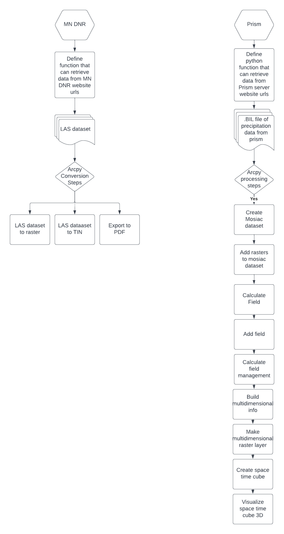

**Results**

The result of lab 2 part 1 is shown below in the screen shot. Its a PDF file that shows the converted tin file in pdf format.

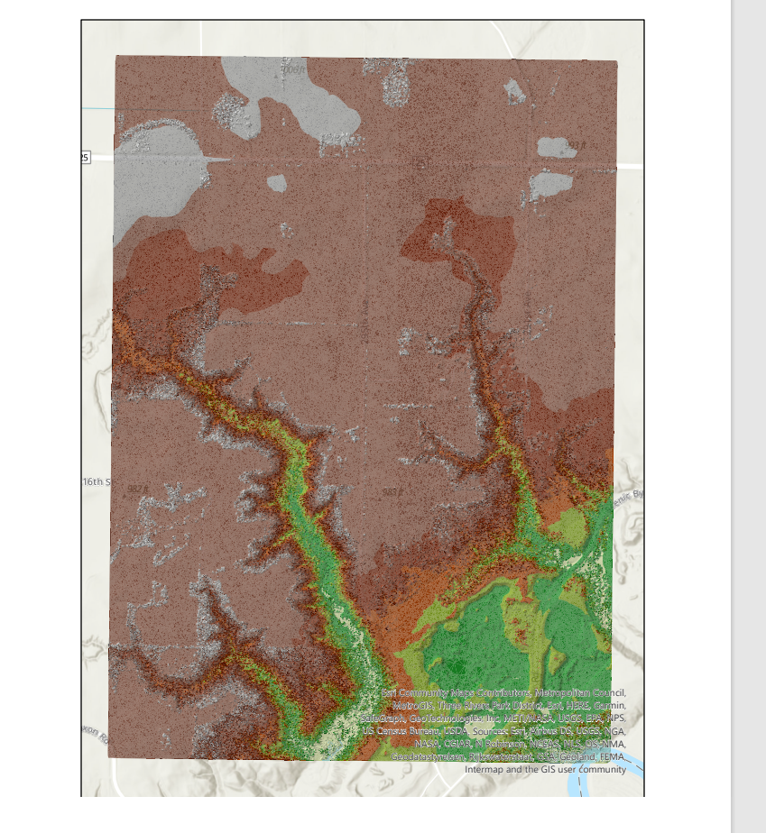

The Prism result is shown in the screen shot below. The first screenshot is a space time cube, the second one is the precipitation data that the space time cube is built upon.

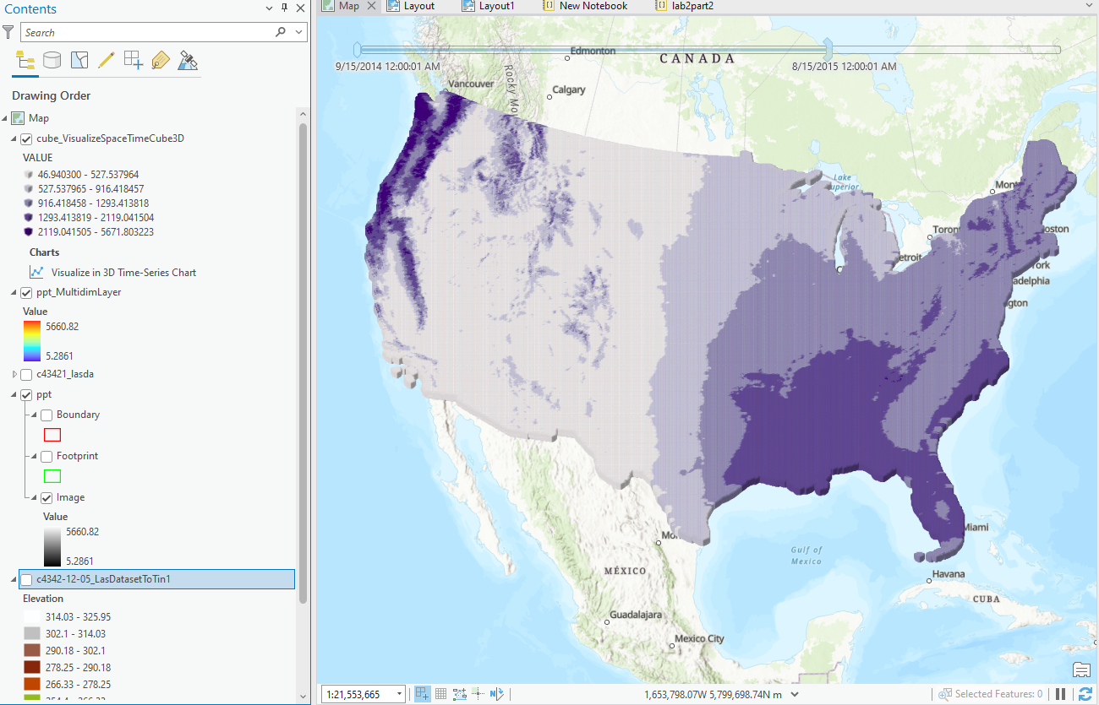

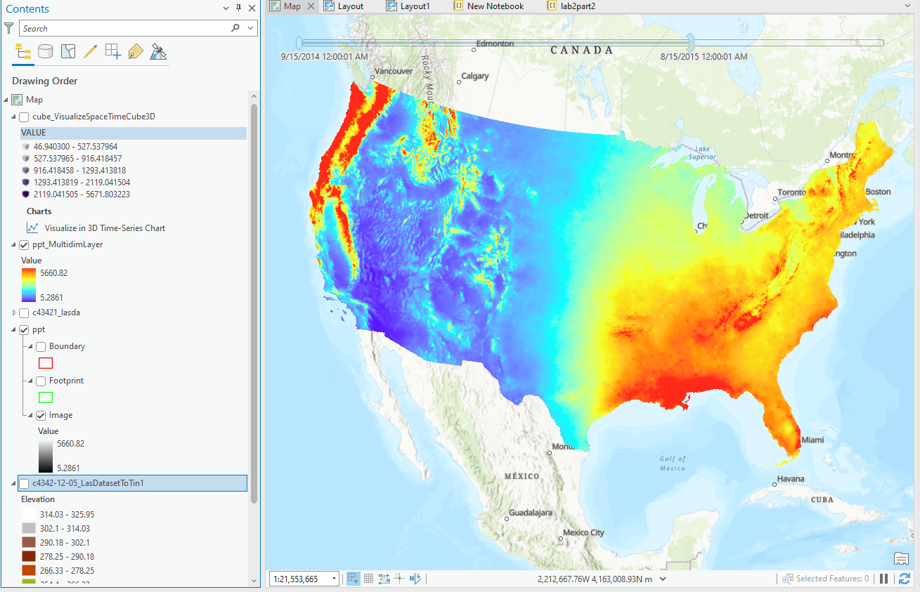

**Results Verification**

For the MN DNR result. I believe that my result is correct because I strictly followed the step listed in the lab documentation, and the both the DEM and TIN file were created correctly using the LAS file from the MN DNR website. Both DEM and TIN file were successfully created and look legit.

For the Prism data, there were a lot of steps involved into creating the animation. However, despite the numerous complicated steps. The end product still showed promising results that show a animation series with given precipitation data that went through numerous steps create. I would say the result is correct because the animation was successfully created, and the animation showed a change thoruhout the month that was created.

**Discussion and Conclusion**

For the part 1 of this lab, I learned how to extract data using ETL, how to convert LAS file into a DEM an TIN file. And how to export the file to PDF format all using arcpy. In addition, I learned how to use PRISM data that has the precipitation information to create a animation series that can show the changes overtime by using arcpy. They are all useful skills to have and the end product was very meaningful.

**Self-score**

*Fill out this rubric for yourself and include it in your lab report. The same rubric will be used to generate a grade in proportion to the points assigned in the syllabus to the assignment.*

| **Category** | **Description** | **Points Possible** | **Score** |
| --- | --- | --- | --- |
| **Structural Elements** | All elements of a lab report are included **(2 points each)**:  Title, Notice: Dr. Bryan Runck, Author, Project Repository, Date, Abstract, Problem Statement, Input Data w/ tables, Methods w/ Data, Flow Diagrams, Results, Results Verification, Discussion and Conclusion, References in common format, Self-score | 28 | **28** |
| **Clarity of Content** | Each element above is executed at a professional level so that someone can understand the goal, data, methods, results, and their validity and implications in a 5 minute reading at a cursory-level, and in a 30 minute meeting at a deep level **(12 points)**. There is a clear connection from data to results to discussion and conclusion **(12 points)**. | 24 | **24** |
| **Reproducibility** | Results are completely reproducible by someone with basic GIS training. There is no ambiguity in data flow or rationale for data operations. Every step is documented and justified. | 28 | **28** |
| **Verification** | Results are correct in that they have been verified in comparison to some standard. The standard is clearly stated **(10 points)**, the method of comparison is clearly stated **(5 points)**, and the result of verification is clearly stated **(5 points)**. | 20 | **20** |
|  |  | 100 | **100** |