5.13

a. 0001011010100000

b. 1001011011111111

0001011011100001

0001001010000011

c. 0001001001100000

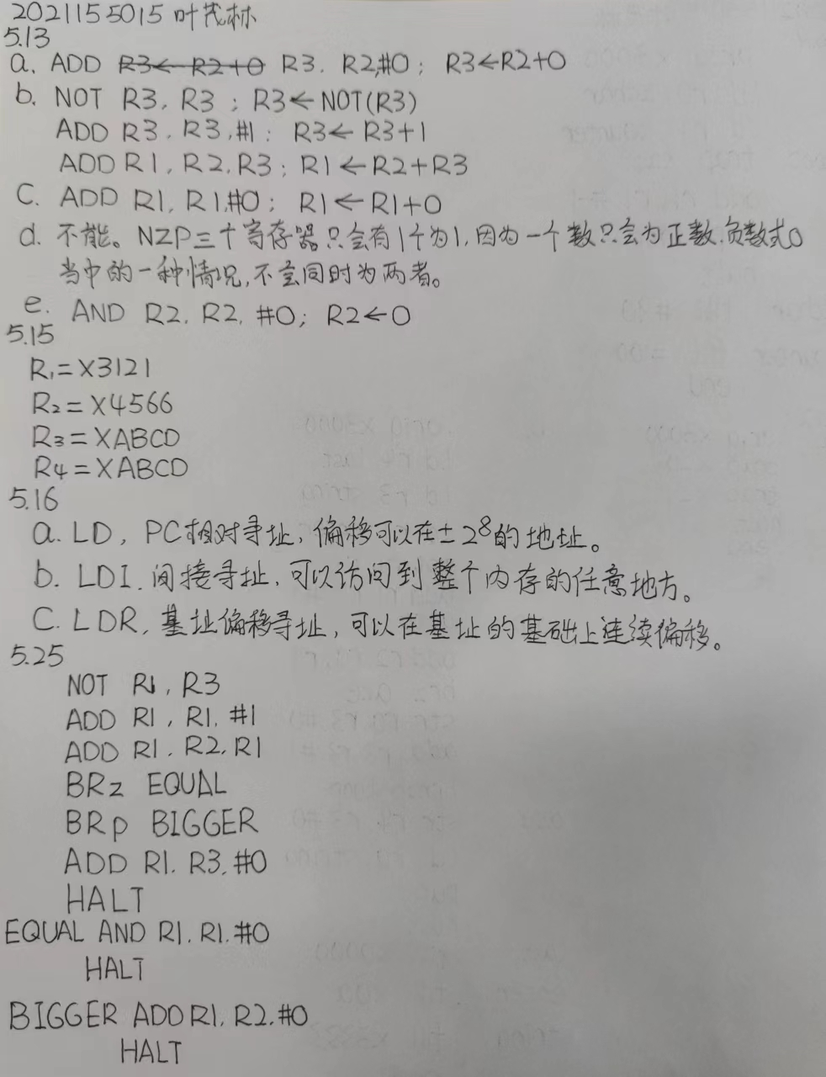

5.25

0011000000000000

1001001011111111

0001001001100001

0001001010000001

0000010000000011

0000001000000100

0001001011100000

1111000000100101

0101001001100000

1111000000100101

0001001010100000

1111000000100101

6.9

0011000000000000

0010000000000101

0010001000000101

1111000000100001

0001001001111111

0000001111111101

1111000000100101

0000000001011010

0000000001100100

6.12

a. 0011000000000000

1111000000100000

1111000000100001

1111000000100101

b. 0011000000000000

0010100000001110

0010011000001111

0010001000001101

1001001001111111

0001001001100001

1111000000100000

0001010000000001

0000010000000011

0111000011000000

0001011011100001

0000111111111010

0111100011000000

0010000000000100

1111000000100010

1111000000100101

0000000000000000

0000000000001010

0011001100110011

6.18

0011000000000000

1010000000001011

1010001000001011

0101010010100000

1001001001111111

0001001001100001

0001000000000001

0000100000000100

0001010010100001

1011000000000110

1011010000000100

0000111111111010

1111000000100101

0100000000000000

0100000000000001

0101000000000000

0101000000000001

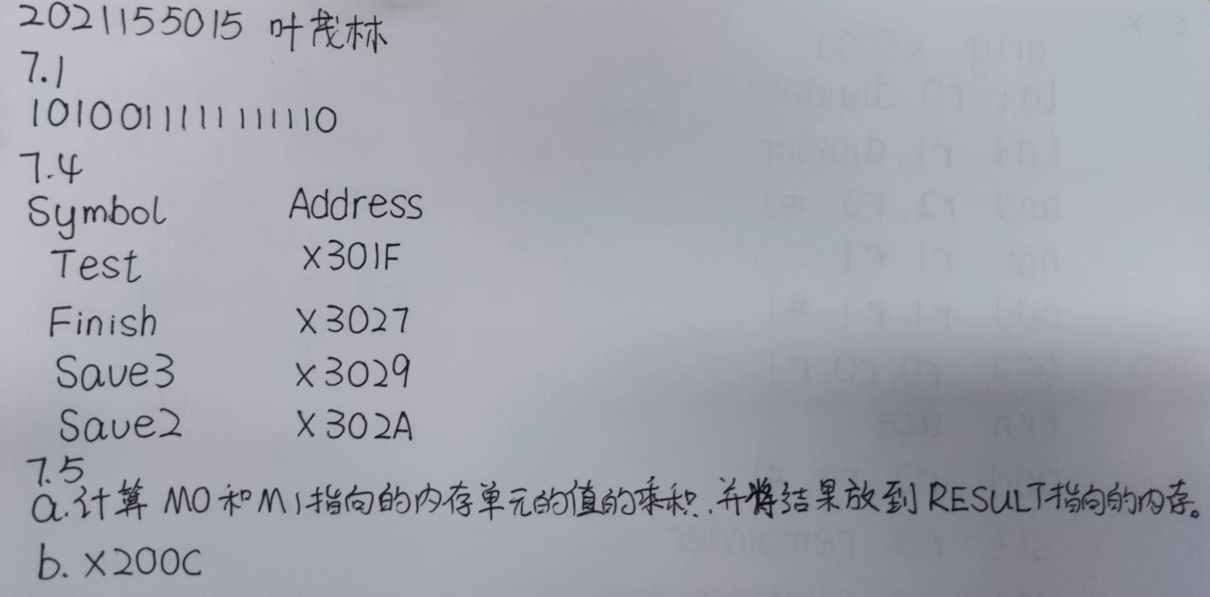

7.11

.ORIG x3000

TRAP x23

AND R3, R3, #0

ADD R3, R3, #9

LD R4, TONUMBER

LD R5, ISHEXNUM

LD R1, DEC

ADD R1, R1, R0

BRz GETNUMS

LD R1, HEX

ADD R1, R1, R0

BRnp FINISH

ADD R3, R3, #6

GETNUMS TRAP x23

ST R0, CHAR1

TRAP x23

ST R0, CHAR2

LEA R6, CHAR1

AND R2, R2, #0

ADD R2, R2, #2

AND R0, R0, #0

LOOP ADD R1, R3, #0

ADD R7, R0, #0

LPCUR ADD R0, R0, R7

ADD R1, R1, #-1

BRp LPCUR

LDR R1, R6, #0

ADD R1, R1, R4

ADD R0, R0, R1

ADD R1, R1, R5

BRn DONECUR

ADD R0, R0, #-7

DONECUR ADD R6, R6, #1

ADD R2, R2, #-1

BRp LOOP

AND R2, R2, #0

ADD R2, R2, #8

LEA R3, BINEND

LD R4, ZEROCHAR

AND R5, R5, #0

ADD R5, R5, #1

STLP AND R1, R0, R5

BRp ONENUM

ADD R1, R4, #0

BRnzp STORCH

ONENUM ADD R1, R4, #1

STORCH ADD R5, R5, R5

STR R1, R3, #-1

ADD R3, R3, #-1

ADD R2, R2, #-1

BRp STLP

LEA R0, BINARY

TRAP x22

FINISH HALT

CHAR1 .FILL x0

CHAR2 .FILL x0

ZEROCHAR .FILL x30

ISHEXNUM .FILL x-11

TONUMBER .FILL x-30

HEX .FILL x-78

DEC .FILL x-23

BINARY .BLKW 8

BINEND .FILL x0

.END