学号：2021155015 姓名：叶茂林

请用英文简要描述该图的基本原理，无需用公式描述

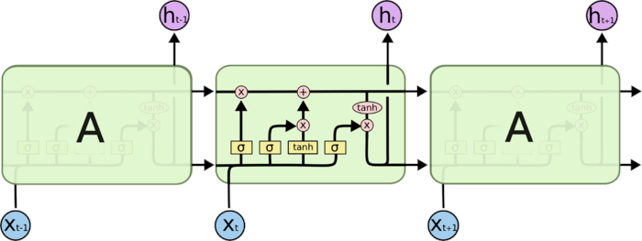

Fig. 1 Architecture of LSTM

LSTM, namely Long Short Term Memory networks, are a special kind of RNN. Instead of having one single neural network layer like standard RNNs, there are more neural network layers in the LSTM.

The above diagram consists of three repeating modules representing three cell states in different times.

The horizontal line running through the top of each module is the cell state, the key to the LSTMs. Information can easily flow along the line with some linear interactions. It seems that the line was a conveyor belt straight down the chain.

The yellow rectangles in the above diagram are called neural network layer, which have two kinds, sigmoid and tanh. And the pink circles are pointwise operations, like addition and multiplication. From the last cell state, A sigmoid layer can decide what information should be kept and what information should be abandoned. For the new information, a sigmoid layer can choose some of them to be added to the cell state with a vector of new candidate values created by a tanh layer. Then we can update the old cell state depending on the previous result and choose what information to output by a sigmoid layer and pass the cell state by a tanh layer.