**HOMEWORK**

LOGIC REVIEW BEFORE MIDTERM EXAM

**Exercise 1:**

The alphabet is given below to help you:

a b c d e f g h i j k l m n o p q r s t u v w x y z

**Q1** a w b ? c o

**Q2** e e z ? y o o

**Exercise 2:**

**Q1** An ASCII represents 245 characters. What is the size (in bits) of an ASCII? *(Justify your answer)*

In 1 character 8 bits. 245 characters=245*8bits=1960bits

**Q2** with 8 bytes, how many values can be represented? *(Justify your answer) ​*

1 bytes =8bits. 8*8bytes= 64 bytes

**Q3** How many bits to store alphabet and number in keyboard 0…9, A…Z and a…z

0…..9=4 bits

A….Z=5 bits

a….z= 5 bits

=4+5+5=14bits

**Exercise 3:**

**Q1** What is the result of this operation with binary numbers? ​

1011 0101

- 0101 1110

________________

101 0111

**Q2** What is the result of this operation with binary numbers? ​

1111 0011

- 0111 1101

- 0011 1011

_________________

11 1011

**Q3** What is the result of this operation with binary numbers? ​

1011 0011

- 0101 1101

- 0011 1011

- 0001 1000

________________

100011

**Q4** What is the result of this operation with binary numbers? ​

1011 0101

+ 0111 1111

________________

10011 0100

**Q5** What is the result of this operation with binary numbers? ​

1111 0011

+ 1001 1101

+ 0111 1011

_________________

10 0000 1011

**Q6** What is the result of this operation with hexadecimal numbers?

D2F7

+ CF84

+ 3CDE

_____________

1DF59

**Exercise 4:**

Compute the following conversions

|  |  |
| --- | --- |
| Base 2 | Base 10 |
| 101101 | *Explanation:*  1*25+0*24+1*23+1*22+0*21+1*20  =32+0+8+4+0+1=45 |

|  |  |
| --- | --- |
| Base 2 | Base 16 |
| 101101 | *Explanation:*  1101=D,0010=2  =2D |

|  |  |
| --- | --- |
| Base 16 | Base 8 |
| D8F | *Explanation*:  D8F=110110001111  =6617 |

|  |  |
| --- | --- |
| Base 16 | Base 2 |
| D8F | *Explanation*:  D=1101, 8=1000, F= 1111  D8F=1101 1000 1111 |

**Exercise 5:**

**Q1. Rules:**

* First 3 characters “AOU”, repeated many times (max repetition is 20)
* In the end you can have X, Y or Z, only one letter

Examples:

AOUAOUX

AOUY

AOUAOUAOUAOUX

1. Explain your encoding
2. Give examples
3. Explain the size

**Q2. Rules:**

* 3 signs: @, #, %
* The sign is any order
* Each sign is repeated the same number of times, maximum of repetition is 5
* In the end you can have A, B or C, only one letter

Examples:

@@###A

%%@@@@@#B

1. Explain your encoding, give the example and your explanation
2. For this example, **%%%%%**C, what is the littlest size possible with your encoding?
3. Explain the size

**EXERCICE 6: Encoding problem**

**Rules:**

* 4 letters: A, B, C, D
* Any order
* Maximum of repetition is 14

Examples:

ABCD

DBCAA

ADABCAA

1. Explain your encoding
2. Give examples
3. Explain the size

**EXERCICE 7: Encoding problem**

**Rules**:

* First 2 characters “AB”, repeated many times (max repetition is 5)
* Then 1 character “*”, repeated many times (max repetition is 5)
* Then 1 number (0-9)

Examples:

ABABAB***8

AB*****7

ABABAB*****3

1. Explain your encoding
2. Give examples
3. Explain the size

**EXERCICE 8: Encoding problem**

**Rules:**

* 4 letters: A, E, O, U
* Each letter is repeated minimum 0 time and maximum 7 times.
* The letters are always in the alphabetic order: A then E then O then U

Examples:

AAAAEEEOOU

EEEUUUUUUU

AAEEOOUU

1. Find an encoding of maximum **12 bits**. Explain the method, explain the size and give examples.
2. Is your encoding lossless or loosely?

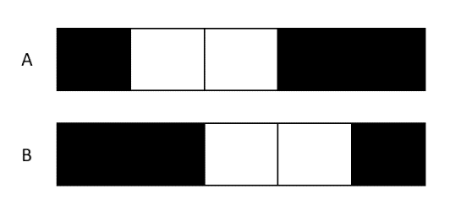**EXERCICE 9: Encoding problem**

**Rules:**

* The image has only 2 options A & B

Question - Find an encoding

|  |  |  |
| --- | --- | --- |
| Meaning | Encoding in decimal | Encoding in binary |
| Choices of images | A=0  B=1 | 0  1 |

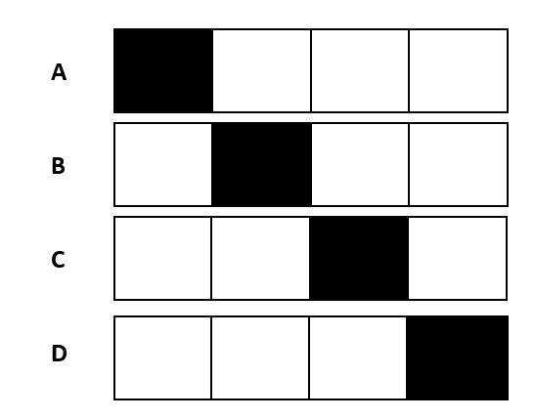

**EXERCICE 10: Encoding problem**

**Rules:**

* The image has only 4 options A, B, C, D

Question - Find an encoding

|  |  |  |
| --- | --- | --- |
| Meaning | Encoding in decimal | Encoding in binary |
| Choices of images | A=0  B=1  C=2  D=3 | 00  01  10  11 |

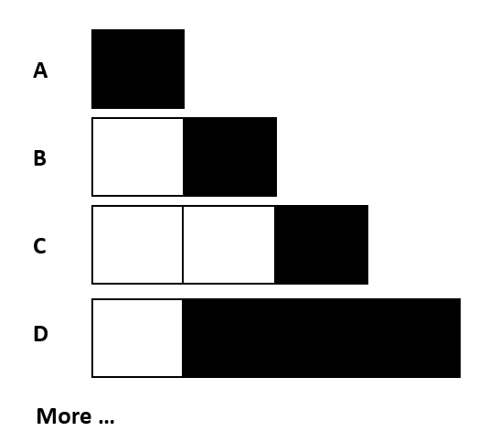**EXERCICE 10: Encoding problem**

**Rules:**

* The image has 1 to 4 pixels
* 1 to 3 black pixels
* The black pixels shall be together

Question - Find an encoding

|  |  |  |
| --- | --- | --- |
| Meaning | Encoding in decimal | Encoding in binary |
| Number of pixels | 1…..4 | 001,010,011,100 |
| Number of black pixels | 1…3 | 001,010,011 |
| Black position | 1…3 | 001,010,011 |

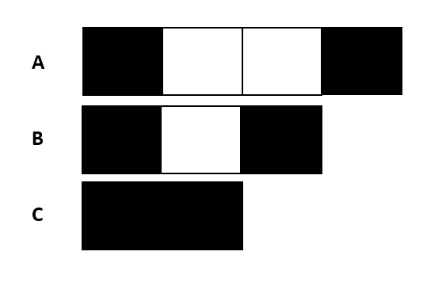

**EXERCICE 11: Encoding problem**

**Rules:**

* The white pixels have 0 to 2
* Black pixel always first and last cells

Question - Find an encoding

|  |  |  |
| --- | --- | --- |
| Meaning | Encoding in decimal | Encoding in binary |
| No need to encode |  |  |