Navaid
Airport Investment Intelligence Agent · Architecture
Assignment deliverable: scoring methodology, key tradeoffs, and where Gemini is used versus deterministic engines. Companion to docs/ARCHITECTURE.md in the repository.
Public aviation files are ingested into a local DuckDB warehouse. Deterministic engines compute TEOI (with a full ScoringTrace), unmet demand, long-haul share, and congestion compares. A Gemini agent reconstructs follow-ups, decomposes multi-part questions, then may only call those engines as tools. A number lock rejects any digit that was not in a tool payload. Gemini may explain a rank; it may never produce one.
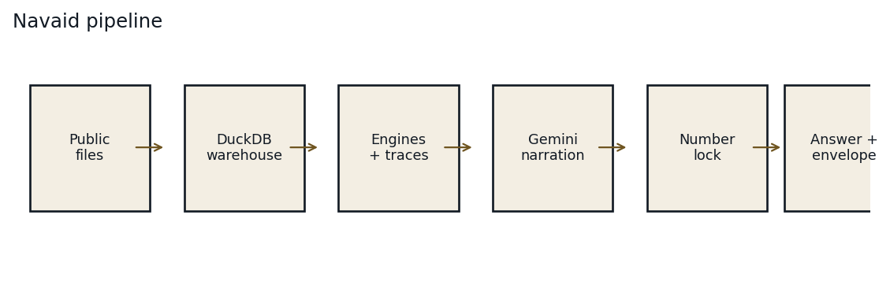
Figure 1. End-to-end pipeline. Live FAA status skips the warehouse and overlays operations delay only.

1. Scoring methodology

Investment thesis
The firm invests in terminal modernization. Profit is a capacity-unlock proxy — not PFC, bond, or NPV. Busy is not investable: an airport can already be maxed on slots, curfew, or a weak catchment. TEOI (Terminal Expansion Opportunity Index) is a 0–100 peer-relative score inside the comparison set S that the analyst named.
- Landside × 1.00 — gates, holdrooms, security, bag claim, curb. Terminal capex can raise throughput.
- Mixed × 0.75 — landside and airside both bind. A terminal project only partially unlocks capacity.
- Airside × 0.40 — runways, slots, weather, ATC, noise curfew. More terminal does not create slots.
- Demand-bound × 0.30 — weak catchment, low load factor, or leakage already served nearby.

Peer-relative min-max
Each feature is stretched 0–1 inside S. Highest in S = 1, lowest = 0. Ask New England and BOS is the high end. Ask only BOS and every feature becomes 0.5, so mixed × 0.75 can print ~37. That is not a new formula — it is a one-airport peer set. Follow-ups such as “why does BOS have this score?” reuse the last set; they must not re-rank BOS alone.

Formula
TEOI = 100 × (0.22·demand_pressure + 0.18·congestion + 0.18·landside_saturation + 0.15·unmet_demand + 0.12·yield_mix + 0.10·growth_outlook + 0.05·capital_feasibility) × constraint_multiplier.
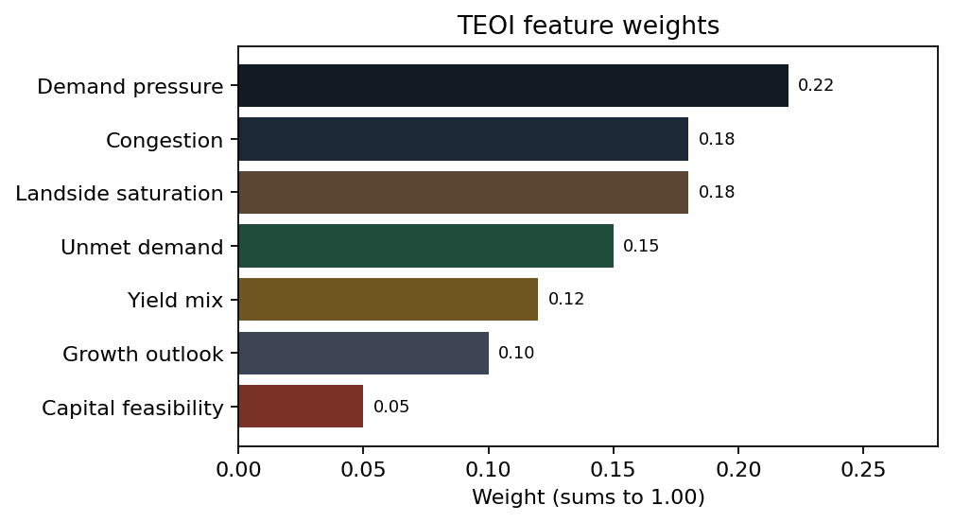
Figure 2. Default TEOI weights in navaid/scoring/weights.py. They sum to 1.00.
Feature | Weight | Role
Demand pressure | 0.22 | Enplanements / YoY vs peers in S
Congestion | 0.18 | Delay / cancel / utilization vs peers
Landside saturation | 0.18 | Passengers per gate vs peers
Unmet demand | 0.15 | Load-factor gap + TAF gap + leakage
Yield mix | 0.12 | Long-haul / international mix as a yield proxy
Growth outlook | 0.10 | TAF / CAGR outlook vs peers
Capital feasibility | 0.05 | NPIAS/AIP; often the dropped weight

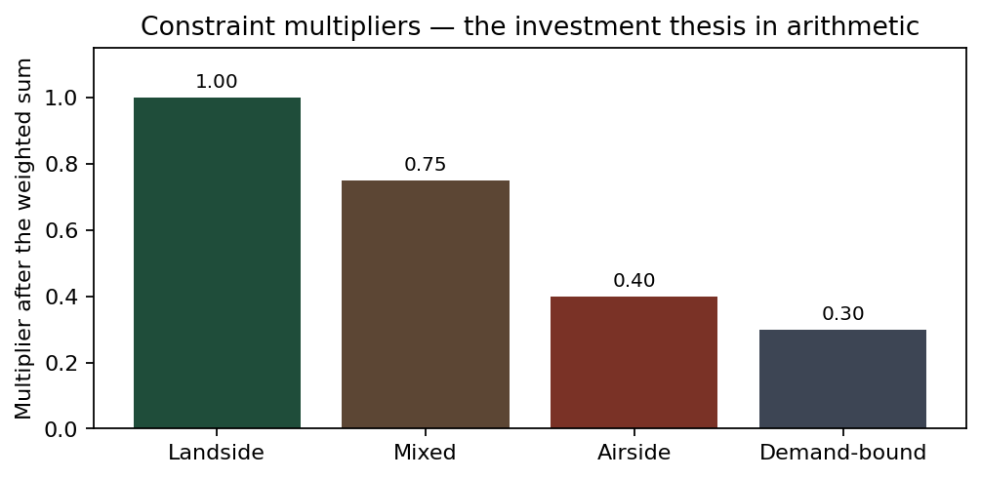
Figure 3. Constraint multipliers applied after the weighted sum.

Drop-and-renormalize
If a feature is missing (for example no NPIAS for capital feasibility), that weight is removed and the remainder is rescaled to 1.0. Navaid never invents gate counts or TAF. The drop is listed on the ScoringTrace (weights_dropped, weights_used) and in the envelope. Example: drop 0.05; remaining mass 0.95; demand pressure used weight becomes 0.22 / 0.95 ≈ 0.232. Contributions are 100 × weight_used × scaled_0_1.
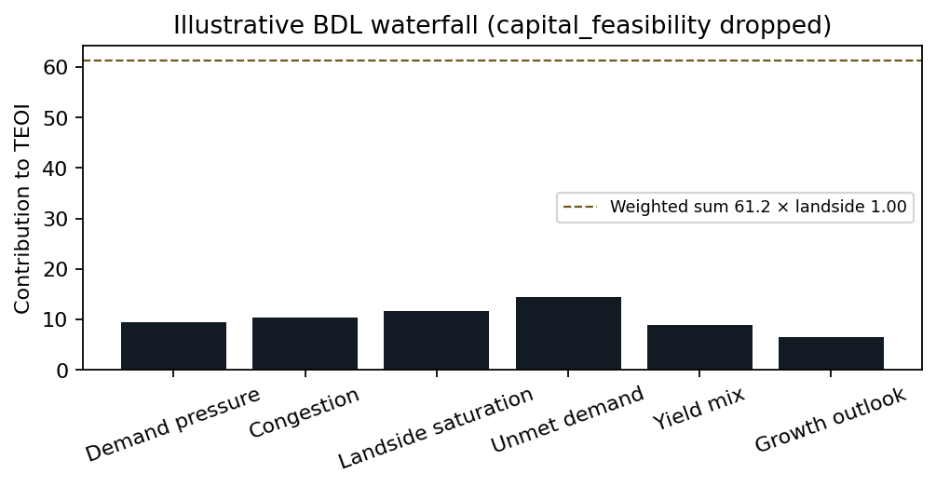
Figure 4. Illustrative BDL waterfall after drop-and-renormalize. Live ranks come from the warehouse, not this picture.

Unmet demand
- Load-factor gap: served × max(0, LF − 0.85) / 0.85.
- Forecast gap: max(0, TAF_10y − implied_current_capacity) if TAF exists.
- Leakage: same-CBSA airports growing faster, only while origin load factor is at or above 85%.
If load factor is below the seat-pressure rule, leakage is qualitative (for SFO: OAK/SJC) and not in the number. A TAF 10-year gap can still produce unmet passengers. Slot/curfew remain the investment caveat: a forecast gap is not a missing concourse.

Long-haul
Great-circle kilometres on BTS T-100 segments, default Eurocontrol threshold 4000 km. The engine reports flight-segment share and passenger share, plus international share and optional percent over 6 hours. Cargo is excluded unless asked. Pin ANC→JFK ≈ 5420 km / 3370 mi. Warehouse T-100 is a filtered commercial sample, not every cargo and connecting itinerary. ANC→SEA→JFK is two segments, not true origin-and-destination.

Congestion and ranker
Congestion is compared axis by axis: delay share, average arrival delay, cancellations, operations per runway, live FAA status, constraint type, and curfew text. There is no single congestion score. Shared ranks are 3, 3, 5; leftover ties break by ICAO ascending. Deterministic.

2. Key tradeoffs
Choice | What we shipped | What we refused | Why
KPI | Peer-relative TEOI + traces | LLM ranking; national grade | The brief requires deterministic scoring and a visible working.
Warehouse | One DuckDB file | Postgres / Snowflake / Pandas-as-SoR | T-100 needs SQL; the assignment is local-first.
RAG | DuckDB FTS, airport-keyed notes | Chroma, embeddings, RAG-as-ranker | Tens of notes. T-100 wins facts.
Agent loop | Owned orchestrator | LangChain, CrewAI, ADK, AFC | Reconstruct, traces, and number lock must be visible Python.
Model | gemini-2.5-flash | Pro as default; OpenAI | Numbers already come from engines. Flash is enough to narrate.
Profit | Capacity-unlock proxy | PFC / NPV / airline equity | Honest scope. AAL is refused.
Long-haul | 4000 km segments | True O&D; mixing km and miles | T-100 is legs. ANC→JFK pins the unit.
Congestion | Axis-by-axis + curfew | Fake composite score | LAX delay volume vs SNA curfew are different facts.

Stale warehouse snapshot (>90 days) is always listed as an uncertainty and pulls confidence to low. Missing required inputs also force low confidence. That is an honesty tradeoff: the demo will not pretend 2024 boardings are live 2026 operations.

3. Where and how AI is used
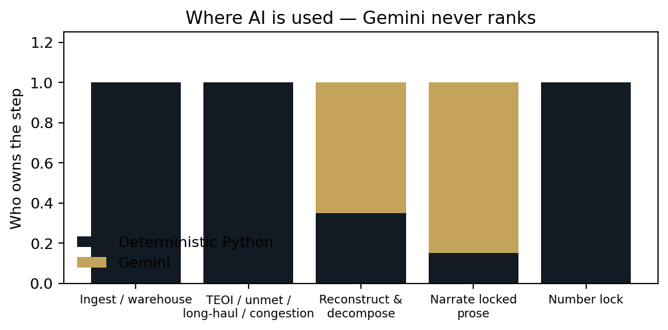
Figure 5. Gemini may reconstruct, decompose, and narrate. Engines own every number.
Gemini is allowed to:
- Rewrite follow-ups (“those two”, “why is #2 above #3?”, “add PWM”) into a standalone reconstructed_query.
- Help decompose a compound question into closed intents — rules still emit every subgoal.
- Call a closed tool list: resolve_airport, rank_expansion, compare_congestion, longhaul_share, unmet_demand, airport_metrics, explain_teoi, search_corpus, get_live_status.
- Narrate locked traces in Markdown. Automatic function calling is off so the number lock can intercept every digit.
- Optional TTS on the workbench. Same vendor as the chat model.
Gemini is forbidden to:
- Produce a TEOI, rank, percent, or gate count that is not in tool JSON.
- Re-rank a singleton when session traces already include a peer set.
- Treat RAG notes as a ranker. If notes and T-100 disagree, T-100 wins.
- Advise on securities (buy AAL), restaurants, or non-airport questions — those parts are refused, the rest still answers.

Every /ask
User question → reconstruct → decompose → plan tools → run engines → number lock + TEOI traces → narrate one section per subgoal → store session. The Answer object always carries assumptions, uncertainties, out-of-scope, confidence, sources, and as_of. Gradio and the designed site are skins over the same FastAPI contract.

Canonical questions
- New England expansion — peer-relative TEOI; BOS is scale; regionals can win landside; PWM is Portland Maine, not PDX.
- LA vs Santa Ana congestion — LA → LAX not the metro; Santa Ana → SNA not SAT; no composite score.
- Anchorage long-haul — 4000 km segments; flight share and passenger share; cargo out unless asked.
- SFO unmet — clamped formula; leakage gated on 85% load factor; slot/curfew still bind.
Related repository files: docs/ARCHITECTURE.md (canonical markdown), docs/GLOSSARY.md, docs/DECISION_LOG.md. Default model gemini-2.5-flash. RAG is DuckDB FTS — no embedding model, no Chroma.

