20th International Conference on Innovative Computing, Information and Control (ICICIC2026)
November 20-23, 2026, Chongqing, China
Copyright©2026 ICIC International

Multi-Level Consistency Rewards: A Ground-Truth-Free Verifiable Signal for Action-Conditioned Diffusion World Models
Maosen Zeng and Yunan Liu

Computational Intelligence Center (CIC)
Institute of Applied AI Engineering and Technology
School of Computer and Artificial Intelligence, Shandong Jianzhu University
Jinan, 250101, P. R. China
2025110104@stu.sdjzu.edu.cn; liuyunan@sdjzu.edu.cn

1. Introduction. An action-conditioned visual world model predicts the next observation from a short history of frames and actions, . In long-horizon video prediction the model is rolled out autoregressively, with each predicted frame becoming the next condition. Diffusion world models such as DIAMOND [1] generate high-fidelity action-conditioned frames and recover texture and local detail that discrete-latent models lose. Per-frame fidelity, however, does not guarantee a stable rollout: small visual, temporal, or action-response errors compound into repeated frames, drift, target loss, or wrong motion. Standard training targets such as denoising reconstruction, maximum likelihood, and single-frame error improve local quality but do not directly optimize long-horizon stability or action-conditioned consistency. RLVR-style fine-tuning [2] scores each candidate against the ground-truth (GT) future frame, which is unavailable for free open-world rollouts. We therefore ask whether a multi-level consistency reward, computed without GT future frames from temporal coherence, repeat-frame suppression, and action consistency, can serve as a verifiable signal for diffusion world-model rollouts, and we validate it on the pretrained DIAMOND CS:GO world model.

2. Research Questions. RQ1: can a GT-free multi-level consistency reward separate well-formed rollouts from degraded ones, namely frozen, temporally scrambled, or action-mismatched variants? RQ2: which consistency terms carry the signal, and where does a lightweight, model-free action proxy fall short? RQ3: among same-condition candidates, can the reward expose within-group quality differences usable for group-relative selection?

3. Methodologies. Given a condition formed by a short history of frames and a future action sequence, the pretrained DIAMOND diffusion world model is rolled out to sample K candidate future-frame sequences, varying only the diffusion seed; Fig. 1 illustrates the pipeline. For each candidate we compute four intrinsic consistency terms without any GT future frame. A repeat-frame penalty, together with an action-conditioned variant, flags adjacent frames whose motion falls below a threshold. A temporal-consistency term measures motion smoothness as the negative jerk of the per-frame motion magnitude. An action-consistency term measures the agreement between per-frame motion and per-frame action strength, and serves as a model-free proxy for a learned inverse-dynamics discriminator. A cross-candidate consensus term measures the neighbourhood support of a candidate's transition feature among its same-condition peers. The four terms are group-standardized and combined with horizon weighting into a sequence-level consistency reward, after which a trust filter removes low-reward, low-consensus candidates. This reward is the intended signal for group-relative, reward-weighted diffusion fine-tuning that optimizes the group-relative advantage on the trusted set. The DIAMOND world model and the feature extractor stay frozen throughout.

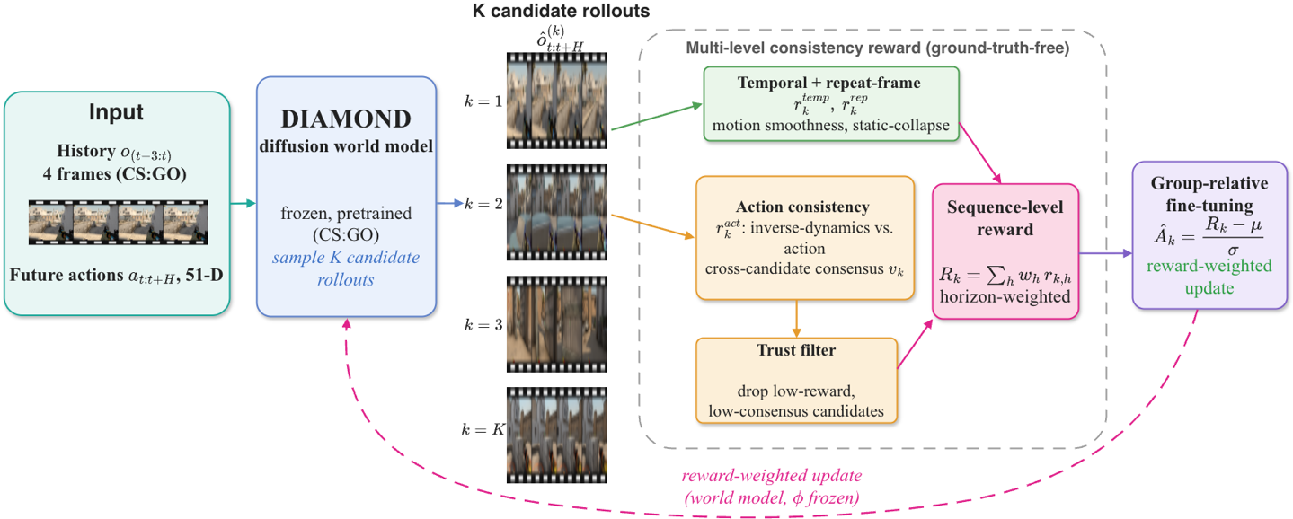
Figure 1. Multi-level consistency pipeline. The pretrained DIAMOND diffusion world model samples K candidate rollouts under one condition; a ground-truth-free multi-level consistency reward combining temporal, repeat-frame, action, and cross-candidate consensus terms scores and trust-filters them; the group-relative advantage feeds reward-weighted fine-tuning. The world model and feature extractor stay frozen.

4. Results. Setting: the pretrained DIAMOND CS:GO world model runs on one 32 GB RTX 5090 at full resolution 150×280, with K = 6 candidates per condition over 7 history conditions, 24-frame rollouts, and 3 denoising steps for the degradation study; no GT future frames are used, giving 21 candidate-windows. RQ1, degradation sensitivity: the clean rollout is preferred over the frozen variant in 81% of windows and over the temporal-shuffle variant in 79%, but over the action-mismatch variant in only 47%, as summarized in Table 1. RQ2, which terms carry the signal: the repeat-frame rate moves from 0.00 on clean rollouts to 1.00 on frozen ones, and the motion jerk rises from 3.38 to 8.26 under temporal shuffling, so the repeat-frame and temporal terms cleanly flag static collapse and scrambling; the model-free action term separates clean from action-mismatch only in aggregate, with means of 0.135 versus 0.016, and not reliably per window, consistent with the near-chance 47%. When the action term is instead realized as a learned inverse-dynamics discriminator, a small CNN trained self-supervised on disjoint seeds to recover the 51-D action from a frame pair, action-mismatch is correctly flagged in 89.7% of windows versus 47.6% for the model-free proxy, as shown in Fig. 2; the action signal is therefore recoverable, but it needs a learned discriminator rather than a raw motion-action correlation. RQ3, selection by sampler fidelity: using denoising steps as an external, ground-truth-free fidelity knob, the smoothness-dominated composite does not track fidelity and even mildly anti-correlates with it at a Spearman of -0.19, with the higher-fidelity candidate preferred in only 21% of cross-setting pairs, because higher-fidelity rollouts carry richer motion that the temporal-smoothness term penalizes; only the action-consistency component trends in the expected direction, rising from 0.063 to 0.075 as the denoising steps increase. Hand-crafted intrinsic terms thus reliably detect gross temporal degradation but not subtle fidelity or action differences.

Table 1. Per-term response of the GT-free consistency reward to controlled degradations and the resulting clean-preferred rate, over 21 candidate-windows; bold marks the term that flags each failure.

Rollout variant | repeat-frame ↓ | motion jerk | action consist. ↑
Clean (intact) | 0.00 | 3.38 | 0.13
Frozen (collapse) | 1.00 | 0.00 | 0.00
Temporal-shuffle | 0.00 | 8.26 | 0.03
Action-mismatch | 0.00 | 3.38 | 0.02
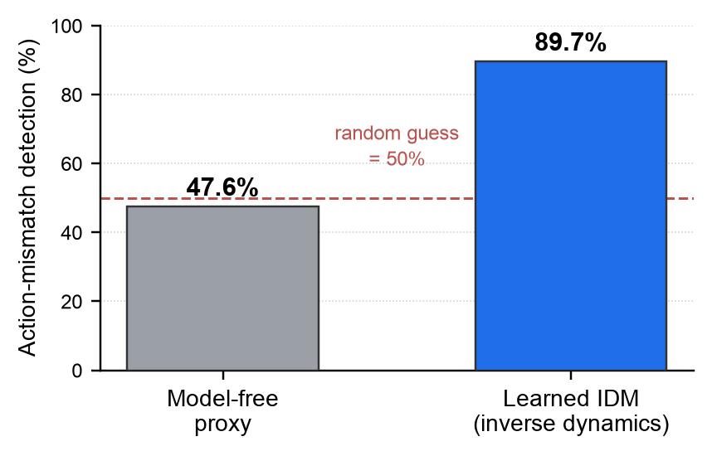
Figure 2. Action-mismatch detection by a learned inverse-dynamics discriminator, at 89.7%, versus the model-free motion-action proxy at 47.6% near chance, on held-out rollouts with disjoint train and eval seeds.

5. Conclusion. A ground-truth-free multi-level consistency reward built from hand-crafted intrinsic terms reliably detects static collapse and temporal incoherence on the pretrained DIAMOND CS:GO model, with the clean rollout preferred over frozen and scrambled rollouts in about 80% of windows. It does not, however, reliably capture action consistency or sampler fidelity: the model-free action proxy performs near chance at 47.6%, and the smoothness-dominated composite mildly anti-correlates with denoising-step fidelity. Replacing the action proxy with a learned inverse-dynamics discriminator restores action sensitivity and raises action-mismatch detection to 89.7%, as shown in Fig. 2, indicating that a learned discriminator outperforms hand-crafted proxies. Together with the group-relative, reward-weighted diffusion fine-tuning that the reward is designed to drive, this points toward a learnable, ground-truth-free consistency reward for diffusion world models. Limitations: results are preliminary, on one RTX 5090 and a single DIAMOND CS:GO world model, with the reward validated only as a GT-free selector and at short horizons where the pretrained model rarely collapses.

REFERENCES
- J. Wu, S. Yin, N. Feng and M. Long, RLVR-World: Training world models with reinforcement learning, Advances in Neural Information Processing Systems, vol. 38, 2025.
- E. Alonso, A. Jelley, V. Micheli, A. Kanervisto, A. Storkey, T. Pearce and F. Fleuret, Diffusion for world modeling: visual details matter in Atari, Advances in Neural Information Processing Systems, vol. 37, 2024.
- Y. Zuo, K. Zhang, L. Sheng, S. Qu, G. Cui, X. Zhu et al., TTRL: Test-time reinforcement learning, Advances in Neural Information Processing Systems, vol. 38, pp. 131459-131483, 2026.
- Z. Shao, P. Wang, Q. Zhu et al., DeepSeekMath: Pushing the limits of mathematical reasoning in open language models, Proc. of the 62nd Annual Meeting of the Association for Computational Linguistics, pp. 23366-23395, 2024.
- R. Zhang, P. Isola, A. A. Efros, E. Shechtman and O. Wang, The unreasonable effectiveness of deep features as a perceptual metric, Proc. IEEE Conf. on Computer Vision and Pattern Recognition, pp. 586-595, 2018.

