Maoxi Li (individual)

A17817791

Python Project instruction

Configuration instructions:

Python 3.7

Document:

student.txt

installation instructions:

pandas

Function instructions:

Main():

To read file and do all the functions

Get_manu_choice():

A menu function to choose what to do next

All_student():

Display all student records

Last_name_student():

Display students whose last name begins with a certain string

Certain_year():

Display all records for students whose graduating year is a certain year

Report_number():

Display a summary report of number and percent of students in each program, for students graduating on/after a certain year

Classmates():

Find your classmates

Operating instructions:

Run this program:

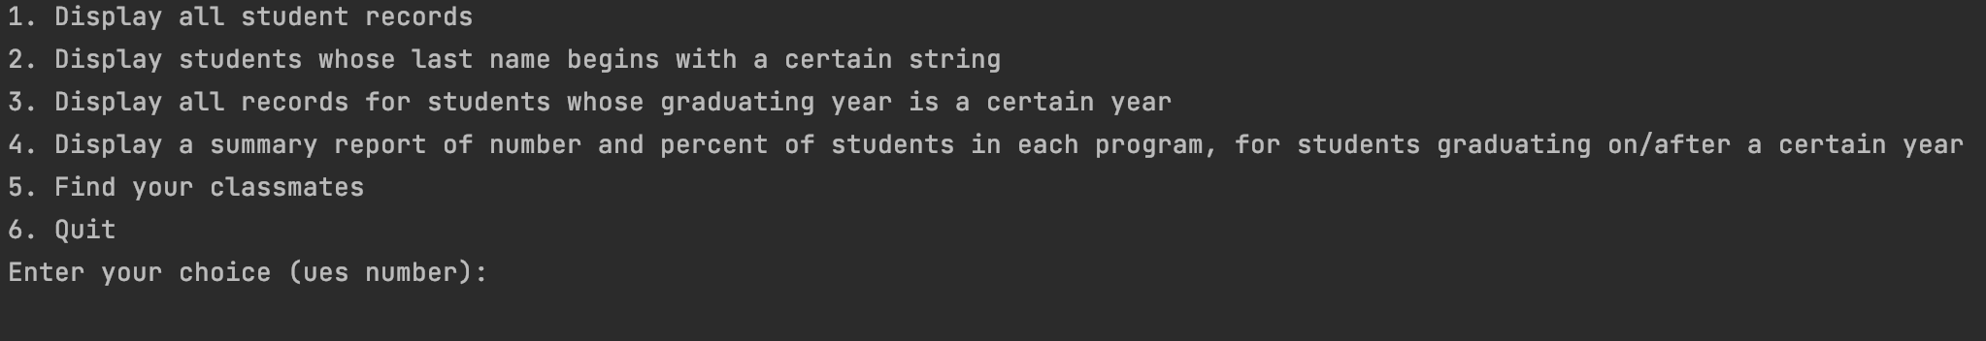When you choose 1(Display all student records):

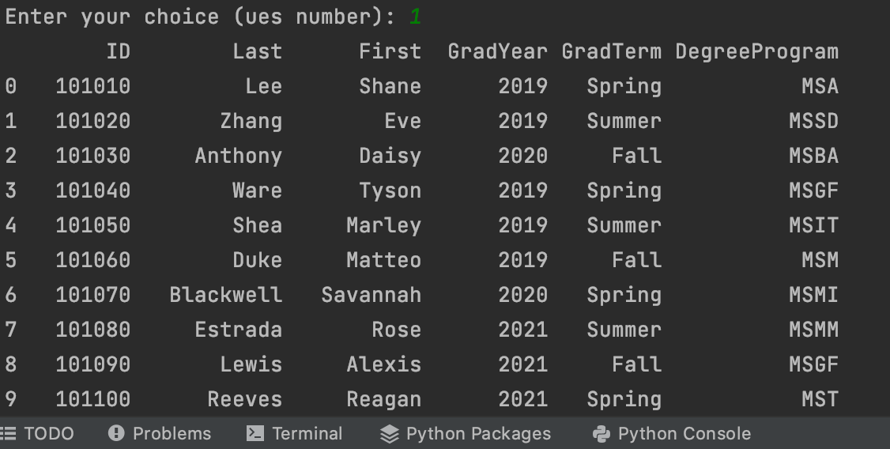

When you choose 2(Display students whose last name begins with a certain string):

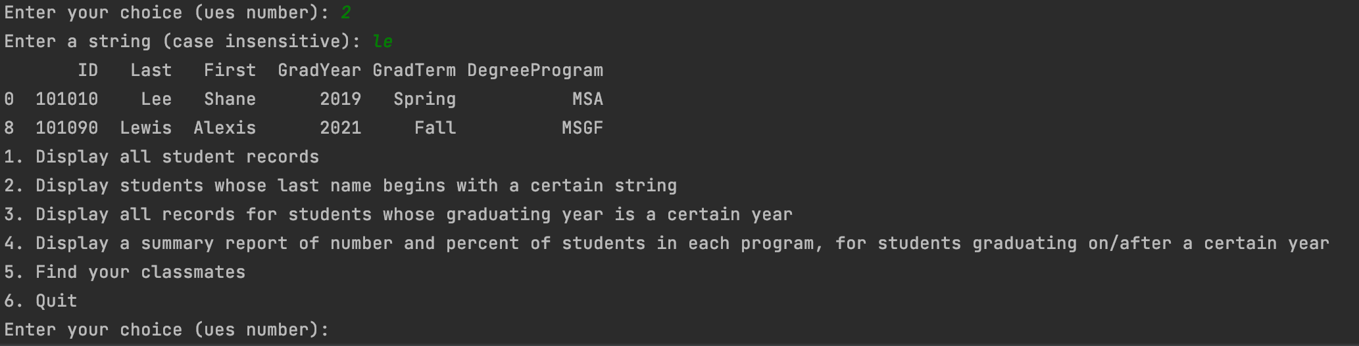

When you choose 3(Display all records for students whose graduating year is a certain year):

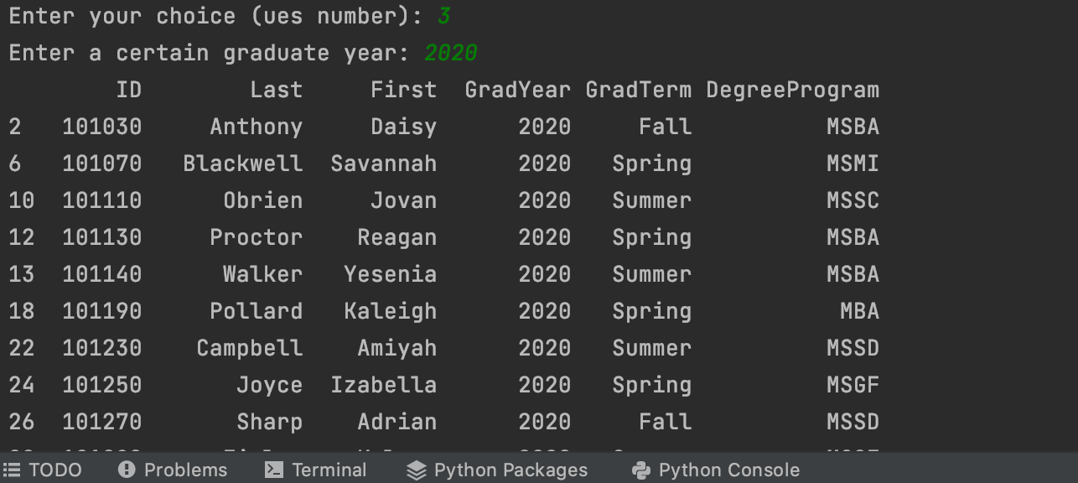

When you choose 4(Display a summary report of number and percent of students in each program, for students graduating on/after a certain year):

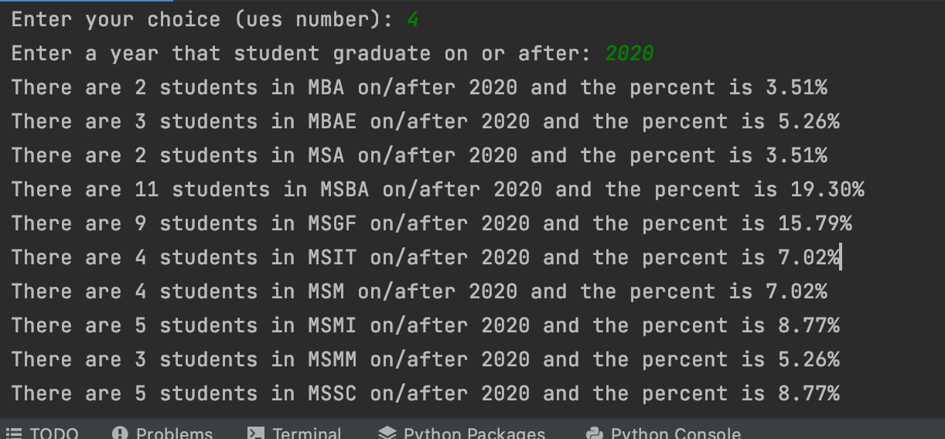

When you choose 5(display all your classmates):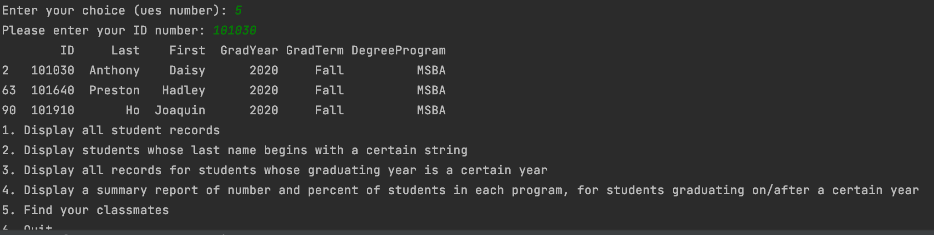

When you choose 6 then quit this program.

For all the input, the wrong input will be checked by the program. For all the wrong input, the program will print a reminder and let you re-enter the correct content. After getting the output you want, you can continue with other operations.

