Accomplishments

# Sprint 1

* Created the base ERD
* 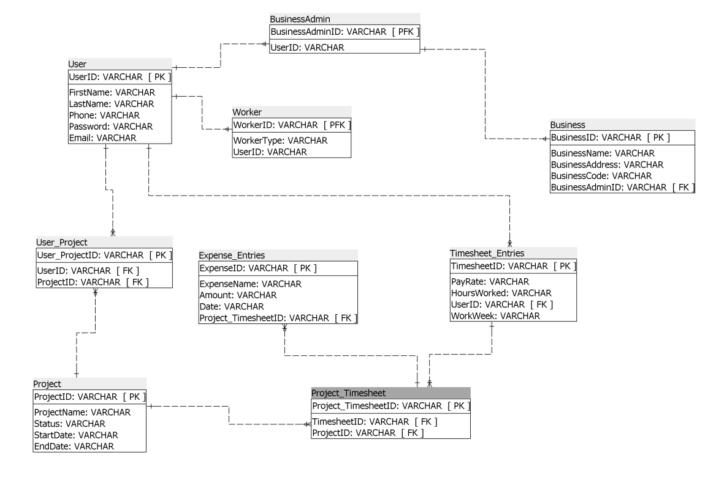
* I was having issues figuring out the email verification, but with Nunj’s help, we were able to figure it out (reference my branch).
* Working on some front-end (reference my branch)
* A lot of Research
  + <https://docs.microsoft.com/en-us/aspnet/core/security/authentication/accconfirm?view=aspnetcore-3.1&tabs=visual-studio>
  + <https://docs.microsoft.com/en-us/aspnet/mvc/overview/security/create-an-aspnet-mvc-5-web-app-with-email-confirmation-and-password-reset>
  + <https://tutorials.visualstudio.com/aspnet-azure/create>
  + <https://tutorials.visualstudio.com/aspnet-azure/publish>
  + <https://docs.microsoft.com/en-ca/azure/>
  + <https://www.c-sharpcorner.com/article/how-to-deploy-web-app-to-azure-using-visual-studio/>
  + <https://tutorials.visualstudio.com/aspnet-azure/create>
  + <https://tutorials.visualstudio.com/aspnet-azure/publish>
  + <https://www.youtube.com/watch?v=3AYoipyqOkQ&list=PL6n9fhu94yhXQS_p1i-HLIftB9Y7Vnxlo>
  + <https://www.w3schools.com/>
  + <https://clockify.me/dcaa-compliance>
* Collaboration over Discord.

# Sprint 2

# Sprint 3

# Sprint 4

# Sprint 5

# Sprint 6