**INSY6212 GROUP TASK**

**Group 2**

**Assignment 2**

**Group Members:**

1. Denzel Tinotenda Pawandiwa ST10457186
2. Joe Leo Van Niekerk ST10445055
3. Tinotenda Nyakatsari ST10437488
4. Tayler Usmar ST10445063
5. Maphutha Nkgopjane Nogana ST10377354

**EMERGENCY SOS SERVICES**

**Q.1.1: Project Evaluation Form**

**Explain the importance of a project evaluation form and explain why you would need to have one set up for your project.**

A **Project Evaluation Form** is a formal, standardized tool used to **objectively assess, score, and compare** potential projects against an organization's strategic goals and defined selection criteria (PMI, 2021).

**Importance:**

* It ensures **strategic alignment**, confirming that the selected project contributes to the organization's mission (Wysocki, 2014).
* It provides a **quantitative justification** for resource allocation, ensuring the most valuable projects receive funding (Heagney, 2016).
* It serves as a **baseline** for measuring success and performance throughout the project lifecycle.

**Why it's needed for the Emergency SOS Project:**

The form is essential to:

1. **Validate Project Selection:** Formally document the reasons why the **Emergency SOS Services** project was chosen over other safety/health/wellness alternatives (e.g., *Anonymous Incident Reporting*).
2. **Assess Feasibility:** Evaluate the project against critical constraints, specifically the **fixed R1 750 000 budget** and the **12-month deadline**, to confirm it is deliverable with the mandated **minimum of four team members** (Project Case Study, 2024).
3. **Priorities Non-Functional Requirements (NFRs):** Score the project based on the ability to achieve the critical NFRs, such as **high availability in low network areas** and **simplicity**, which are non-negotiable for an emergency application (ISO/IEC/IEEE, 2011).

**Q.1.2: Cross-Platform Development Trend**

**What is cross-platform development?**

**Cross-platform development** is the practice of building software applications, specifically mobile apps, that are designed to run on multiple operating systems (like **iOS** and **Android**) using a single, unified codebase (Leffingwell, 2011). Frameworks like Flutter or React Native are used to translate this single code into native-like applications for each platform, allowing for wider market reach.

**How will cross-platform development contribute to meeting your project timelines?**

Cross-platform development is a critical factor for meeting the strict **12-month project timeline** by offering significant efficiency gains:

* **Reduced Development Effort:** Since only one codebase is written and maintained, development time is substantially reduced compared to building two separate native applications (iOS and Android) (Gupta and Sharma, 2020).
* **Faster Team Velocity:** The small, mandated team only needs expertise in a single technology stack, allowing the four members to work concurrently on the same code without the need for platform-specific specialists for the majority of the work.
* **Simplified Testing and Deployment:** Testing and quality assurance (QA) cycles are shortened as a single code base is tested, accelerating the project through development milestones and reducing the risk of missing the 12-month deadline.

**Identify three potential risks associated with cross-platform development.**

1. **Performance Degradation:** Cross-platform apps may introduce an **abstraction layer** that can lead to slightly slower performance or reduced fluidity compared to purely native apps, which is a risk for an SOS application where immediate responsiveness is vital (Shahzad et al., 2021).
2. **Limited Access to Native APIs:** New or highly specific platform features (e.g., advanced location services, biometric security features) may not be immediately supported by the cross-platform framework, potentially requiring complex, time-consuming **"bridge code"** to be written (Gupta and Sharma, 2020).
3. **Tool/Framework Dependency and Stability:** The project is reliant on the long-term stability and update schedule of the third-party framework (e.g., React Native or Flutter). A sudden change in the framework or its discontinuation could severely halt development and maintenance efforts.

**Explain how cross-platform development will enhance the user experience and usability of your application.**

Cross-platform development enhances the user experience (UX) and usability of the Emergency SOS application by focusing resources on **consistency** and **simplicity**:

* **Consistent UI/UX:** The single codebase ensures that the application's interface, navigation flow, and critical elements (like the SOS button) look and behave identically across both Android and iOS devices. This **consistency** improves **usability** by reducing the cognitive load on users, especially crucial in a high-stress emergency situation (Nielsen, 1993).
* **Focused Design Effort:** The development team's design efforts are concentrated on perfecting a single, optimal user flow, ensuring the app remains **simple enough to be used quickly in an emergency situation** (Project Case Study, 2024), regardless of the user's mobile operating system.

**Q.1.3: Project Charter Deliverables**

**Identify five major deliverables that would form part of your project charter.**

The Project Charter is a key project management document that formally authorizes the existence of a project and provides the project manager with the authority to apply organizational resources to project activities (PMI, 2021).

The five major deliverables are:

1. **Project Purpose and Measurable Objectives:** The primary goal (e.g., "Deploy a stable cross-platform Emergency SOS mobile app within 12 months.") coupled with measurable objectives (e.g., "Achieve 99% uptime availability and a 4-star minimum user rating for usability and simplicity.").
2. **High-Level Project Requirements and Success Criteria:** Identification of the core need (addressing safety/health/wellness) and the conditions that must be met to declare the project a success (e.g., successful deployment to both major app stores and adherence to the **high availability in low network areas** NFR).
3. **Summary Milestone Schedule:** A high-level schedule showing the major checkpoints (e.g., "Phase 1 Completion: End-to-end prototype tested by Month 3," and "Project Go-Live: Month 12"), essential for managing the strict **12-month deadline**.
4. **Assigned Project Manager and Responsibility Authority Level:** Formal identification of the individual assigned as the Project Manager and the scope of their authority to utilize the **R1 750 000** budget and direct the minimum **four-member** project team.
5. **Summary Budget and Key Stakeholder List:** Documentation of the total authorized budget (**R1 750 000**) and a list of key parties, including the **Sponsor** (Community-Driven Technology Initiative) and the ultimate **Beneficiaries** (Community Residents).

**Question 2**

<https://drive.google.com/file/d/1RYFltISgPUlEukoFzfK0YHeMEJgGBCmf/view?usp=sharing>

* The proper version is on the other folder!!

**Question 3**

<https://github.com/VanNiekerkJoe/SOS-Emergency-App.git>

Milestone 1: Requirements Approved

Milestone 2: Prototype Ready

Milestone 3: Launch

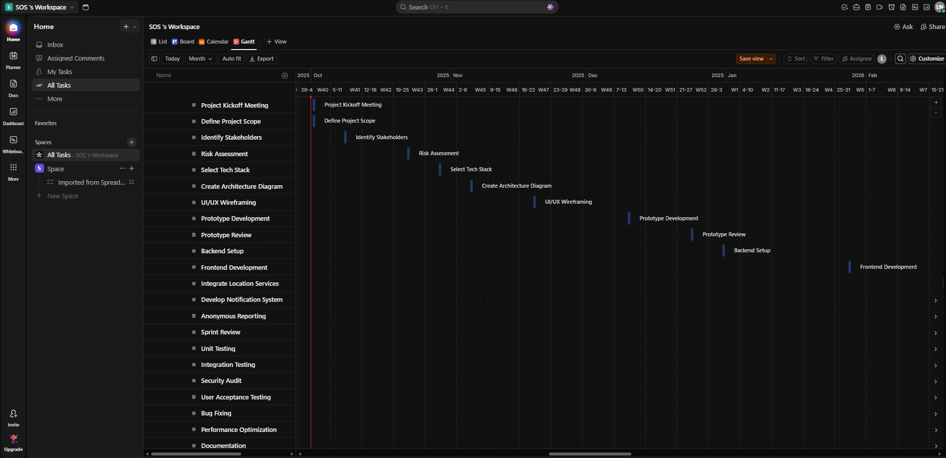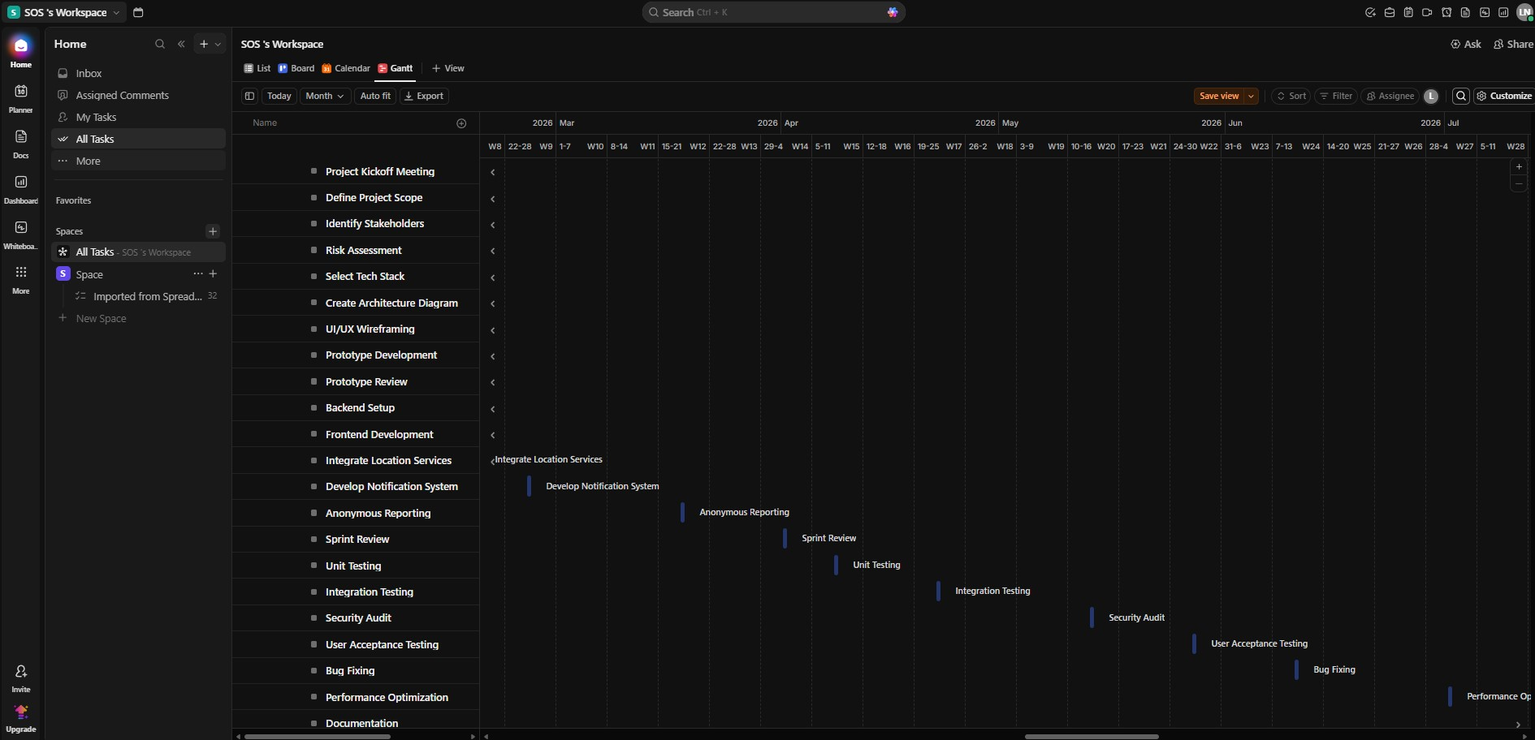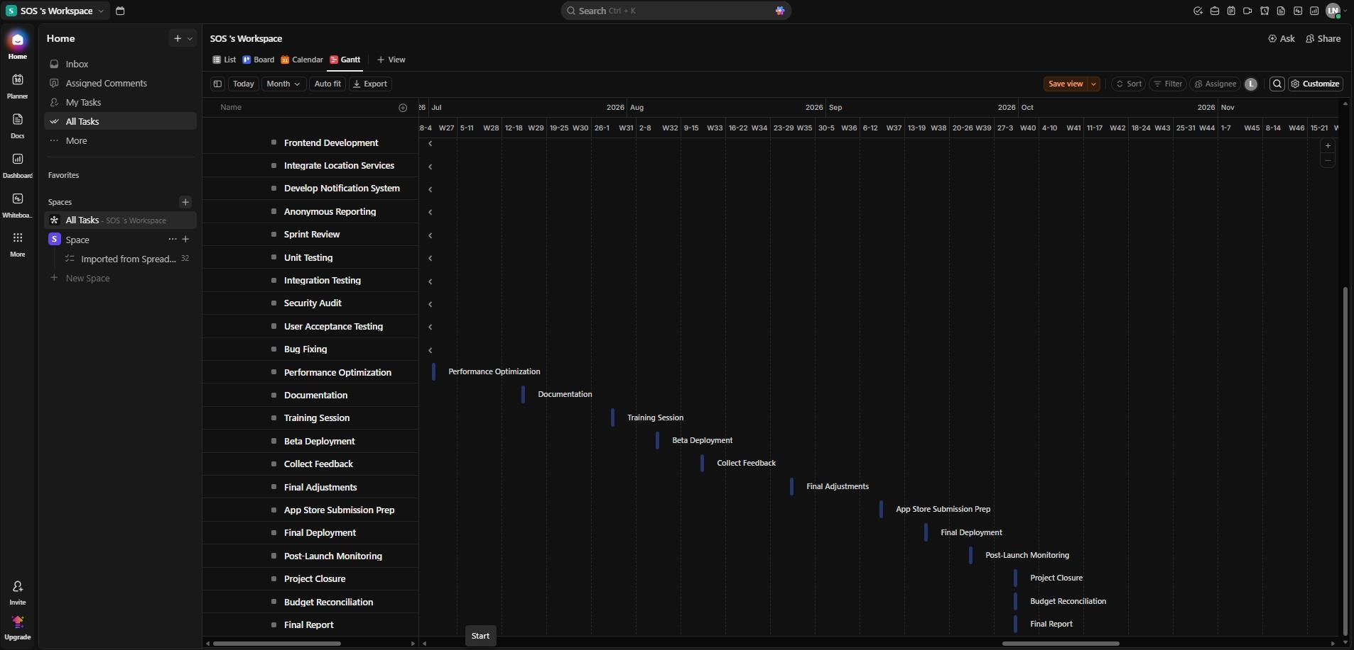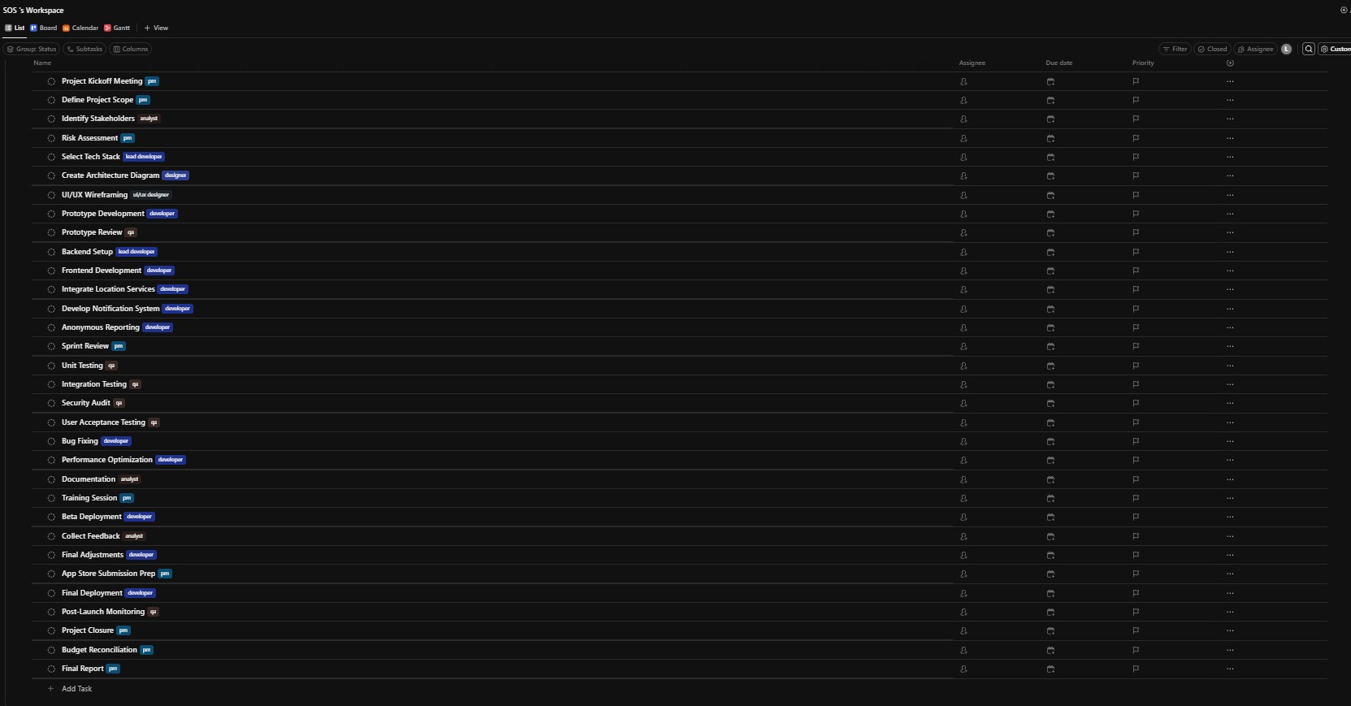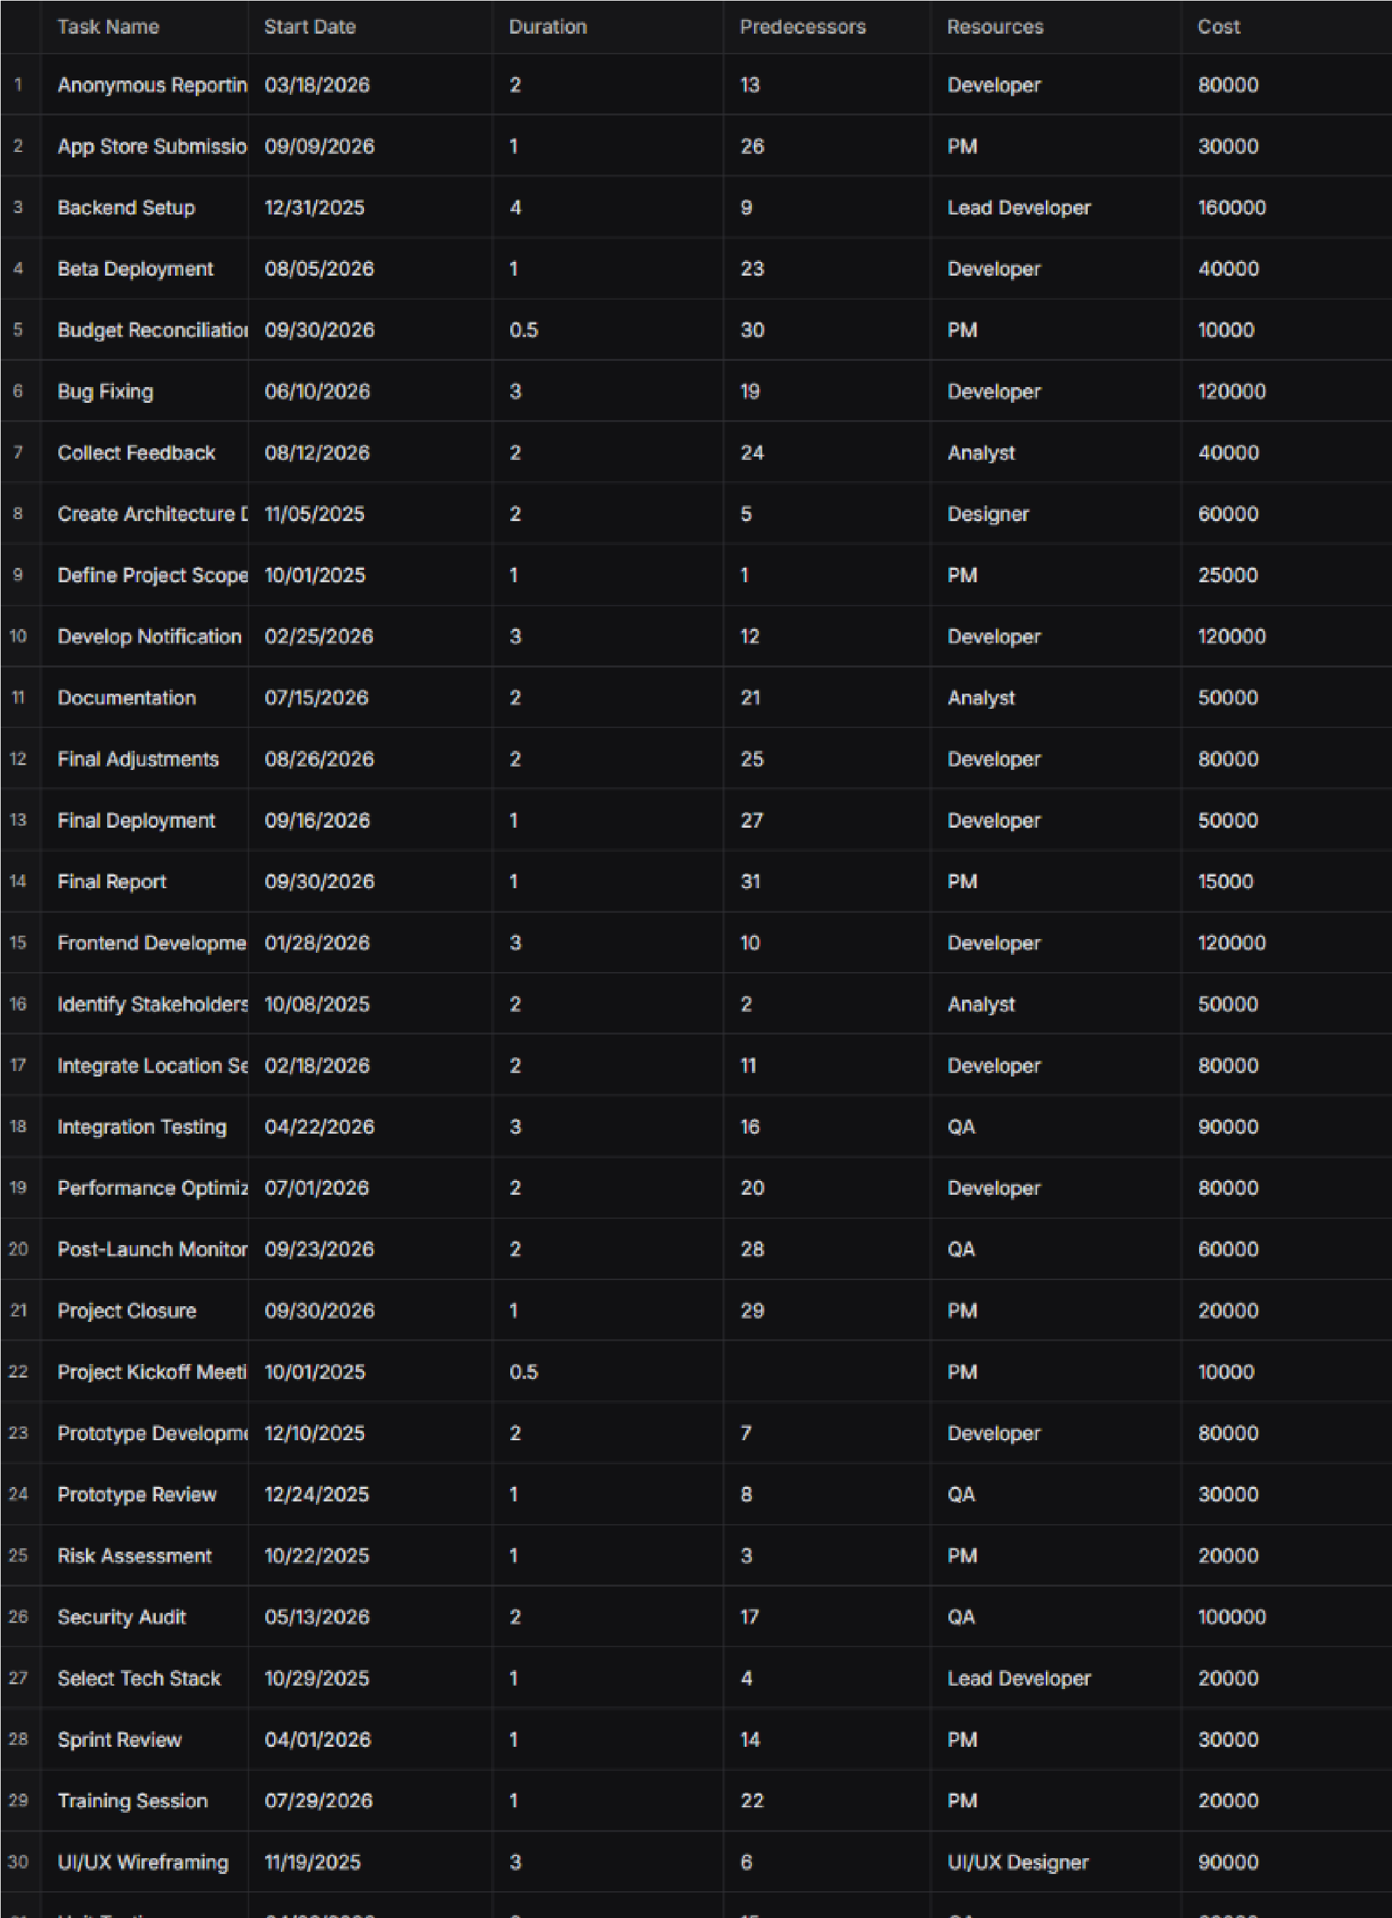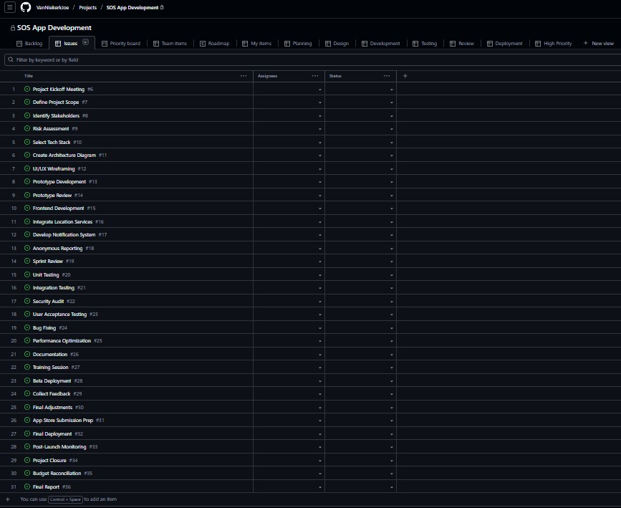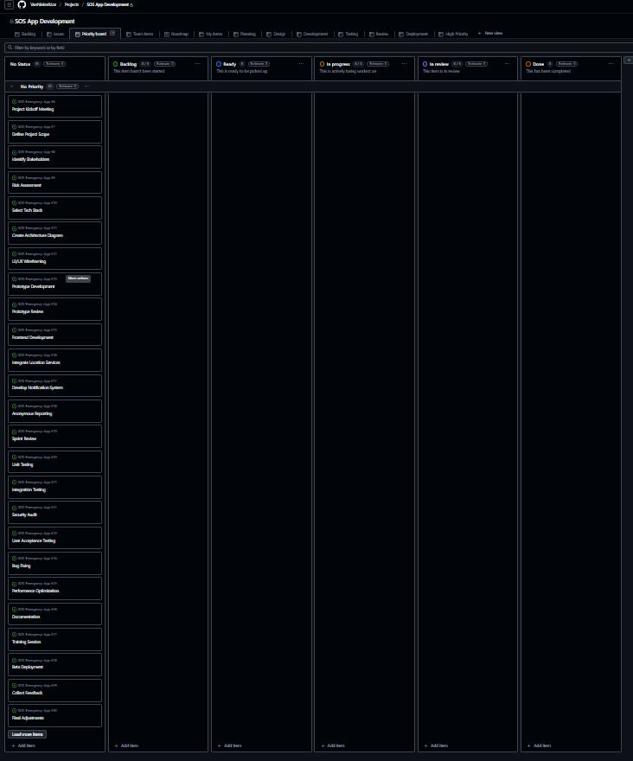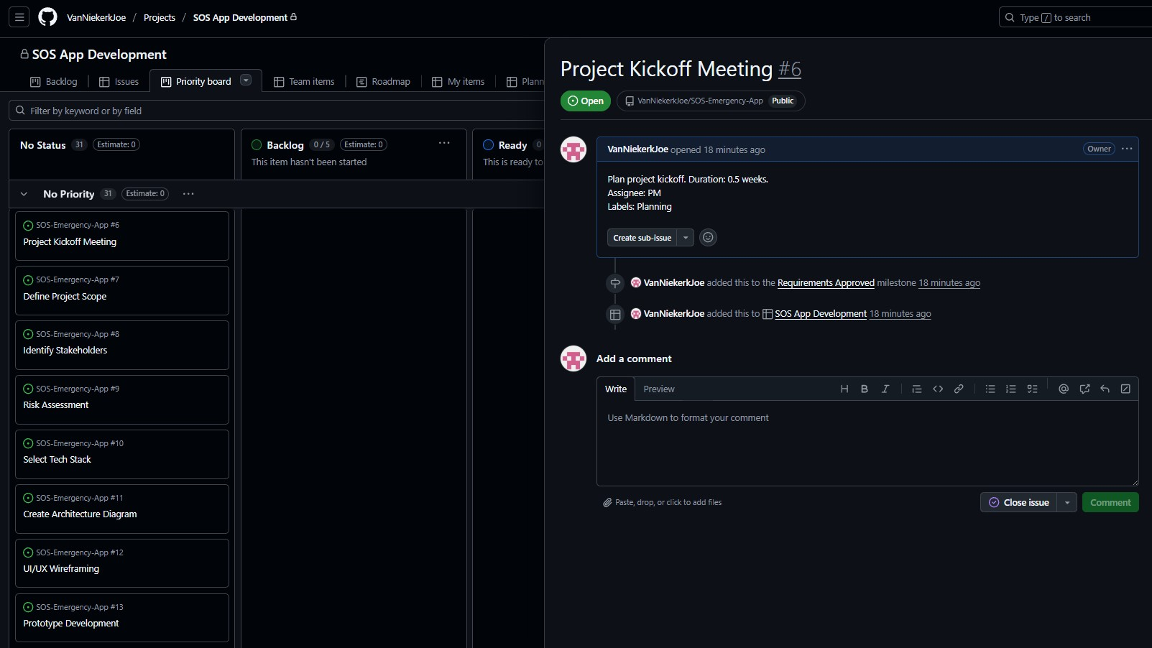

**Question 4**

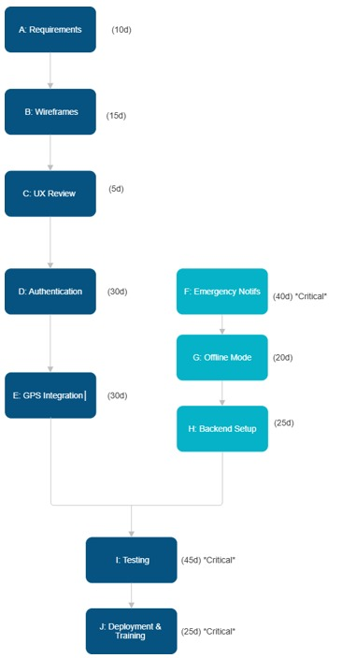

**Question5 :**

|  |
| --- |
| 1. **Name of students being evaluated:** Denzel Tinotenda Pawandiwa ST10457186 2. Joe Leo Van Niekerk ST10445055 3. Tinotenda Nyakatsari ST10437488 4. Tayler Usmar ST10445063 |

|  |  |  |  |  |  |  |
| --- | --- | --- | --- | --- | --- | --- |
| **The student’s personal work:** | | **Seldom**  **0** | | **Frequently**  **1** | | **Always**  **2** |
| The student contributed good ideas that added value to the people and produced high quality work. | |  | |  | | **2** |
| The student performed their tasks in line with what was expected of them. | |  | |  | | **2** |
| The student managed their own time well and met deadlines. | |  | |  | | **2** |
| **The students work as part of a team:** | | | | | | | |
| The student accepted responsibility for a far portion of the tasks and was an enthusiastic member of any team. | | |  | |  | | **2** | |
| The student helped others to be successful and worked well with other members of the team. | | |  | |  | | **2** | |

Total: 10/10

**Q.5.2**

**SELF-EVALUATION: REFLECTIVE REPORT**

**Student:** Maphutha Nkgopjane Nogana (ST10377354) **Group:** 2 (INSY6212 Assignment 2) **Project:** Emergency SOS Services Mobile Application

**1.0 Introduction**

This self-reflective report serves to document the personal and professional experience gained during the planning and initiation phase of the **Emergency SOS Services Mobile Application** project. The primary purpose of this assignment was to apply core project management principles—specifically project initiation documentation and requirements analysis—to a complex, constrained, real-world case study. The value of this assignment lies in developing the ability to strategically justify technical decisions, manage fixed resources (R1,750,000 budget and 12-month deadline), and create foundational documents (like the Project Evaluation Form and Project Charter) essential for project success and stakeholder alignment.

**2.0 Skills Learnt**

The project provided practical experience in three distinct areas of professional skill development:

**2.1 Technical Skills**

I significantly enhanced my **academic research and justification skills**. This involved deep-diving into sources like the *PMBOK Guide* and ISO standards (e.g., ISO/IEC/IEEE 29148) to ground project decisions formally. For instance, I used data and scholarly articles to justify the critical decision to use **cross-platform development** by analyzing the trade-off between slight performance degradation and the substantial efficiency gains needed to meet the **12-month deadline**.

**2.2 Communication and Teamwork Skills**

I played an active role in **brainstorming** the necessary deliverables for the Project Charter and providing **critical, structured feedback** on draft sections. The team established a successful feedback loop by clearly articulating project constraints (like the mandated four-member team) and ensuring all written justifications were coherent, contributing to a unified final document.

**2.3 Management Skills**

I applied **time management** by prioritizing the complex, research-heavy questions (Q1.1, Q1.2, Q1.3) early in the project timeline, ensuring that the project's strategic foundations were locked in before proceeding to other sections. My primary **problem-solving** effort involved proposing a standard citation style and structure, which streamlined the consolidation of work from different team members and ensured final academic integrity.

**3.0 Role in the Team**

**3.1 Role and Contribution**

My primary function within the team was the **Lead Researcher and Foundational Document Coordinator**. My specific contribution was authoring the initial core sections of the assignment: **Project Evaluation Form Justification**, **Cross-Platform Development Analysis**, and the **Project Charter Deliverables**.

My work added value by:

* Establishing the **academic rigor** and formal project management language used throughout the report.
* Solidifying the **technical justification** for using cross-platform methods, which is critical for adherence to the tight 12-month schedule and R1,750,000 budget.
* Defining the core success criteria and deliverables, preventing scope creep.

**3.2 Handling Team Dynamics**

The team dynamics were generally positive, facilitated by open communication channels (e.g., dedicated group chat). We successfully handled a minor conflict concerning the presentation format and citation style by implementing a democratic vote, followed by my detailed instruction on the chosen **Harvard referencing standard**. This promoted a sense of shared ownership and resolved the concern quickly and constructively.

**4.0 Research and Technology**

**4.1 Information Gathering and Presentation**

Information was primarily gathered from **academic databases** and reputable **industry sources** (e.g., the Project Management Institute).

**Task Examples:**

1. **Project Evaluation Form Justification:** Required research into the formal purpose and strategic value of project selection tools, referencing texts by Wysocki and Heagney.
2. **Cross-Platform Risk Analysis:** Required comparative research on frameworks (e.g., Flutter/React Native) to identify associated risks like **Performance Degradation** and **Limited Access to Native APIs**.

**4.2 Tools and Technology**

We utilized **Google Docs** for real-time collaborative editing, which was essential for a geographically dispersed team. **Zotero** was used as the primary citation management tool to ensure the referencing section was accurate and consistent.

The final deliverable was presented as a **formal academic report** using numbered headings, in-text citations, and a dedicated reference list, suitable for submission to a university module.

**5.0 Personal Strengths and Weaknesses**

**5.1 Tasks Excelled In**

I excelled in the **analytical and strategic justification** components of the assignment (Q.1.1 and Q.1.2), where the core arguments needed to be built on formal project management theory and specific project constraints.

**5.2 Strengths Identified (At least five)**

1. **Meticulous Researcher:** Ensuring all facts and claims were backed by current, reputable citations.
2. **Clear, Concise Writer:** Structuring complex arguments into easily digestible, formal report language.
3. **Strong Task Ownership:** Taking full responsibility for my assigned deliverables from initial draft to final review.
4. **Proactive Communicator:** Initiating check-ins and providing updates to the team without prompting.
5. **Systems-Thinking Approach:** Evaluating decisions (like Cross-Platform) based on their downstream impact on the budget, timeline, and team composition.

**5.3 Tasks Struggled With and Improvement**

**Struggled With:** Consolidating the final report structure and writing style from various contributors. This proved time-consuming due to variations in individual writing styles and formatting preferences. **Why Challenging:** The need to unify the document late in the process led to a bottleneck in the final quality assurance stage. **Improvement:** In future projects, I will advocate for setting up a **mandatory, shared style guide** and assign a **dedicated Document Editor** role from the start of the project to manage style consistency dynamically.

**6.0 Relationships**

**6.1 Aspects that Worked Well**

The working relationship with all team members, particularly Joe Leo Van Niekerk, was highly effective. This success stemmed from **mutual trust**, which allowed for clear division of labour without the need for micromanagement, and **high accountability**, ensuring all group members met their promised internal deadlines.

**6.2 Ways to Strengthen or Improve Relationships**

To strengthen the collaboration further, I would implement a more **formalised, standing weekly status check** (even if only 15 minutes). While ad-hoc communication was strong, a dedicated session would ensure everyone is aware of potential non-critical blockers or resource issues early, further reducing overall project risk.

**7.0 Impact**

**7.1 How Contributions Added Value**

My work provided the **critical rationale** for the Emergency SOS App project. By formally justifying the use of a Project Evaluation Form, I provided the necessary structure to strategically align the app with the sponsor's goals. Furthermore, my analysis of the **Cross-Platform Trend** directly ensured the team's technical approach was optimized to respect the non-negotiable **12-month completion deadline** and small four-member team constraint.

**7.2 Creating a More Positive or Significant Impact**

To have had a more significant impact, I could have proactively initiated the creation of the **Summary Milestone Schedule** (a deliverable I identified in Q1.3) immediately after the Project Charter was drafted. Translating the defined requirements into a visual timeline would have given the team a better sense of progress and provided stronger project control from the outset.

**8.0 Conclusion**

The completion of the INSY6212 assignment was an invaluable exercise in foundational project management and technical justification. **Key Takeaway 1** is the non-negotiable need for **strategic alignment** through formal documentation (like the Project Charter) before any execution begins. **Key Takeaway 2** highlights the practical necessity of making informed **technical trade-offs** (e.g., choosing cross-platform) when facing severe resource and time constraints. My primary **Learning Outcome** is the importance of not only being a strong individual contributor but also taking on the proactive role of **document steward** to ensure the entire final report is structurally and stylistically seamless.

**References**

* The Independent Institute of Education (IIE). (2025). Information Systems 2B: INSY6212 Module Outline 2025 (First Edition: 2025). [Module Outline].
* Gupta, A. and Sharma, A., 2020. Cross-platform mobile development using React Native framework. *International Journal of Computer Applications*, 174(5), pp.1-4.
* Heagney, J., 2016. *Fundamentals of project management*. 5th ed. New York: AMACOM.
* ISO/IEC/IEEE, 2011. *ISO/IEC/IEEE 29148:2011 Systems and software engineering - Life cycle processes - Requirements engineering*. Geneva: International Organization for Standardization.
* Leffingwell, D., 2011. *Agile software requirements: Lean requirements practices for teams, programs, and the enterprise*. Boston: Addison-Wesley.
* Nielsen, J., 1993. *Usability engineering*. San Diego: Academic Press.
* PMI (Project Management Institute), 2021. *A Guide to the Project Management Body of Knowledge (PMBOK® Guide) – Seventh Edition and The Standard for Project Management*. Newtown Square: Project Management Institute.
* Project Case Study, 2024. *Assignment Topic: Designing and Developing an App project*. [Internal Document].
* Shahzad, M.K., Anjum, S. and Bashir, I., 2021. Performance Analysis of Cross-Platform Mobile Application Development Frameworks: A Comparative Study. *IEEE Access*, 9, pp.76348-76361.
* Wysocki, R.K., 2014. *Effective project management: Traditional, agile, extreme*. 7th ed. Indianapolis: Wiley.