Project10_1:

import javax.swing.*;

import javax.swing.event.*;

import java.applet.*;

import java.awt.*;

import java.awt.event.*;

public class Project10_1 extends Applet implements ActionListener{

// define components

Label

lblTitle = new Label("California Nite Club Check-in"),

lblName = new Label("Name"),

lblAddr = new Label("Address"),

lblPhoneNum = new Label("Phone Number"),

lblList = new Label("List of guests in the club");

TextField

txtName = new TextField(),

txtAddr = new TextField(),

txtPhoneNum = new TextField();

Button

btnAdd = new Button("Add to the List");

TextArea

txtaReport = new TextArea("Name\tAddr\tPhone\n",4,80,TextArea.SCROLLBARS_BOTH);

public void init(){

setLayout(null);

int startTop = 70;

int lblLeft = 50;

int txtLeft = 250;

int lblWidth = 100;

int txtWidth = 200;

int height = 20;

int gap = 30;

lblTitle.setFont(new Font("Serif", Font.ITALIC | Font.BOLD, 30));

lblTitle.setBounds(60,20, 480, 50); add(lblTitle);

lblName.setBounds(lblLeft, startTop, lblWidth, height); add(lblName);

txtName.setBounds(txtLeft, startTop, txtWidth, height); add(txtName);

lblAddr.setBounds(lblLeft, startTop + gap, lblWidth, height); add(lblAddr);

txtAddr.setBounds(txtLeft, startTop + gap, txtWidth, height); add(txtAddr);

lblPhoneNum.setBounds(lblLeft, startTop + gap*2, lblWidth, height); add(lblPhoneNum);

txtPhoneNum.setBounds(txtLeft, startTop + gap*2, txtWidth, height); add(txtPhoneNum);

btnAdd.setBounds(350, startTop + gap*4,lblWidth, height); add(btnAdd);

lblList.setBounds(100, startTop + gap*5, 200, height); add(lblList);

txtaReport.setBounds(lblLeft, startTop + gap*6, 400,200 ); add(txtaReport);

btnAdd.addActionListener(this);

}

@Override

public void actionPerformed(ActionEvent e) {

// TODO Auto-generated method stub

// This is action for btnAdd button

String line, strName, strAddr, strPhoneNum;

// get the input content

strName = txtName.getText();

strAddr = txtAddr.getText();

strPhoneNum = txtPhoneNum.getText();

// combain all the input content

line = strName + "\t" + strAddr + "\t" + strPhoneNum;

// put it in the text Area

txtaReport.append(line + "\n");

// Clear the input in the text field

txtName.setText("");

txtAddr.setText("");

txtPhoneNum.setText("");

// place the cursor in the name field

txtName.requestFocus();

}

}

output:

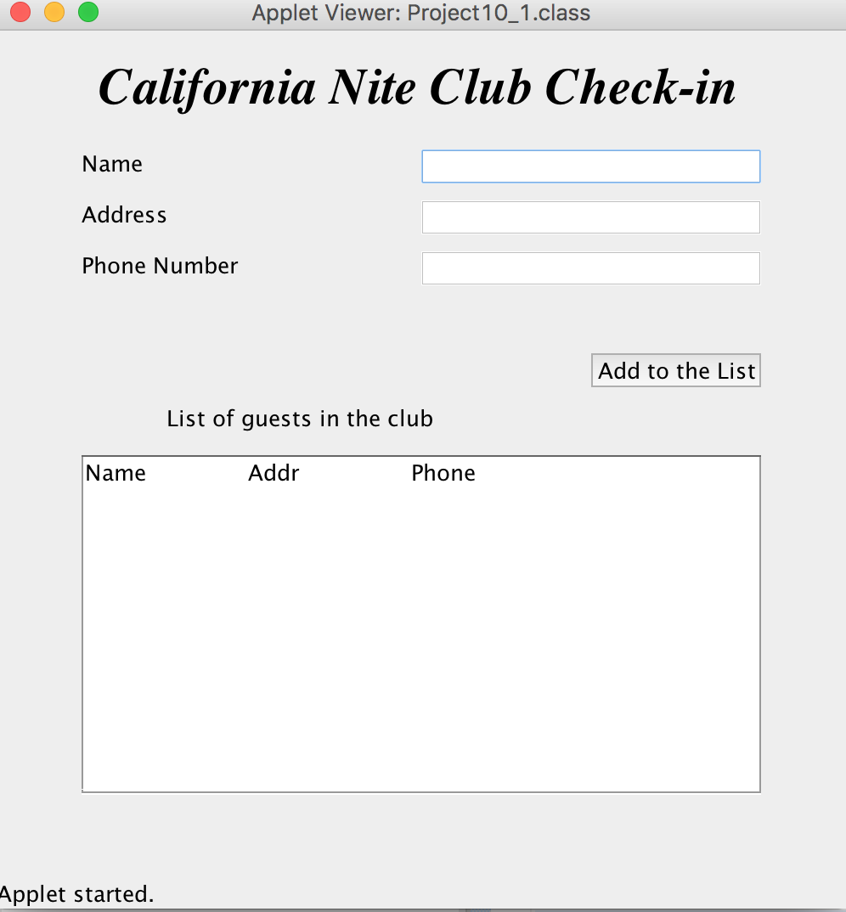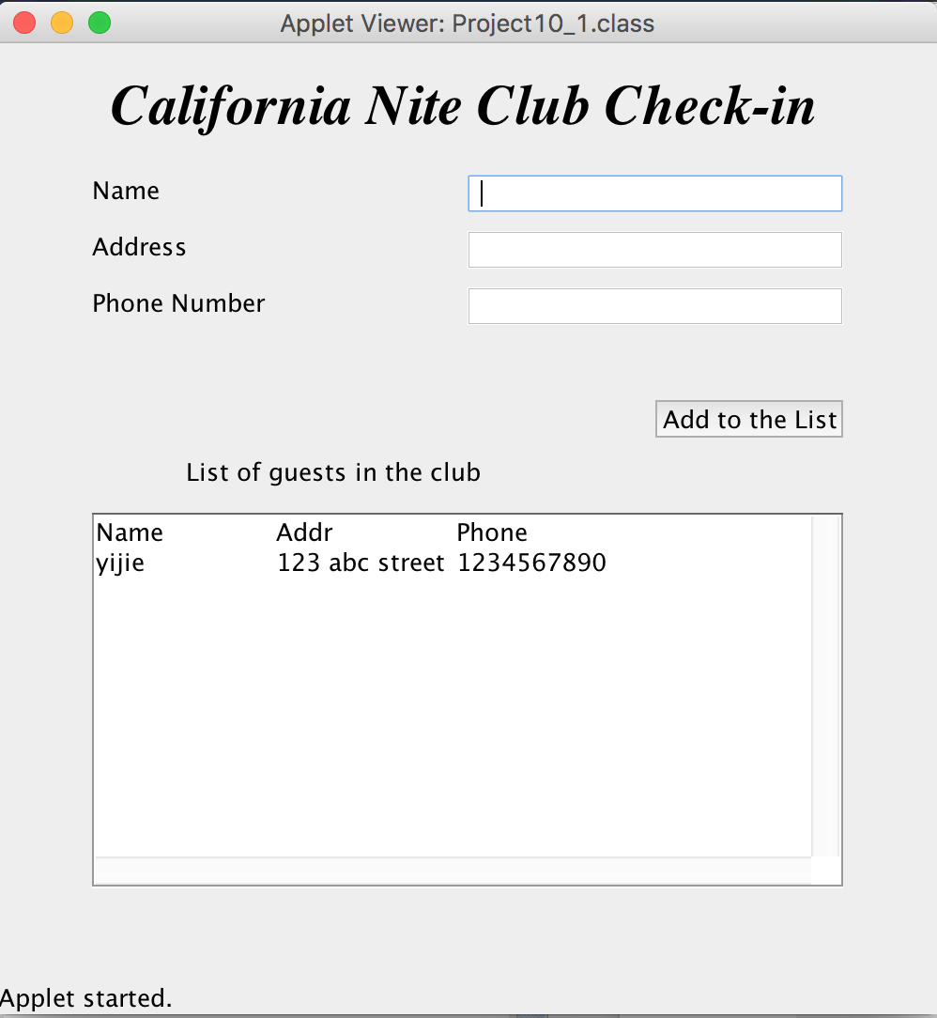

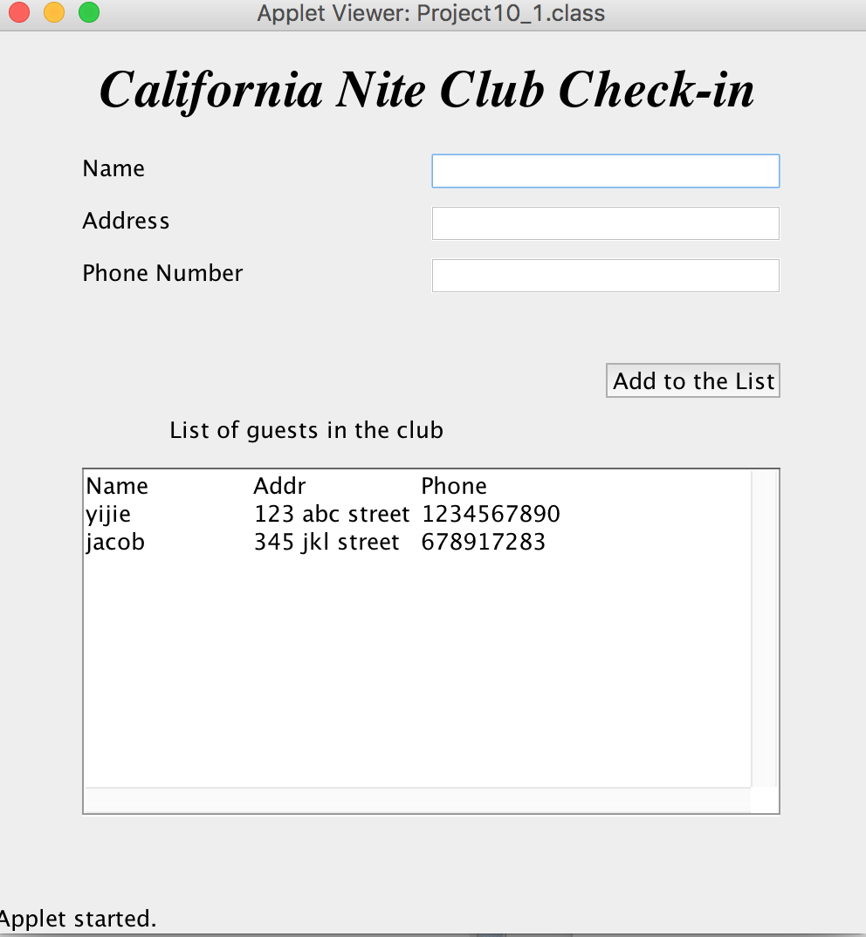

Project10_2:

import javax.swing.*;

import javax.swing.event.*;

import java.applet.Applet;

import java.awt.*;

import java.awt.event.*;

public class Project10_2 extends Applet implements ActionListener{

Button

Btn1 = new Button("1"),

Btn2 = new Button("2"),

Btn3 = new Button("3"),

Btn4 = new Button("4"),

Btn5 = new Button("5"),

Btn6 = new Button("6"),

Btn7 = new Button("7"),

Btn8 = new Button("8"),

Btn9 = new Button("9"),

Btn0 = new Button("0"),

BtnAdd = new Button("+"),

BtnMinus = new Button("-"),

BtnMul = new Button("*"),

BtnDivd = new Button("/"),

BtnEqual = new Button("="),

BtnNeg = new Button("+/-"),

BtnClear = new Button("CLEAR"),

BtnFactorial = new Button("n!");

TextField

txtWin = new TextField();

String n="", n1st, n2st;

int n1, n2;

String operator = new String();

public void init(){

setLayout(null);

int top = 100;

int left = 50;

int edge = 60;

int width = edge;

int height = edge;

int gap = 20;

int wide = width * 2 + gap;

txtWin.setBounds(left, 20, 300, 70); add(txtWin);

Button [] Btns = {Btn7,Btn8, Btn9, BtnAdd,

Btn4, Btn5, Btn6, BtnMinus,

Btn1, Btn2, Btn3, BtnMul,

Btn0, BtnEqual, null, BtnDivd,

BtnNeg, BtnClear, null, BtnFactorial};

for(int i = 0; i<Btns.length; i++){

int col = i%4;

int row = i/4;

if(Btns[i]!=null){

Btns[i].setSize(width, height);

Btns[i].setLocation((left+(width+gap)*col), top+(height+gap)*row);

add(Btns[i]);

Btns[i].addActionListener(this);

}

}

BtnEqual.setSize(wide,height);

BtnClear.setSize(wide,height);

}

@Override

public void actionPerformed(ActionEvent e) {

// TODO Auto-generated method stub

Button [] BtnNum = {Btn0, Btn1, Btn2, Btn3,

Btn4, Btn5, Btn6,

Btn7, Btn8, Btn9 };

boolean function = true;

for(int i = 0; i<BtnNum.length; i++){

if(e.getSource() == BtnNum[i]){

n+=i; txtWin.setText(n);

function = false;

}

}

if(function){

if(e.getSource() == BtnAdd){

n=txtWin.getText().trim();

n1 = Integer.parseInt(n);

txtWin.setText("");

n="";

operator = " + ";

/*n+=" + ";

txtWin.setText(n);

n2 = Integer.parseInt(n); n = "";

n1st = Integer.toString(n1);

n2st = Integer.toString(n2);*/

}else if(e.getSource() == BtnAdd){

n=txtWin.getText().trim();

n1 = Integer.parseInt(n);

txtWin.setText("");

n="";

operator = " + ";

}else if(e.getSource() == BtnMinus){

n=txtWin.getText().trim();

n1 = Integer.parseInt(n);

txtWin.setText("");

n="";

operator = " - ";

}else if(e.getSource() == BtnMul){

n=txtWin.getText().trim();

n1 = Integer.parseInt(n);

txtWin.setText("");

n="";

operator = " * ";

}else if(e.getSource() == BtnDivd){

n=txtWin.getText().trim();

n1 = Integer.parseInt(n);

txtWin.setText("");

n="";

operator = " / ";

}else if(e.getSource() == BtnNeg){

n=txtWin.getText().trim();

if(n.charAt(0)=='-'){

n = n.substring(1);

}else{

n = "-"+n;

}

txtWin.setText(n);

}else if(e.getSource() == BtnFactorial){

n=txtWin.getText().trim();

n1 = Integer.parseInt(n);

//txtWin.setText("");

n+="!";

txtWin.setText(n);

operator = "!";

}else if(e.getSource() ==BtnEqual){

if(operator != "!"){

n = txtWin.getText().trim();

n2 = Integer.parseInt(n); n="";

n1st = Integer.toString(n1);

n2st = Integer.toString(n2);

if(operator == " + "){

txtWin.setText(n1st + operator + n2st + " = " + Integer.toString(n1+n2));

}else if(operator == " - "){

txtWin.setText(n1st + operator + n2st + " = " + Integer.toString(n1-n2));

}else if(operator == " * "){

txtWin.setText(n1st + operator + n2st + " = " + Integer.toString(n1*n2));

}else if(operator == " / "){

txtWin.setText(n1st + operator + n2st + " = " + Double.toString(n1/(double)n2));

}

}else{

n = txtWin.getText().trim();

n1st = Integer.toString(n1);

txtWin.setText(n + " = " + Integer.toString(factorial(n1)));

}

}

else if(e.getSource() == BtnClear){

txtWin.setText(""); n="";

txtWin.requestFocus();

}

}

}

int factorial(int val){

if(val==1) return val;

return val * factorial(val-1);

}

}

output:

