Project12_1:

import java.applet.Applet;

import java.awt.Button;

import java.awt.Choice;

import java.awt.Font;

import java.awt.Graphics;

import java.awt.Image;

import java.awt.Label;

import java.awt.TextField;

import java.awt.event.ActionEvent;

import java.awt.event.ActionListener;

import java.awt.event.ItemEvent;

import java.awt.event.ItemListener;

import java.util.Calendar;

public class Project12_3 extends Applet implements ActionListener {

Label

Welcome = new Label("Welcome to the United States of America"),

lblTime = new Label("Select time zone"),

lblPacific = new Label("Pacific Time");

Image sample, screen;

Choice TimeZone = new Choice();

TextField time = new TextField();

Button show = new Button("Show Info");

String[] Area = {"Pacific", "Mountain", "Central","Eastern"};

public void init(){

setLayout(null);

resize(600,400);

Welcome.setFont(new Font("Courier",Font.BOLD,13));

Welcome.setBounds(120, 30, 300, 30); add(Welcome);

lblTime.setBounds(35,75,120,20); add(lblTime);

for(int i = 0; i<Area.length; i++){

TimeZone.add(Area[i]);

}

TimeZone.setBounds(25,100,130,30); add(TimeZone);

sample = getImage(getDocumentBase(),"../image/Pacific.png");

screen = getImage(getDocumentBase(),"../image/screen.jpg");

lblPacific.setBounds(35,150,120,20); add(lblPacific);

time.setBounds(25,180,120,20); add(time);

show.setBounds(25, 240,130,30); add(show);

show.addActionListener(this);

}

public void paint(Graphics g){

g.drawImage(sample,180,70,170,300,this);

g.drawImage(screen,400,70,170,180,this);

}

@Override

public void actionPerformed(ActionEvent e) {

// TODO Auto-generated method stub

Calendar c = Calendar.getInstance();

int hour = c.get(Calendar.HOUR);

int min = c.get(Calendar.MINUTE);

int sec = c.get(Calendar.SECOND);

int index = TimeZone.getSelectedIndex();

hour += index;

String timeline = hour + ":"+min+":"+sec;

time.setText(timeline);

sample = getImage(getDocumentBase(),"../image/"+ Area[index]+".png");

repaint();

}

}

Project12_2

import java.applet.Applet;

import java.awt.*;

import java.awt.event.ActionEvent;

import java.awt.event.ActionListener;

import java.awt.event.AdjustmentEvent;

import java.awt.event.AdjustmentListener;

public class Project12_4 extends Applet implements ActionListener{

Label

title = new Label("My Family Album"),

subTitle = new Label("Image description");

Button

back = new Button("<<<"),

next = new Button(">>>"),

display = new Button("Show describtion");

TextArea description = new TextArea();

Scrollbar sb = new Scrollbar(0,10,10,0,190);

Image img;

String[] Pics = {"face", "Eastern", "Mountain"};

public void init(){

setLayout(null);

resize(600,400);

back.setBounds(50,50,60,30);

next.setBounds(190,50,60,30);

add(back); add(next);

back.addActionListener(this);

next.addActionListener(this);

sb.setBounds(60,80,180,30); add(sb);

img = getImage(getDocumentBase(),"../image/"+ Pics[0]+".png");

display.setBounds(260, 150, 120, 50); add(display);

display.addActionListener(this);

title.setBounds(400,80,120,20);add(title);

subTitle.setBounds(400,100,120,30); add(subTitle);

description.setBounds(400,140,180,80); add(description);

}

public void paint(Graphics g){

g.drawImage(img, 60, 120, 180, 130, this);

}

@Override

public void actionPerformed(ActionEvent e) {

// TODO Auto-generated method stub

int value = sb.getValue();

int interval = 100;

if(e.getSource() == back && value > 0){

sb.setValues(value - interval, 10, 10, 210);

}else if(e.getSource() == next && value <200){

sb.setValues(value + interval, 10, 10, 210);

}

int newIndex = (sb.getValue()+20)/interval;

img = getImage(getDocumentBase(),"../image/"+ Pics[newIndex]+".png");

repaint();

if(e.getSource() == display){

description.setText(Pics[newIndex]);

}

}

}

Project12_3

import java.applet.Applet;

import java.awt.Button;

import java.awt.Checkbox;

import java.awt.CheckboxGroup;

import java.awt.Font;

import java.awt.Graphics;

import java.awt.Image;

import java.awt.Label;

import java.awt.List;

import java.awt.event.ActionEvent;

import java.awt.event.ActionListener;

public class Project12_1 extends Applet implements ActionListener {

Label

title = new Label("Macy's Department Store"),

firstL = new Label("Shoes on sale choose / return Your Shopping Cart"),

//cr = new Label(""),

//shoppingCart = new Label(""),

report = new Label("Report");

List

shoesList = new List(),

shoppingCartList = new List(),

reportList = new List();

Button

issue = new Button("Issue Report"),

choose = new Button(">>>"),

ret = new Button("<<<");

Image img;

CheckboxGroup cbg = new CheckboxGroup();

// color box

Checkbox

opRed = new Checkbox("Red",cbg, true),

opBlack = new Checkbox("Black",cbg,false),

opBrown = new Checkbox("Brown",cbg,false);

String[] pic = {"winter", "sandals","boots","sneakers","Calf","Alaskan","Lucky"};

String[] shoesName = {"Winter Shoes", "Sandals","Boots","Sneakers",

"Calf boots", "Alaskan boots", "Luckt brand"

};

String[] price = {"$100.25","$75.99","$55.50","$23.99", "$69.99","$85.50","$220.9"};

int i = 0;

public void init(){

//Graphics g = new Graphics();

setLayout(null);

resize(600,400);

title.setBounds(220,10,200,20); add(title);

// first level

firstL.setBounds(50,50,500,20); add(firstL);

/*String[] shoesName = {"Winter Shoes $100.25", "Sandals $75.99","Boots $55.50","Sneakers $23.99",

"Calf boots $69.99", "Alaskan boots $85.50", "Luckt brand $220.9"

};*/

shoesList.setFont(new Font("Courier", 0, 12));

for(int i = 0; i<shoesName.length;i++){

shoesList.add(shoesName[i] +" "+price[i]);

}

shoesList.setBounds(25,75,160,300); add(shoesList);

shoesList.select(0);

shoesList.addActionListener(this);

choose.setBounds(190,75,70,20); add(choose);

ret.setBounds(260,75,70,20); add(ret);

img = getImage(getDocumentBase(),"../image/winter.jpg");

opRed.setBounds(190,300,60,20); add(opRed);

opBlack.setBounds(250,300,70,20); add(opBlack);

opBrown.setBounds(320,300,80,20); add(opBrown);

issue.setBounds(210,320,120,40); add(issue);

shoppingCartList.setBounds(375,75,200,90); add(shoppingCartList);

report.setBounds(430,175,80,20); add(report);

reportList.setBounds(375,200,200,90); add(reportList);

// Listener

//shoesList.addActionListener(null);

choose.addActionListener(this);

ret.addActionListener(this);

issue.addActionListener(this);

}

public void paint(Graphics g){

g.drawImage(img,190,110,170,180,this);

}

@Override

public void actionPerformed(ActionEvent e) {

// TODO Auto-generated method stub

img = getImage(getDocumentBase(), "../image/"+pic[shoesList.getSelectedIndex()]+".jpg");

repaint();

String shoeType, color, shoeprice, shoppingCart, line;

double totalPrice = 0.0;

if(opRed.getState()){

color = "Red";

}else if(opBlack.getState()){

color = "Black";

}else{

color = "Brown";

}

if(e.getSource() == choose){

int index = shoesList.getSelectedIndex();

shoeType = shoesName[index] ;

shoeprice = price[index];

line = shoeType + "\t" + shoeprice+ "\t" + color;

shoppingCartList.add(line);

}else if(e.getSource() == ret){

shoppingCartList.remove(shoppingCartList.getSelectedIndex());

}else if(e.getSource() == issue) {

for(int i = 0; i< shoppingCartList.getItemCount(); i++){

String [] shoes = shoppingCartList.getItem(i).split("\t",3);

String newLine = shoes[0] + "\t" + shoes[1];

reportList.add(newLine);

totalPrice += Double.valueOf(shoes[1].substring(1));

}

line = "Total Bill" + "\t$" + totalPrice;

reportList.add(line);

}

}

}

Project12_4

import java.applet.Applet;

import java.awt.Button;

import java.awt.Checkbox;

import java.awt.CheckboxGroup;

import java.awt.Font;

import java.awt.Graphics;

import java.awt.Image;

import java.awt.Label;

import java.awt.List;

import java.awt.TextArea;

import java.awt.TextField;

import java.awt.event.ActionEvent;

import java.awt.event.ActionListener;

import java.util.Calendar;

import java.util.Date;

public class Project12_2 extends Applet implements ActionListener {

Calendar c = Calendar.getInstance();

int day = c.get(Calendar.DATE);

int month = c.get(Calendar.MONTH);

int year = c.get(Calendar.YEAR);

Label

title = new Label("Practing addition"),

lblDate = new Label("Today's date: " + month +"/"+day+"/"+year),

lblNum = new Label("Select the number of questions: "),

lblQues = new Label(),

lblMsg = new Label("A Message from the Institution"),

lblReport = new Label("Report"),

lblResult = new Label("result");

Image Face, Img;

Button

btnStart = new Button("Click to start"),

btnNext = new Button("Press for next question");

CheckboxGroup cbg = new CheckboxGroup();

Checkbox

Q5 = new Checkbox("5",cbg, true),

Q10 = new Checkbox("10",cbg,false);

TextArea

comment = new TextArea(),

report = new TextArea();

TextField

answer = new TextField();

List

Message = new List();

int Correct=0,Wrong=0;

int rn1,rn2,result,questionNum = 1;

int ques;

public void init(){

setLayout(null);

resize(600,400);

title.setFont(new Font("Courier", Font.BOLD, 16));

title.setBounds(200,20,200,30); add(title);

// Calendar

lblDate.setBounds(30,50,200,20); add(lblDate);

// Question Number

lblNum.setBounds(30,80,210,20); add(lblNum);

Q5.setBounds(240,80,50,20); add(Q5);

Q10.setBounds(290,80,60,20); add(Q10);

//

Img = getImage(getDocumentBase(),"../image/school.jpg");

// action listener

btnStart.setBounds(70,110,120,50);add(btnStart);

btnNext.setBounds(400,180,180,40);add(btnNext);

btnStart.addActionListener(this);

btnNext.addActionListener(this);

lblQues.setBounds(30,180,170,20); add(lblQues);

answer.setBounds(200,180,40,20); add(answer);

lblResult.setBounds(250,180,80,20); add(lblResult);

lblMsg.setBounds(55,210,200,20); add(lblMsg);

comment.setBounds(40,250,180,120); add(comment);

Face=getImage(getDocumentBase(),"../image/face.png");

lblReport.setBounds(460,230,100,20); add(lblReport);

report.setBounds(400,250,180,120); add(report);

}

public void paint(Graphics g){

g.drawImage(Img, 400, 50, 180, 120, this);

if(Correct/(double)ques > 0.5){

g.drawImage(Face,230, 250, 150, 100, this);

}

}

@Override

public void actionPerformed(ActionEvent e) {

long currentTime = 0;

Date d1 = new Date();

Calendar c = Calendar.getInstance();

if(Q5.getState()){

ques = 5;

}else{

ques = 10;

}

if(e.getSource() == btnStart){

questionNum = 1;

currentTime=d1.getTime();

rn1 = (int)(Math.random()*100);

rn2 = (int)(Math.random()*100);

result =rn1 + rn2;

lblQues.setText("Question No." + questionNum + " " + rn1 + "+" + rn2 + "=?");

}else if(e.getSource() == btnNext && questionNum <= ques){

if(Integer.valueOf(answer.getText()) == result){

lblResult.setText("CORRECT");

Correct++;

}else{

lblResult.setText("WRONG");

Wrong++;

}

answer.setText("");

rn1 = (int)(Math.random()*100);

rn2 = (int)(Math.random()*100);

result =rn1 + rn2;

questionNum++;

lblQues.setText("Question No." + questionNum + " " + rn1 + "+" + rn2 + "=?");

}

if(questionNum == ques+1){

long finishTime = d1.getTime();

if(Correct/(double)ques > 0.5){

comment.setText("Very Good! Keep up the good work");

Face = getImage(getDocumentBase(),"../image/face.png");

repaint();

}else{

comment.setText("Don't give up. Keep trying");

}

long diff = finishTime - currentTime;

report.setText("Duration: " + diff/1000%60 + " seconds"

+"\nNo. of CORRECTs: " + Correct

+"\nNo. of WRONGs: " + Wrong);

}

}

}

Output1:

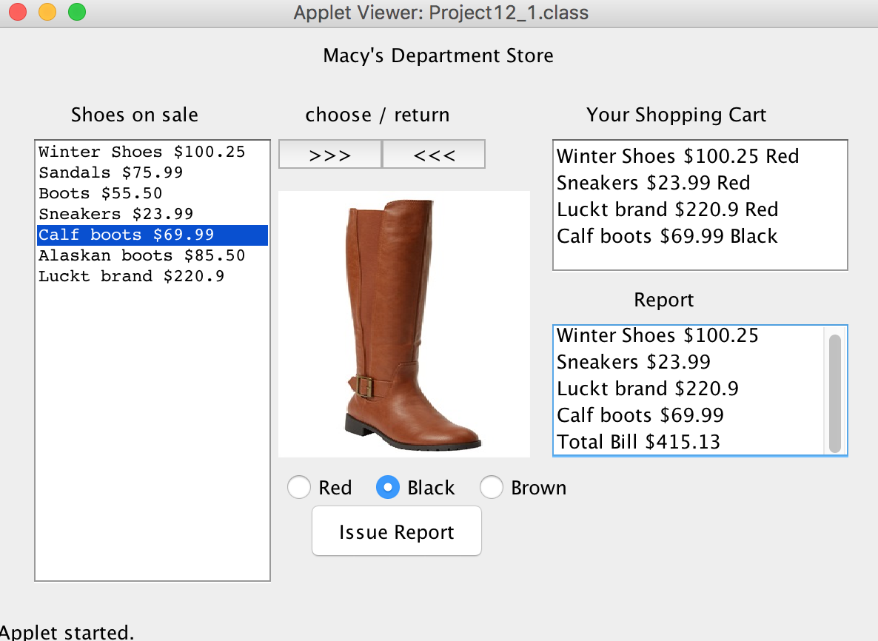

Output2:

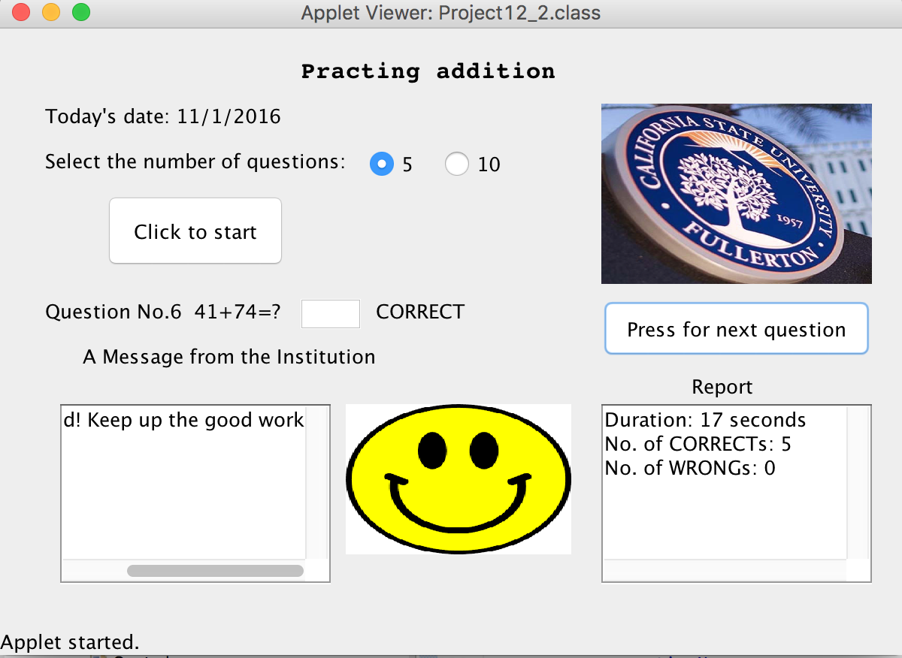

Output3:

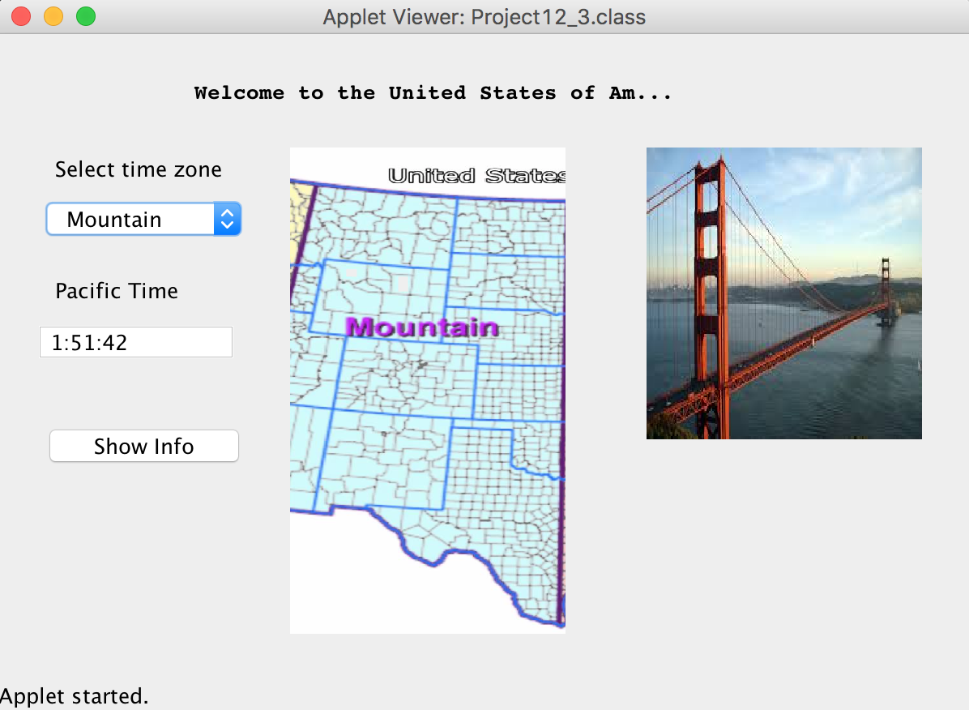

Output4:

