Project9_1:

import java.awt.*;

import javax.swing.*;

public class Project9_1 {

public static void main(String[] args){

JFrame frame = new JFrame("Project9_1");

frame.setSize(500,300);

frame.setLocation(0,0);

frame.setVisible(true);;

Container cPane = frame.getContentPane();

Graphics g = cPane.getGraphics();

g.drawString("Geometric Shapes", 200, 20);

g.drawLine(250, 25, 250, 50);

// second horizontal line

g.drawLine(150, 50, 350, 50);

// line above polygons

g.drawLine(150, 50, 150, 90);

g.drawString("Polygons", 125, 100);

// line above Ovals

g.drawLine(350, 50, 350, 90);

g.drawString("Ovals", 340, 100);

// third level height

int height = 25;

// polygons

g.drawLine(150, 110, 150, 110+height+25);

// horizontal

g.drawLine(50, 135, 250, 135);

// vertical

g.drawLine(50, 135, 50, 135+height);

g.drawLine(250, 135, 250, 135+height);

// polygons rect:(50,135+height), tri:(150,135+height), ti:(250,135+height)

//rect

//g.setColor(Color.black);

//g.drawRect(10, 135+height, 80, 40);

g.setColor(Color.gray);

g.fillRect(10, 135+height, 80, 40);

// tri

int[] x = {150, 130, 170};

int[] y = {135+height, 135+height+40, 135+height+40};

g.fillPolygon(x, y, 3);

// ti

int[] x_ti = {230,270,280,220};

int[] y_ti = {135+height,135+height,135+height+40,135+height+40};

g.fillPolygon(x_ti,y_ti,4);

g.drawLine(350, 110, 350, 110+height);

// horizontal

g.drawLine(300, 135, 400, 135);

// vertical

g.drawLine(300, 135, 300, 135+height);

g.drawLine(400, 135, 400, 135+height);

// circle:(290,135+height,height,height)

g.fillOval(280, 135+height, 40, 40);

// Oval

g.fillOval(360, 135+height, 80, 40);

}

}

Output:

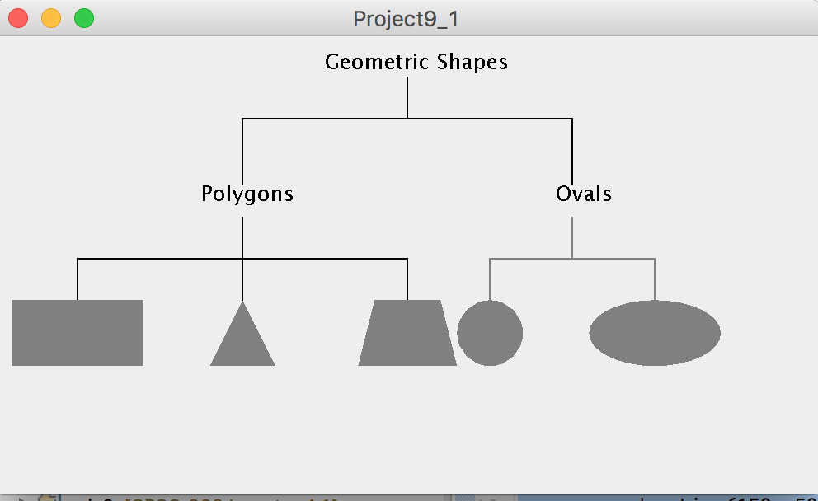

Project9_2:

import java.awt.Color;

import java.awt.Container;

import java.awt.Graphics;

import java.io.IOException;

import java.util.concurrent.TimeUnit;

import javax.swing.JFrame;

import javax.swing.JOptionPane;

import javax.swing.SwingUtilities;

public class Project9_2 {

public static void main(String[] args){

JFrame frame = new JFrame("Project9_2");

frame.setSize(500, 500);

frame.setLocation(0,0);

//frame.pack();

frame.setVisible(true);

frame.setDefaultCloseOperation(JFrame.EXIT_ON_CLOSE);

Container cPane = frame.getContentPane();

Graphics g = cPane.getGraphics();

String option;

int width = (int)cPane.getSize().getWidth();

int height = (int)cPane.getSize().getHeight();

do{

displayMenu(g);

try {

TimeUnit.SECONDS.sleep(1);

} catch (InterruptedException e) {

// TODO Auto-generated catch block

e.printStackTrace();

}

option = JOptionPane.showInputDialog("Enter your menu option");

//Ellipse(g);

g.clearRect(0, 0 ,width,height);

switch(option){

case("a"): Trangles(g);break;

case("b"):Ellipse(g); break;

case("c"): Polygons(g); break;

default: break;

}

try {

TimeUnit.SECONDS.sleep(1);

} catch (InterruptedException e) {

// TODO Auto-generated catch block

e.printStackTrace();

}

option = JOptionPane.showInputDialog("Continue(y/n)");

g.clearRect(0, 0, width, height);

}while(option.equals("Y") || option.equals("y"));

}

static void displayMenu(Graphics g){

g.drawString("---------------Menu-------------",10,20);

g.drawString("a. Compute the area of triangles",10,35);

g.drawString("b. Compute the area of ellipse",10,50);

g.drawString("c. Compute the area of polygons",10,65);

}

// area of Trangles=1/2(x1(y2-y3)+x2(y3-y1)+x3(y1-y2));

static void Trangles(Graphics g){

g.drawString("Press enter trangles info", 10, 20);

int[] x = {20,80,140};

int[] y = {100,50,100};

g.setColor(Color.DARK_GRAY);

g.fillPolygon(x, y, 3);

double abs = (x[0]-x[2])*(y[2]-y[0])-(x[0]-x[1])*(y[2]-y[0]);

g.drawString("Area = |(xA−xC)(yB−yA)−(xA−xB)(yC−yA)|/2 = " + Math.abs(abs)/2 ,20,200);

}

static void Polygons(Graphics g){

int num = 5;//Integer.parseInt(JOptionPane.showInputDialog("How many edges?"));

int[] x = {20,50,90,120,60};

int[] y = {50,100,100,50,30};

g.setColor(Color.BLACK);

g.fillPolygon(x,y,num);

double abs = 0;

for(int i=0; i<num-1; i++){

int j=i+1;

if (j>num) j=0;

abs += x[i]*y[j]-x[j]*y[i];

}

g.drawString("Area = |(xA−xC)(yB−yA)−(xA−xB)(yC−yA)|/2 = " + Math.abs(abs)/2 ,20,200);

}

static void Ellipse(Graphics g) {

g.drawString("Press enter ellipse info", 10, 20);

int major = Integer.parseInt(JOptionPane.showInputDialog("What is the length of major axis?"));

int minor = Integer.parseInt(JOptionPane.showInputDialog("What is the length of minor axis?"));

g.setColor(Color.DARK_GRAY);

g.fillOval(20, 50, major, minor);

g.drawString("Major axis = " + major, 20,50+minor+20);

g.drawString("Minor axis = " + minor, 20,50+minor+50);

g.drawString("Area = pi*(major/2)*(minor/2) = " + Math.PI*major*minor/4, 20, 50+minor+70);

}

}

Output:

