Author: Eric Simmons, Yijie Sun

Due day: Saturday, December 17, 11:55 pm

The input: number of rows, number of cols, the matrix (which is a N*N matrix, row is equal to cols) The file name should be matrix.txt

Example:

5 5

1 2 4 8 4

3 4 4 0 32

5 6 5 23 1

3 3 4 5 0

2 9 8 5 2

The output: The transposed matrix

How to run:

mpicc -o project2 ./project2_scatter.c

mpirun –n <number of process> ./project2

The number of process must be greater than or equal to the number of rows

// author: Eric Simmons, Yijie Sun

// Project: Transpose a m*m dense matrix parallely using MPI

// input: text file with the number of row and col, the original matrix followed by the matrix body

// output: the transposed matrix

#include <stdio.h>

#include <stdlib.h>

#include <mpi.h>

int main(int argc, char **argv) {

//declare variables

int myrank, nprocs;

int nrow, ncol;

//open file and read the number of columns and rows

FILE* fp;

fp = fopen("matrix.txt", "r+");

fscanf(fp,"%d %d", &nrow, &ncol);

//create 2 dynamic arrays that are contigeous in memory

int (*matrix)[nrow];

int (*result)[ncol];

if(myrank == 0){

matrix = malloc(ncol * sizeof(*matrix));

for(int i = 0; i<nrow; i++){

for(int j = 0; j<ncol; j++){

fscanf(fp,"%d", &matrix[i][j]);

}

}

result = malloc(nrow * sizeof(*result));

}

fclose(fp);

//initalize MPI environment

MPI_Init(NULL,NULL);

MPI_Comm_rank(MPI_COMM_WORLD,&myrank);

MPI_Comm_size(MPI_COMM_WORLD,&nprocs);

// If there are not enough processes exit the program

if(nrow > nprocs)

{

MPI_Finalize();

if(myrank ==0)

printf("Number of processes need to be >= %d\n", nrow);

exit(0);

}

//create new communicator. If number of processes is greater than the matrix size split the communicator into two groups

//if the process = matrix size just set the new communicator = to MPI_COMM_WORLD

MPI_Comm newworld;

int color;

if(nprocs > nrow){

color = myrank<nrow?0:1;

MPI_Comm_split(MPI_COMM_WORLD, color, myrank, &newworld);

}else{

newworld = MPI_COMM_WORLD;

}

//reinitalize MPI environment

int row_rank, row_size;

MPI_Comm_rank(newworld, &row_rank);

MPI_Comm_size(newworld, &row_size);

//process 0 prints out the original matrix

if(myrank == 0){

printf("\n Ori: \n");

for(int i =0; i< ncol; i++){

for(int j=0;j<nrow; j++){

printf("%d ", matrix[i][j]);

}

printf("\n");

}

}

//create matrix buffers

int local_row[ncol];

int local_new_row[nrow];

//MPI_Barrier(newworld);

//scatter and reorganize the matrix

MPI_Scatter(&matrix[row_rank], ncol, MPI_INT, &local_row, ncol, MPI_INT, 0, newworld);

//MPI_Barrier(MPI_COMM_WORLD);

/*printf("Rank: %d\n", myrank);

for(int j = 0; j<ncol; j++){

printf("%d ", local_row[j]);

}

printf("\n");*/

free(matrix);

MPI_Alltoall(&local_row, 1, MPI_INT, &local_new_row, 1, MPI_INT, newworld);

/*

printf("Rank: %d\n", myrank);

for(int j = 0; j<ncol; j++){

printf("%d ", local_new_row[j]);

}*/

MPI_Gather(&local_new_row, ncol, MPI_INT, &result[row_rank], ncol, MPI_INT, 0, newworld);

//print out transposed matrix

if(myrank == 0){

printf("\n Result: \n");

for(int i =0; i< ncol; i++){

for(int j=0;j<nrow; j++){

printf("%d ", result[i][j]);

}

printf("\n");

}

}

if(nprocs > nrow){

MPI_Comm_free(&newworld);

}

free(result);

MPI_Finalize();

return 0;

}

The output screenshot:

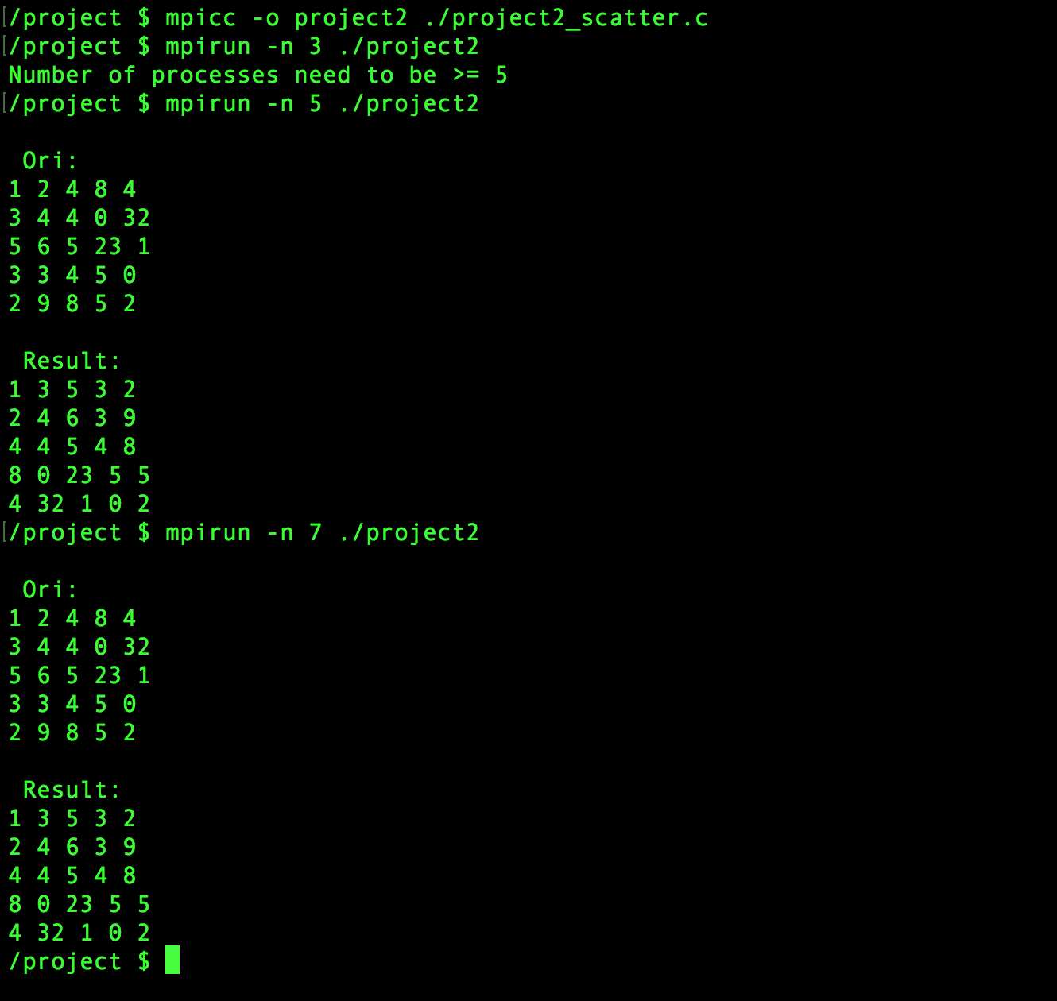

matrix.txt:

