Tuple: cannot change the element in the tuple

Tuple_1=(1,2,’abc’)

List: can change the elements in the list

List_1=[1,2,’abc’]

Change the element:

List_1[2]=’different’

List_1=[1,2,’different’]

List.append(x) – add an item (x) to the end of the list

List.pop() – remove the last item

List.pop(1) – remove the item at index 1

Function

If you change a variable in the function, it didn’t change the value of that variable if you not assign the value to the variable

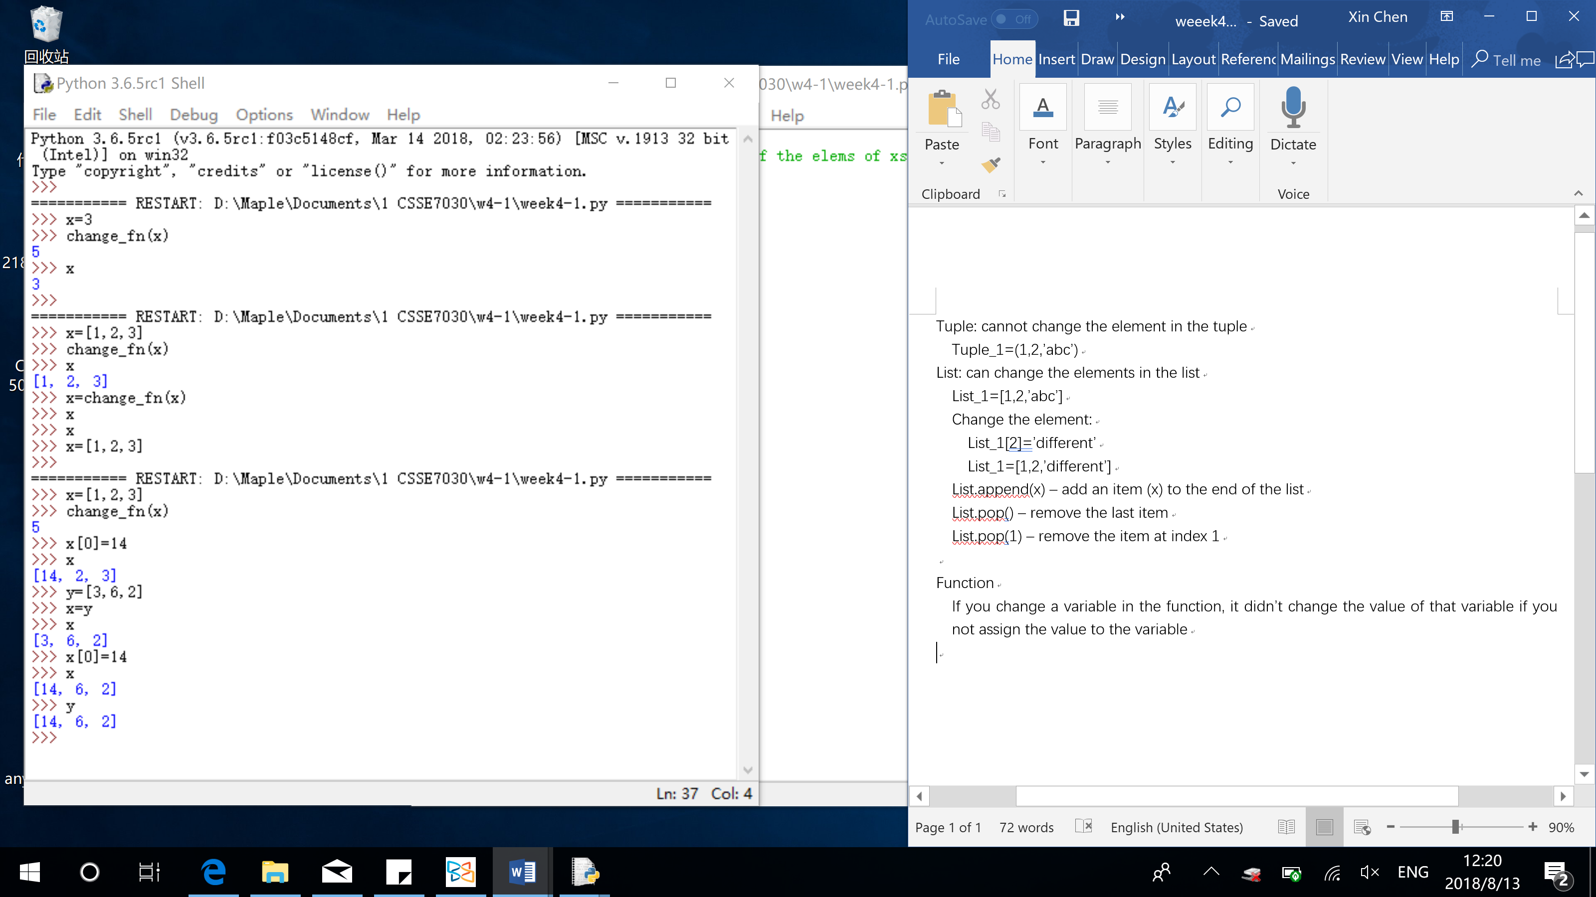

Python treat x and y as the same object

Ways to not doing that (x change BUT y not change):

