Use dictionary to do:

* Edit
* Tide

Sorted

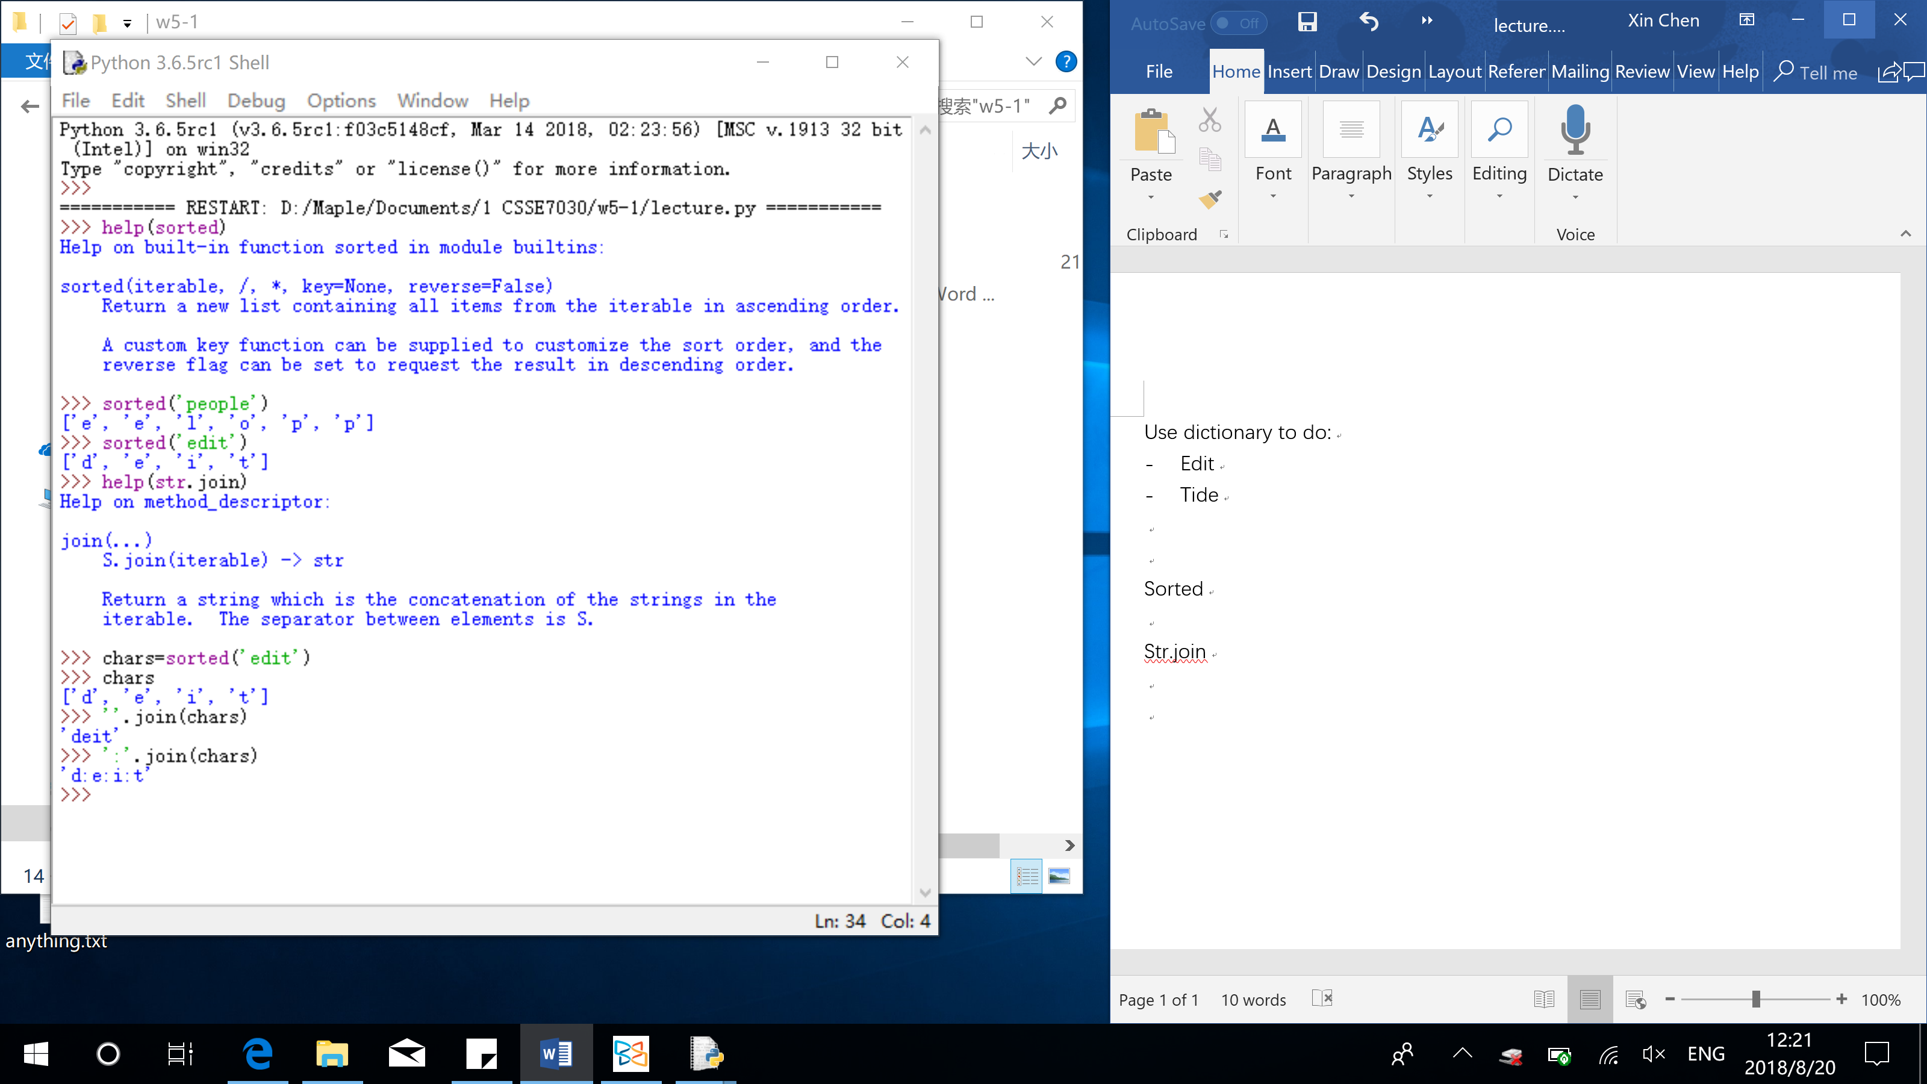

Difference between sort_string (alphabetly order the word and put it into a word) & sorted (alphabetly order each character in the word and put it into a list):

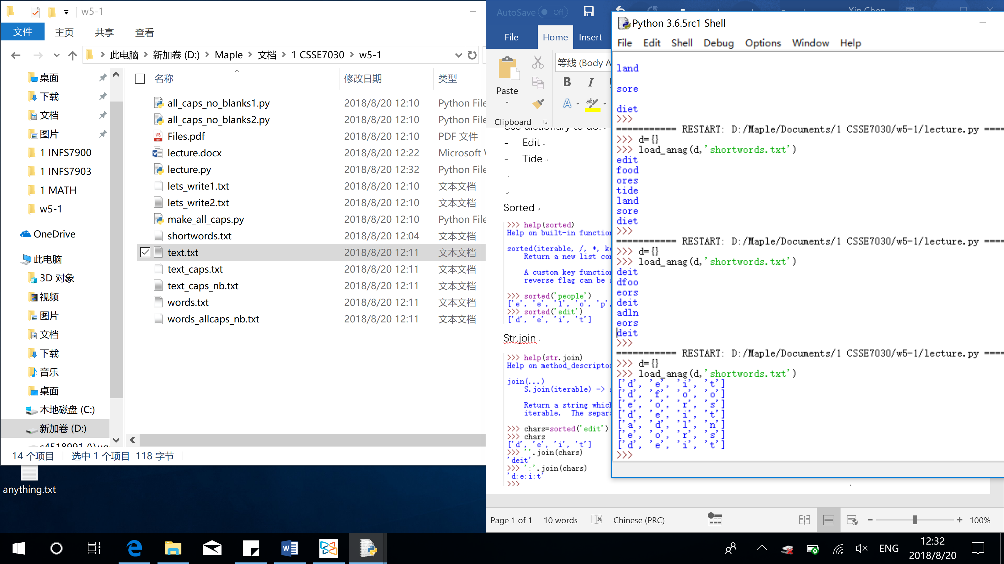

Str.join



Bool()

Return True or False

If empty, return False

