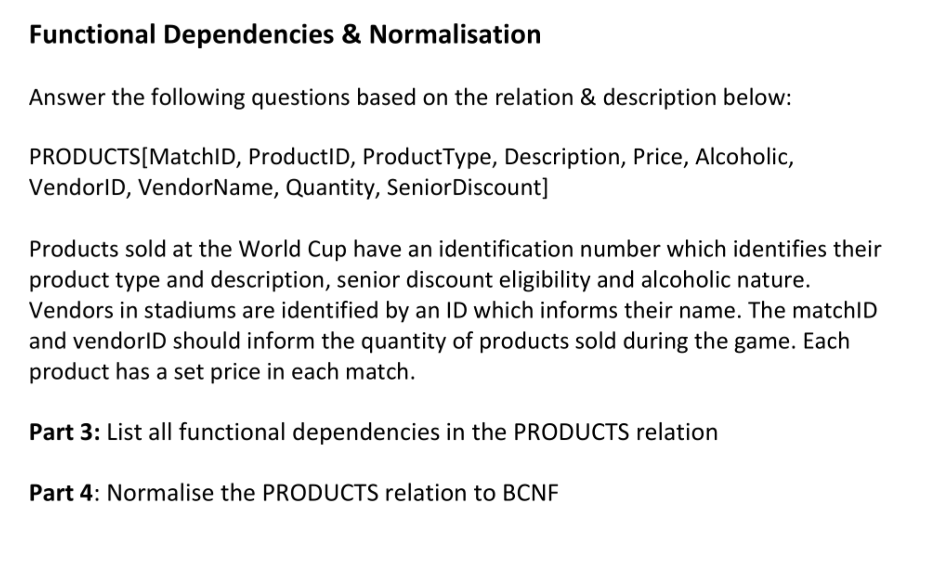

FD1: ProductID 🡪 {ProductType, Description, SeniorDiscount, Alcoholic}

FD2: VendorID 🡪 VendorName

FD3: {MatchID, VendorID} 🡪 Quantity

FD4: {ProductID, MatchID} 🡪 Price

BCNF:

Candidate Key: {ProductID, VendorID, MatchID}

ProductID 🡪 {ProductType, Description, SeniorDiscount, Alcoholic} violates BCNF

So decompose,

R1[ProductID, ProductType, Description, SeniorDiscount, Alcoholic]

R2[MatchID, ProductID, Price, VendorID, VendorName, Quantity]

VendorID 🡪 VendorName violates BCNF in R2

So decompose,

R3[VendorID, VendorName]

R4[MatchID, ProductID, Price, VendorID, Quantity]

{MatchID, VendorID} 🡪 Quantity violates BCNF in R4

So decompose,

R5[MatchID, VendorID, Quantity]

R6[MatchID, ProductID, Price, VendorID]

{ProductID, MatchID} 🡪 Price violates BCNF in R6

So decompose,

R7[MatchID, ProductID, Price]

R8[MatchID, ProductID, VendorID]

Final Result:

R1[ProductID, ProductType, Description, SeniorDiscount, Alcoholic]

FD1: ProductID 🡪 {ProductType, Description, SeniorDiscount, Alcoholic}

R3[VendorID, VendorName]

FD2: VendorID 🡪 VendorName

R5[MatchID, VendorID, Quantity]

FD3: {MatchID, VendorID} 🡪 Quantity

R7[MatchID, ProductID, Price]

FD4: {ProductID, MatchID} 🡪 Price

R8[MatchID, ProductID, VendorID]

Non-trivial FD

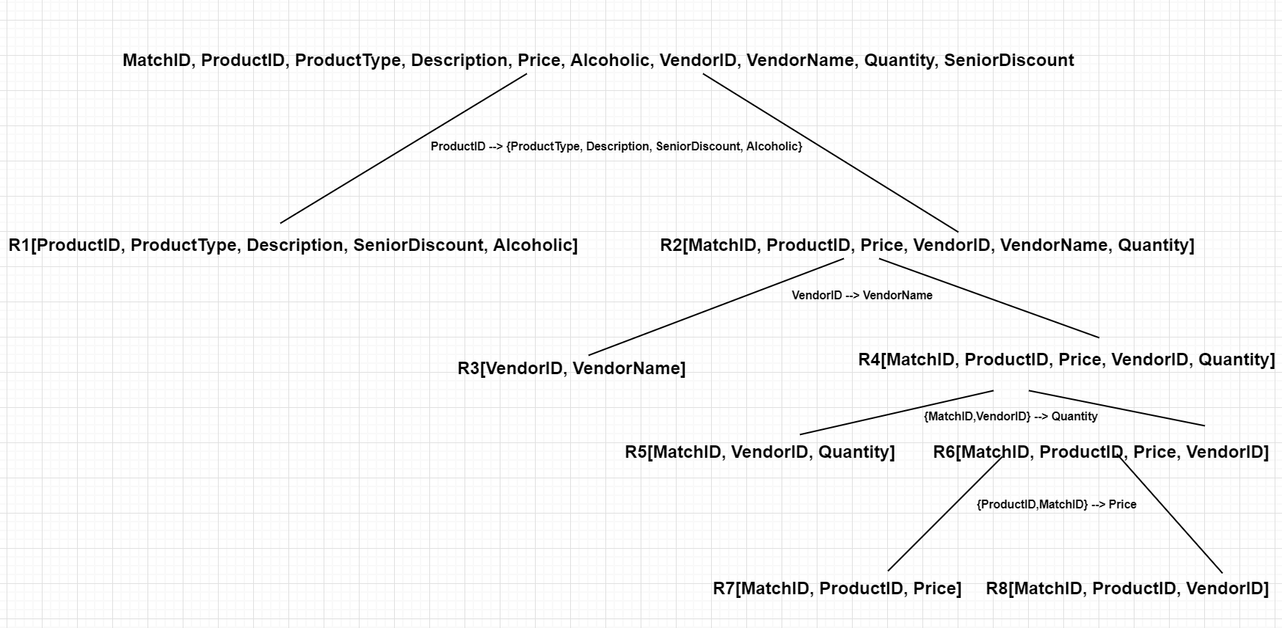

Tournament[Year, HostCountry]

Country[CountryName, Population, Year]

Team[TeamName, CountryName]

Customer[PassportID, Name, EmailAddr, Nationality]

Member[MemberID, MemberName, TeamName]

Player[PlayerID, Club]

Manager[ManagerID]

SupportStaff[SupportStaffID]

Match[Year, Venue, Date, Time, Team1_Name, Team2_Name]

Pool[Year, Venue, Date, Time]

Elimination[Year, Venue, Date, Time, Penalty Shoot-out score]

Save_goal[Year, Venue, Date, Time, PlayerID, SaveTime]

Score_goal[Year, Venue, Date, Time, PlayerID, ScoreTime]

PhoneNumbers[PassportID, PhoneNumbers]

Has_ticket[Year, Venue, Date, Time, PassportID, Price]

Foreign keys:

Player.PlayerID 🡪 Member.MemberID

Manager.ManagerID 🡪 Member.MemberID

SupportStaff.SupportStaffID 🡪 Member.MemberID

Match.Year 🡪 Tournament.Year

Pool.{Year, Venue, Date, Time} 🡪 Match.{Year, Venue, Date, Time}

Elimination.{Year, Venue, Date, Time} 🡪 Match.{Year, Venue, Date, Time}

Country.Year 🡪 Tournament.Year

Member.TeamName 🡪 Team.TeamName

Team.CountryName 🡪 Country.CountryName

Match.Team1_Name 🡪 Team.TeamName

Match.Team2_Name 🡪 Team.TeamName

Save_goal.{Year, Venue, Date, Time} 🡪 Match.{Year, Venue, Date, Time}

Save_goal.PlayerID 🡪 Player.PlayerID

Score_goal.{Year, Venue, Date, Time} 🡪 Match.{Year, Venue, Date, Time}

Score_goal.PlayerID 🡪 Player.PlayerID

PhoneNumbers.PassportID 🡪 Customer.PassportID

Has_ticket.{Year, Venue, Date, Time} 🡪 Match.{Year, Venue, Date, Time}

Has_ticket.PassportID 🡪 Cutomer.PassportID