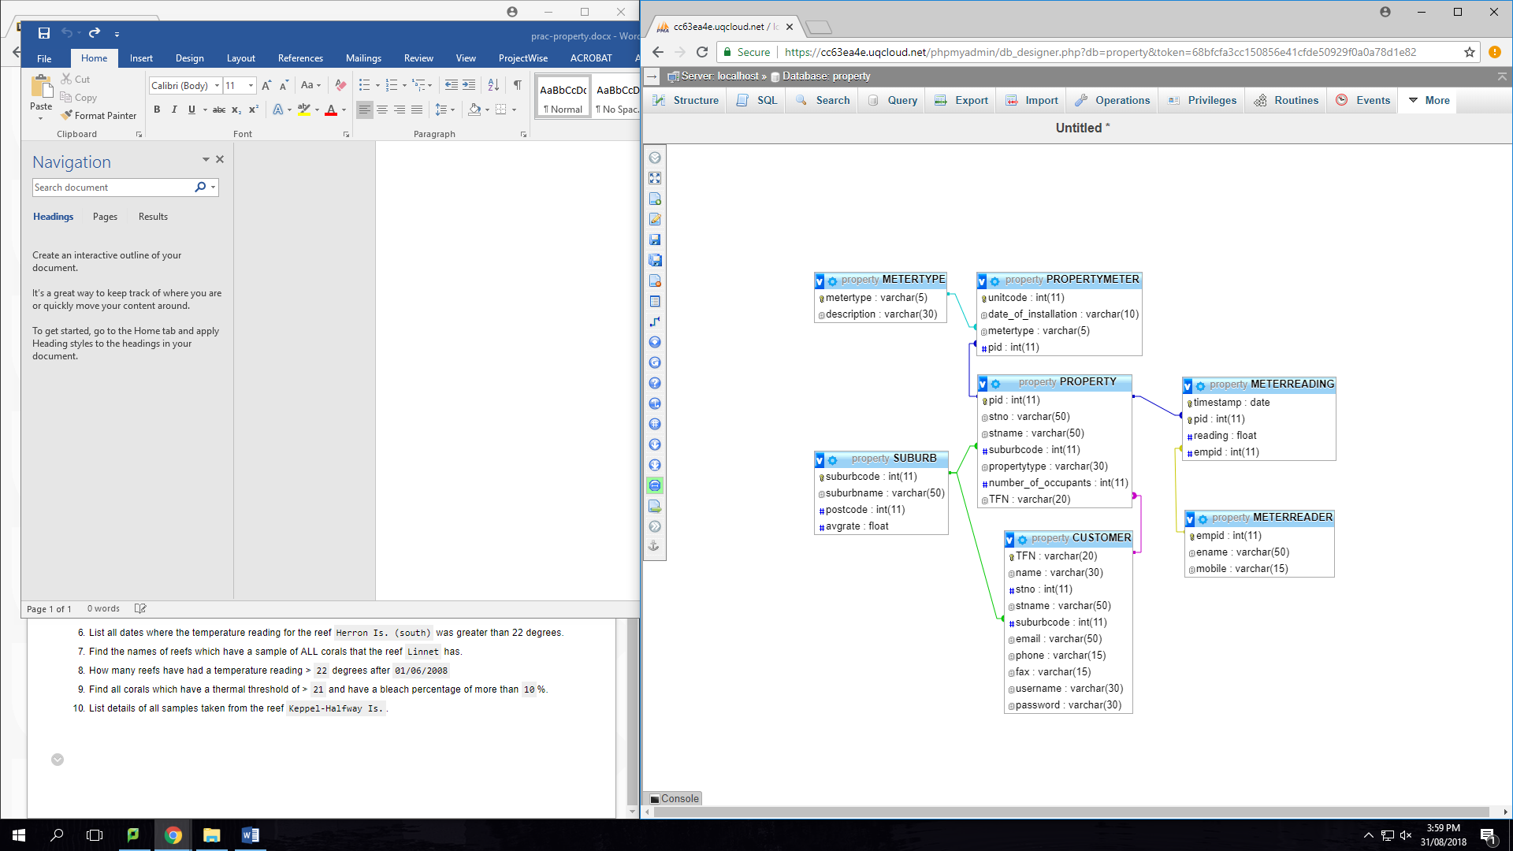

**Practicing queries for the property database**

1. List the names of all suburbs that have an average rate < 2.9

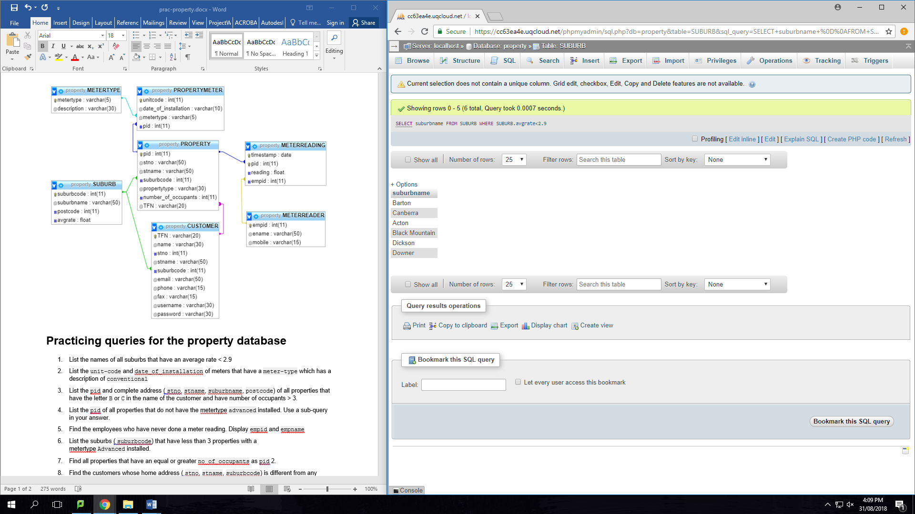

1. List the unit-code and date_of_installation of meters that have a meter-type which has a description of conventional

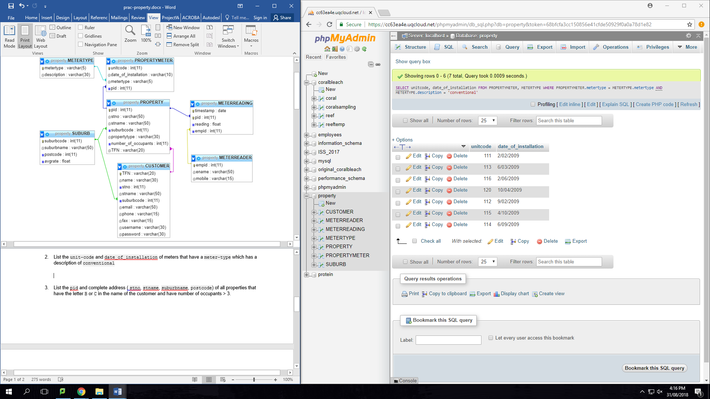

1. List the pid and complete address ( stno, stname, suburbname, postcode) of all properties that have the letter B or C in the name of the customer and have number of occupants > 3.

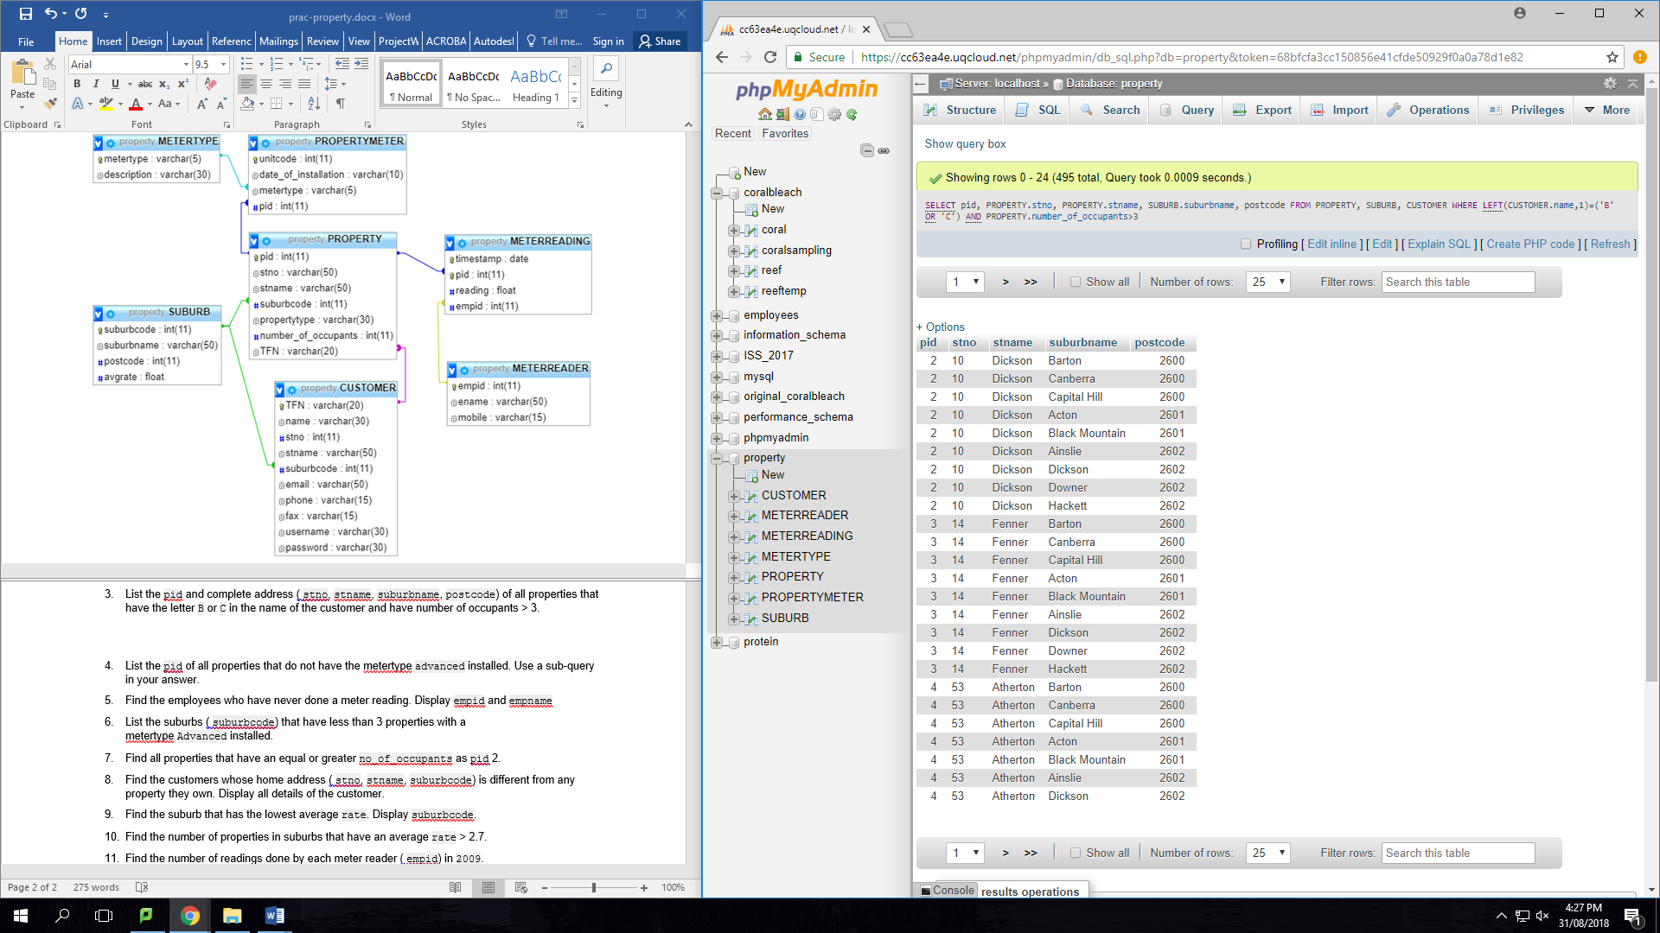

1. List the pid of all properties that do not have the metertype advanced installed. Use a sub-query in your answer.

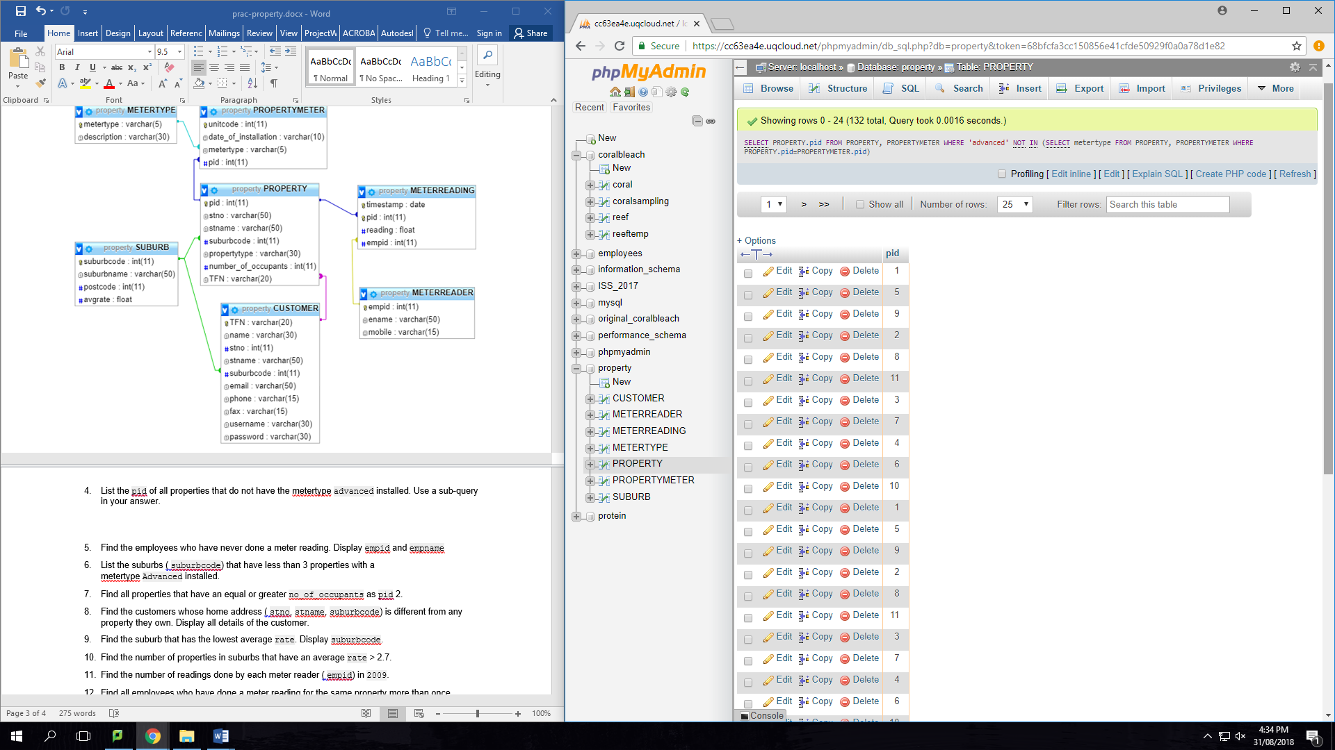

1. Find the employees who have never done a meter reading. Display empid and empname

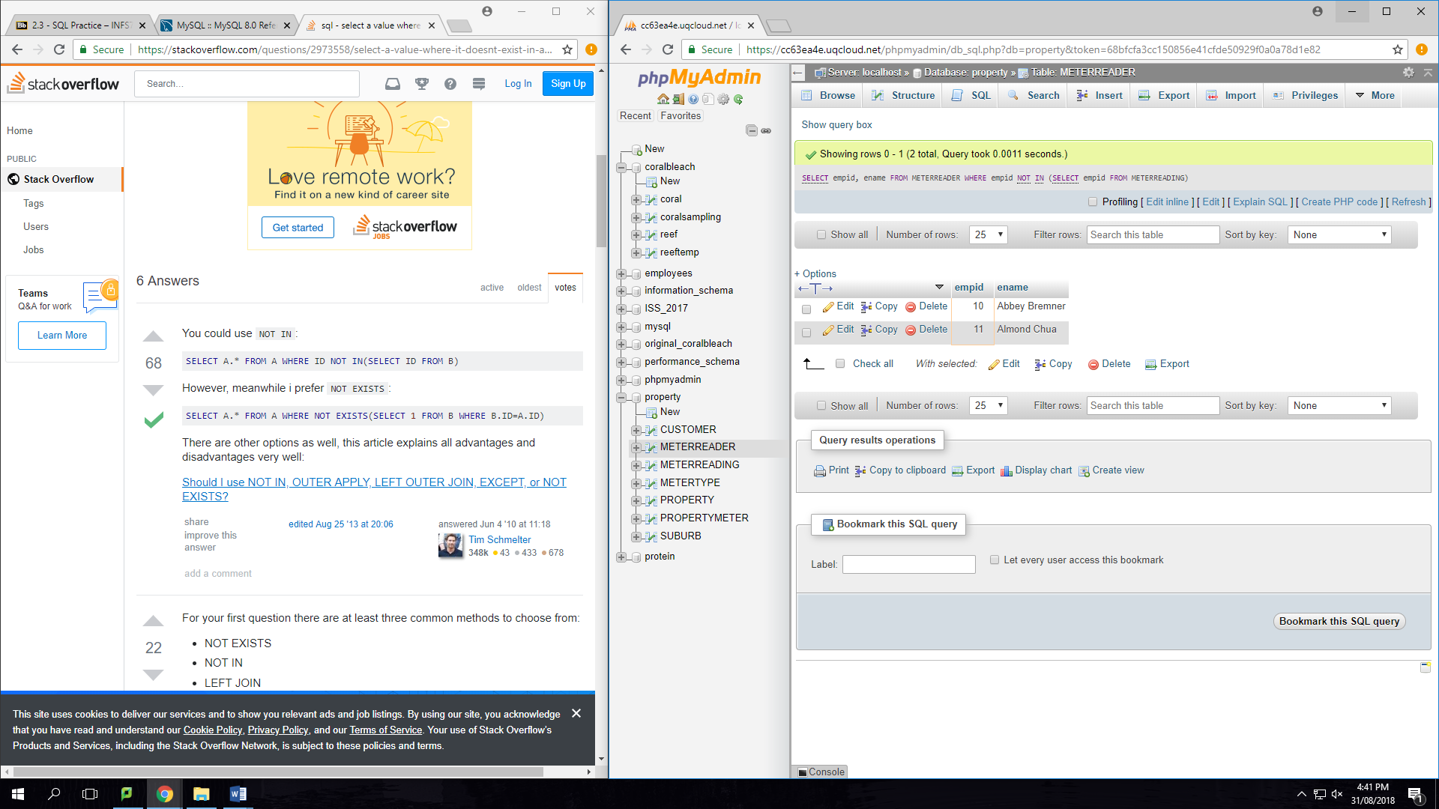

1. List the suburbs ( suburbcode) that have less than 3 properties with a metertype Advanced installed.

SELECT SUBURB.suburbcode

FROM SUBURB

WHERE SUBURB.suburbcode=PROPERTY.suburbcode AND PROPERTY.pid=PROPERTYMETER.pid

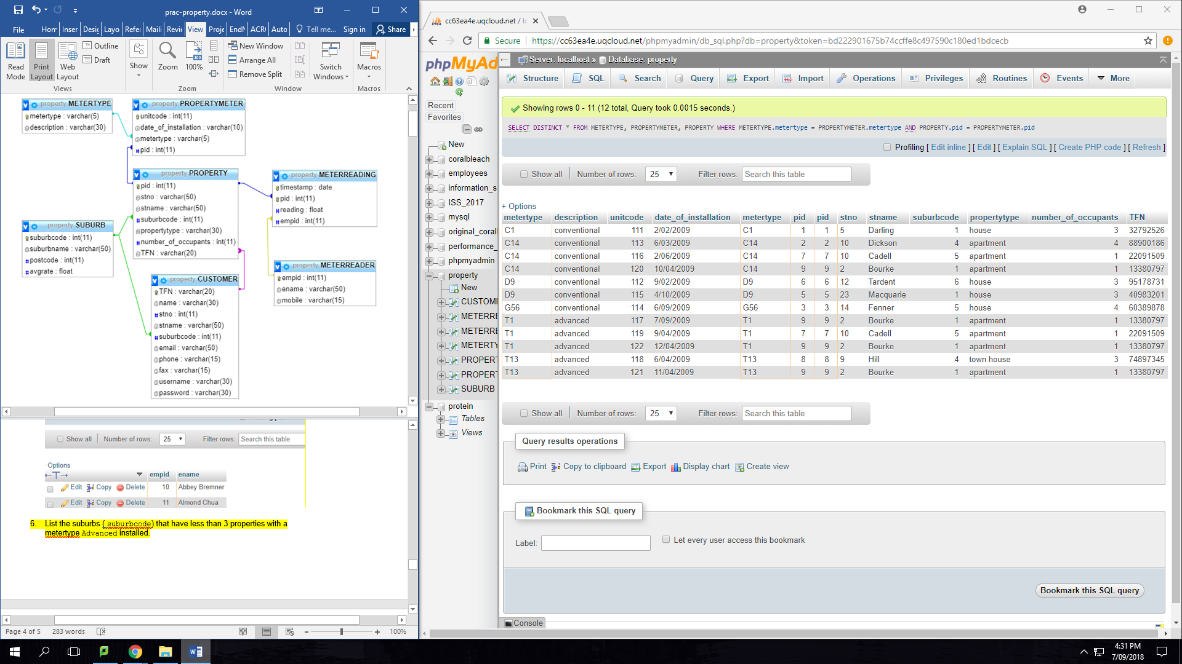

1. Find all properties that have an equal or greater no_of_occupants as pid 2.

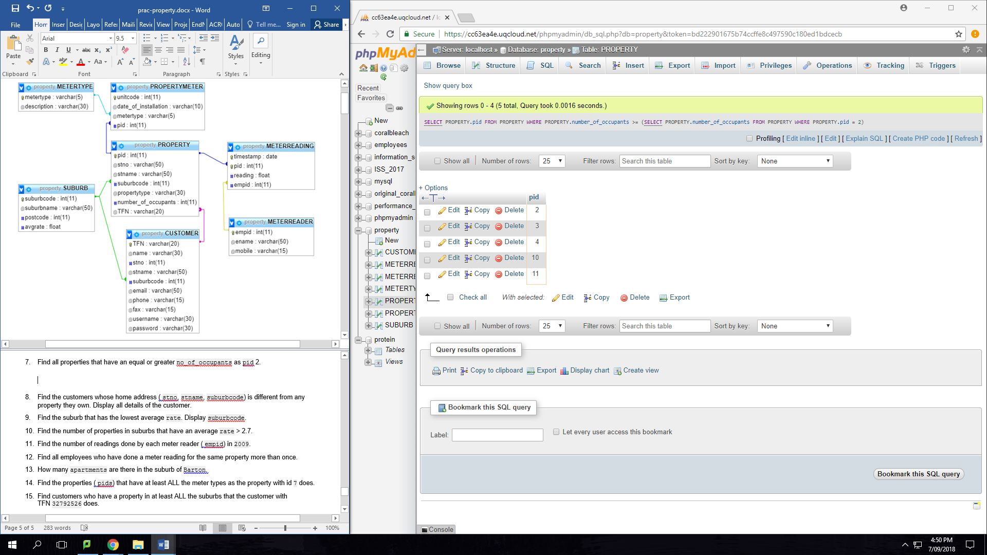

1. Find the customers whose home address ( stno, stname, suburbcode) is different from any property they own. Display all details of the customer.
2. Find the suburb that has the lowest average rate. Display suburbcode.
3. Find the number of properties in suburbs that have an average rate > 2.7.
4. Find the number of readings done by each meter reader ( empid) in 2009.
5. Find all employees who have done a meter reading for the same property more than once.
6. How many apartments are there in the suburb of Barton.
7. Find the properties ( pids) that have at least ALL the meter types as the property with id 7 does.
8. Find customers who have a property in at least ALL the suburbs that the customer with TFN 32792526 does.