Prerequisite

1.Third party dependencies

Since this is a server-client architecture, there are
five third party libraries needed as belows:
(1)tornado – for server side (support restful api)
(2)pandas – for server side(read from database and do the statistics summary)
(3)sqlalchemy – for server side(connent, read, write to database)
(4)requests – for client side(request data from server side)

On Windows:

(1)To install the third party libraries globally make sure Administrator Access obtained and run:
python3 setup.py install

On Linux and Mac:

(1)activate a virtual python3 environment through virtualenv, then run:
python3 setup.py install

a. Please start the server first by:
python3 server.py

b.Then run the client by:
python3 a3.py

c.(optinal) there is a one-step script that starts the sever and client which is the start.py, simply run:
python3 start.py

2.The restful apis for server are as below:

(1) URL:/data
METHOD: GET
URL Params:
Required:
question_type[str]
example: question_type=’quick’
(2) URL:/accept
METHOD: POST
Data Params:
Require:
question_type[str]
name[str]
example:
{
question_type:’quick’,
name:’Leslie’
}
(3)URL:/cancel
METHOD:POST
Data Params:
Required:
quetion_type[str]
name[str]
example:
{
question_type:’quick’,
name:’Leslie’
}
(4)URL:/submit
METHOD:POST
Data Params:
Required:
name[‘str’]
content[‘str’]
question_type[‘str’]
example:
{
name:’Leslie’,
content: ‘MyPytutor’,
question_type:’long’,
}
(5)URL:/statistics
METHOD:POST
Data Params:
Required:
question_type[‘str’]
example
{
question_type: ‘long’
}

3.Use the sqlite3 as the backend database with 2 tables

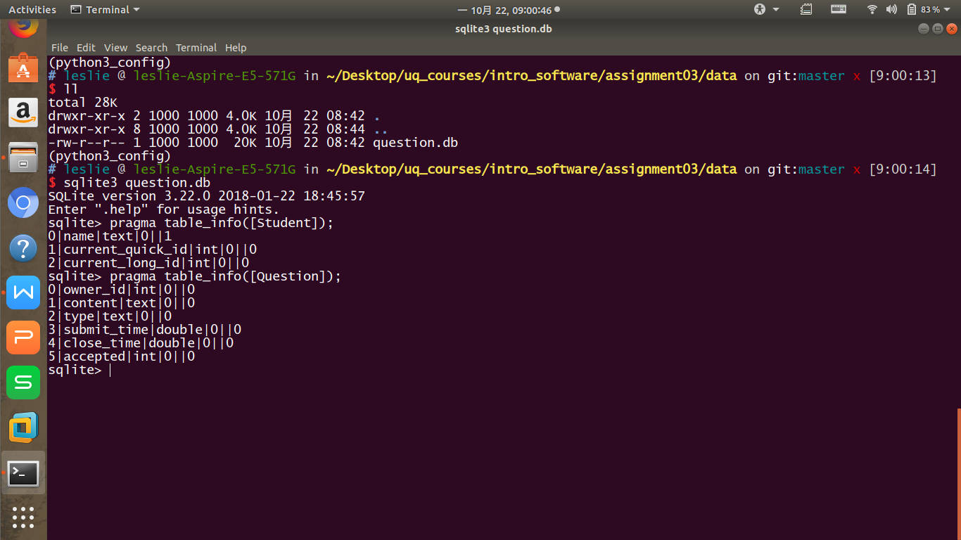
Table Student:

name: str, to store the student name
current_quick_id: int, null if student is currently not request for a question, otherwise it would be the rowid of the Question table
current_long_id:int, null if student is currently not request for a question, otherwise it would be the rowid of the Question table

Table Question:

owner_id: int, the rowid of the Student Table, indicates which Student owns this Question
content: str, the content of the question
type:str, question type, either quick or long
submit_time: double the timestamp when Student submit this question
close_time: double the timestamp when this question is accepted, if the question is canceled,
the value will be null
accept: int 0 or 1 when the value is 0 it means this question not yet been accepted it could either be this question is still waiting or been cancel.
If close_time is null and accepted is 0, it means this question is still waiting on request.
If the close_time is not null and accepted is 0, it means this question has been canceled.
If accepted is 1, it means this question has been accepted.

3.Testing restful api examples

(1) /data

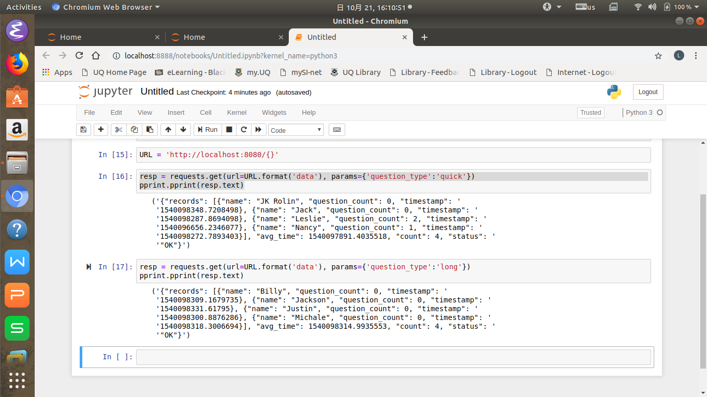

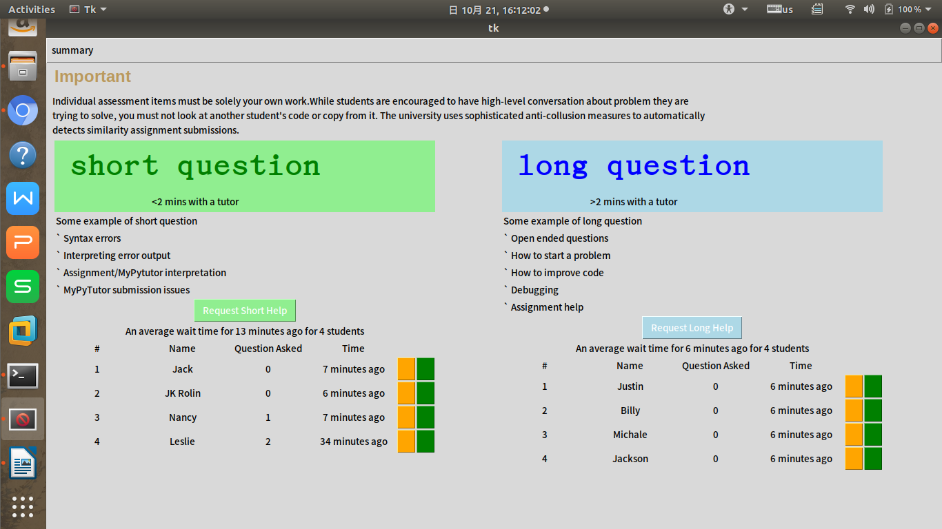

(2)/statistics
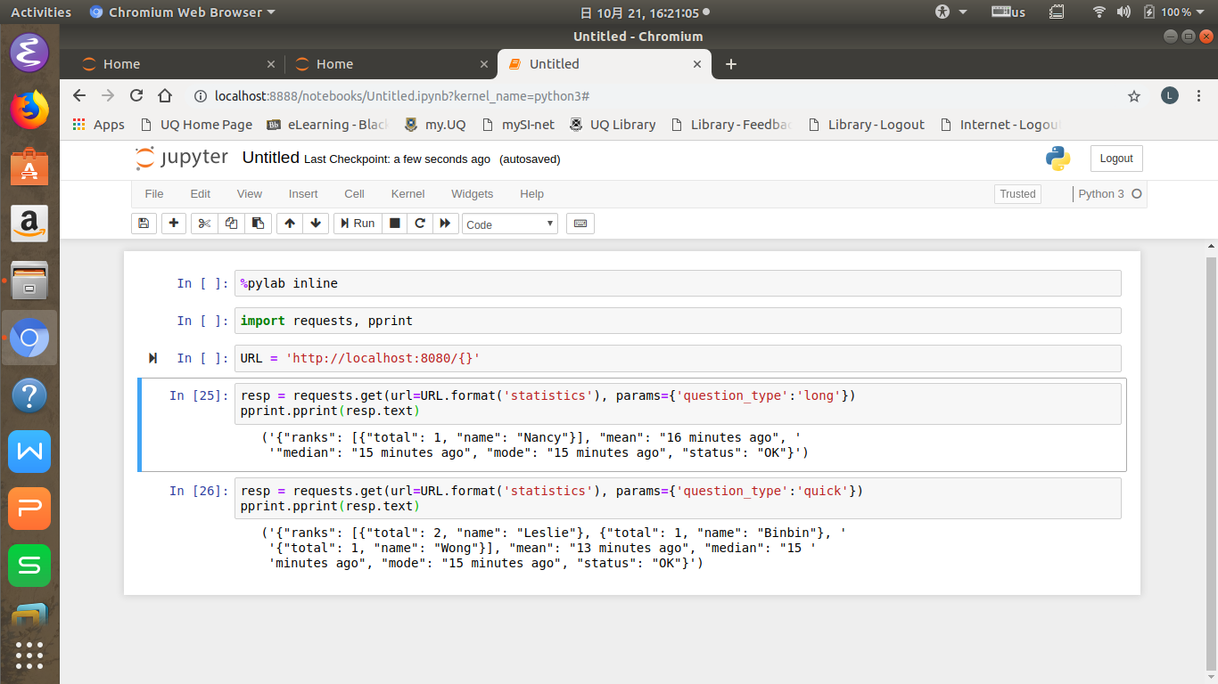
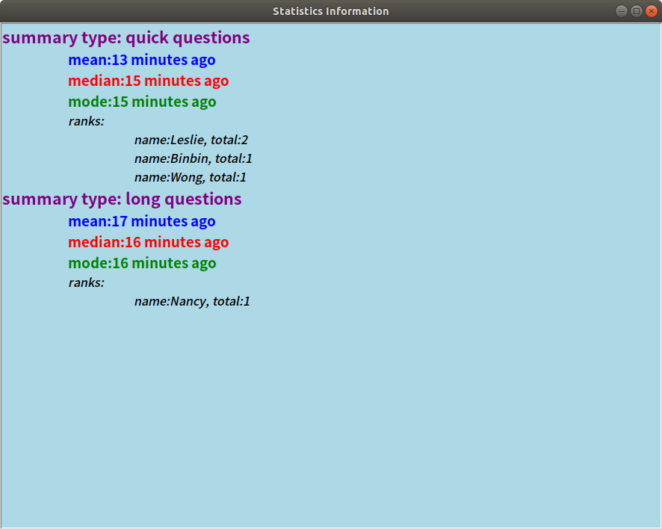

(3)/submit
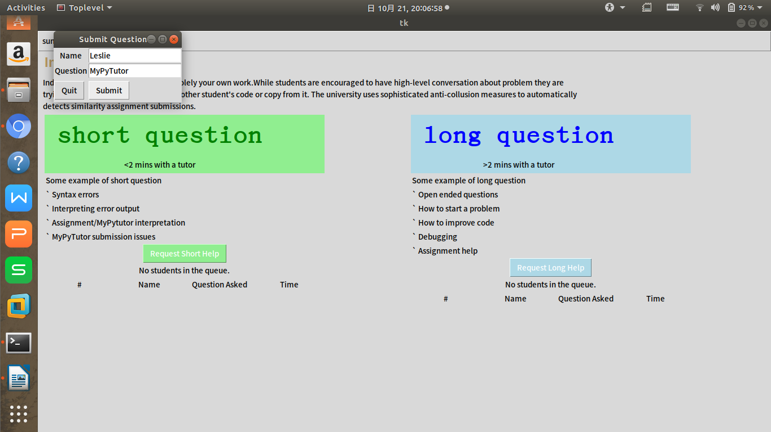
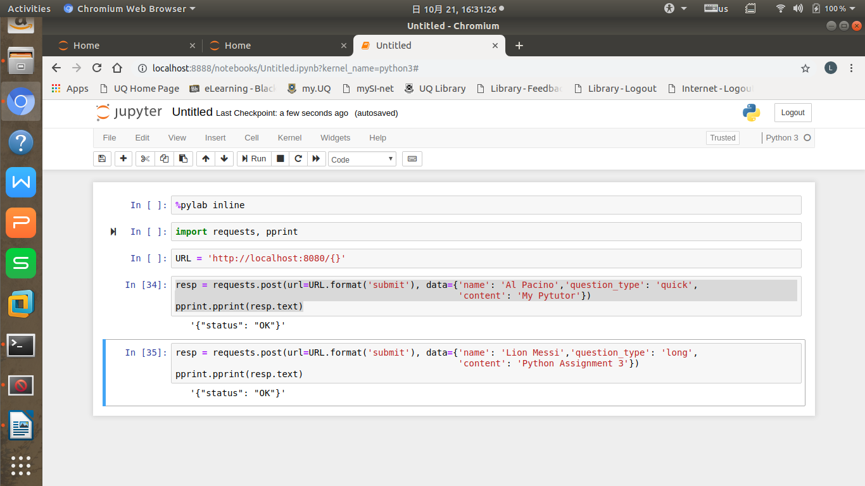
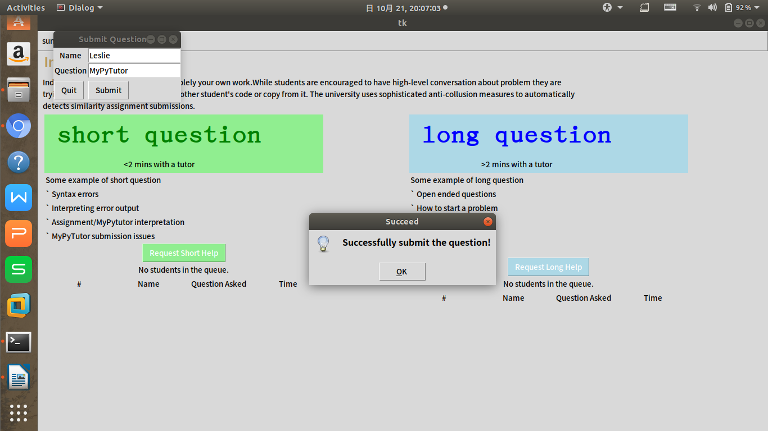
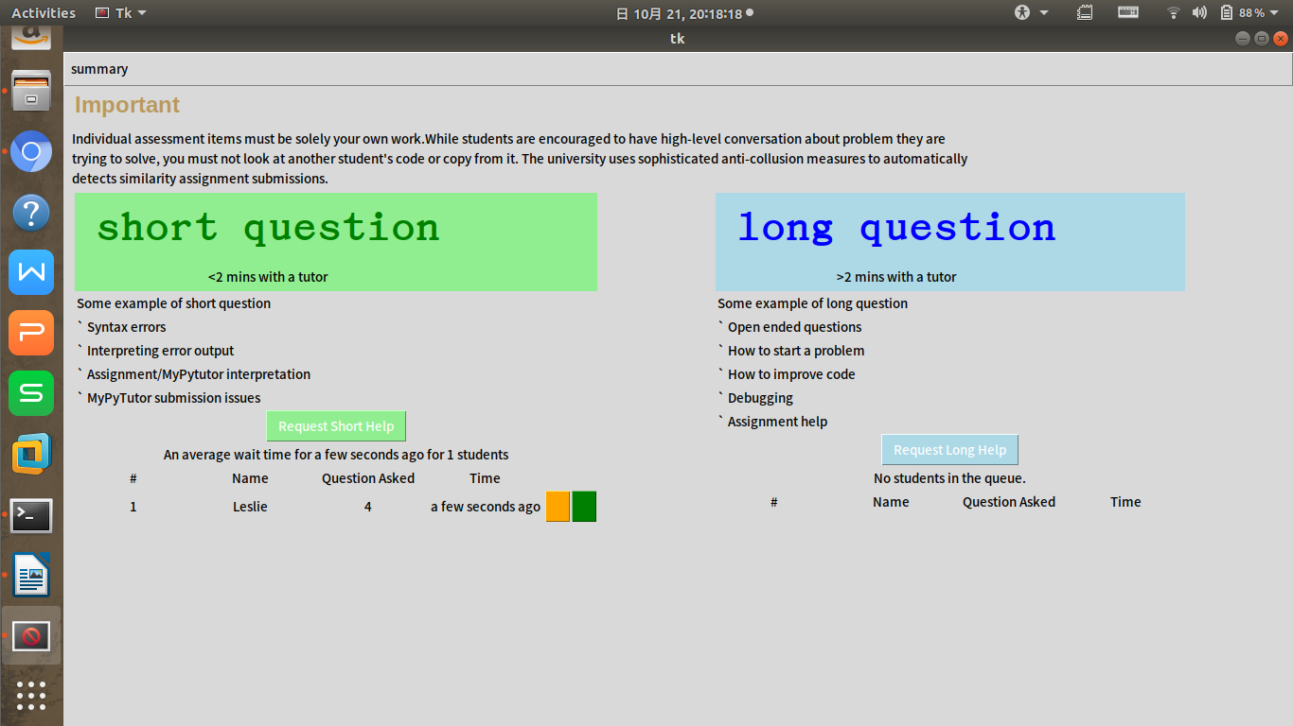
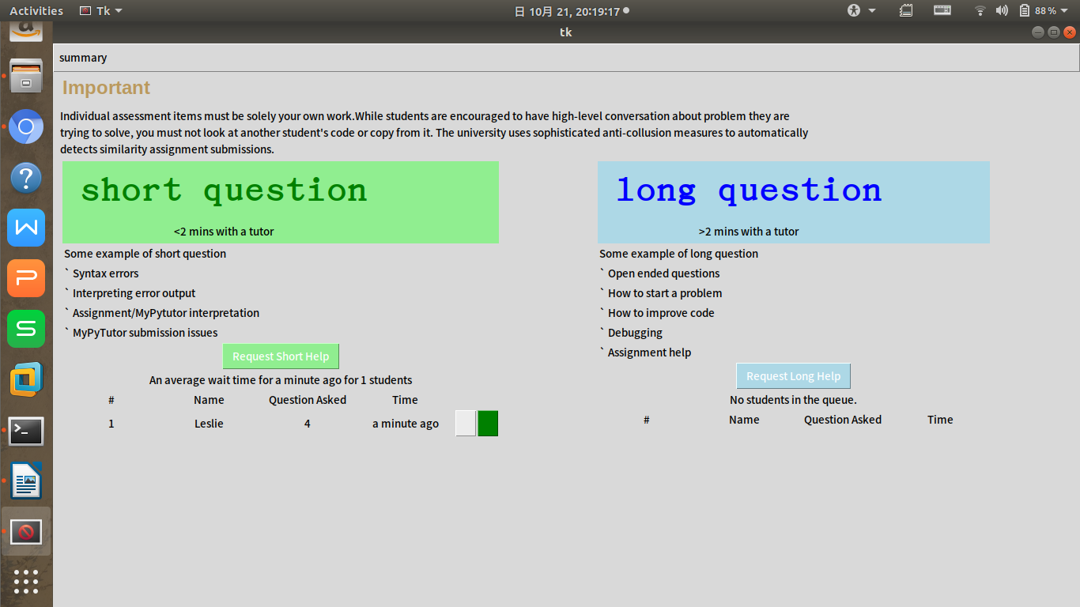
(4)/cancel
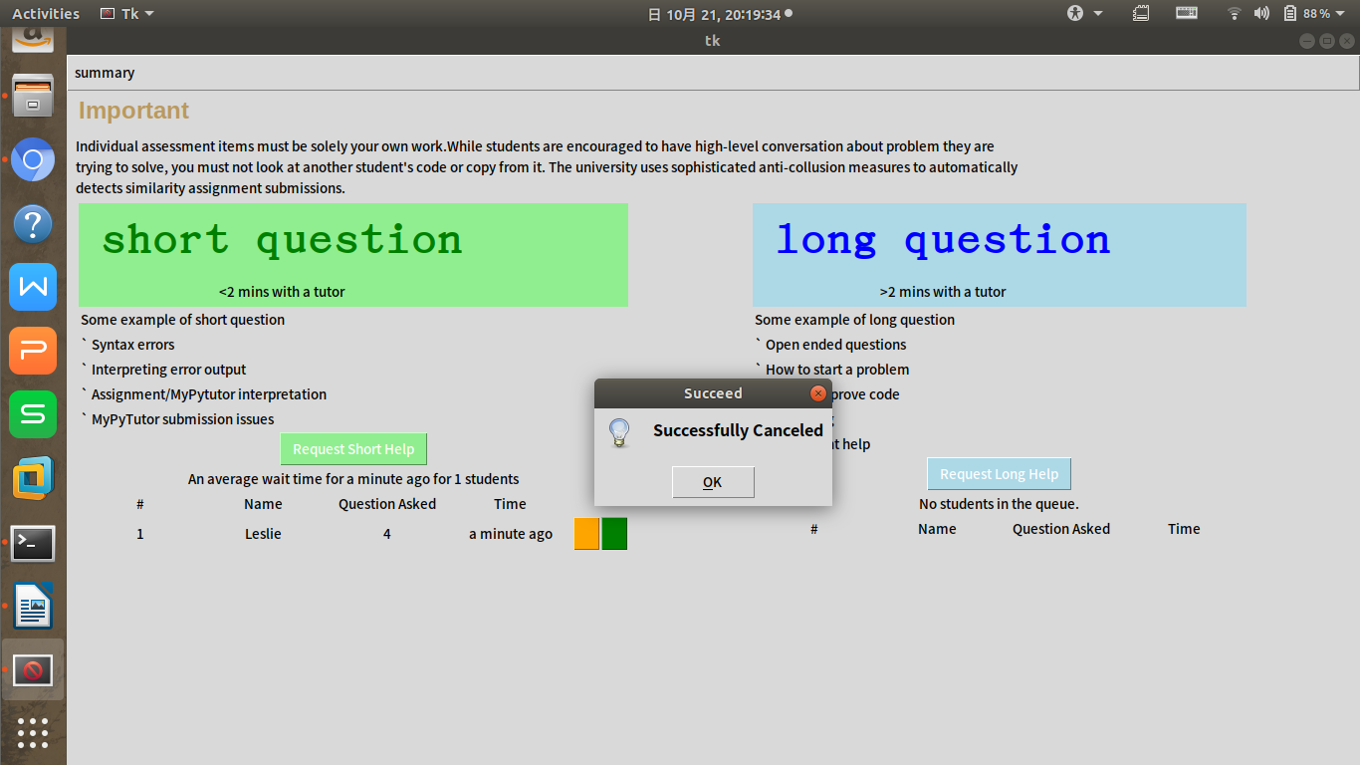
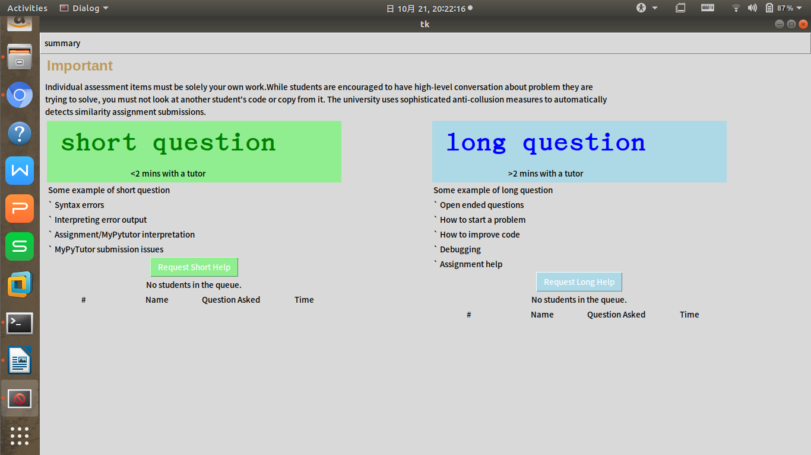
(5)/accept
