**DEDAN KIMATHI UNIVERSITY OF TECHNOLOGY**

**BSc. MECHANICAL ENGINEERING**

**INTERNAL COMBUSTION ENGINES**

**LABORATORY REPORT ON:**

**PERFORMANCE ANALYSIS OF A DIESEL ENGINE**

**WRITTEN BY:**

**JACOB MUTHUI MAINA, E023-1295/2011**

**ABSTRACT**

Through photosynthesis, energy from the sun is converted to chemical energy. Burning dried plants or wood produces energy in form of heat and light. This is the energy originally stored in the plants through photosynthesis. In the contemporary world, wood has been discouraged from being the main source of reliance for energy. In the world today petrol based fuel and coal is being used as a source of energy to heat water for steam production for driving turbines in power generation plants. The various types of fuels depend on various factors such as storage handling, cost, pollution and combustion equipment such as boilers, furnaces amongst others. Availability of knowledge on fuels is vital in choosing the right fuel for the right purposes. In laboratory tests are usually conducted for determining the nature and fuel quality.

**OBJECTIVE**

To conduct a test on a four cylinder diesel enginerunning at constant speed to determine its speed, brake power, rate of fuel consumption, rate of air flow through engine, and brake thermal efficiency.

**INTRODUCTION**

Engine tests are carried out in order to evaluate the parameters which are used to illustrate some particular characteristic of the engine such as air – fuel ratio and breakthermal efficiency. With the growing demand for transportation, IC engines have gained a lot of importance in automobile industry. It is then necessary to produce efficient and economical engines. While developing IC engines it is important to take in consideration all the parameters influencing the engine design and performance. There many parameters hence it is difficult to account for all while designing an engine. Engines tests are the necessary to conduct for determination of factors that improve engine performance. They include:

* Fuel –air ratio
* Power and mechanical efficiency
* Volumetric efficiency
* Specific output
* Specific fuel consumption
* Effective pressure and torque
* Thermal efficiency and heat balance
* Exhaust smoke and emissions

When an engine is assigned to a task, its degree of success is the engine performance.The particular application of the engine decides the relative importance of these performance parameters. For instance, an aircraft engine specific weight is more important whereas for an industrial engine specific fuel consumption is more important.

**THEORY**

The first law of thermodynamics states that energy cannot be created or destroyed, but can be converted from one form to another. As an equation, this is simply:

Esystem = 0 = Ein – Eout

∆ E = (Qin - Qout) - (Wout- Win) =Qnet, in- Wnet, out

Wnet,out= Qin - Qout

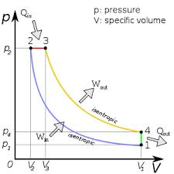

Thermal efficiency is defined as:



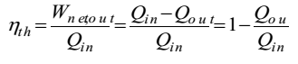

For an internal combustion engine, break thermal efficiency is also written as:

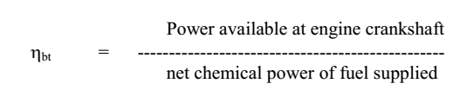

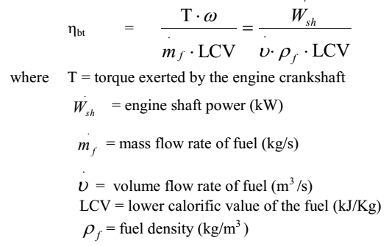

**Procedure and Measurement**

(a) The engine was warmed up and ran at a steady speed of 2500 rev/min and at a high throttle opening until all temperatures stabilised.

(b) A set of readings and their units were taken as follows:

Air inlet temperature T3 (Celsius)

Air manometer reading ha (mm water)

Atmospheric pressure Pa (mm Hg)

*Heenan-Froude dynamometer*

Added mass m (kg)

Spring balance reading L (N)

Engine speed N (rev/min)

*Fuel:*

Lower calorific value LCV = 43 MJ/kg

Density ρ (kg/l)

Volume V (ml)

Consumption time t (s)

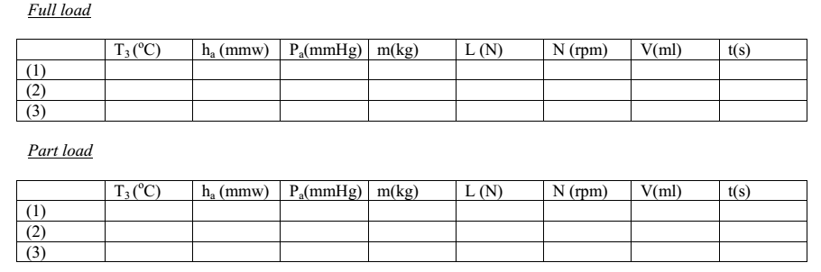

(c) The reading was repeated for a further two times.

(d) The fuel pump rack was then partly closed, the temperatures were allowed to stabilise for about ten minutes, and a further set of readings was taken.

(e) Discuss the different sources of errors and quantify measurement errors in V and t for the measurement of the mass flow rate of fuel; and in T 3, ha and Pa for the measurement of the mass flow rate of air.

**RESULTS**

The following are tabulated results for the experiment that carried out to test for performance of a four cylinder diesel engine.

|  |  |  |  |  |  |  |  |  |
| --- | --- | --- | --- | --- | --- | --- | --- | --- |
|  | **T3 (Temperature) ˚C** | **ha (atmospheric pressure) mmw** | **Pa (mmH)** | **Mass (kg)** | **Load (Newton)** | **N (rpm)** | **Volume (ml)** | **Time (s)** |
| **Full Load** | 21 | 33.5 | 730.6 | 22 | 145 | 2500 | 200 | 65.61 |
| **Part Load** | 20 | 35 | 730 | 0 | 129 | 2500 | 100 | 86 |

|  |  |  |
| --- | --- | --- |
| 100 millilitre = 0.0001 cubic meter | | |
| Fluid Density | 780 | kg/m3 |
| LCV | 43000 | kJ/kg |
| Density of air | 1.205 | kg/m3 |

**DATA ANALYSIS**

Calculation of A/F ratio: 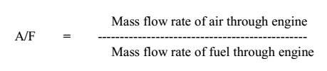

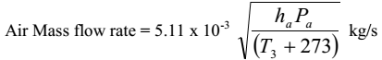

= 5.11×10-3 $\sqrt{\frac{33.5 ×730.6}{(21+273)}}$ = 0.0466 kg/s

Fuel Mass Flow rate: =Volume Flow rate (m3/s) × Fuel Density (kg/m3)

=× 780 = 0.002378 kg/s

A/F = $\frac{0.0466}{0.002378}$ = 19.6

Calculation of Break thermal efficiency:

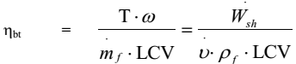



= × = 33.62 kW

ήbt= = 0.3288 , = 32.88%

Volumetric Efficiency:

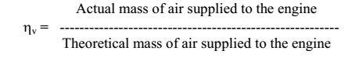

= Theoretical mass of air = (n/2) (/4) D2S ρa N/60 (kg/s)

Where: D = the cylinder diameter (bore) in (m).

S = the stroke in (m)

N = engine speed in (rpm)

n = number of cylinder

ρa= air density at room temperature (kg/m3)

= (4/2) (/4) × 0.0942 × 0.083 x 1.205 x 2500/60

= 0.0578

ήv=0.0466/0.0578 = 0.8062, =80.62%

**For Part Load:**

Air Mass Flow Rate: 5.11 × 10-3 = 0.0477

Fuel Mass Flow Rate: $\frac{.0.0001}{86}$ × 780 = 0.000907 kg/s

A/F = 0.0477/ 0.000907 = 52.61

Shaft Power:

$\frac{\left(0 ×9.81\right)+129 }{447.2}$ × $\frac{2500}{60}$ = 12.19kW

ήbt= = 0.3126, = 31.26%

Volumetric Efficiency:

ήv= 0.0477/0.0578 = 0.8253, = 82.53%

ERRORS calculations:

Fuel Mass Flow Rate: $\frac{0.002378- 0.000907}{0.002378}$ = 0.6186, = 61.86%

Air Mass Flow Rate: $\frac{0.0466- 0.0477}{0.0466}$ = - 0.024

Air Fuel Ratio: $\frac{19.6-52.61}{19.6}$ = - 1.684

**DISCUSSION**

The first law of thermodynamics, also known as the conservation of energy principle, provides a sound basis for studying therelationships among the various forms of energy and energy interactions.

Based on experimental observations, the first law of thermodynamics statesthat energy can be neither created nor destroyed during a process; it canonly change forms.Therefore, every bit of energy should be accounted forduring a process.

The **second law of thermodynamics** states that in a natural [thermodynamic process](http://en.wikipedia.org/wiki/Thermodynamic_process), there is an increase in the sum of the [entropies](http://en.wikipedia.org/wiki/Entropy) of the participating systems. It is an [empirical finding](http://en.wikipedia.org/wiki/Empirical_evidence) that has been accepted as an axiom of [thermodynamic theory](http://en.wikipedia.org/wiki/Thermodynamics). The law defines the concept of thermodynamic [entropy](http://en.wikipedia.org/wiki/Entropy) for a [thermodynamic system](http://en.wikipedia.org/wiki/Thermodynamic_system) in its own state of internal [thermodynamic equilibrium](http://en.wikipedia.org/wiki/Thermodynamic_equilibrium). It considers a process in which that state changes, with increases in entropy due to [dissipation of energy](http://en.wikipedia.org/wiki/Dissipation) and to dispersal of matter and energy. It also envisages a compound [thermodynamic system](http://en.wikipedia.org/wiki/Thermodynamic_system) that initially has interior walls that constrain transfers within it. The law then envisages a process that is initiated by a [thermodynamic operation](http://en.wikipedia.org/wiki/Thermodynamic_operation) that changes those constraints, and isolates the compound system from its surroundings, except that an externally imposed unchanging force field is allowed to stay subject to the condition that the compound system moves as a whole within that field so that in net, there is no transfer of energy as work between the compound system and the surroundings, and finally, eventually, the system is stationary within that field.

During the process, there may occur chemical reactions, and transfers of matter and of energy. In each [adiabatically separated](http://en.wikipedia.org/wiki/Adiabatic_wall) compartment, the [temperature](http://en.wikipedia.org/wiki/Temperature) becomes spatially homogeneous, even in the presence of the externally imposed unchanging external force field. If, between two adiabatically separated compartments, transfer of energy as work is possible, then it proceeds until the sum of the entropies of the equilibrated compartments is maximum subject to the other constraints. If the externally imposed force field is zero, then the chemical concentrations also become as spatially homogeneous as is allowed by the perm abilities of the interior walls, and by the possibilities of phase separations, which occur so as to maximize the sum of the entropies of the equilibrated phases subject to the other constraints.

The brake power was less than chemical power fed to the engine since some power was lost to the surroundings in form of heat and also the fact that there are additions in the engine that draw their power from the engine and include: the camshaft, alternator and the like.

**REFERENCES**

1. Monyem A., Gerpen J.H.V., *Biomass and Bioenergy,* 20 (2001) 317–325

2. Tormos B., Novella R., Garcia A., Gargar K., *Renewable Energy, 35* (2010) *368–378*

3. Nurun Md., Rahman Md., Akhter Md., *Applied Thermal Engineering ,*29, (2009) 2265–2270

4. Lapuerta M., Armas O., Fernandez F., *Progress in Energy and Combustion Science,* 34 (2008) 198

5. Roskilly P A., Nanda S.K., Wang D.W., Chirkowski J., *Applied Thermal Engineering,* 28, (2008) 872

6. Zheng M., Mwila C.M., Reader T.G., Wang M., David S.K., Ting Tjong J.T., *Fuel* 87, (2008) 714–722

7. Lujan J.M., Bermu V.D., Tormos B., *biomass and bio energy,* 33, (2009) 948– 956

8. Korres M.D., Karonis D., Lois E., Martin B., Gupta A.K., Fuel, 87, (2008) 70–78

9. Chen H.Q.H.D., Geng, M., Bian H.Z.Y., *Applied Energy,* 87 (2010) 1679–1686

10. Ballesteros. R., Hernandez J.J., Lyons L.L., Cabanas B. Tapia A., *Fuel,* 87, (2008) 1835–1843

11. Aydin. H., Ilkilic I., *Applied Thermal Engineering,* 30(2010) 1199–1204