

**Data Structures**

**and**

**Algorithms**

M2I222994-19-B

**Demonstration**



**Ivan Todorov**  
S1822426

ITODOR200@caledonian.ac.uk

1. Start-up

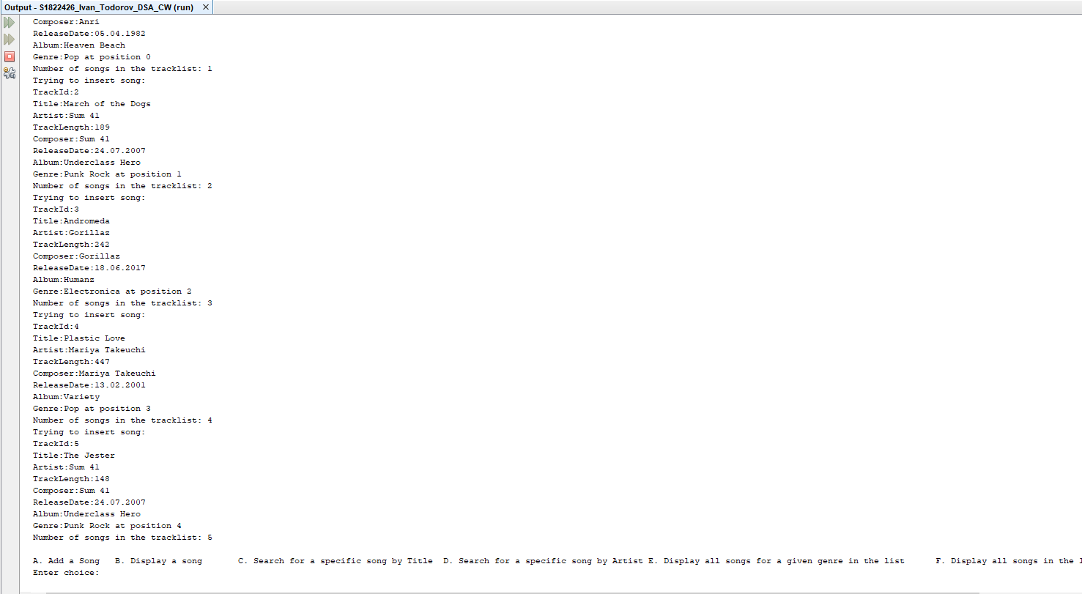

2) /**A**/ Add a Song

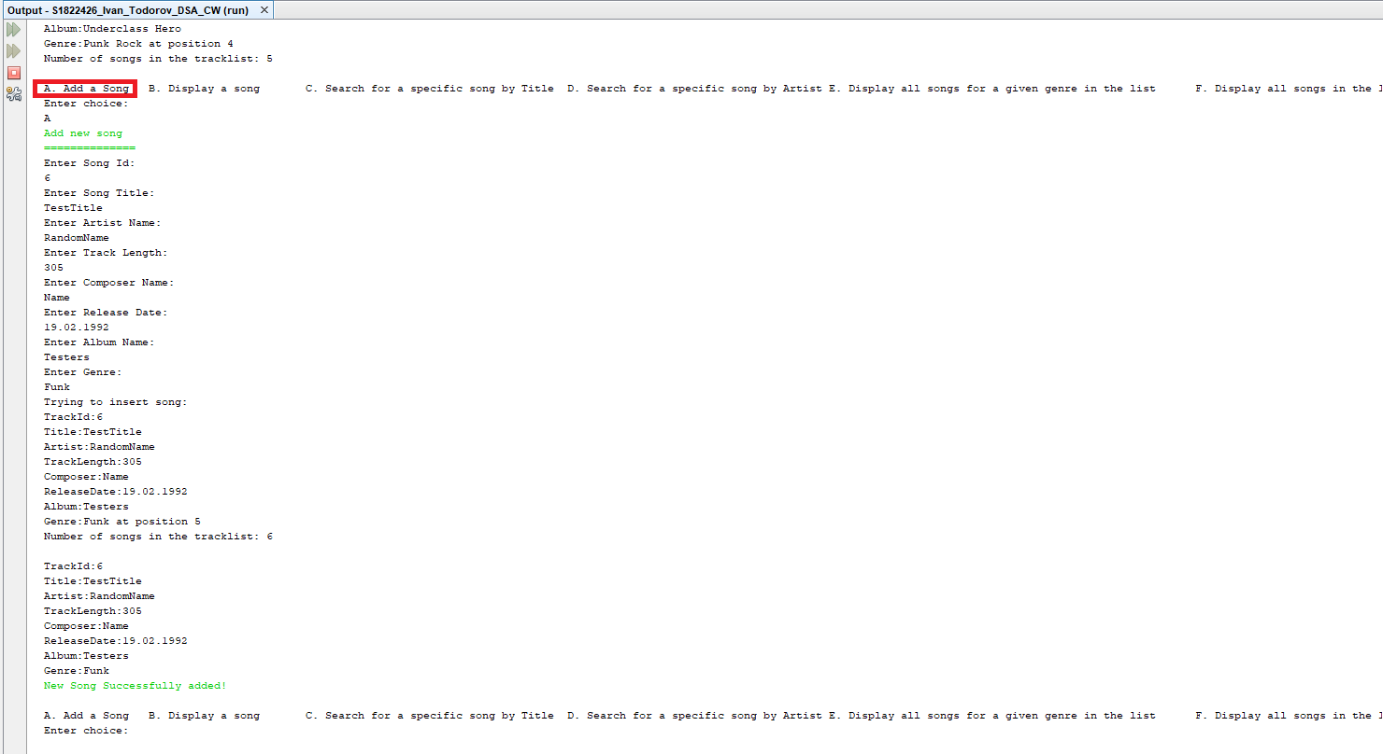

3)/**B**/ Display a Song

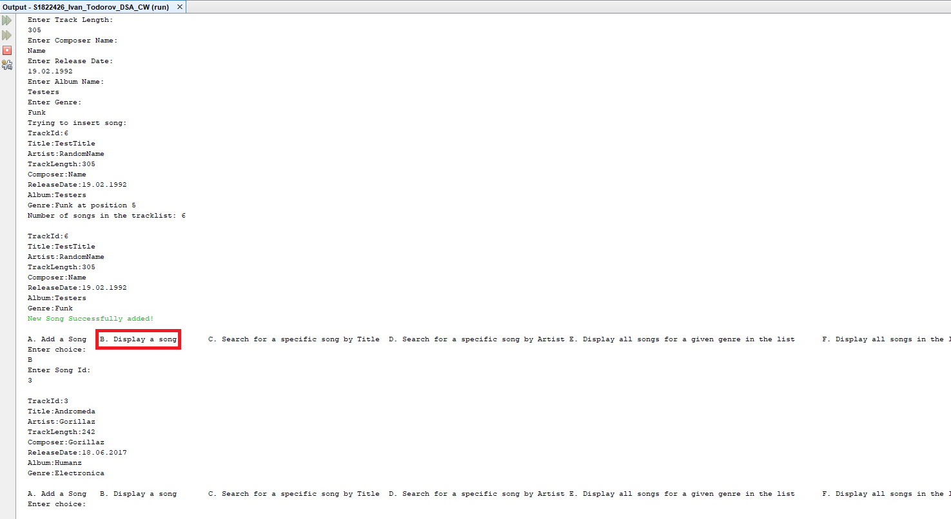

4)/**C**/ Search for a specific song by Title

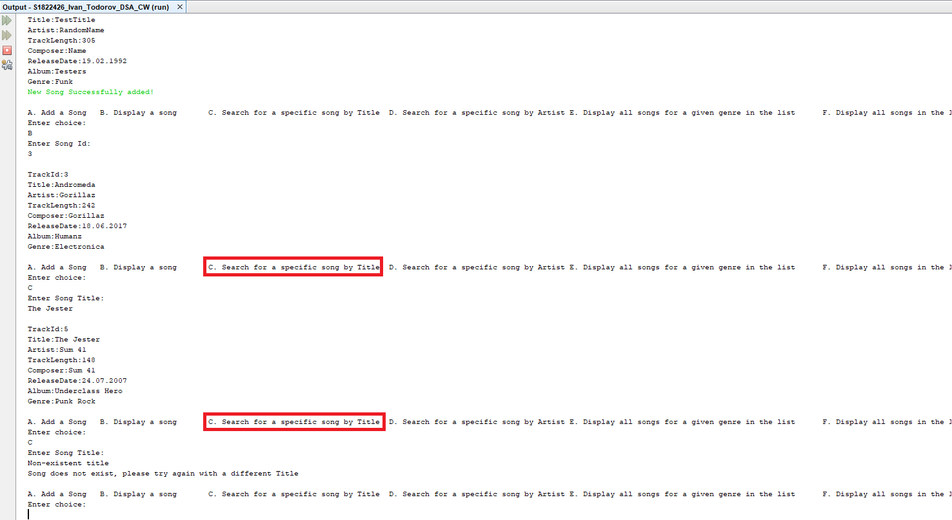

5)/**D**/ Search for a specific song by Artist

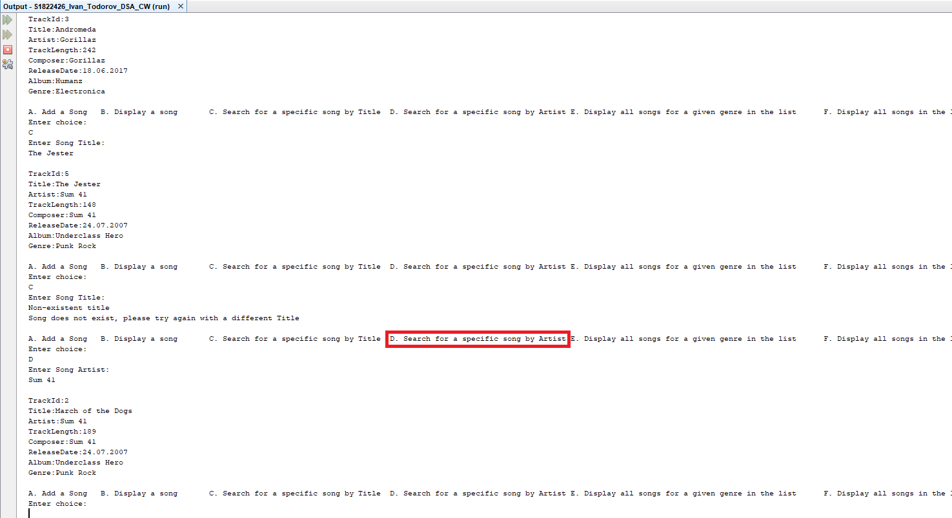

6)/**E**/ Display all songs for a given genre in the list

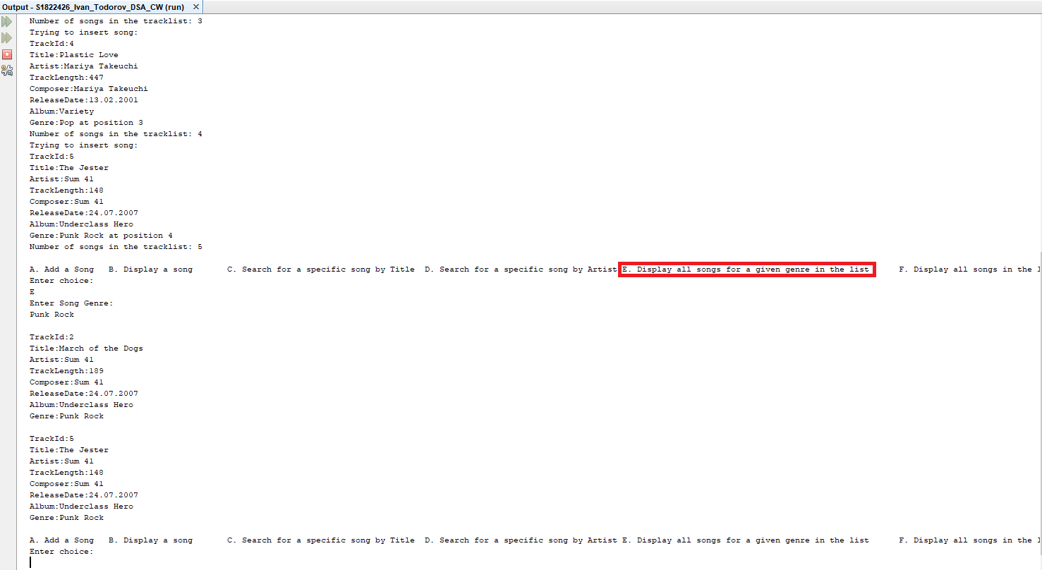

7)/**F**/ Display all songs in the list

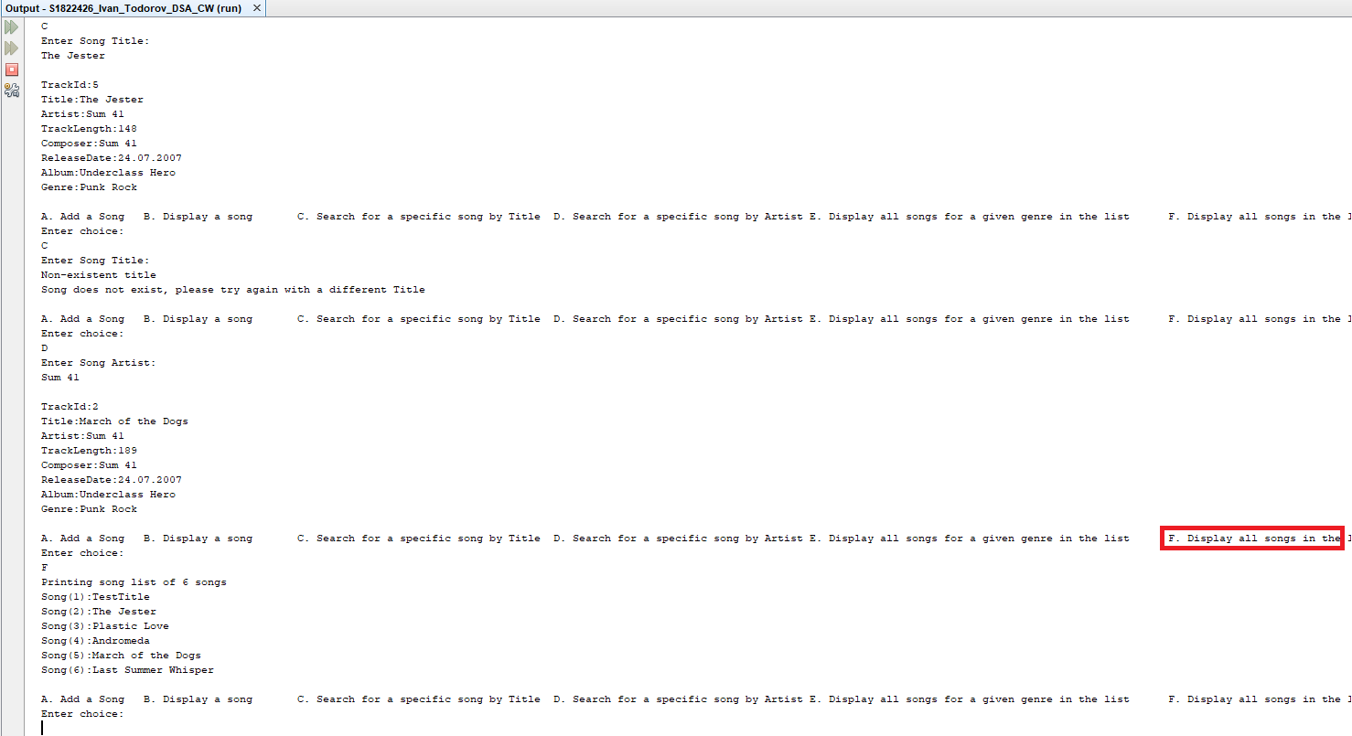

8)/**Q**/ Quit

