1. Full outer Join on user id 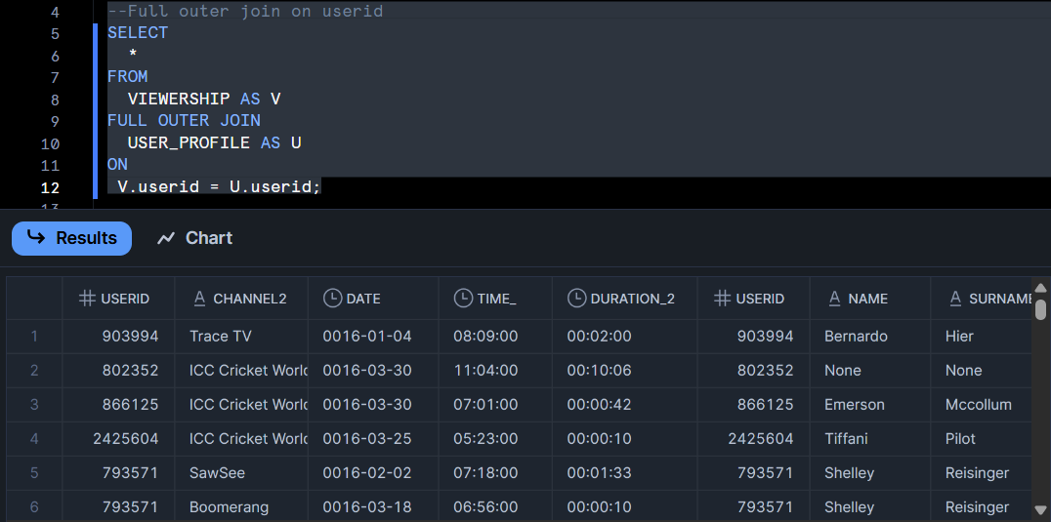
2. Total viewership by Channel A screenshot of a computer

   AI-generated content may be incorrect.
3. Viewership by gender A screenshot of a computer

   AI-generated content may be incorrect.
4. Daily interval A screenshot of a computer

   AI-generated content may be incorrect.
5. Converting duration to seconds (00:00:000 A screenshot of a computer

   AI-generated content may be incorrect.
6. Time intervals ,age grouping and Month convertion